**The Car Renters**



**Presented by**

Jelani Garnes

Baktash Sana

Kobra Nateghi

Fawad Syed Rahim

Contents

Overview 3

Goals 3

Application Capabilities 3

Business Benefits 3

Entities 4

ERD Diagram 4

Tables and fields 5

Simple paper prototype or storyboarding 7

Team members' responsibilities 10

**The Car Renters**

**Car Rental Application**

# Overview

Web applications are being used more daily by corporate businesses and small companies to expand their services and capabilities. We have decided and plan to develop a fully functional web application for a car rental company. The application will only be operated by the company administration and staff and it is available for all the business branches. The application will be used to create/edit/update/delete rental forms or applications on a customer’s request, add memberships whether regular or enterprise, show fees and fee statements and also store customer rental records.

# Goals

* Build and Develop a fully Functional Web Application.

# Application Capabilities

* User enter his/her login id and password to access the application
* User can register a client
* User can create/edit/update/delete a membership on client’s request
* User can create/edit/update/delete rental forms or application on client’s request
* Save client records securely

# Business Benefits

* There would be increasing demand for e-business.
* The same application for each branch making business more efficient.
* Clients can return a rental at any nearby branch without any records needing to be transferred
* Time saving and more organized.

# Entities

Vehicle

Rental_Transaction

Branch

Branch_Address

Address

Customer

Customer_Address

Membership

Employee

# ERD Diagram

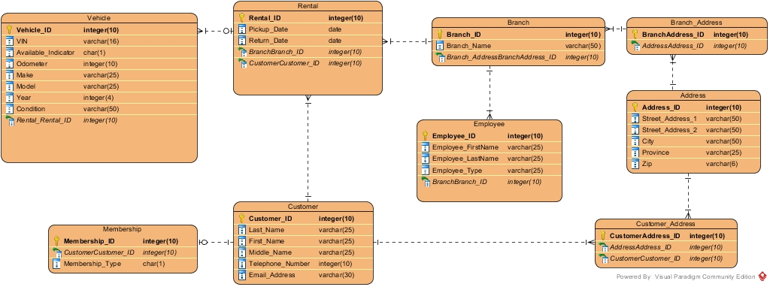

# Tables and fields

**Vehicle**

|  |  |  |
| --- | --- | --- |
| Vehicle_ID | Integer(10) | PK |
| VIN | Varchar(16) |  |
| Available_Indicator | Char(1) |  |
| Odometer | Integer(10) |  |
| Make | Varchar(25) |  |
| Model | Varchar(25) |  |
| Year | Integer(4) |  |
| Condition | Varchar(50) |  |
| Rental_Rental_ID | Integer(10) | FK |

**Rental**

|  |  |  |
| --- | --- | --- |
| Rental_ID | Integer(10) | PK |
| Pickup_Date | Date |  |
| Return_Date | Date |  |
| CustomerCustomer_ID | Integer(10) | FK |
| BranchBranch_ID | Integer(10) | FK |

**Branch**

|  |  |  |
| --- | --- | --- |
| Branch_ID | Integer(10) | PK |
| Branch_Name | Varchar(50) |  |
| Branch_AddressBranchAddress_ID | Integer(10) | FK |

**Branch_Address**

|  |  |  |
| --- | --- | --- |
| BranchAddress_ID | Integer(10) | PK |
| AddressAddress_ID | Integer(10) | FK |

**Address**

|  |  |  |
| --- | --- | --- |
| Address_ID | Integer(10) | PK |
| Street_Address_1 | Varchar(50) |  |
| Street_Address_2 | Varchar(50) |  |
| City | Varchar(50) |  |
| Province/State | Varchar(25) |  |
| Zip | Varchar(6) |  |

**Customer_Address**

|  |  |  |
| --- | --- | --- |
| CustomerAddress_ID | Integer(10) | PK |
| AddressAddress_ID | Integer(10) | FK |
| CustomerCustomer_ID | Integer(10) | FK |

**Customer**

|  |  |  |
| --- | --- | --- |
| Customer_ID | Integer(10) | PK |
| Last_Name | Varchar(25) |  |
| First_Name | Varchar(25) |  |
| Middle_Name | Varchar(25) |  |
| Telephone_Number | Integer(10) |  |
| Email_Address | Varchar(50) |  |

**Membership**

|  |  |  |
| --- | --- | --- |
| Membership_ID | Integer(10) | PK |
| CustomerCustomer_ID | Integer(10) | FK |
| Membership_Type | Char(1) |  |

**Employee**

|  |  |  |
| --- | --- | --- |
| Employee_ID | Integer(10) | PK |
| Employee_FirstName | Varchar(25) |  |
| Employee_LastName | Varchar(25) |  |
| Employee_Type | Varchar(25) |  |
| BranchBranch_ID | Integer(10) | FK |

# Simple paper prototype or storyboarding

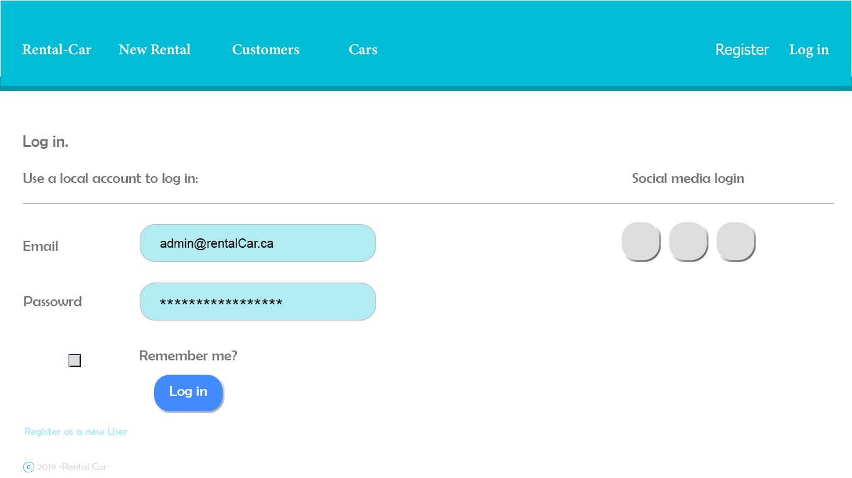

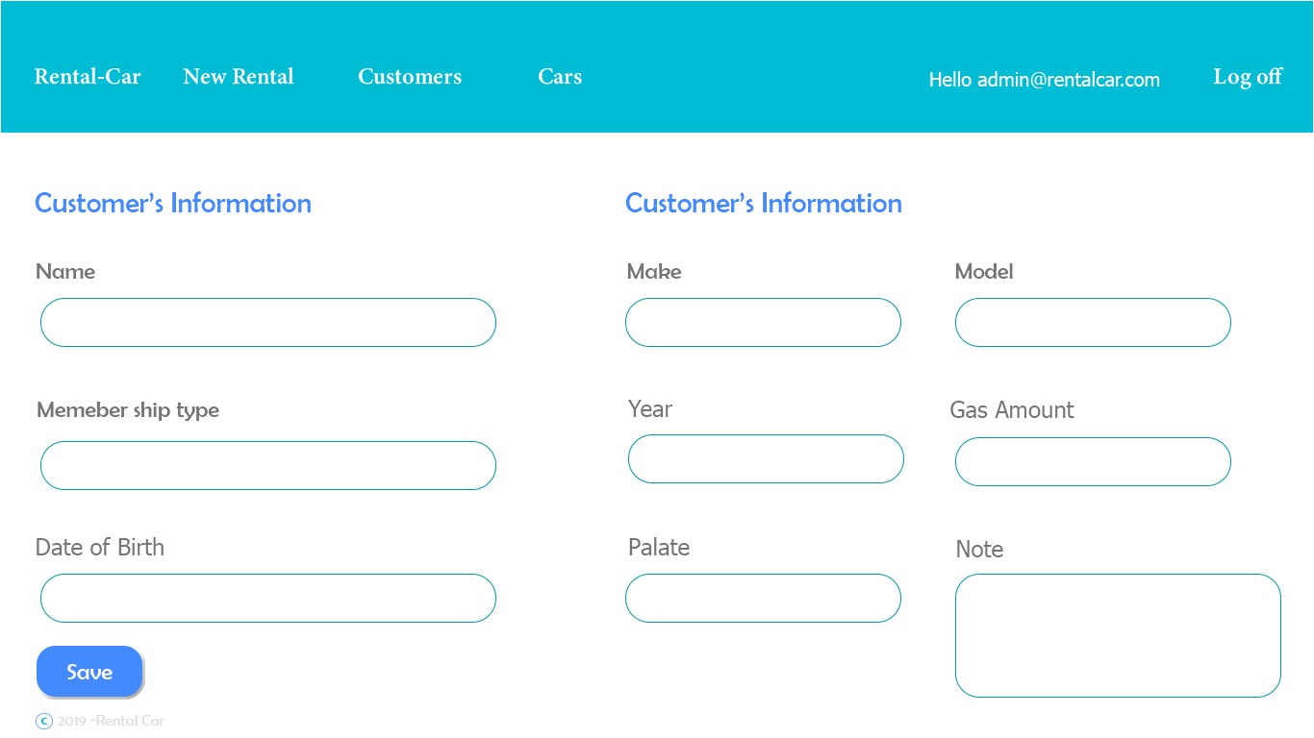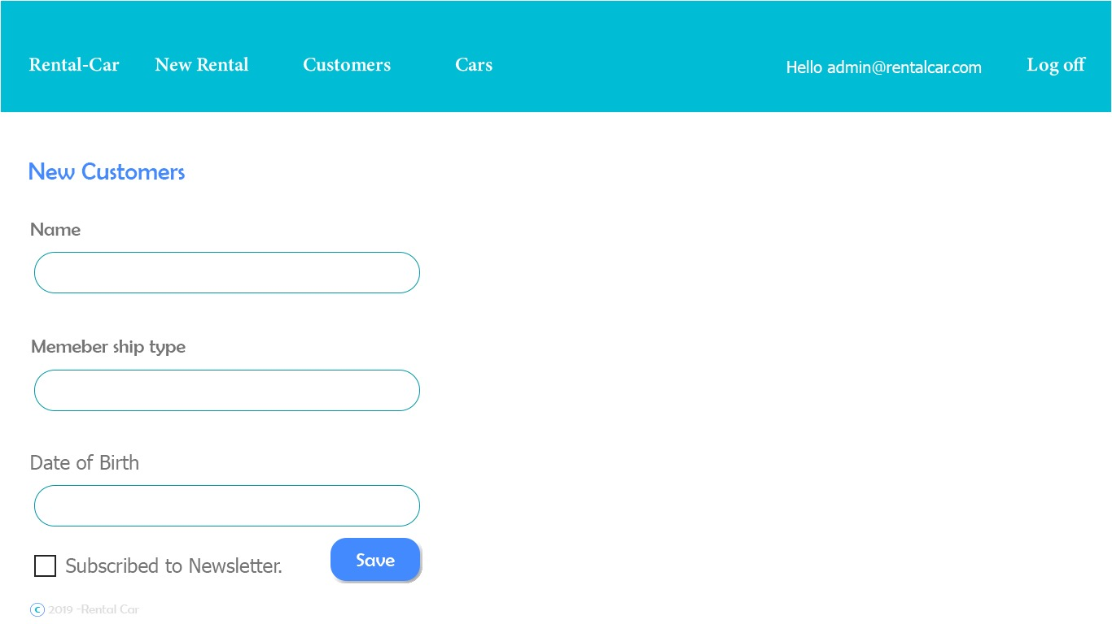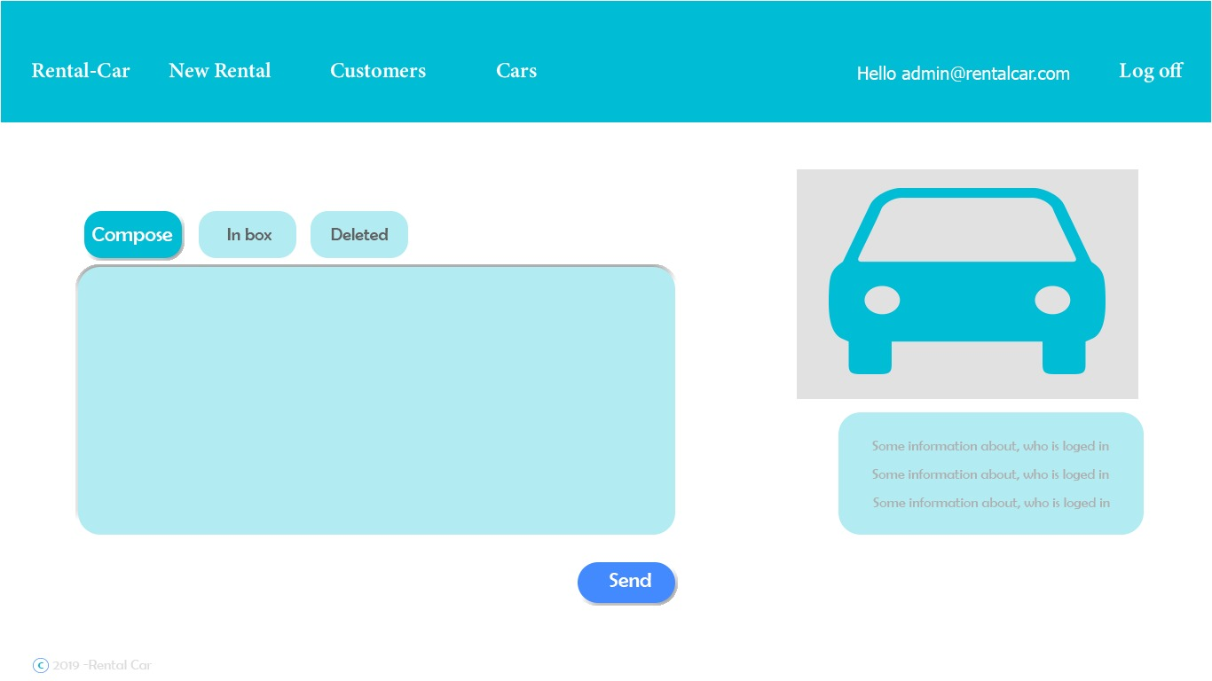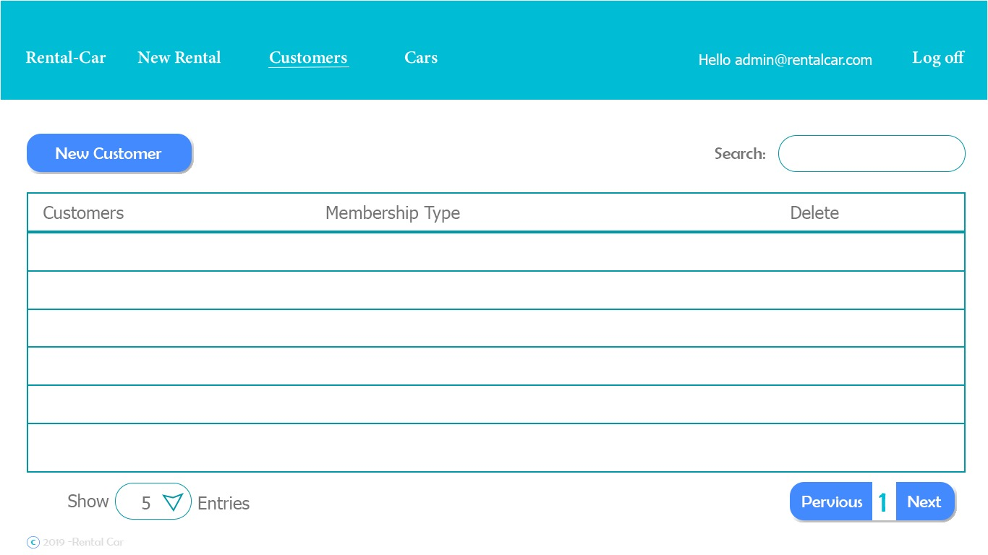

# Team members' responsibilities

|  |  |  |  |
| --- | --- | --- | --- |
| **Group Members** | **Stage 1-Proposal** | **Stage 2-Proposal** | **Stage 3-Proposal** |
| Jelani | Abstract | Abstract improvements | Abstract improvements |
| Baktash | Prototype | Abstract improvements | Abstract improvements |
| Kobra | Abstract | Abstract improvements | Abstract improvements |
| Fawad | Abstract | Abstract improvements | Abstract improvements |