Introduction:

*Finding the right supervisor and an interesting project topic is many times taken as a given, but it is a crucial step to ensure a successful final year project. Working in a topic which is of interest to both you and your supervisor will keep you both motivated, and it can also ensure the supervisor has the right technical skills to support you through this process.*

In the past, allocation relied on students personally approaching (potential) supervisors, with no clear timeline or support about who to approach and very few students finding a supervisor/project.

An automated allocation followed, in which the students picked a few [research groups](https://www.ucl.ac.uk/computer-science/research/research-groups) from the department, and they were matched to supervisors according to preferences and supervisor availability. However, many of these groups are large and very diverse, so picking a group was far from the same than picking a “topic”.

This year we want to improve this process, making it easy for everyone, while allowing students to get the right supervisors and topics, avoiding frustrations and multiple rejections, and still respecting the freedom of academics to propose specific projects that fit their research interests. More specifically, students will get access to information about supervisors through a single webpage, making it easier for them to understand who is who, and hopefully guiding the process of approaching supervisors to agree on a project.

While talking face to face and agreeing a project is the preferred method (this ensures you are doing something that you both find interesting), this might not be always possible. In this case, an automated matching will still be available, but we want it to be more representative than the name of the Research Group. Instead, we are using the ACM Classification Keywords, as a more representative way of describing the supervisors’ expertise and as a way of guiding the range of topics available within the department. Unassigned students will be able to select a range of keywords, and we will use this information to find a suitable match (i.e. supervisor).

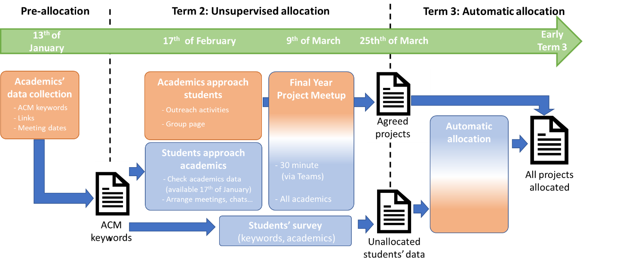

## **Figure 1: Overview of the allocation process followed for this year, with reference dates. We collected information from academics (left); students can use this information to approach academics and agree projects during term 2 (centre); Otherwise, students can fill in a survey expressing their interests (ACM keywords), and an automatic allocation process will be used considering students’ preferences, academics expertise and availability (right).**

## Allocation Process for 2022-2023

This document provides information about how this process will work this year. The process is summarized in the figure above, and is divided in two main stages:

* **Unsupervised allocation (term 2):** This stage starts after the Reading Week. Students will be provided with information about the tutors (e.g. areas of expertise, as ACM keywords, links, project descriptors), all as a single [page](https://liveuclac-my.sharepoint.com/:x:/g/personal/ucacdm0_ucl_ac_uk/EQIDSsPjZmJHoz-gLlYu2ygBCxhTXr5rhSq2F-ViWVhB5w?e=g8vKr6). Students are encouraged to try and find a project, approaching potential supervisors, brainstorming, etc. Tutors have also been encouraged to reach out to students, to try to secure supervising students working on projects of the tutor’s choice. This is the preferred way to allocate project, ensuring they are interesting to both students and tutors.
* **Automatic allocation (early term 3):** This stage will ensure all students are allocated to a supervisor, fitting students‘ preferences where possible. Students who could not secure a project/supervisor in the previous stage will be automatically matched to the remaining supervisors (i.e. taking into account the projects supervisors have already secured and the number of students each supervisor can take). Students will be allocated to tutors according to the keywords selected during the students’ survey and supervisor's expertise (from pre-allocation).

The main tasks in each of these stages, and their timing are described next:

* **Data distribution (17th February 2022):** Emails will go out to all students, providing them with information about the supervisors (see link to [information page](https://liveuclac-my.sharepoint.com/:w:/g/personal/ucacdm0_ucl_ac_uk/EbZnHNciuPpBiuG48vOze4EBlje02k-Ft4TzxiDM74Ioag?e=wT8oEF)) and with the instructions required to start looking for a project supervisor during term 2.
* **Unsupervised allocation (17th February – 17th March):** Students are encouraged to check academics' profiles and approach potential supervisors. Academics are also recommended to approach potential students with project ideas. Agreed projects should be notified via the following [form](https://forms.office.com/Pages/ResponsePage.aspx?id=_oivH5ipW0yTySEKEdmlwilJffhblelBgkhD5IrwMe1UQVk5M05GNzhJQlk2ODZCV0dMU0JTRk00WS4u). Please note **it is the supervisor who needs to fill in this form**. However, as this is a new process this year, we are leaving he link here so you can send it to your supervisor, in case s/he does not know how to do it.
* **Final Year Project Meet-up (9th of March 2022):** All supervisors will be available to chat with students about projects on 9th of march (we will share links to these meetings closer to the date). This meeting is a last effort to meet with supervisors and try to agree projects, avoiding the keyword-based allocation, which is likely to lead to weaker matchings. If you are planning to attend these meetings, it would be good if you come prepared with a project pitch (1-2 minute description of your idea), that you can share with your potential supervisor. You should also contact the supervisor ahead of the meeting, potentially sharing this project idea.
* **Gathering data for automatic allocation (9th of March - Early term 3):** If you have not agreed a project by 9th of March, you should fill in a survey describing your interests (the link will be provided by 1st of March). This survey will gather your preferences on a range of topics (e.g., preference for a research project or an industry-led project). One of the key bits of information you will need to provide is your choice of [ACM Keywords](https://liveuclac-my.sharepoint.com/:w:/g/personal/ucacdm0_ucl_ac_uk/EbO8iJGe53hEreG2DFsUzO4B5TtLs8oeVDBAXLFnKYfZRQ?e=19Sgwy) (please, make sure to **use this file**, as the coding is specific for UCL Final Year Projects). The information webpage will provide you with a list of “available topics”, and you should pick topics among such list. Please note that some topics are very specific, and you might not be sure about their meaning. You are encouraged to do a bit of research (maybe even checking the academics that work on that topics, to see more specifically what they do). If you are still unsure, you can pick *topic areas* (e.g., C.2 or I.3), instead of specific *topics* (e.g., C.2.6 or I.3.5). In this case, you will be considered for any topics within that area.
* **Automatic allocation (End of term 3):** Students who did not secure a project by directly talking to supervisors will be assigned to one using their preferences (automatic allocation), ensuring all students have a supervisor. All students are encouraged to engage with supervisors before/during summer, as to start working towards their project. The first steps can involve conducting preliminary research, getting familiar with key tools and/or technologies, anything required as to get a clearer idea of their project goals and scope. However, this step is particularly relevant for students that were automatically matched, as no preliminary idea was discussed with the supervisor.