Q1. When nominal action probability is set to 0.8, is it expected that the TERMINAL action would also lead to random actions.

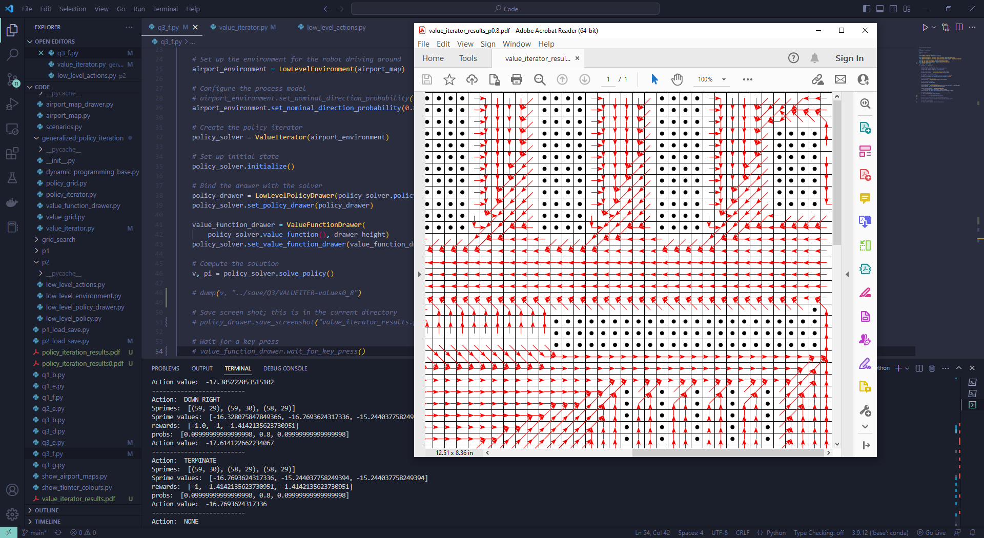

Here the TERMINAL action yielded the optimal action value, resulting in the weird arrow in the policy diagram.

Q2. Are we allowed to import other libraries such as joblib