Poppy Space

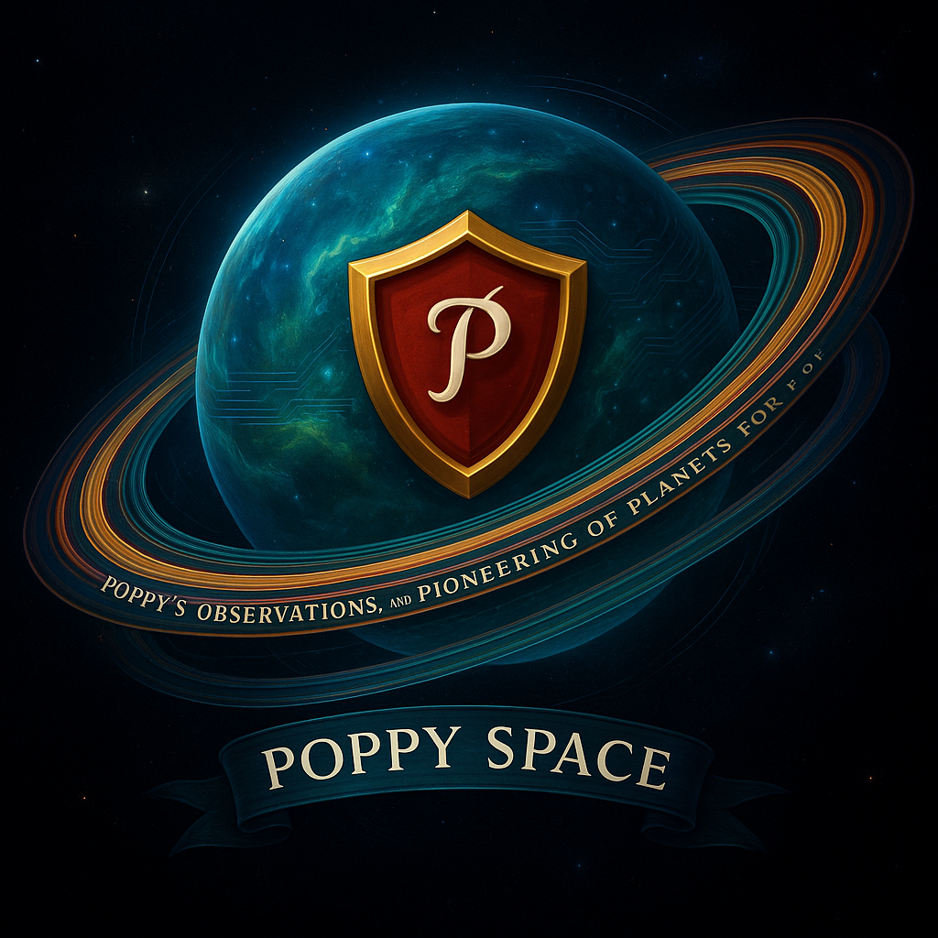Poppy’s Observations, and Pioneering of Planets for You

Table of Contents

1. Welcome to Poppy Space – A Poppy Corporation Initiative 2

2. The Situation 2

3. Your Mission 3

4. What’s next? 3

5. Poppy Corporation Overview 3

6. Get Started! 4

6.1. Instructions 4

# Welcome to Poppy Space – A Poppy Corporation Initiative

**Welcome to Poppy Space!**

**Poppy Space** is part of the **Poppy Corporation**, a leading innovator in both the space and hospitality industries. Alongside **Poppy Space**, we are proud to also run **Poppy Stays (Poppy Offers Perfect Places for You** (the Poppy in Poppy Stays)**)**, a cutting-edge booking platform for perfect travel destinations (My web development project).

At **Poppy Space**, we specialize in observing, exploring, and pioneering new frontiers in space. Our motto, **"Poppy’s Observations, and Pioneering of Planets for You** (the Poppy in Poppy Space)", reflects our mission to explore the universe, document new discoveries, and bring these findings back to Earth to benefit everyone. Whether we’re uncovering the mysteries of distant planets or investigating potential new technologies, we are at the forefront of space exploration.

# Poppy Corporation Overview

• **Poppy Space**: exploring the universe, one planet at a time. Our mission is to lead the way in space research, planetary observation, and the pursuit of new technologies.

• **Poppy Stays**: Your go-to platform for booking the best travel destinations on Earth (for now). With a variety of options, we offer experiences that suit all preferences and budgets.

As a part of **Poppy Corporation**, we’re constantly pushing the boundaries of exploration and innovation. Whether it’s space or travel, we are committed to making the world (and the universe) a better and safer place for everyone.

# The Situation

While we were conducting our research and exploration, **Poppy Space** found itself in an unexpected position. Some rival companies in the space industries of other, unknown planets targeted us with cyberattacks, infiltrating our system and hacking into our sensitive data. But we didn’t just sit back and let it slide. In true Poppy fashion, we launched a counterattack!

Our elite hacking team infiltrated these companies' systems, uncovering valuable information hidden within their files. But digital data wasn’t enough—we needed boots on the ground.

So, Poppy Space took it one step further:  
We sent in an undercover astronaut (that’s me!) to each of these planetary organizations to verify the intel, investigate their operations from the inside, and gather firsthand insight into their missions.

This is where your mission begins, **Head of Interspatial Security & Peace** — to review everything we uncovered and determine just how deep this galactic rabbit hole goes.

# Your Mission

As part of the **Poppy Space Investigation** Team, you’ve been tasked with reviewing the files we retrieved. The data we uncovered sheds light on the activities of several rival companies in the space industry. These companies not only attempted to infiltrate our systems, but we also discovered that they may be engaged in activities that pose a threat to the safety and integrity of space exploration.

Here’s what you will be reviewing:

1. **Intelligence report** – After accessing their systems, we sifted through the data to uncover valuable information about their space missions, technologies, and potential future plans. These **Research Reports** will provide you with an overview of what we found in terms of their technological advancements and their operations in space.
2. **Hacking Logs** – These files provide a step-by-step account of how our **Poppy Space** hacking team infiltrated the rival companies' systems. You'll gain insight into the methods we used to access their data, what we found, and how we took action to secure **Poppy Space**.
3. **Mission Logs & reports** – As the astronaut leading the mission, I kept detailed **Mission Logs** throughout the entire investigation. These logs document my personal reflections, the challenges I faced during the mission, and my thoughts on the space-related findings we uncovered. These logs provide a narrative of my journey through the investigation process.

# What’s next?

Now that you’re familiar with the situation and the overall mission, it’s time for you to begin your review. As the **Head of Inter-spatial Security & Peace**, your job is to evaluate the **Hacking Logs**, **Space Research Reports**, and **Mission Logs & reports** to ensure that all findings are legitimate and in line with the security protocols of **Poppy Space**. Your keen eye for detail will be essential in making sure the mission is a success.

# Get Started!

Now that you understand the mission, it’s time to dive into the company files and uncover the truth. As **Head of Inter-spatial Security & Peace**, you’ll be reviewing confidential materials gathered during our counterintelligence operations. Everything you need has been neatly organized and classified for your eyes only.

Here’s how the files are structured:

|  |
| --- |
| Poppy_Space/  ├── Company1/  │ ├── Hacking_Log.md # Files detailing how the hacking team uncovered Company 1's data  │ ├── Intelligence_Report.md # Intelligence gathered from Company 1's data  │ ├── Mission_Log.md # Personal mission log for Company 1  │ └── Mission_Report.md # Official mission report for Company 1  ├── Company2/  │ ├── Hacking_Log.md  │ ├── Intelligence_Report.md  │ ├── Mission_Log.md  │ └── Mission_Report.md  ├── Company3/  │ ├── Hacking_Log.md  │ ├── Intelligence_Report.md  │ ├── Mission_Log.md  │ └── Mission_Report.md  └── (Additional Company Folders) |

## Instructions

1. Navigate to the Poppy_Space/ folder — this serves as the central command for the project.
2. To facilitate easier exploration, we have developed an interactive website that organizes and presents all the data intuitively. Access it here:  
   [**https://poppy-space-interactive-map.my.canva.site/**](https://poppy-space-interactive-map.my.canva.site/)
3. If the website is inaccessible or encounters issues, please feel free to contact me via email. Alternatively, you may review the files individually within each company folder.
4. Within each company folder, you will find the following documents:

* Hacking Log — Technical details of how the hacking team accessed the company’s data
* Intelligence Report — Insights and analysis derived from the obtained data
* Mission Log — Personal notes and observations recorded during the mission
* Mission Report — Formal report summarizing mission outcomes and conclusions

1. Please review all materials thoroughly and apply your professional judgment to assess the findings.
2. Take notes or highlight any points of interest for potential follow-up or subsequent phases.