Lab 3

# Digital Design using FPGAs

## Connor Aksama – 1778028

The K-maps or Boolean simplification you did to create your design (Discounted and Stolen).

K-Maps for Discounted and Stolen Circuits

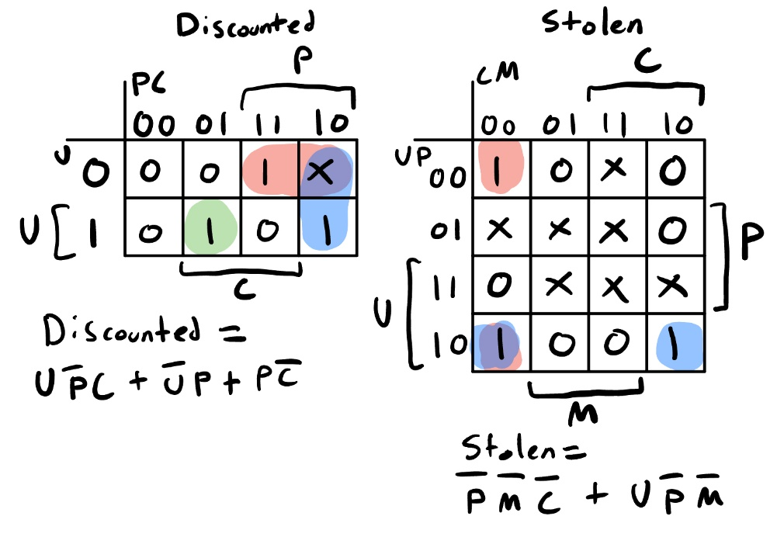

Boolean Simplification for Discounted Circuit

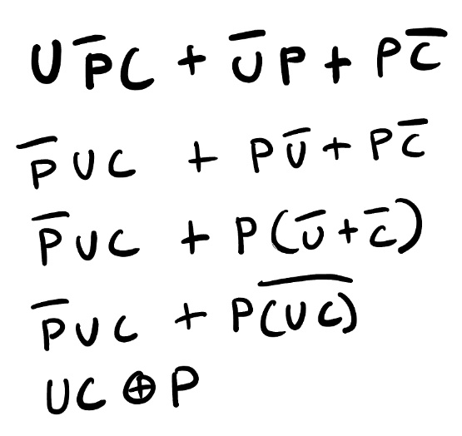

Boolean Simplification for Stolen Circuit

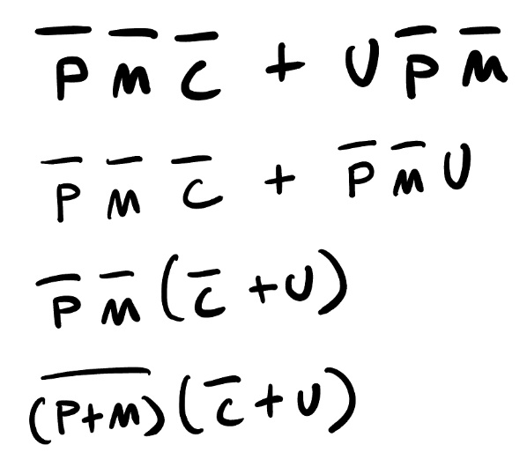

Your circuit diagrams (separate) for Discounted and Stolen.

Circuit Diagram for Discounted

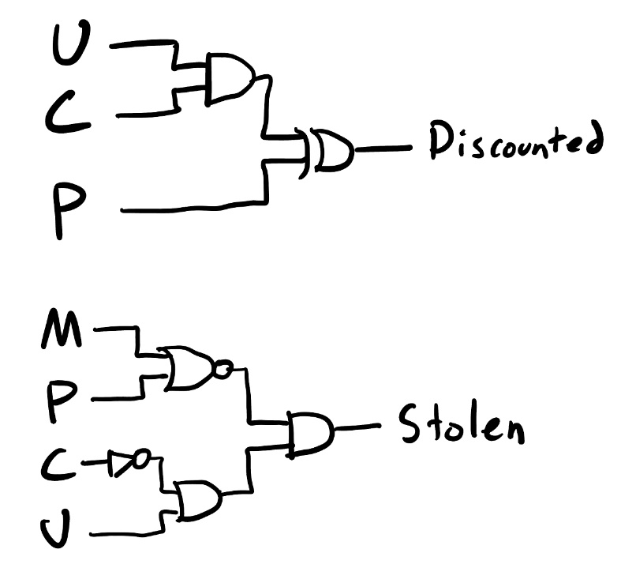

This circuit takes in an item’s UPC, encoded as a 3-bit integer (inputs U, P, C), and outputs 1 if and only if the corresponding item is discounted.

Circuit Diagram for Stolen Circuit

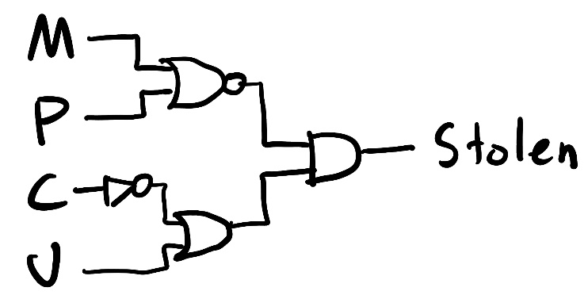

This circuit takes in an item’s UPC, encoded as a 3-bit integer (inputs U, P, C) and a signal that indicates if the item was marked (input M), and outputs 1 if and only if the item is stolen.

A screenshot of the ModelSim simulation with explanation.

Nordstrom Circuit Simulation

This simulation shows the Discounted and Stolen outputs for each of the 8 possible UPCs each being “marked” and “unmarked.” Notice that the “discounted” signal is 1 only when the corresponding UPC matches to a discounted item, or the UPC is unused. Also notice that for any UPC that corresponds to an expensive item, the “stolen” signal is 1 when the marked signal “M” is 1, and the “stolen” signal goes to 0 when “M” goes to 0.

### Time Estimation

This lab took approximately 4 hours, in total, to complete.