Lab 4

# High-Level Verilog

## Connor Aksama – 1778028

Your completed Table 1, showing your new items, their UPC codes, and classifications.

|  |  |  |  |  |
| --- | --- | --- | --- | --- |
| Item Name | UPC | Discounted | Expensive | Display |
| Potato Crown | 0 0 0 | No | Yes | POtAtO |
| Pig’s Foot | 0 0 1 | No | No | FOOt |
| Rocket Launcher | 0 1 1 | Yes | No | --[≡≡]- |
| Pigman Sword | 1 0 0 | No | Yes | BLOOd |
| Steering Wheel | 1 0 1 | Yes | Yes | StEEr |
| Anarchy Technoblade Youtooz Figure (Drops April 29th for only $29.99 with worldwide shipping!!!!) | 1 1 0 | Yes | No | tECH∏O |

*Table 1.* New list of products being sold, including UPCs, classifications, and HEX display patterns.

A screenshot of the ModelSim simulations you will demonstrate during the demo.

Double 7-Segment Display Simulation

The top two simulation screenshots show that for each of the 100 possible two-digit decimal integers, a valid output is given to the HEX displays. The bottom screenshot shows a small region shows that the correct display is given for each of the two-digit numbers. For example, notice that for SW=01111000 (78), the correct light pattern for the two HEX displays is correct.

Fred Circuit Simulation

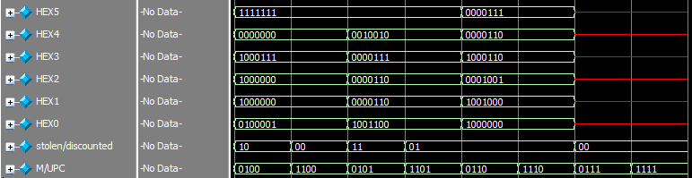

These screenshots show the output for the Fred circuit, combining the UPC description module and the Lab 3 Nordstrom circuit. Notice the HEX display patterns match what is given in Table 1 for each item. Also notice the displays show “Don’t Care” outputs for unused UPCs.

Drawings of the 7-seg display output for each of the unused UPC codes.

Pictures of the HEX displays for unused UPCs. The above screenshot shows the display for UPC 010. The bottom screenshot shows the display for UPC 111.

### Time Estimation

This lab took approximately 4 hours, in total, to complete.