Lab 6

# Communicating Sequential Logic

## Connor Aksama – 1778028

The top-level block diagram, showing the major modules and how they are interconnected.

Tug-of-War Top Level Block Diagram

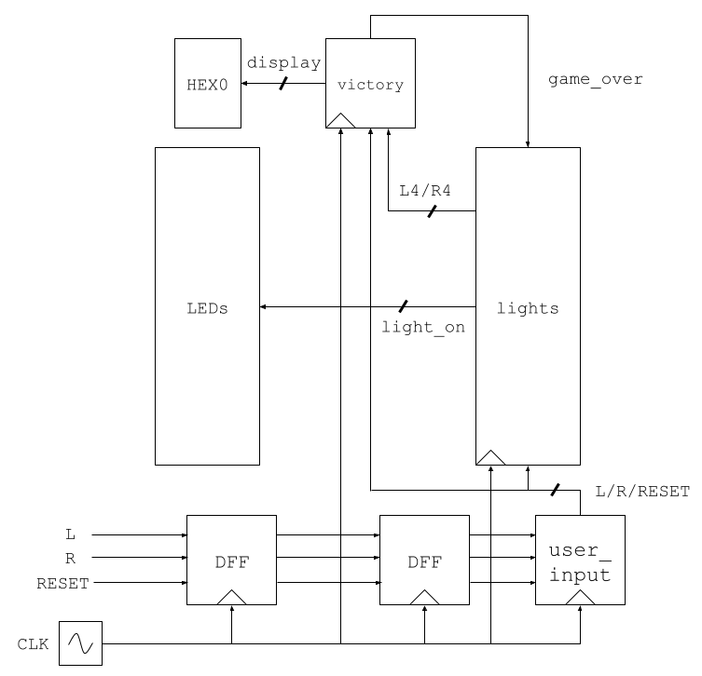

The top-level block diagram of the major modules in this lab. The lights block abstracts 9 individual light-controlling modules (See below). DFF blocks are used to stabilize direct user input, the user_input block detects the moment an input toggles high, and the victory block controls the HEX0 display and feeds back a game_over state to each light module.

lights Block Top Level Block Diagram

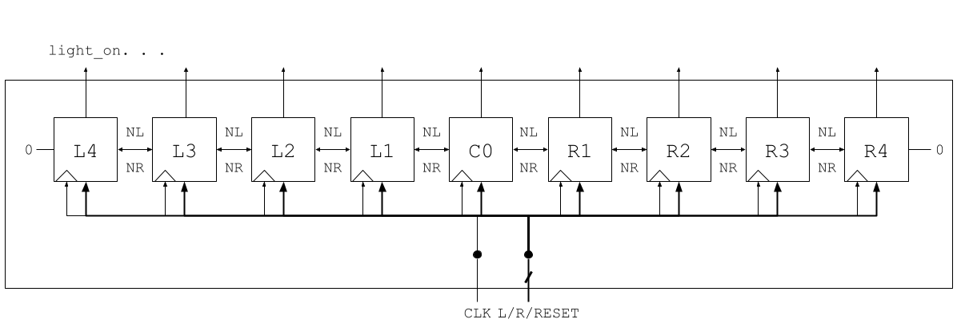

The block diagram for the individual light-controlling modules. The output signal from an individual block is wired into the block to its left (as an input signal, NR), and to the block to its right (as an input signal, NL).

For each of the major modules, include a state diagram (if applicable) and screenshot of the ModelSim simulation. Also include a ModelSim simulation for the top-level module).

User Input State Diagram

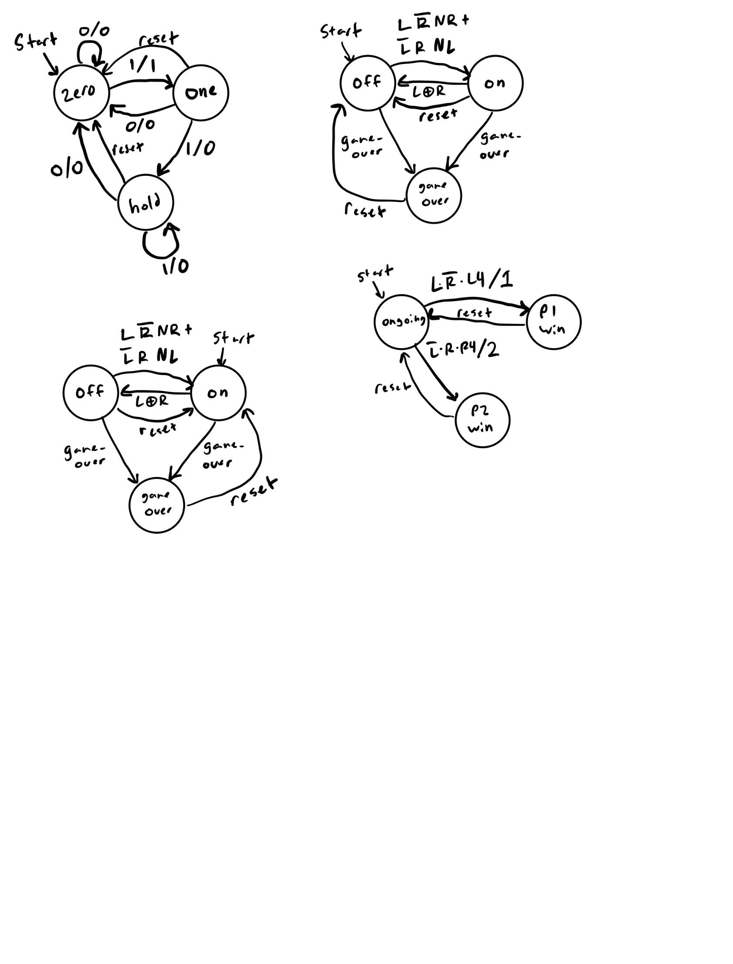

The state diagram for the user_input module. This state machine will output 1 for the first 1 in a consecutive run of 1s, and 0 for every other input.

User Input Simulation

This screenshot shows output for all of the possible state transitions for the user_input state machine. Notice that the output toggles high for only one clock cycle after the input toggles high.

Normal Light State Diagram

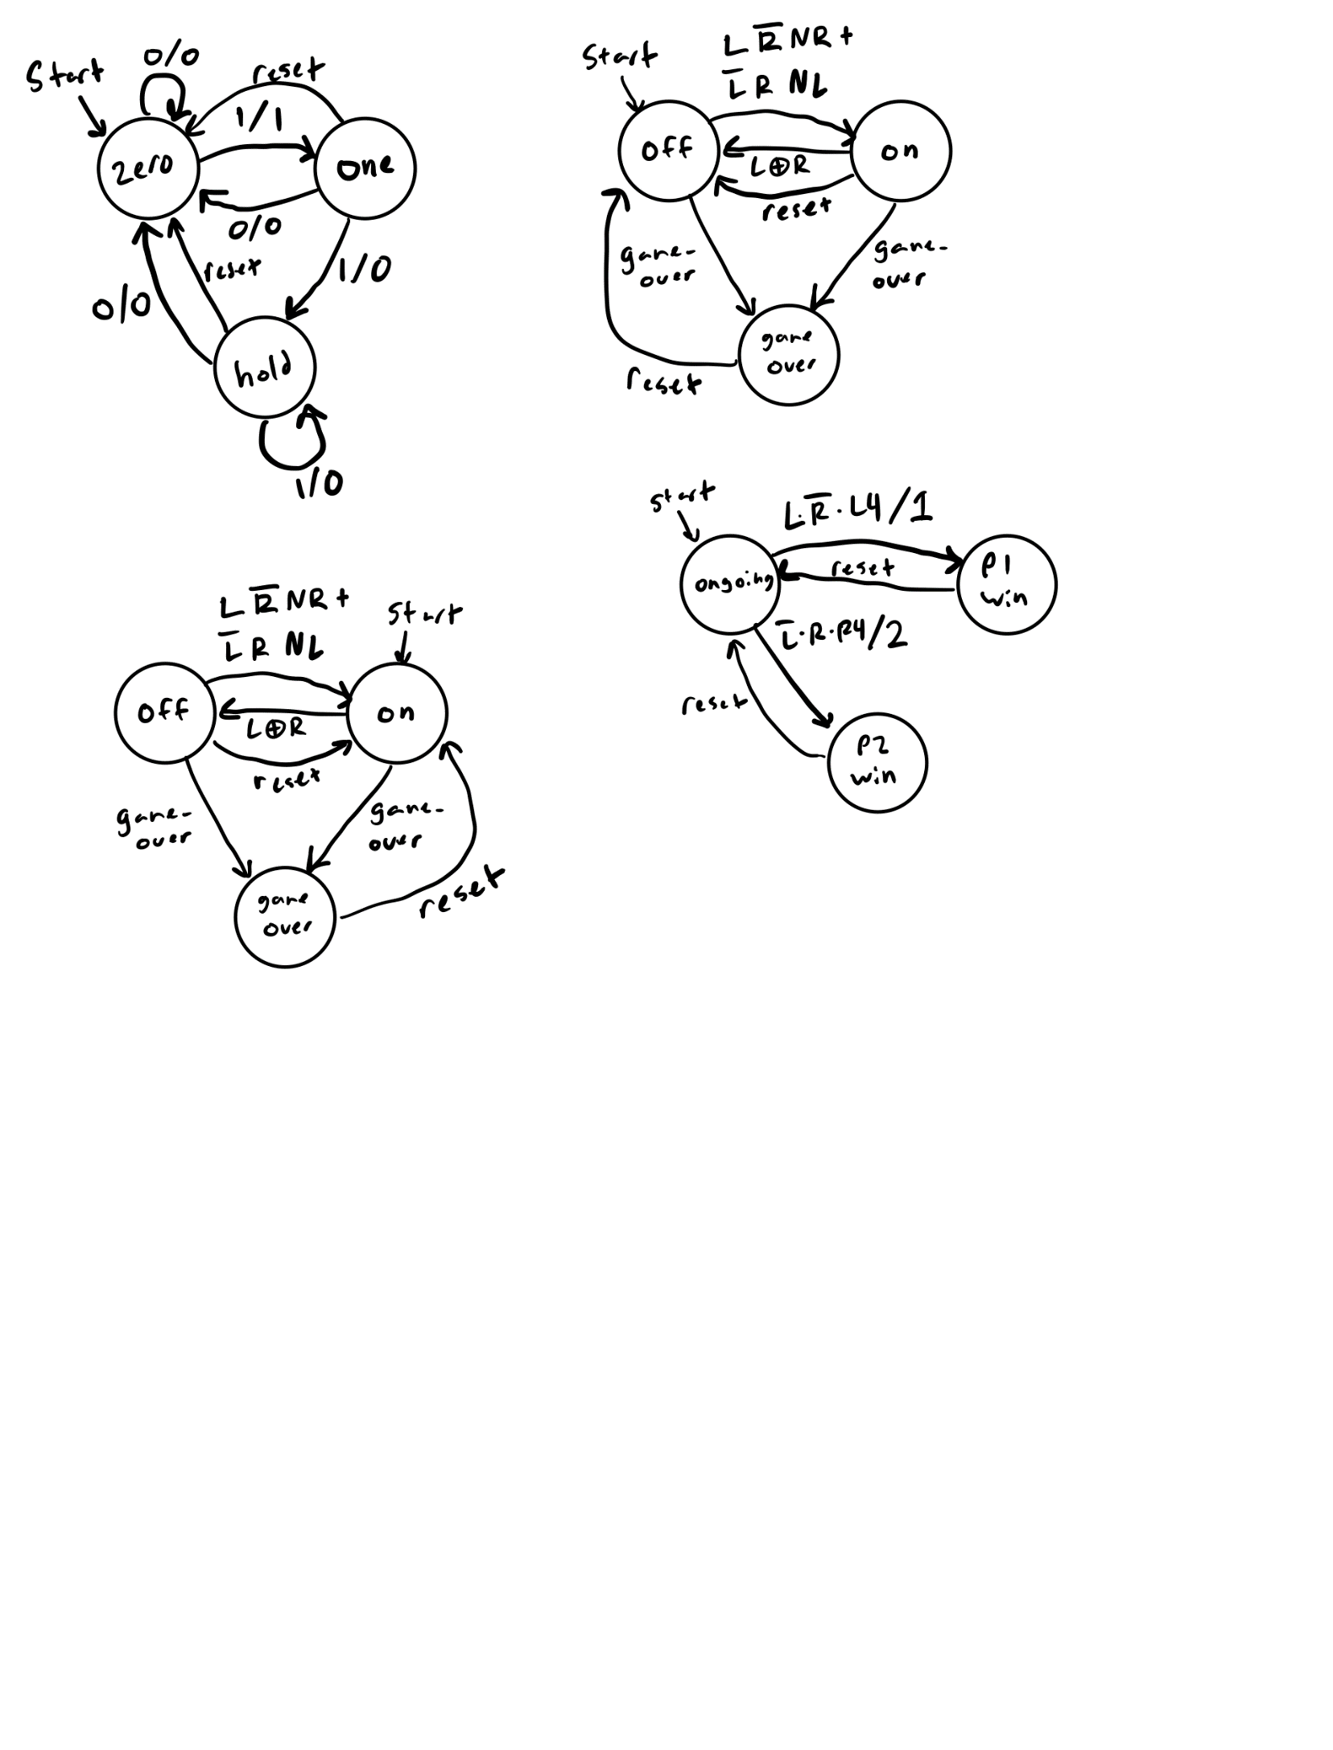

The state diagram for L4-L1 and R4-R1 modules. This state machine takes 6 inputs: L, R, NL, NR, game_over, and reset. If the expression associated with a transition is true, then the state machine follows that transition to the next state. All other transitions not pictured are self-transitions.

Normal Light Simulation

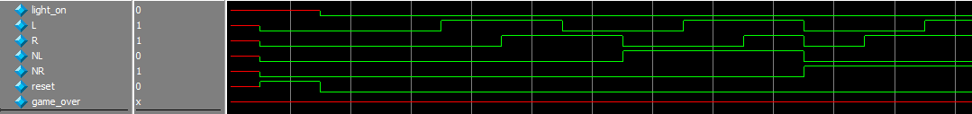

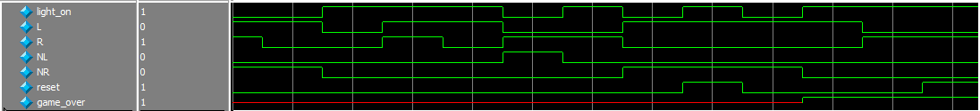

The simulation for the normal_light module. This simulation runs through all of the possible state transitions and shows the resulting light_on output. Notice that the output starts off, and is toggled on when an appropriate input is received and stays on unless one of the appropriate inputs is received.

Center Light State Diagram

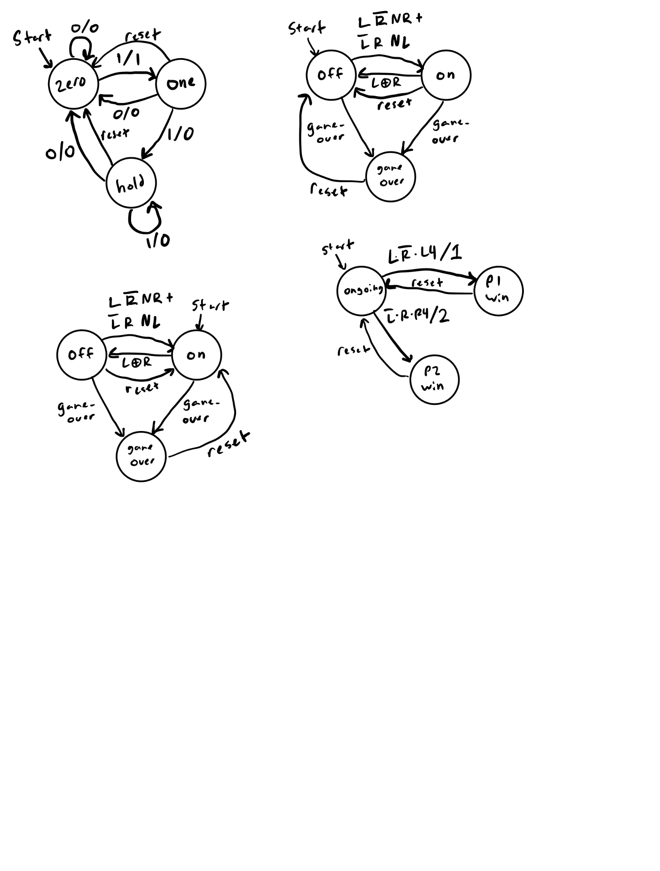

The state diagram for the C0 module. This state machine takes 6 inputs: L, R, NL, NR, game_over, and reset. If the expression associated with a transition is true, then the state machine follows that transition to the next state. All other transitions not pictured are self-transitions.

Center Light Simulation

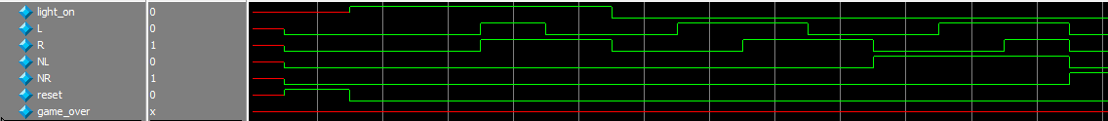

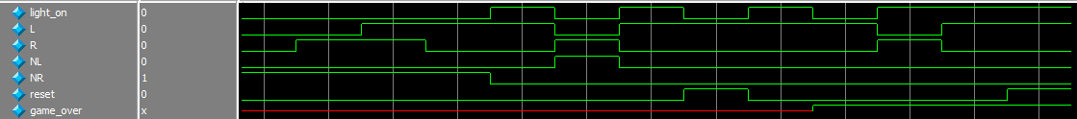

The simulation for the center_light module. This simulation runs through all of the possible state transitions and shows the resulting light_on output. Notice that the output starts on, and is toggled off when an appropriate input is received and stays off unless one of the appropriate inputs is received.

Victory State Diagram

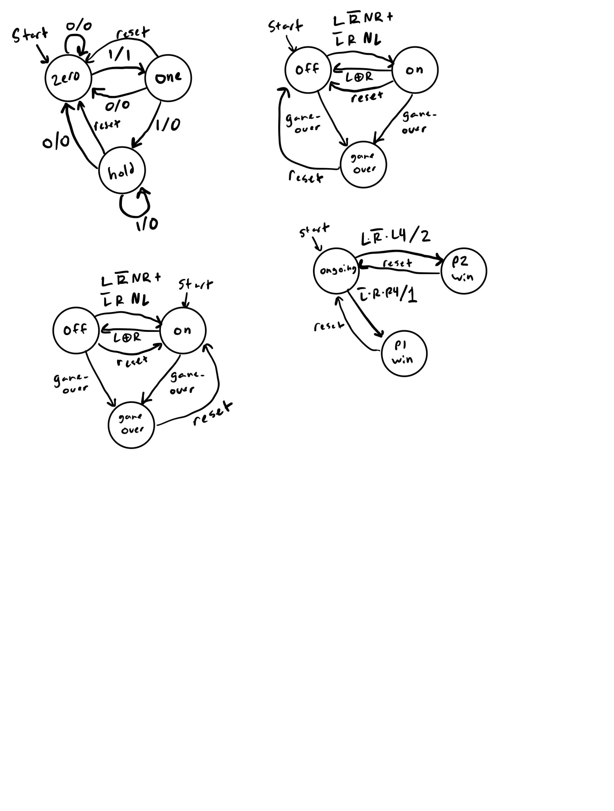

The state diagram for the victory module. This state machine takes 5 inputs: L, R, NL, NR, and reset. When the state machine is in one of the “win” states, it outputs the corresponding number (1/2) to the HEX0 display and a true game_over signal. All other transitions not pictured are self-transitions.

Victory Simulation

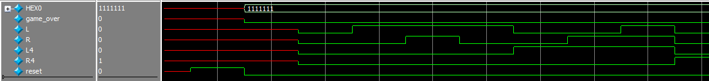

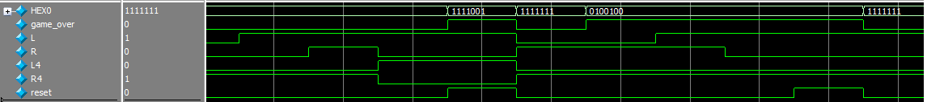

The simulation for the victory module. Notice that the HEX0 display shows the correct pattern and the game_over signal toggles on when transitioning into a winning state. Any other input while the module is in a winning state does not change the output. Only the reset signal puts the module back in its original state.

Tug-of-War Simulation

1:



2:

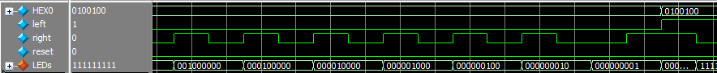

3:



4:

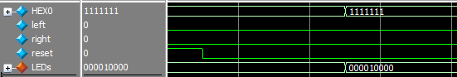

The simulation for the top-level tug_of_war module. This is simulating moving the playfield to the left end (1), moving the playfield to the right end (1-2), a player 1 victory (2-3), and a player 2 victory (3-4). Notice that whenever the circuit enters a winning state, the only input that will change the output is a reset signal (which reverts the circuit to its original state).

A screenshot of the “Resource Utilization by Entity” page, showing your design’s computed size.

Resource utilization for the tug_of_war top-level module.

### Time Estimation

This lab took approximately 7 hours, in total, to complete.