Lab 7

# Useful Components

## Connor Aksama – 1778028

State diagrams derived from the 3-bit and 4-bit LFSRs.

3-bit LFSR State Diagram

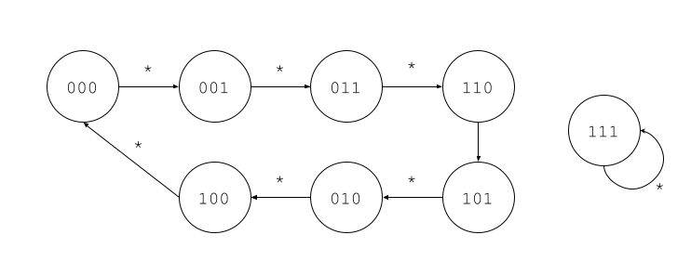

The state diagram for the 3-bit LFSR, which uses the XNOR of the 2 most significant bits to produce the next least significant bit. Each state transition labeled with a “*” is followed on each clock edge. The starting state for this state machine is “000”.

4-bit LFSR State Diagram

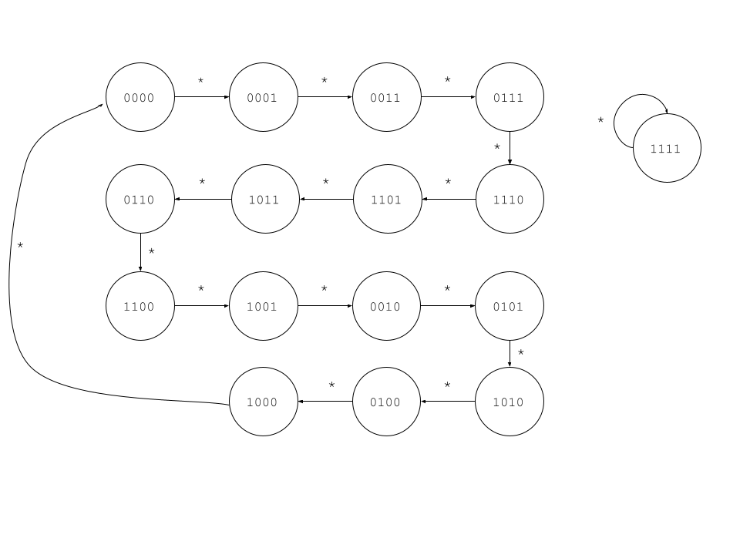

The state diagram for the 4-bit LFSR, which uses the XNOR of the 2 most significant bits to produce the next least significant bit. Each state transition labeled with a “*” is followed on each clock edge. The starting state for this state machine is “0000”.

Simulation of your working 10-bit adder that covers the 6 situations described.

10-bit Adder Simulation

The simulation for the 10-bit adder, demonstrating (in order): (1) an addition where one input is 0, (2) an addition whose result is 511, (3) an addition whose result is 0, (4) an example of unsigned overflow ( -1 [signed] is equivalent to 1023 [unsigned] ), (5) an example of positive signed overflow, and (6) an example of negative signed overflow.

Simulation of your working 3-bit counter.

3-bit Counter Simulation

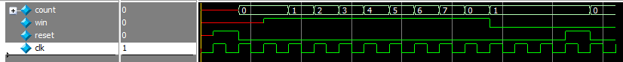

The simulation for the 3-bit counter showing that every clock cycle where a “win” input is received, the count increases by 1, and that the count stays the same when a “win” input is not received.

Simulation of your working 9-bit LFSR with the state cycle length indicated.

9-bit LFSR Simulation































The simulation for the 9-bit LFSR. The “out” signal shows the output of the LFSR, and the “i” counter shows the number of states visited by the LFSR. The initial state of the LFSR is 9’b0, and the simulation is set to stop once it loops back to the initial state. Notice that in the bottom screenshot, the simulation reaches 511 unique states before coming back to the initial 9’b0 state and stopping.

A screenshot of the “Resource Utilization by Entity” page, showing your design’s computed size.

Resource utilization for the tug_of_war top-level module.

### Time Estimation

This lab took approximately 7 hours, in total, to complete.