Final Project Write Up

1. Intro

This visualisation component was added after the data had been cleaned. Data visualisation can assist us in understanding the data better. This graphic analysis first concentrates on every major region before turning its attention to Europe.

The original dataset is “Trends in International Migrant Stock: The 2015 Revision” form United Nations. After cleaning the dataset, the table contains 4770 rows and 10 columns.

The program needs to use six tables, five of them is cleaned data and one of them is country codes.

1. Methods

Table of used columns

|  |  |
| --- | --- |
| Major area, region, country or area of destination | List of areas, regions and countries 232 countries |
| Gender | “both”, “male” and “female” |
| Year | “1990”, “1995”, “2000”, “2005”, “2010”, “2015” |
| International migrant stock at mid-year | The estimates of the number (or “stock”) of international migrants disaggregated by age, sex and country or area of origin are based on national statistics, in most cases obtained from population censuses. Additionally, population registers and nationally representative surveys provided information on the number and composition of international migrants. (International migrant stock | population division. (n.d.). Retrieved December 12, 2022) |
| Annual rate of change of the migrant stock | The percentage of the change of International migrant stock compared to 5 years ago |

https://www.un.org/development/desa/pd/content/international-migrant-stock

In this write up, choropleth map, bar plot, box plot, histogram and line graph are used to visualize the dataset.

1. Results

First of all, Figure 1 is a choropleth map that shows all international migrant stock in different countries around the world at year 2015. Because of its yellow tint, the United States of America has the largest international migrant stock, as shown on the map. Other than that, it is difficult to identify a nation that has a stock of international migrants comparable to that of America. Additionally, Canada has a respectable stock of foreign migrants. The conclusion that follows is that "North America must have the biggest quantity of international migrant stock worldwide." Is that actually the case, though?

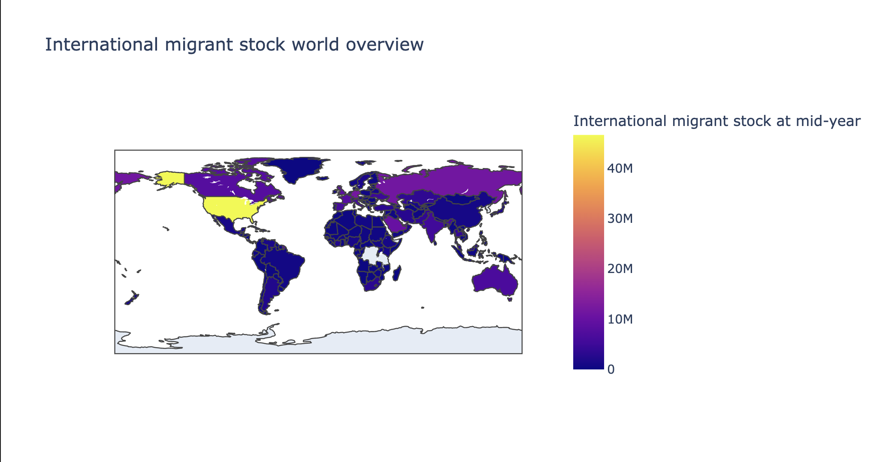

Figure 1

The stock of international migrants in the major regions from 1990 to 2015 is depicted in the following bar graph (Figure 2). The Tufte' small multiples principle dictates that there be six subplots based on the year in this graph. This graph shows that Europe has the greatest international stock of migrants. In contrast to the preceding part, we arrived at an entirely different result. The following section will concentrate on the Europe region and uncover additional information.

Figure 2

Before mainly focus on Europe, there are still some information available at overview. The figure 3 shows international migrant stock around the world differ by gender. According to the Tufte' content focus principle. This graph only shows year 2015. This graph tells us the amount of international migrant stock is does not have much difference between male and female. This can be also seen from figure 4. Figure shows international migrant stock in all major areas in 2015.

Figure 3

Figure 4

Data in Europe:

First, Figures 5 and 6 depict the international migrant stock's trend and its yearly rate of change from 1990 to 2015. Figure 5 describes the general increasing trend in detail. Since every point in Figure 6 has a positive rate of change value, this is also a clear evident.

Figure 5

Figure 6

Figure 7 shows a boxplot of Europe's international migrant stock in 2015 for both genders. Because there are six outliers in this image, we can observe that the migrant stock differs significantly across all of the European countries.

Figure 7

The stock of international migrants from all the nations is finally shown in figure 8 with sorted values. We can observe that Germany has the largest stock of foreign migrants. Returning to the first question, "Why do we get conflicting conclusions from Figures 1 and 2?" We might start by contrasting the populations of foreign migrants in Germany and America. Despite the fact that Germany has Europe's highest proportion of migrants. The migrants are still far from the value of America’s. Due to this, North America in Figure 1 has a more vibrant colour palette (close to yellow in the map). This might make us draw the wrong conclusion. The number of nations in Europe is far greater than that in North America, even though that each country's migrant stock is relatively modest. As a result, Europe has a larger overall population of migrants than North America. Figure 1 makes it very difficult to see this reality.

Figure 8

1. Discussion section

The advantages of data visualisation are numerous. It can aid in our intuitive understanding of the data and aid in our quest to unearth its hidden worth. Different visualisation techniques, however, may lead us to very different conclusions, much like the example provided previously. This explains why political data occasionally exists, i.e., data that has been skewed to favour the objectives of some individuals. Since various graphs can cause individuals to draw different conclusions about the data, data visualisation can easily be used for political purposes. In order to properly evaluate data, we must be cautious while looking at data visualisation and employ several graphs.