**LAB QUIZ #2 (Static Website)**

**Requirements:**

|  |  |
| --- | --- |
| **HARDWARE** | **SOFTWARE** |
| 1. Personal Laptop | 1. HTML  2. CSS  3. Git  4. JavaScript |
| 2. Personal Laptop | 3. Microsoft Word/WPS |

**Groupmates:**

|  |  |
| --- | --- |
| **Names** | **Contribution** |
| Simon, Krizia Mae Ann G. | Assisting on the documentation of what we did. |
| Reyes, Aika L. | Documentation organizer and taking screenshots of the output that we will create. |
| Romeo, Ar Jay N. | Accessing and creating a website with git progress of static website and organize the web |
| Romero, Heherzon M. | Creating a web pages using html and css |

**Laboratory Problem (Provide with Screenshots)**

1. Create a website with git as your version control system. Minimum of 5 web pages. Submit your website in zip file with link using the OneDrive attached in your documentation. The documentation should be submitted in your assignment.

**Website in zip file with link:**

<https://drive.google.com/file/d/1TtWdNLHF0IHxmWhGbq7KP3BcRmrE1Mgz/view?usp=sharing>

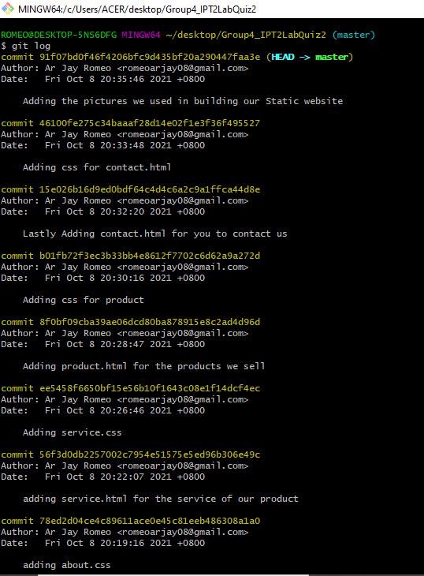

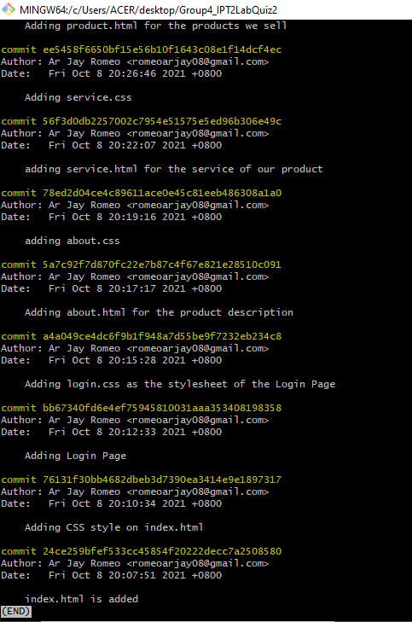

HTML

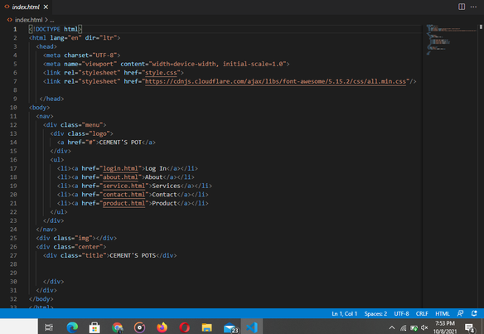

CSS

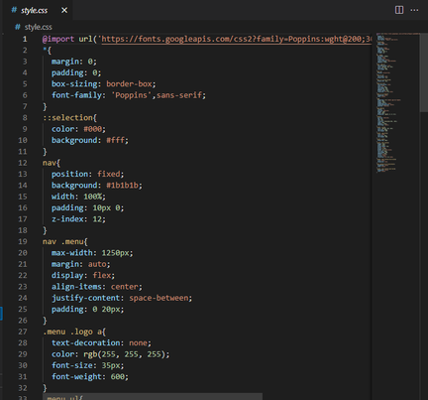

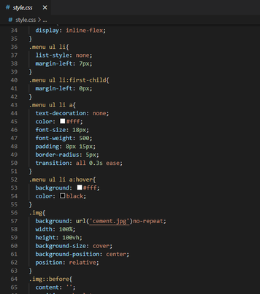

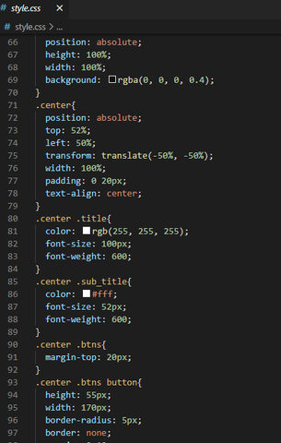

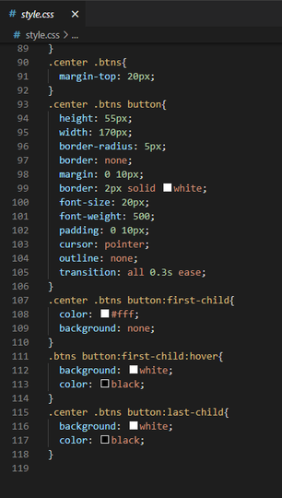

LOGIN

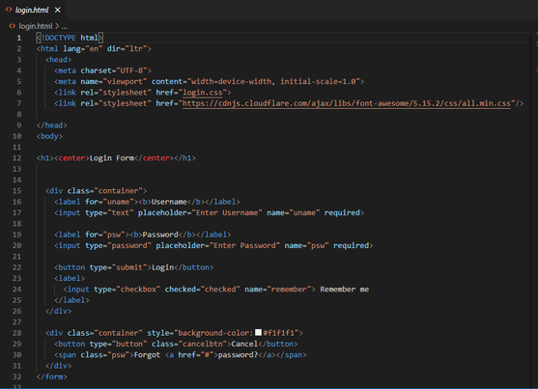

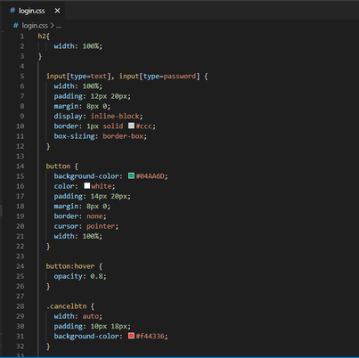

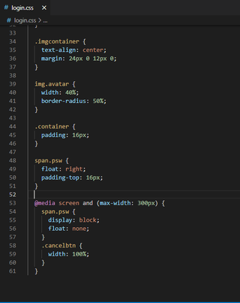

ABOUT

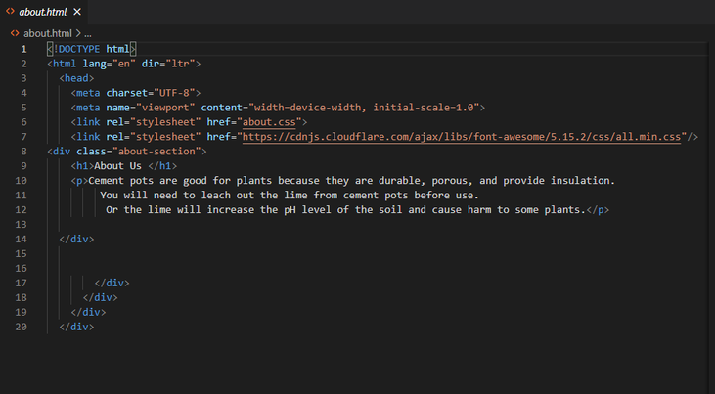

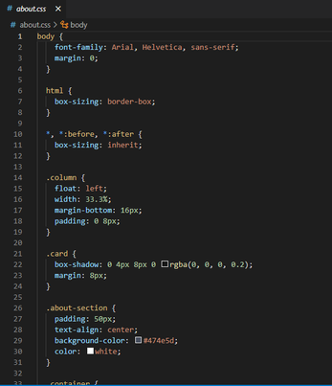

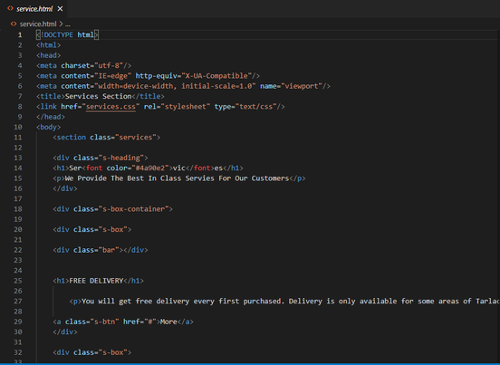

SERVICE



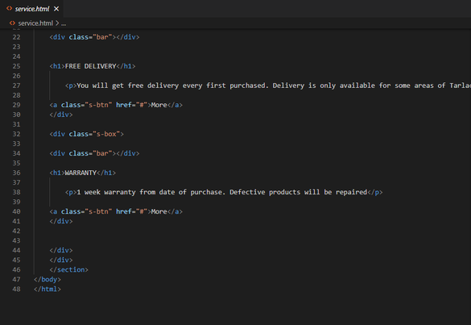

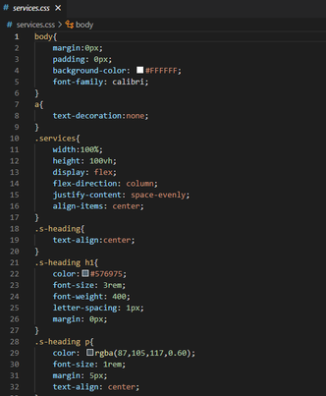

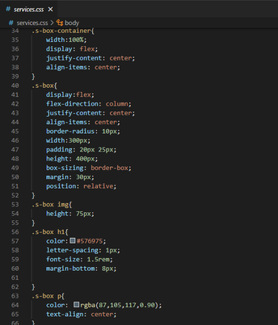

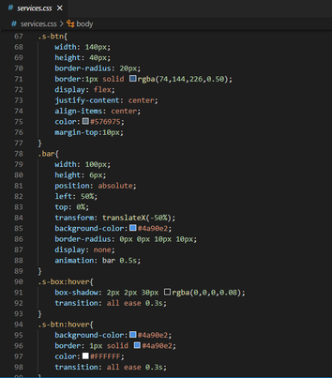

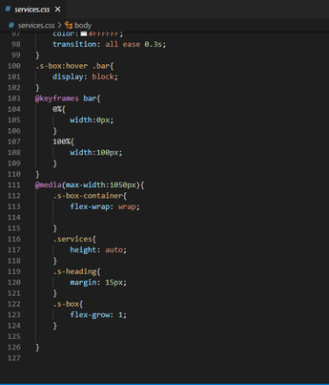

PRODUCT

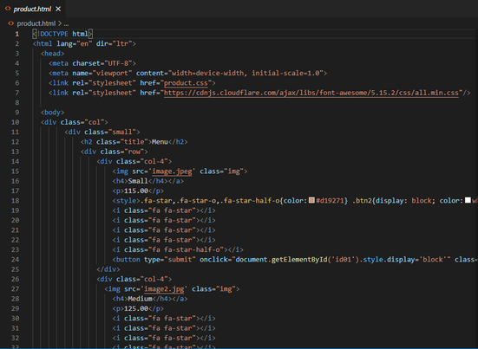

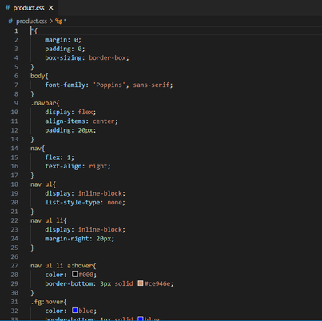



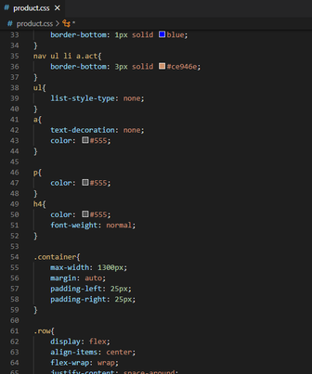

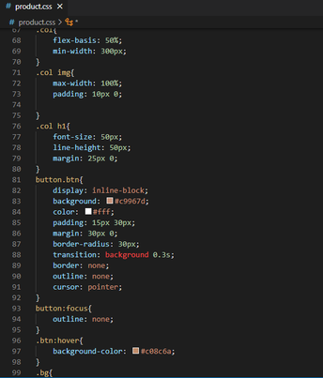

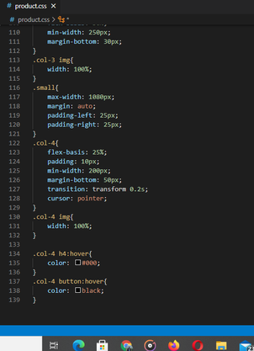

CONTACT

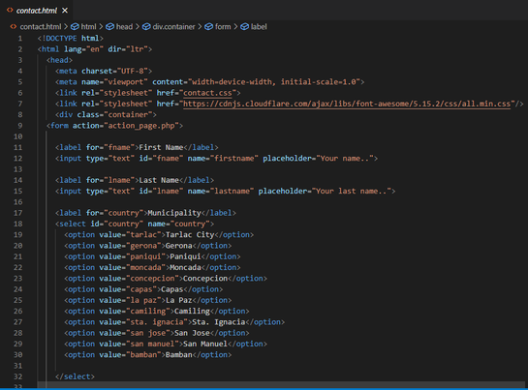

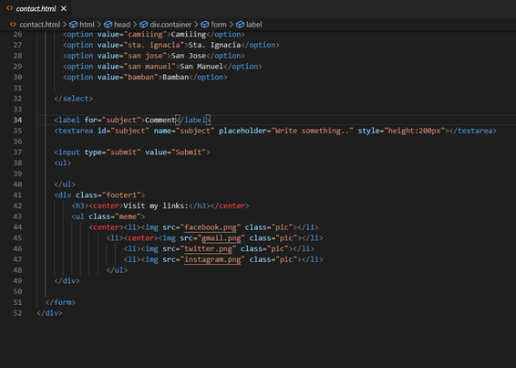

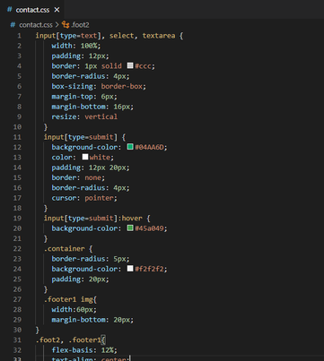

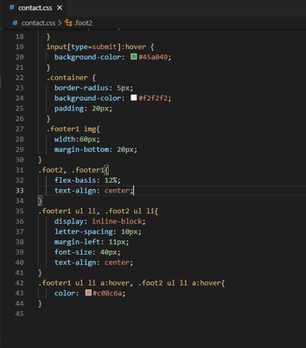

OUTPUT

