Joel Sivanish
Professor Thurston
HW2
10/6/2025
The Internet is built upon a hierarchy of interconnected Internet Service Providers, which can be broadly categorized into Tier 1, Tier 2, and Tier 3 networks. Each tier plays a distinct role in how data travels across the globe.
Tier 1 ISPs form the backbone of the Internet. They have extensive, worldwide networks and do not pay for Internet transit since they can reach every part of the Internet through mutual peering agreements with other Tier 1 providers. Examples include AT&T, Cogent Communications, and Hibernia Networks. These providers often build and maintain large-scale infrastructure such as undersea cables to ensure global connectivity (GeeksforGeeks, 2020).
Tier 2 ISPs serve as intermediaries between Tier 1 and Tier 3 providers. They usually have regional or national reach and use a combination of paid transit from Tier 1 networks and settlement-free peering with other ISPs to reduce costs. Common Tier 2 providers include Vodafone and BT.
Tier 3 ISPs are the local access providers that connect end users such as homes, schools, and small businesses to the broader Internet. They purchase transit from Tier 2 ISPs and typically do not engage in peering. Examples include Comcast and Verizon (GeeksforGeeks, 2020).
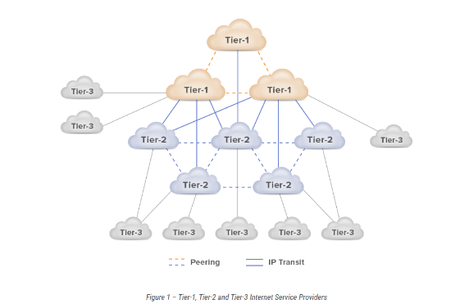
A crucial part of this global system is the Internet Exchange Point, a physical facility where multiple ISPs interconnect and exchange data traffic directly. IXPs allow ISPs to peer with one another, reducing the need for costly upstream transit and improving speed and reliability. During peering, traffic between customers of participating ISPs flows directly through the IXP rather than traversing third-party networks, making Internet communication more efficient (Noction).

Work Cited:
- GeeksforGeeks. (2020, October 8). Internet Service Provider (ISP) hierarchy. Retrieved from https://www.geeksforgeeks.org/computer-networks/internet-service-provider-isp-hierarchy/

- Noction. (n.d.). IP Transit, Peering, and ISP Interconnection. Retrieved from https://www.noction.com/blog/ip-transit-providers

