**README**

**How to run**

Open main.html in VSCode or PyCharm

Or you can just follow the demo

**introducation**

This project implements a guide for the fourth floor of the Jishi Building. Users can click on corresponding buttons on the map to enter rooms and view relevant information. The project supports keyword search; for example, searching for "446" will provide information related to Room 446, searching for the name "张林" will display the office information for Professor Zhang Lin, and searching by office name, such as "创新创业办公室" will direct users to the corresponding office. Clicking on a teacher's name to view personal information allows access to that teacher's homepage on the Software School of Tongji University website (sse.tongji.edu.cn).

Additionally, we have implemented quick access to adjacent offices. In the bottom left and right corners of the office page, there are quick access buttons for the offices on the left and right sides, respectively. Pressing these will take the user to the neighboring office's page. We also support navigation backward; pressing the back button on the page will return to the previously visited page.

Search “创新创业办公室”

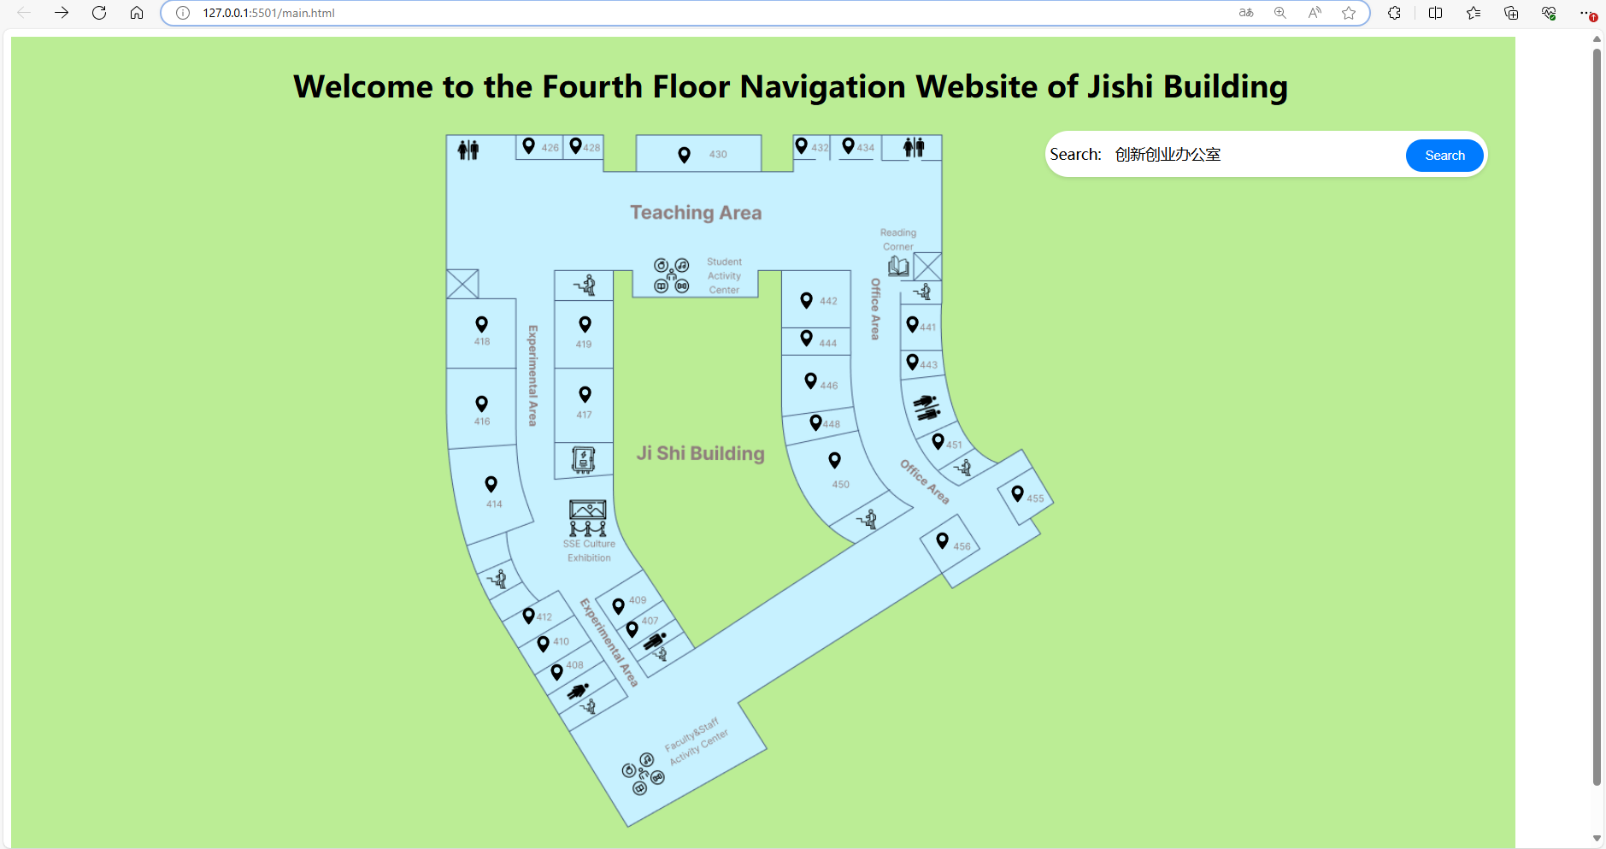

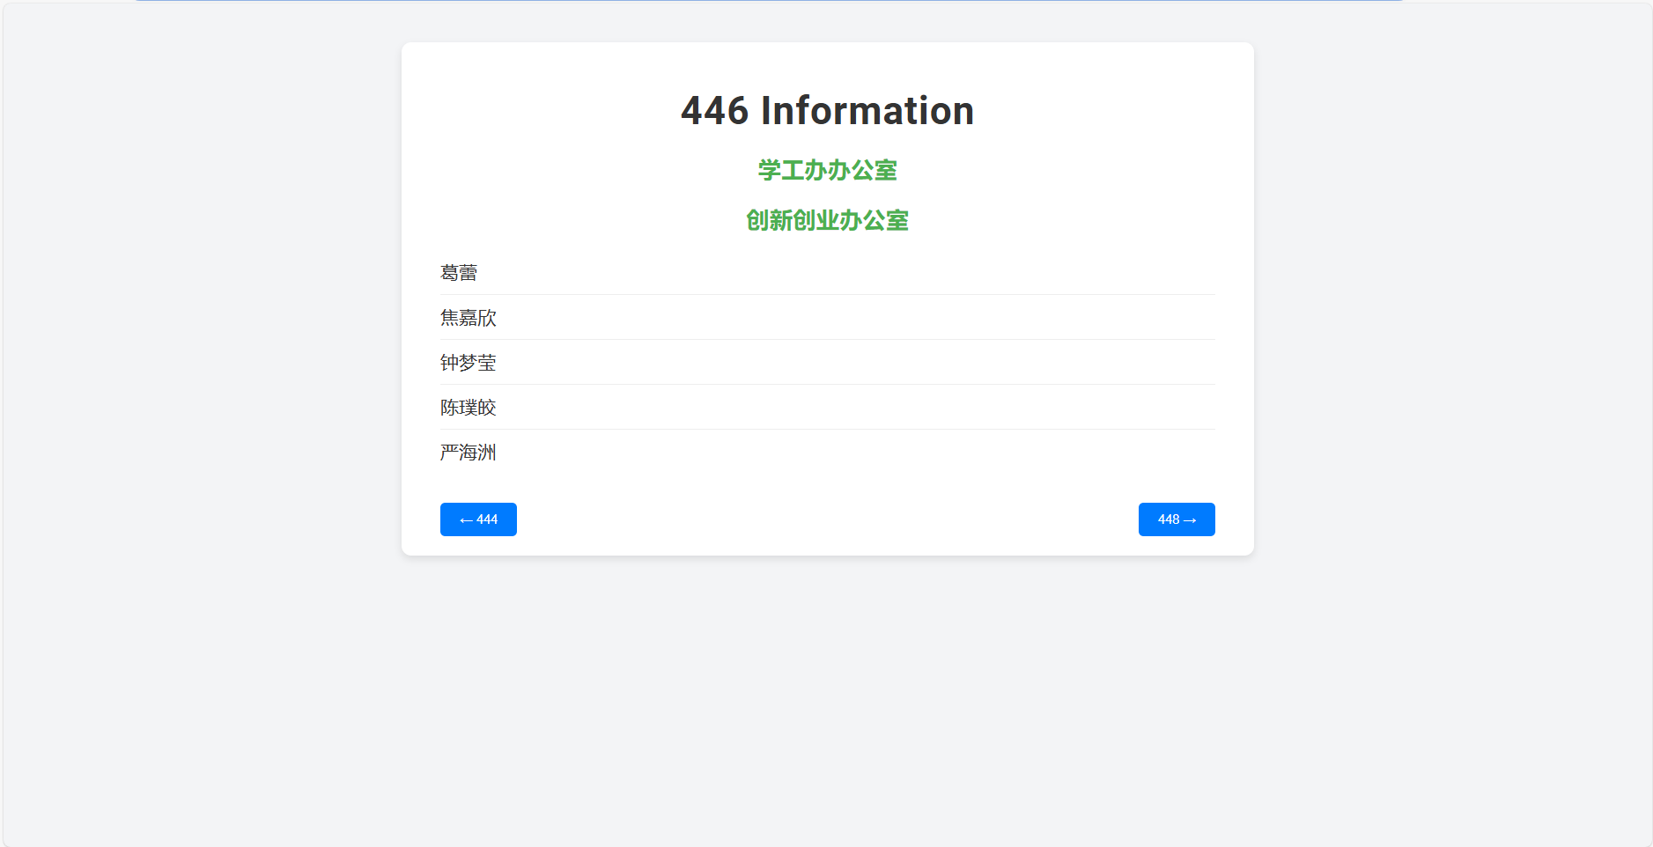

Press next button

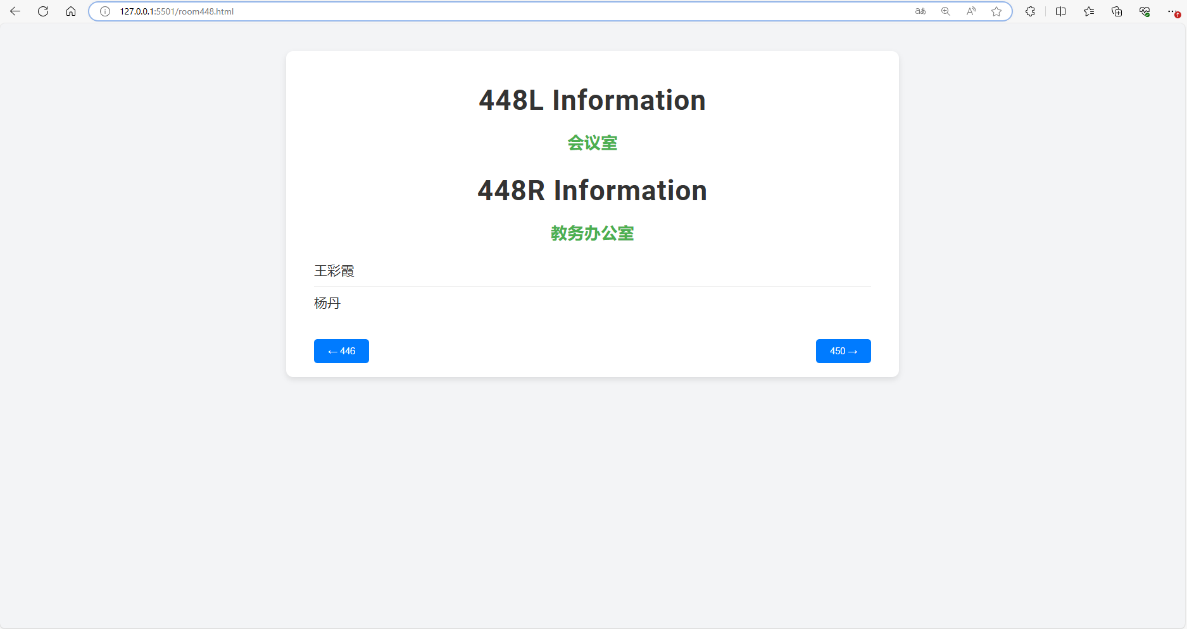

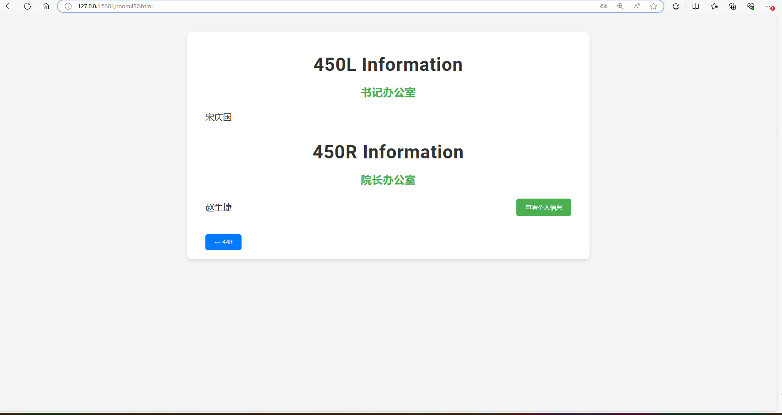

Press “查看个人信息”button

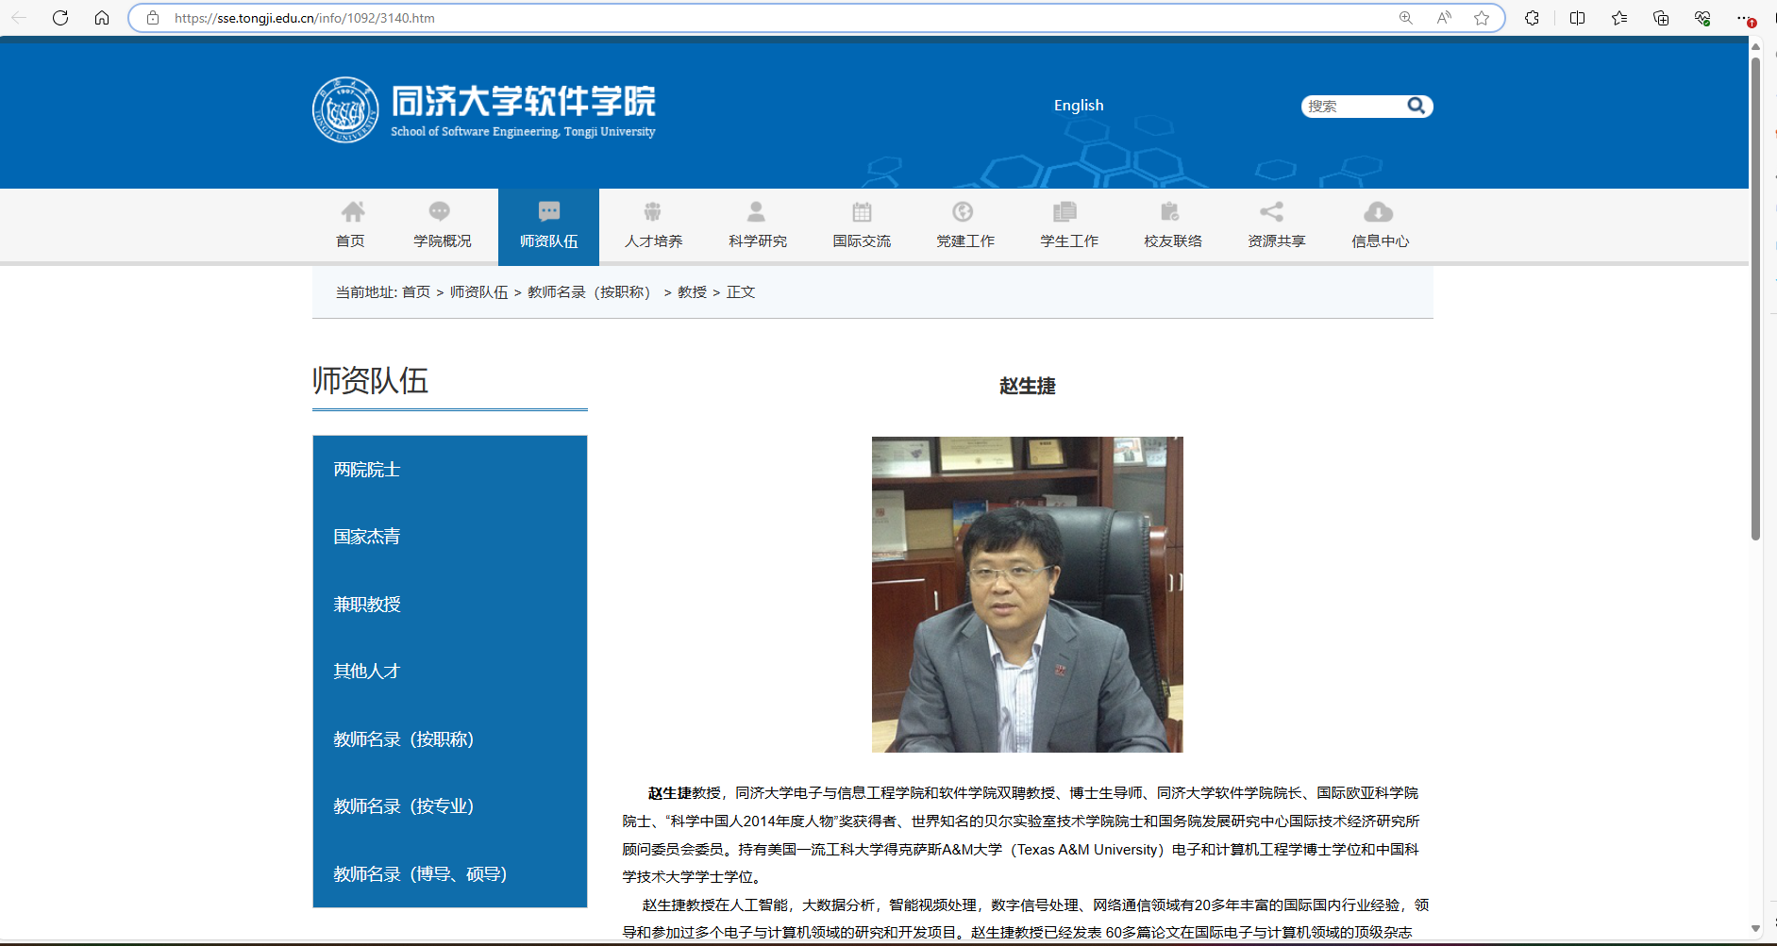

Search “张林”

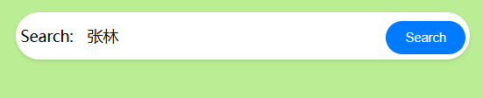

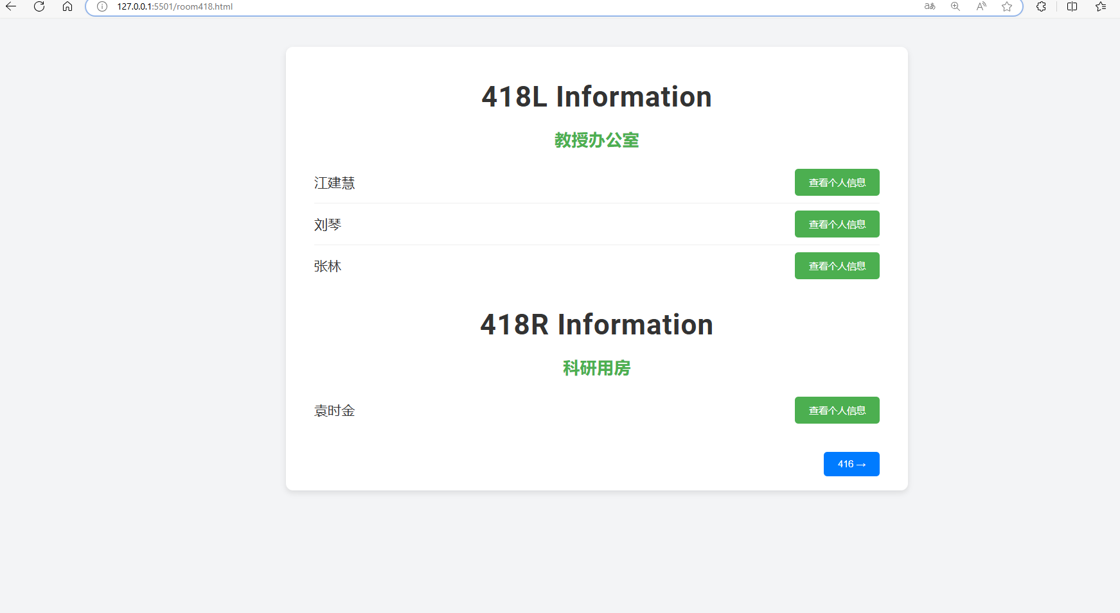

Click on 419 on the map.

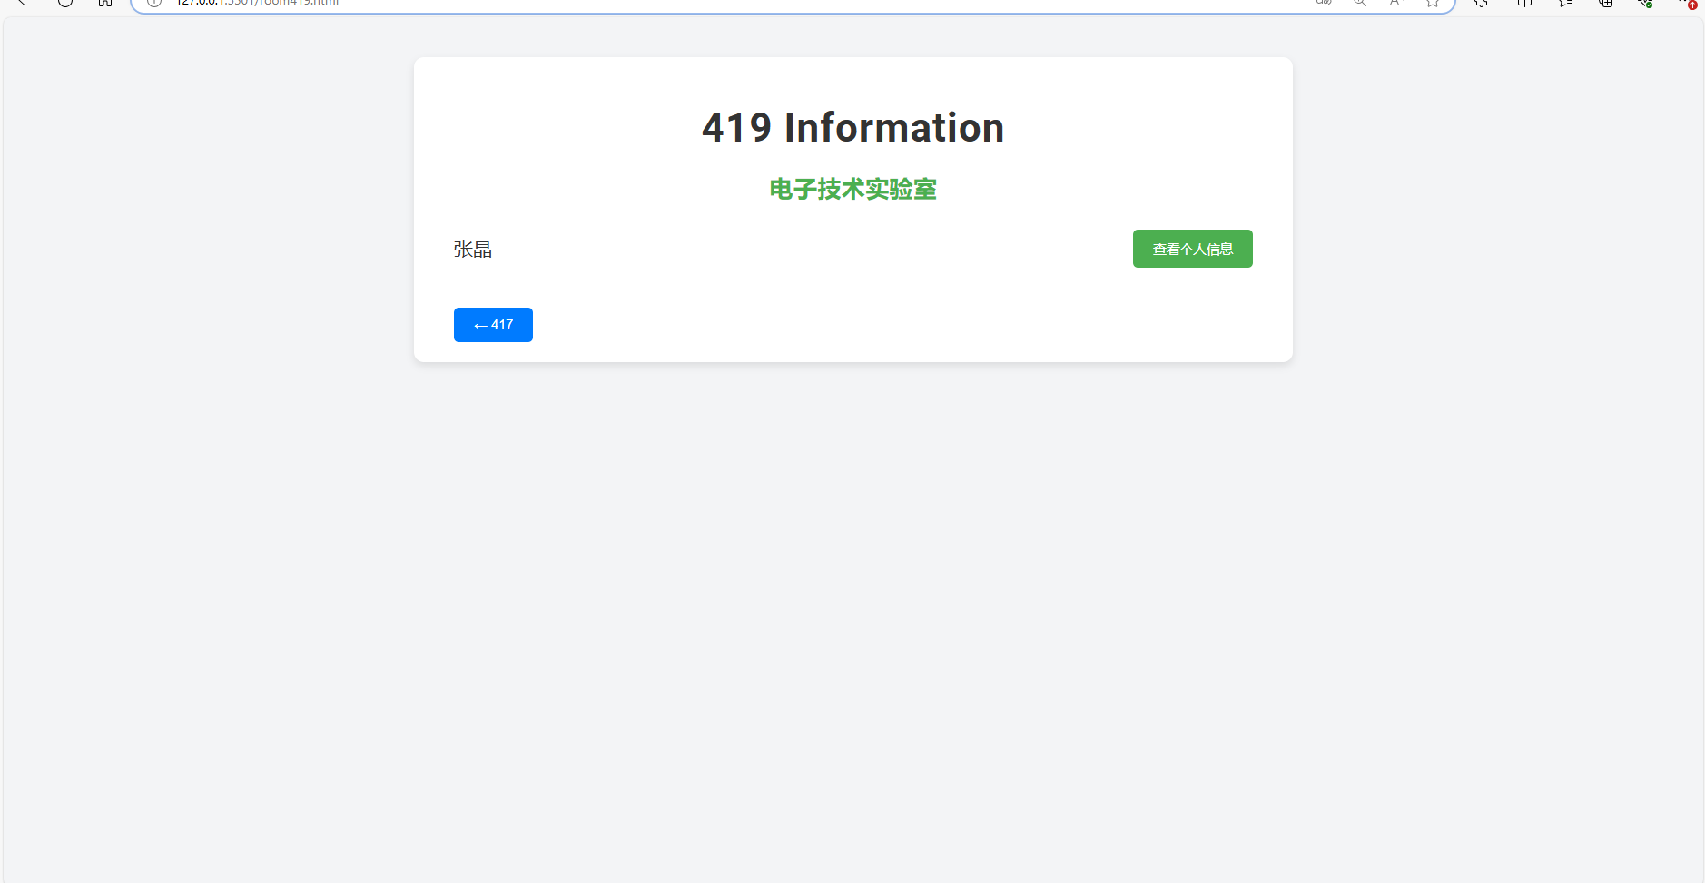

"Fluid navigation" refers to a user interface design that allows users to move naturally, quickly, and intuitively between different parts or pages of an application. In our project, we have implemented several key features for fluid navigation:

**Keyword Search Functionality**: Users can quickly find specific rooms or teacher information by entering keywords. This search functionality reduces the need for extensive browsing and clicking, making navigation more efficient.

**Quick Access to Adjacent Offices**: By providing direct access buttons to adjacent offices on each office page, users can explore related spaces without having to return to the main navigation interface. This enhances the fluidity of the interface and the efficiency of user exploration.

**Back Functionality**: Allows users to return to previously browsed pages via a simple back button. This offers a more natural navigation experience, especially when users wish to quickly return to an initial or specific location after exploring multiple pages.

Together, these features provide a smooth and coherent user experience, allowing users to access and explore information effortlessly. This is the essence of "fluid navigation."