Mechatronic Design and Evaluation

ECEN430 Team 1 2018 T2

Name: Angus Tan ID: 300289679

Introduction

Key functionalities of robots tasked with localisation techniques include autonomous exploration of unknown sites and recognition of objects of interest. Open source software modules are often used for the development of such complex capabilities which include simultaneous Localization and Mapping (SLAM) for self-localization and mapping in an urban environment.

Increased autonomy level is an area of research that has the potential to vastly improve the operation of autonomous robots. The use of freely available reusable and adaptable open source software can significantly reduce development time and increase robot capabilities. Robot Operating System (ROS) [1] is used as the robot middleware for the software modules. It has been widely adopted in robotics research and can be considered a de-facto standard.

Hardware dependent modules like cameras and motor drivers are assumed to provide the necessary sensor data according to existing ROS standards and are steerable by velocity commands.

The criteria selection and evaluation results of the six NIARC robots are presented in the following sections. The components currently presented on the platforms were considered, as well as the missing components which are required for full operation.

Location and Mapping

Creating maps of the environment is important for two reasons: performing situation assessment and localizing the platform inside buildings and for path planning and high level autonomous behaviours. While purely geometric maps such as occupancy grid maps are useful for navigation and obstacle avoidance, additional semantic information like the location of objects of interest is required for intelligent high level autonomous behaviour control [4]. SLAM Robots have to be considered as operating in unknown environments as to be most robust against changes in order to generate sufficiently accurate metric maps useful for navigation of a robot system. As odometers are notoriously unreliable, hector slam is designed to not require odometry data, instead purely relying on fast LIDAR data scan-matching at full LIDAR update rate [3]. As hector slam is dependent upon the sampling rate of the LiDAR, while these are more resource intensive implementing, gmapping or rgbdslam can be practical. Combined with an attitude estimation system and an optional pitch/roll unit to stabilize the laser scanner, the system can provide environment maps even if the ground is non-flat

The full six degrees of freedom can be realized in the implementation of an Extended Kalman Filter (EKF) and fuses measurements from an inertial measurement unit (IMU), the 2D mapping from the LiDAR and optionally from additional localization sensors like cameras [2]. The filter is primarily driven by the IMU, without using the control inputs or wheel odometry as they typically are unreliable due to wheelspin or side drift on the ground.

Platform Analysis

In order to fully realise the goal of localisation and mapping within a given indoor environment, for example, a warehouse, the manoeuvrability of the platform and how freely it is able to turn is vital. This is closely related to slippage of the platform while it traverses its environment. For this reason, the six platforms considered all used wheels rather than continuous tracks. Wheels present distinct advantages in reduced slipping, higher manoeuvrability, and lower production costs when compared to tracks [5].

While a tracked platform may be able to traverse larger obstacles with increased power efficiency due to higher traction, these were not deemed to outweigh their disadvantages such as encoder errors, given the types of environments the platform will be deployed in. Similarly, as the platform is to be deployed on a solid, mostly flat surface such as a warehouse floor, the weight and height of the platform are not vital but weight should be minimised to increase power efficiency.

As previously stated, the ability to travel over small obstacles, for example, the saddle in a doorway, is important when considering functionality the platform is tasked with. Thus, it is important to consider the ground clearance of each of the six platforms.

Soft constraints were also looked into, ideally, a platform should have minimal work done in order for it to be viable, reducing further costs and time spent. Also, development software should be familiar or readily available, further reducing time costs. The following paragraphs detail the analysis of the viability of each of the platforms given their specifications when weighed against the recommended criteria.

Bolt

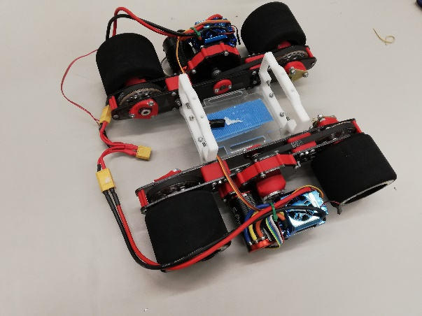

This platform is almost complete, missing a LiDAR, IMU, and development board. An ams AS5048A 14-bit rotary sensor is present on each motor, which affords a resolution of 16384 positions per full revolution of the motor. The platform’s ability to rotate and perform precise manoeuvres is however poor, in addition to its low clearance. This is due to the choice of motor and motor drivers, which are the Toro S-Pro4 and Toro TS150, respectively; which are designed for high-speed RC applications. Moreover, a track is present on each side of the platform to drive both of the wheels on one side at the same speed, essentially this is a tracked platform. 30:1 gear reduction is present on Bolt to reduce its speed, linked to each of the motors.

Power requirements of Bolt are as follows: the motor drivers require a 2S to 6S LiPo battery pack where each LiPo cell has a nominal voltage of 3.7 V connected in series; this is equivalent to a total of 7.4 – 22.2 V.

This platform does not meet the criteria for the specification, hence it is not suitable.

|  |  |  |
| --- | --- | --- |
| **Dimension** | **Parts included** | **Missing Parts** |
| W:32cm  L:28.5  Clearance: 7mm | 2x Motor Drivers  2x 3 Phase Motors  4x 80mm Racing Tires  2x 14-bit Magnetic rotary sensor | Microcontroller  IMU  Lidar mount |

Triangle

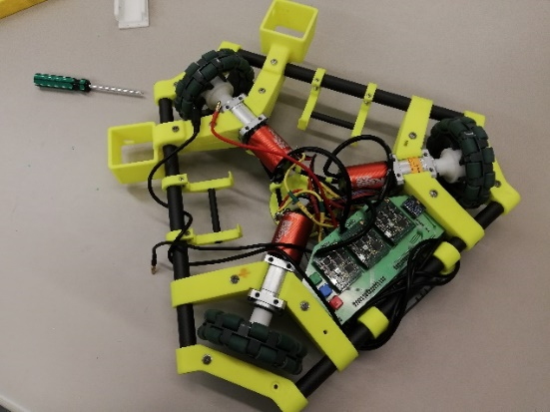

The triangular three-wheeled design presents advantages in decreased risk of wheel slippage and is able to better manoeuvre in a closed environment.

The use of Omni wheels presents great manoeuvrability and control in movement, driven using Tekin ROC 412 DC motors, gearboxes with a 2:1 gearing ratio is used to reduce the speed from the motors. Maxon 438725 servo controllers allow highly efficient control of the motors. Except for LiDAR, all required sensors are present. A power supply is also required. Two LiDAR mounts are present, as presumed if using one LiDAR, one mount should be shifted on the front of the platform in order to optimise the field view. The platform is fitted with a myRIO evaluation board, LabVIEW is required if using the board. To reduce time cost, it is recommended to use an Arduino to interface with ROS, which is likely to be a more familiar interface.

The operating voltage for the ROC412 motor drivers is 10-15VDC, hence a 12 V battery is suitable for this platform. Voltage regulation must also be performed in order to power the microcontroller, typically 9 V for an Arduino Uno.

This platform is ranked third, its meets all the necessary criteria but requires modifications to the existing structure.

|  |  |  |
| --- | --- | --- |
| **Dimension** | **Parts included** | **Missing Parts** |
| W: 44cm  L: 39cm  Clearance:12mm | 3x DC motors  3x Motor Drivers  3x Gearboxes  BB 26:1  1x IMU  1x Mouse sensor  3x 100mm Omni wheels  2x Lidar Mounts | Battery  Microcontroller  LiDAR |

Mini-Triangle

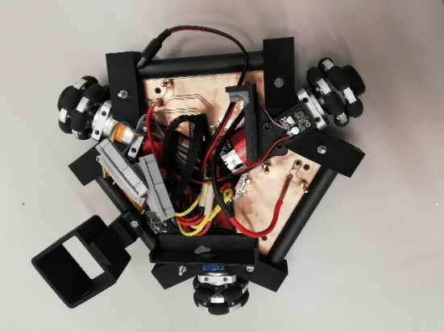

As its name suggests, this platform is similar to the previously discussed triangle, differing in its smaller size. Again, it requires a LiDAR unit and a power supply, as well as a development board. A single LiDAR mount is present on the front end of the platform. It was found that a power connector to one of the DC motors was broken, needing to be soldered into place, this is a trivial fix and does not negatively impact the viability of the platform. A ribbon-to-USB adapter is required to interface the motor driver breakout board to the microcontroller.

The nominal operating voltage for motor drivers is 10-15 VDC and can be stepped down for the microcontroller, hence a 3S, 4S LiPo or 12V battery is recommended.

Mini-Triangle is ranked first among the platforms considered as its design is optimal and sensors are already optimised, needing minimal repairs.

|  |  |  |
| --- | --- | --- |
| **Dimension** | **Parts included** | **Missing Parts** |
| W: 28cm  L:32cm  Clearance: 7mm | 3x DC motors  Thunder Power Z3R  3x motor drivers  3x gearboxes  BB 26:1  1x IMU  1x Mouse sensor  3x 40mm Omni Wheels  1x Lidar mount | Broken power connector  Battery  Microcontroller  Ribbon-USB adapter |

PWNBot

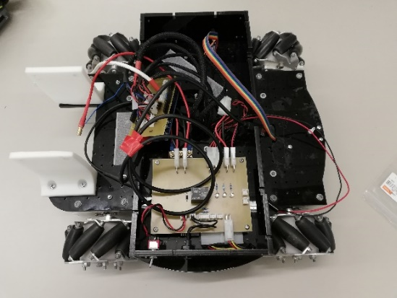

PWNBot is another Mecanum wheel based platform, missing components are encoders, LiDAR, and IMU. As it has 100 mm Mecanum wheels, the platform is afforded three degrees of freedom but is prone to slippage, which will result in erroneous tracking in its movements. An Arduino Mega affords interfacing with ROS. An ADNS-9800 laser motion sensor is presented on the underside of the platform to track its movement. Power requirements are as follows: the Maxon 230572 Motor Drivers require a nominal operating voltage of 10–50 V. The Hall sensor present on the platform requires 12 V DC. A M4-ATX DC power supply is present on the board which requires a 6-30 V input; hence a 2S LiPo or equivalent voltage battery is sufficient.

This platform is ranked second, its meets the recommended criteria but has some design flaws.

|  |  |  |
| --- | --- | --- |
| **Dimension** | **Parts included** | **Missing Parts** |
| W:37cm  L:29.5cm  H: 16cm  Clearance:1cm | 4x Maxon Geared motors  4x Maxon motor drivers  4x 100mm Mecanum Wheels  Arduino Mega  Mouse sensor  DC-DC power supply | Battery  LiDAR  IMU  LiDAR  mount |

Michelangelo:

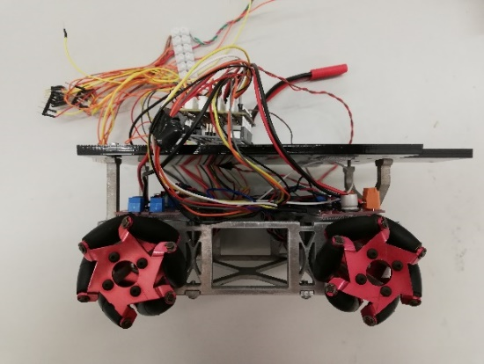

Michelangelo is a Mecanum wheel-based platform; most of the components are present except for the exteroceptive sensors, power supply and battery. This platform is driven by four NEMA 17 ST42STH47 stepper motors with STMicro L6470 motor driver units. The 40 mm Mecanum wheels afford the platform three degrees of freedom, however, it has weaknesses which are: difficult to calculate kinematics and inaccurate movement should slippage occur, this can be overcome with sensor fusion or EKF. An Arduino Uno is present which can be interfaced with ROS, along with a fused breakout board interfacing the Arduino with the motor drivers. Regarding sensors, an IMU, LiDAR, LiDAR mount and some type of odometry sensor are needed. Based off these assessments, this will add to parts cost as well as time spent waiting for parts to arrive. Based on the requirements of the motor drivers, a 5 V battery or 2S LiPo is sufficient to power the platform.

With necessary repairs and design changes, this platform can be suited to the task and it ranked fourth among the six platforms.

|  |  |  |
| --- | --- | --- |
| **Dimension** | **Parts included** | **Missing Parts** |
| W: 19CM  L: 25cm  Clearance: 6mm | 4x Stepper motors  4x Motor Drivers  4x 40mm Mecanum Wheels  Arduino Uno  Fused Breakout Board  Lidar Mount | Encoder  LiDAR  IMU  Battery |

Bean MK1

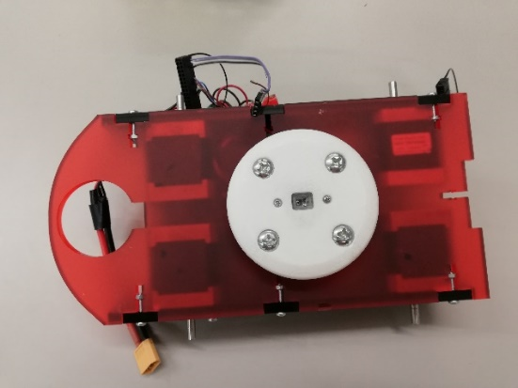

This platform is driven by four NEMA 17 ST42STH47 stepper motors with STMicro L6470 motor driver units, however encoders and wheels are not present. A mouse sensor is present which allows for tracking the movement of the platform. A LiDAR mount is present, designing an additional mount for the IMU is trivial in terms of overhead. In order for the platform to function, it will require: four wheels, an encoder for each wheel, a LiDAR, an IMU, and a development board. The mouse sensor on the underside of the platform has a range of 1 to 5 mm, as it cannot be moved upwards to clear obstacles, the clearance is limited to under 5mm. Furthermore, a battery will need to be procured; based on the requirements of the motor drivers, a 5 V battery or 2S LiPo is sufficient to power the platform. Based off these assessments, this will add to parts cost as well as time spent waiting for parts to arrive.

This platform does not fully meet the criteria for the task and is not suitable for the specification.

|  |  |  |
| --- | --- | --- |
| **Dimension** | **Parts included** | **Missing Parts** |
| L: 25cm  W: 16CM | 4x Stepper motors  4x Motor Drivers  Mouse Sensor  Lidar Mount | 4x wheels  LiDAR  Microcontroller  IMU  Battery |

Conclusion

An in-depth analysis was performed on the six robotic platforms, showing the advantages and disadvantages presented by each of the platforms. Based on how the platforms meet the set criteria, as ranking was found showing the viability of these platforms for the prescribed task; as follows: Mini-Triangle, PWNBot, Triangle, Michelangelo, and Bean MK1. The design of the platform was found to be crucial to the feasibility of each of the platforms, in particular the locomotive system and choice of wheels.

The choice of SLAM solution was found to be dependent on the environment for the specification, as well as the capabilities of the LiDAR system.

Bibliography

[1] Quigley, M., Gerkey, B., Conley, K., Faust, J., Foote, T., Leibs, J., Berger, E., Wheeler, R., Ng, A: ROS: an open-source Robot Operating System. In: ICRA workshop on open source software. Volume 3. (2009)

[2] Embedded Systems Architecture for SLAM Applications <https://arxiv.org/ftp/arxiv/papers/1702/1702.01295.pdf>

# [3] Teaching Robots Presence: What You Need to Know About SLAM

<https://blog.cometlabs.io/teaching-robots-presence-what-you-need-to-know-about-slam-9bf0ca037553>

[4] Hector Open Source Modules for Autonomous Mapping and Navigation with Rescue Robots <http://citeseerx.ist.psu.edu/viewdoc/download?doi=10.1.1.435.9600&rep=rep1&type=pdf>

[5] Wheels vs Continuous Tracks: Advantages and Disadvantages <https://www.intorobotics.com/wheels-vs-continuous-tracks-advantages-disadvantages/>