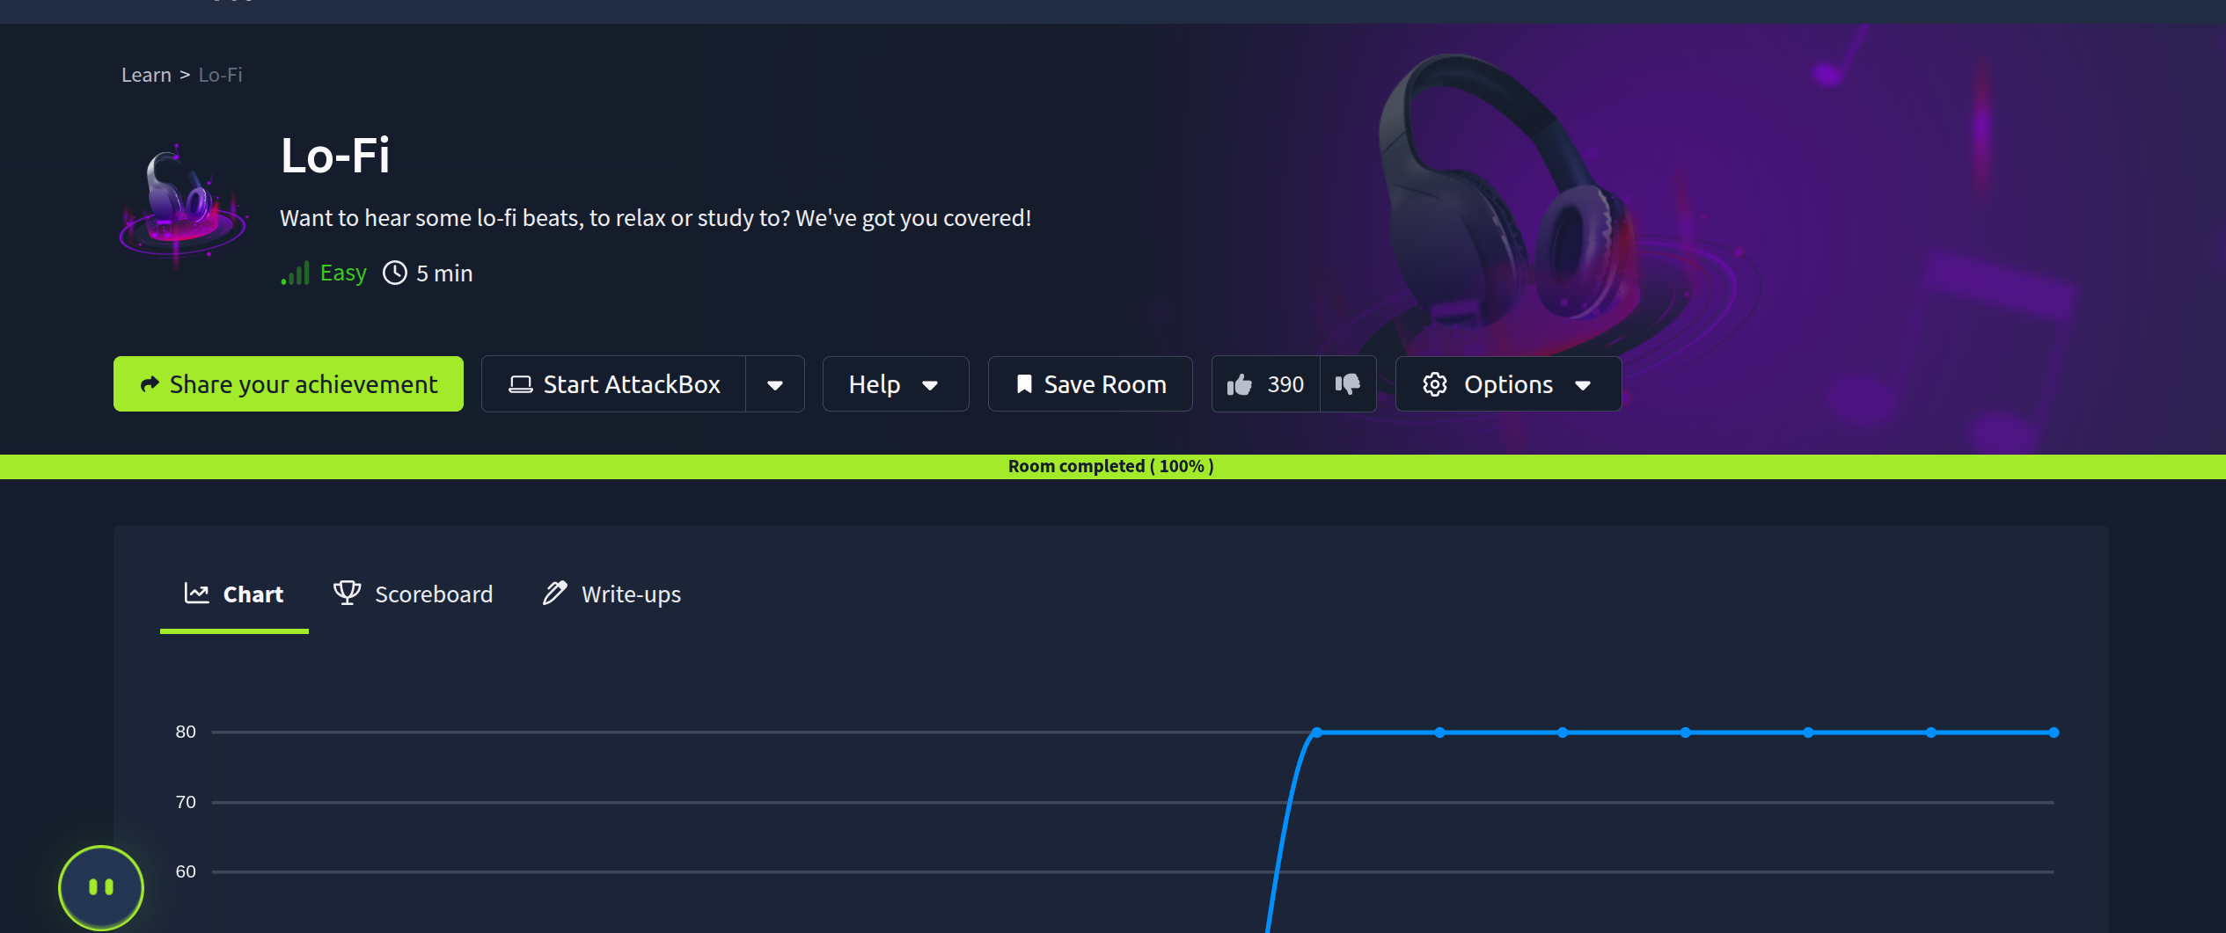

For this room we are told to navigate to a web address that shows us Lo-Fi beats. The description makes it pretty clear we are looking for LFI.

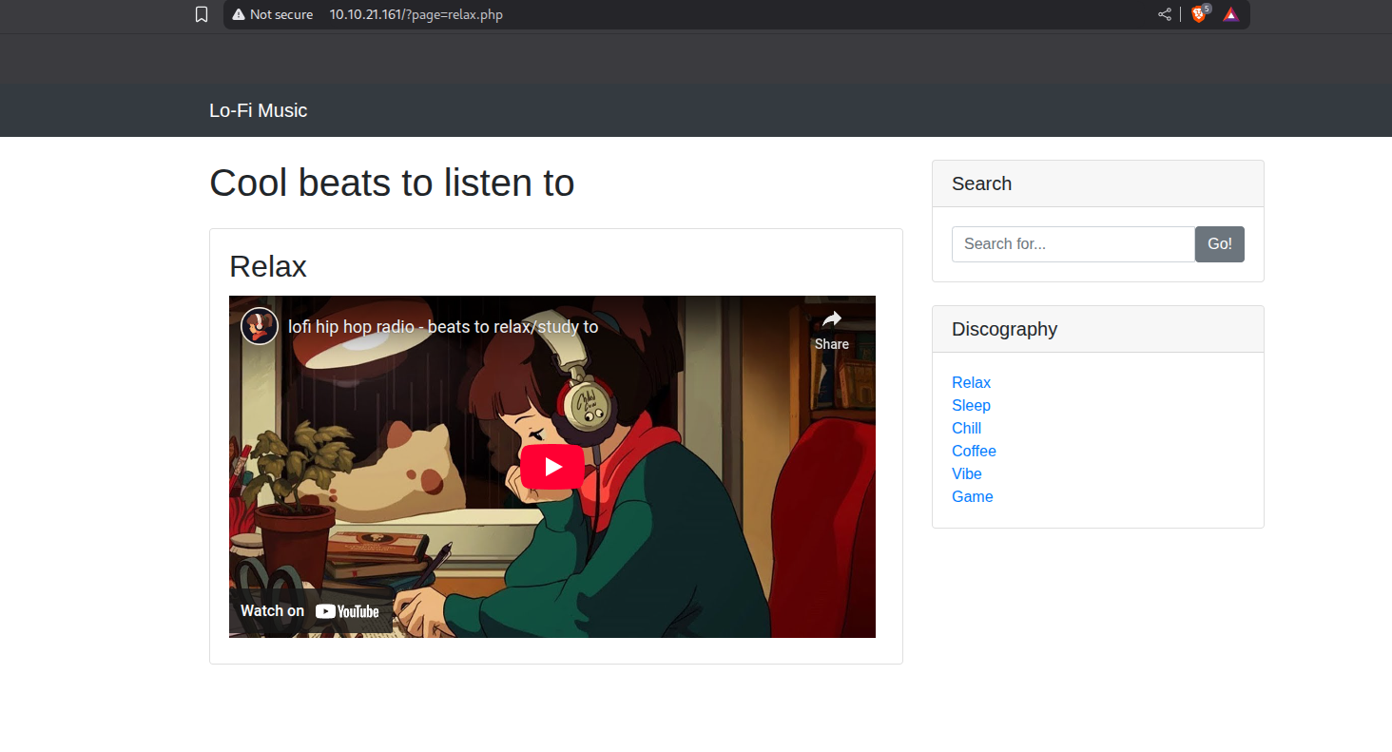
While browsing the site you can see it has a page parameter which is begging for LFI. If we attempt to navigate to any directory for file we get blocked.
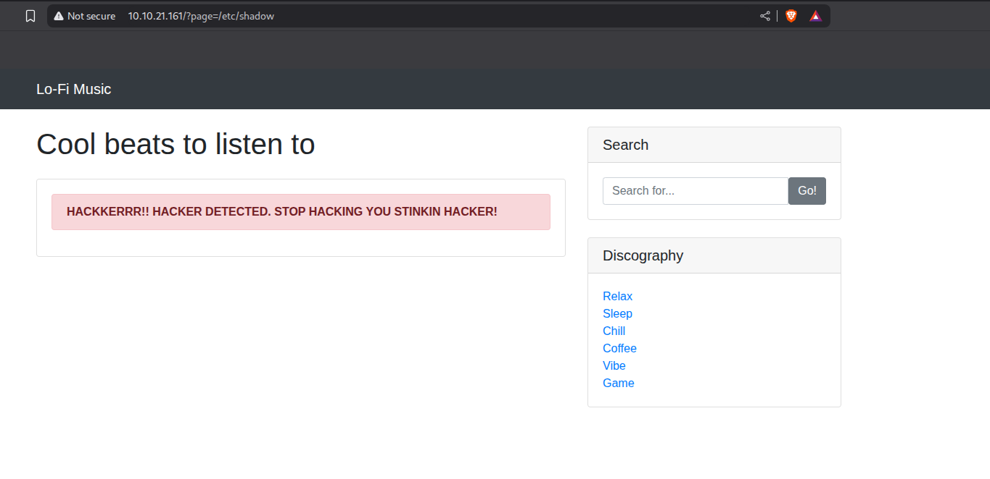
My next move was to try directory traversal. If we attempt to move back a directory with “../” we don’t get an error just a blank page. So I attempt to move to the root of the file system by adding a few “../../../../” and then navigating to the a file named flag.txt. And that’s all there is too it we are able to read the flag file.

