Writeup: TakeOver tryhackme

To solve this room I first added the ip and the domain futurevera.thm to the /etc/hosts file.
The title says that this challenge revolves around subdomain enumeration so we will start there.

The info in the first task says the they do lots of space research and write blogs about it. Which made me thing that there is a subdomain for blogs. They also say they are rebuilding their support page which hints to the idea of a support page or subdomain. I added both blog.futurevera.thm and support.futurevera.thm into the hosts file and browsed to them.

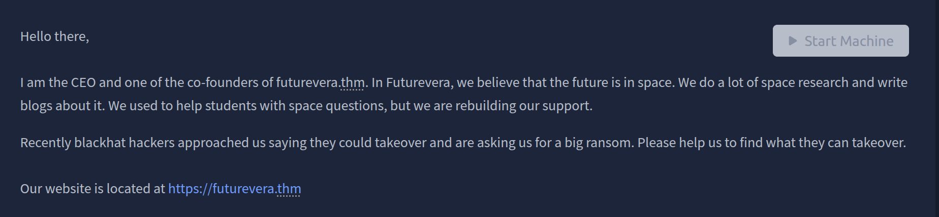

There is a page at http://blog.futurevera.thm but after exploring it I found nothing of note.

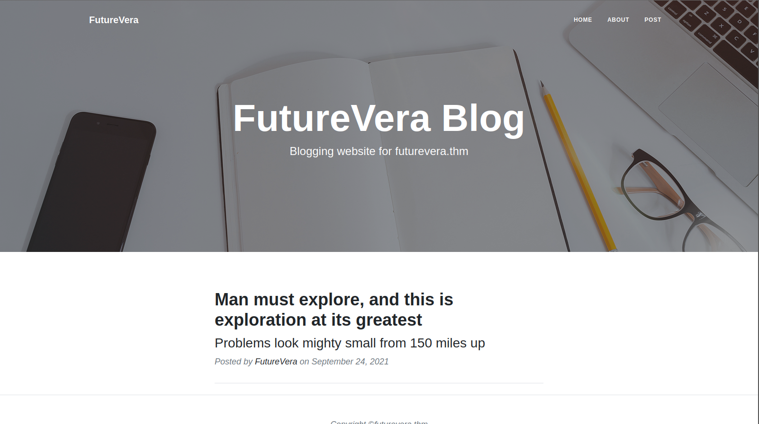
Browsing to http://support.futurevera.thm we get another website that didn’t seem to have anything important.

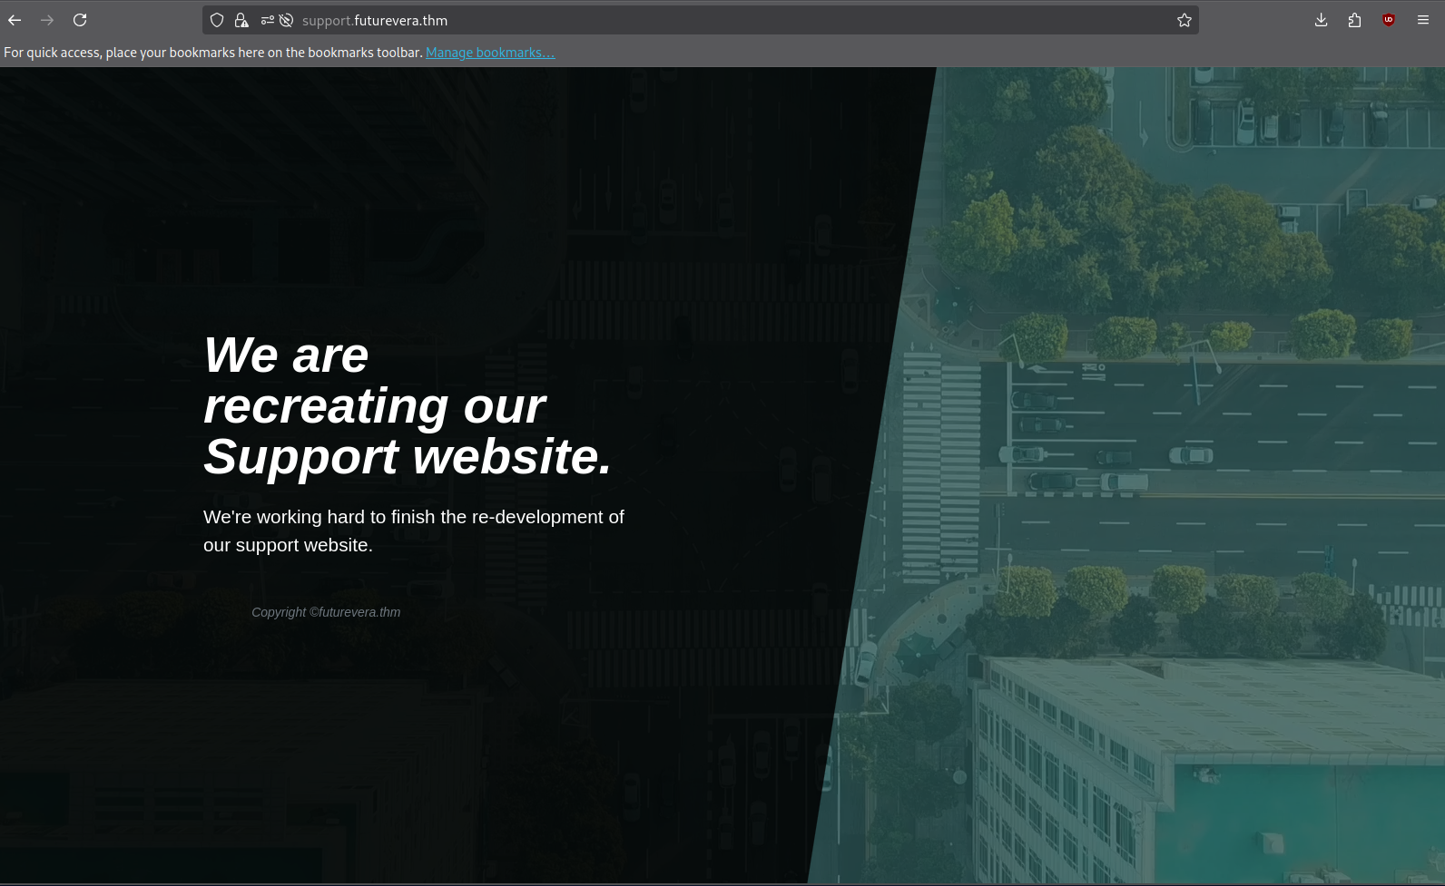

I was stumped so I decided to research into subdomains and subdomain takeovers as the room name hints to. After reading up on subdomain takeovers I decided to look at the certificates of each subdomain. I found that the support subdomain has a alt name that looked pretty interesting. I navigated to it and was served an s3 bucket with a flag as the subdomain.

