U.A. High School writeup



Starting with an Nmap scan we see we have two open ports 22 and 80. Navigating around the website I took note of a contact us form which I attempted a few payloads but with no success.

Next I started some directory fuzzing and found and assets directory. Browsing to the the assets page gives us a white page. I decided to start up OWASP ZAP and capture the responses. When browsing to the /assets directory the web server responds with a PHP session cookie, meaning the web server is running PHP.
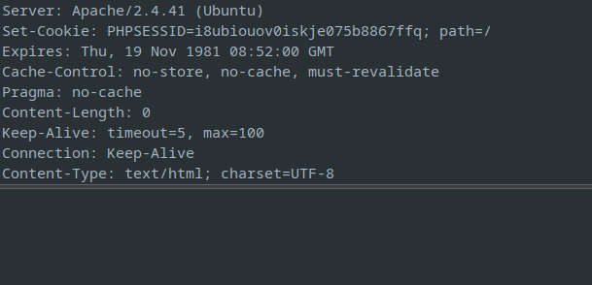
I then browsed to the /assets/index.php knowing the web server uses php and received another white screen. I then attempted to fuzz for php parameters with ffuf.

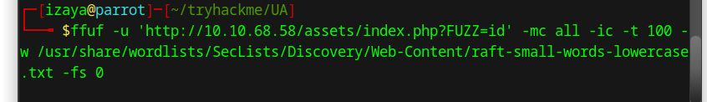
We find a cmd parameter.
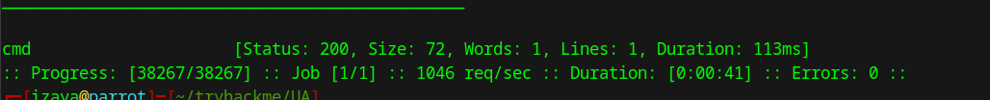
If we request the page we get a base 64 encoded reply for the command we ran (id). Identifying us as www-data.

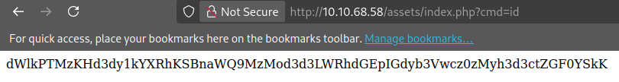
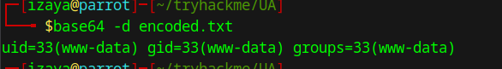

From there a put a php shell in the cmd parameter and received a shell. Browsing the file system we see a Hidden_Content directory with a passphrase.txt file. After decoding the base64 text we get the phrase AllmightForEver!!!. I tried this as the password for the User Deku and for root and didn’t have success.

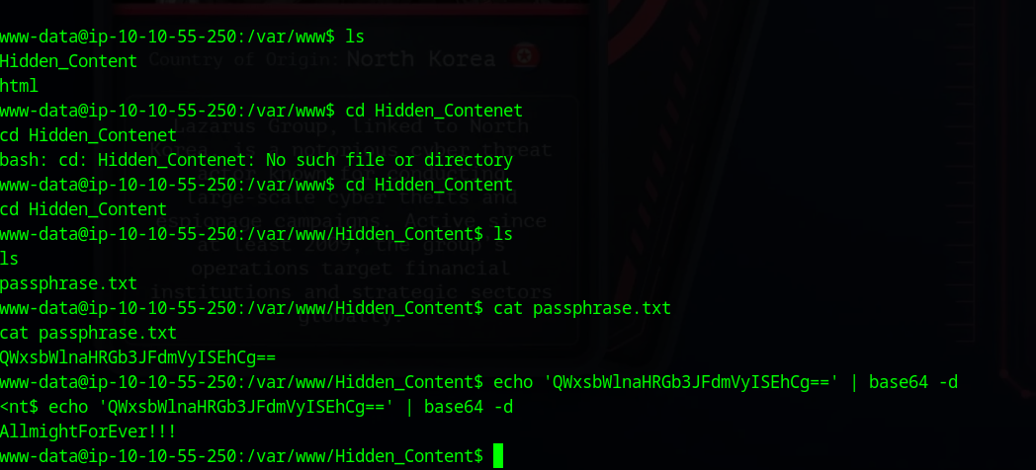
Browsing the assets directory we find and images folder with two images. One of the images oneforall.jpg doesn’t open. Running the file command identifies the file as just data which is weird. Opening the file in a hex editor we see that it has PNG file headers.
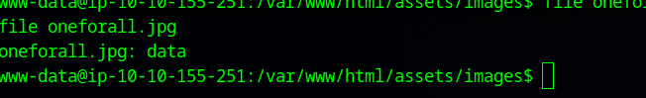
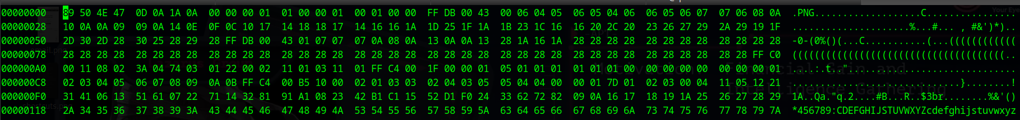
I first just tried to change the file type to PNG and attempted to open the file again, but that didn’t work. I then edited the file header to be a JPG file header and was able to open the image.

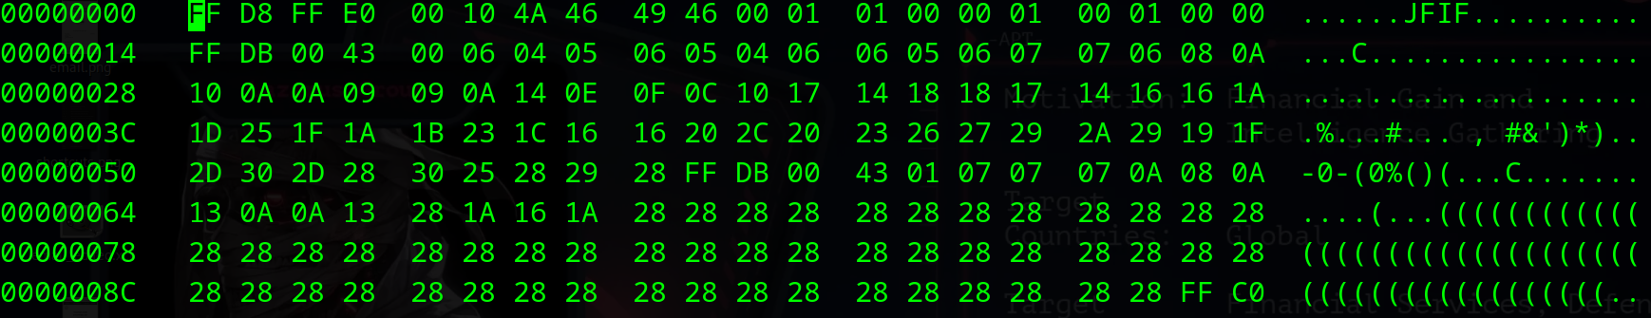
But what next? Remember we found a passphrase earlier that didn’t work for much so I thought maybe there is embedded data in this image so I used steghide to extract data using the passphrase “AllmightForEver!!!” and boom we get a some creds.

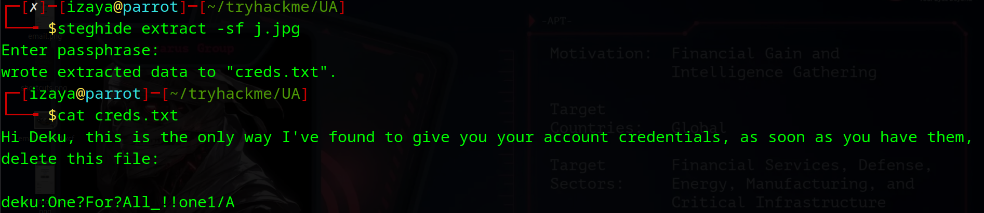
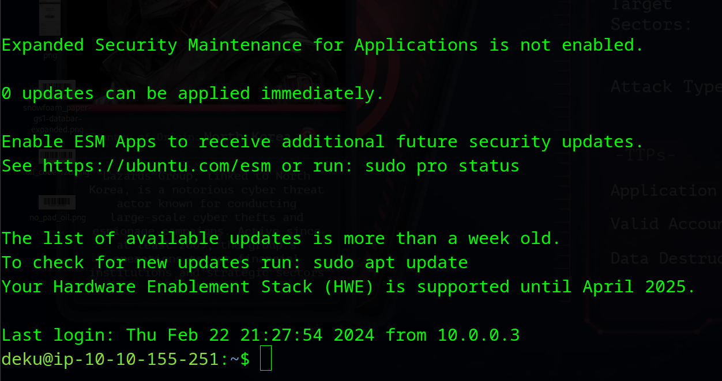
We can then ssh as deku.
Then we can read the user.txt file in Deku’s home directory and get our first flag.

Next we work on the root flag so I see what commands deku can run as root. Deku can run a bash script called feedback.sh as root.

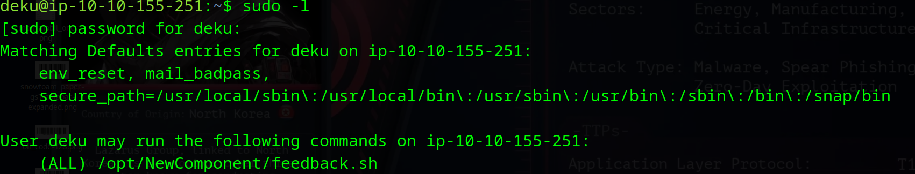

Reading this file you can see that it takes a input as variable feedback and then does some checks to see if it has bad characters and if it doesn’t have bad characters it will run the eval command and echo whatever we put in.

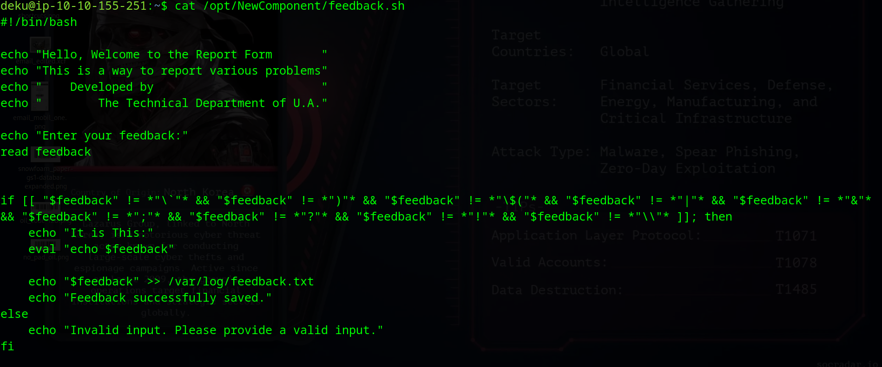
Now we don’t have permissions to edit the script and we cant add on a command because of the checks the file does. However, we can basically echo whatever we want into whatever file we want. So, I decided to just echo deku into the sudoers file giving me root permissions.

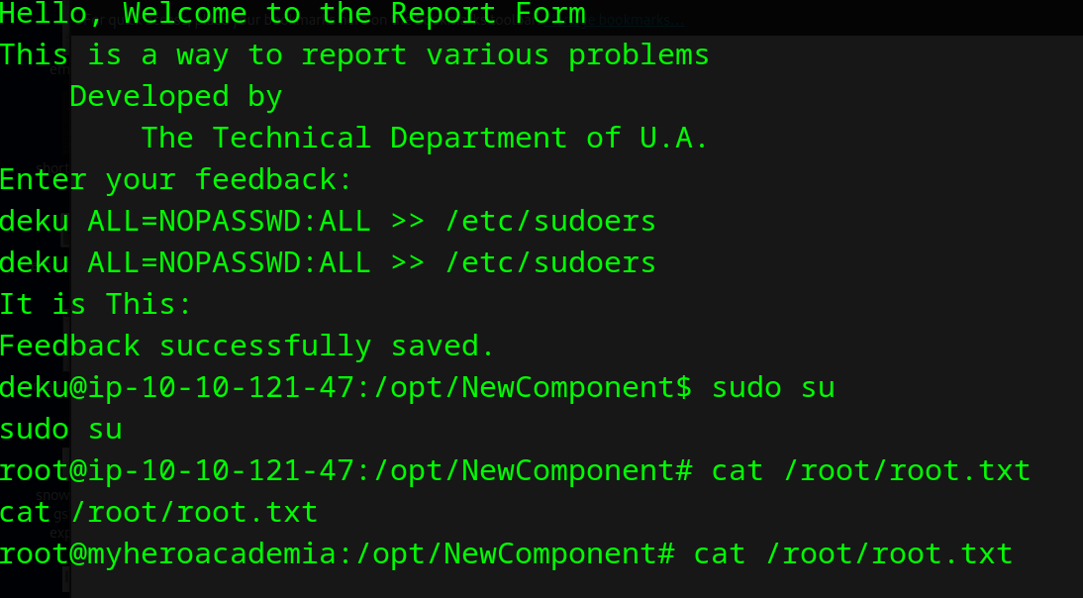

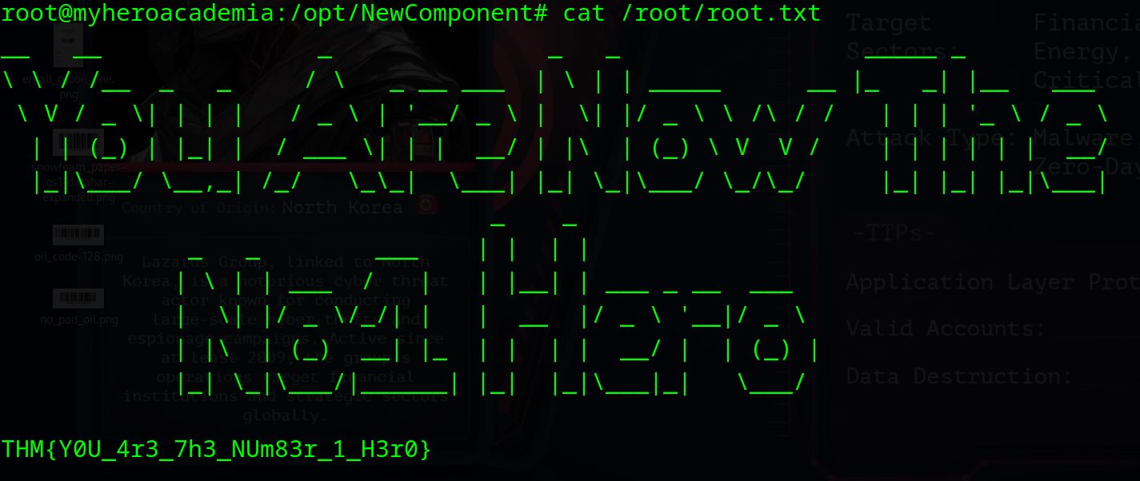
We can then cat out the root flag.

