PRJ4 Marketing

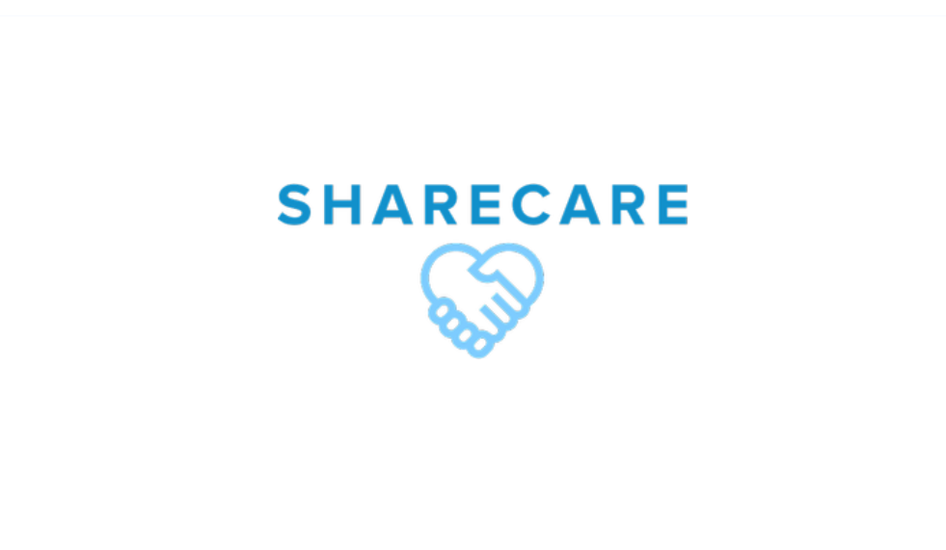

ShareCare - Context of campaign and promotional activities

Our marketing campaign's major goal is to expand ShareCare's audience.

*“****ShareCare*** *has everything you need to make the most of your expat experience, from social activities and opportunities to learn from others to social guidance on living in the Netherlands.”*

**Key Message:** You are not alone. We understand the challenges of living and working in a foreign country, and we are here to support you every step of the way.

**Brand Cornerstones:**

**Values**

1.1 Commitment

Our company is committed to offering our expat customers the greatest experience possible while they are living in The Netherlands. We are confident that by offering excellent group expat meetings, we can aid in assisting expats in navigating the difficulties of living in a foreign country and facilitating a smooth transition. We pledge to support our customers every step of the way, and we'll do all in our power to meet and even exceed their expectations.

1.2 Community

For expats relocating to a new country, community is crucial, according to our brand. Because of this, we hold group expat sessions that not only offer practical guidance and encouragement, but also help our customers feel a sense of belonging. We urge expats to interact with one another, exchange stories, and form lifelong friendships. We think we can assist our clients feel more at home in The Netherlands by creating a vibrant expat community.

1.3 Comfort

We think that comfort is essential because adjusting to life in a foreign country can be difficult. Even in a new place, our group expat gatherings are made to feel at home and reassuring. We provide helpful guidance on a variety of topics that would be interesting to our customers. Also, we offer a secure environment where our customers may relax and connect with people who understand their struggles.

1.4 Compassion

Relocating to a foreign nation can be intimidating and stressful. Therefore, our company approaches its work with understanding and compassion. We are aware of the difficulties expats experience, and we work to create a welcoming environment where they can express their worries and seek assistance. We are always available to talk and give advice, and we think that by being compassionate, we can improve the lives of our customers.

**Vision –** To be the leading community for young expats in the Netherlands, providing them with the support, resources, and connections.

**Mission –** Our mission is to provide a safe and welcoming environment for young expats in the Netherlands to connect, share their experiences, support, and learn from one another.

**Target Audience –** 18-25 year old expats living in the Netherlands

**Brand Persona**

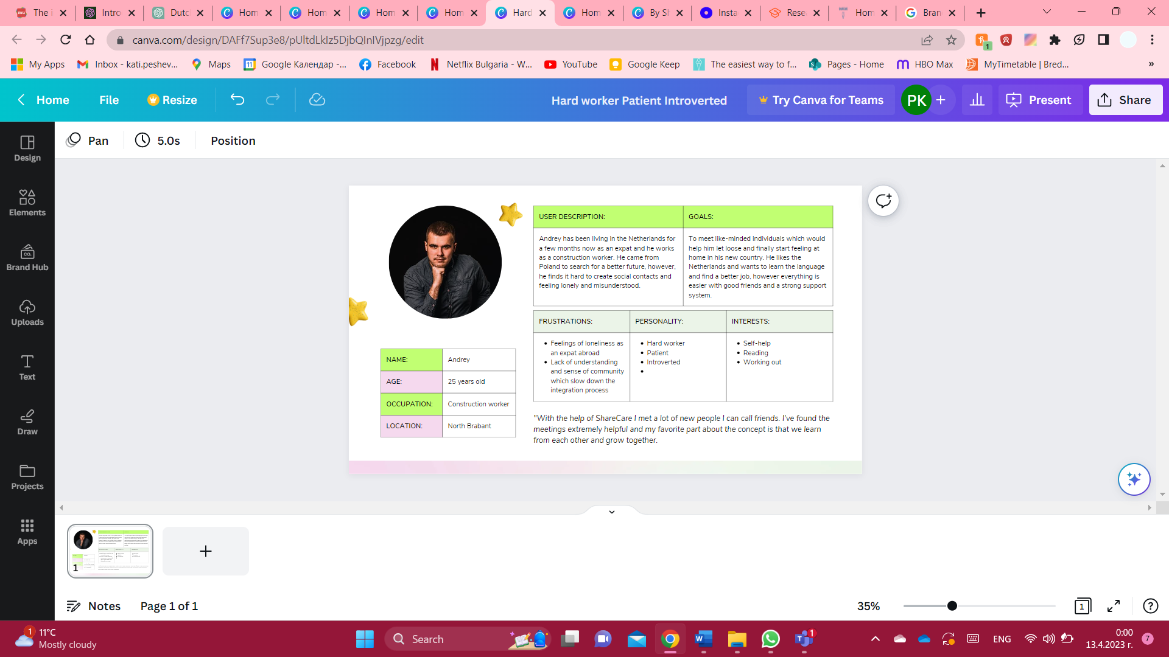

**Online Marketing**

We are posting three Instagram posts every week, with the purpose to promote this message and reach our marketing objective. The Instagram campaign began on March 20th, and the last post is published on April 13th. Attached to the corporate page of our website can be found all social media posts which can be divided into 3 main groups: real expat stories, which include photos of the participants, a short summary of their story and an inspiring message that aligns with our brand values. Another segment of posts we worked on discuss mental and emotional hardships and loneliness, which was a predominant problem that expats abroad experienced according to our findings. The 3rd type of post was fun facts about the Netherlands and sharing of culture shocks expats have experienced when first coming to the Netherlands. Relevant hashtags are used in the promotional activities carried out throughout the project to create interesting and informative Instagram posts that highlight the advantages of joining the ShareCare community. To showcase the benefits of joining ShareCare to potential new members, we have planned a launch event and created an event poster as the centrepiece of our final Instagram post.

For a social media platform of choice, our pre-requisites in the form of interviews and survey led us to believe that the most suitable networking site would be Instagram as recent research on the age demographics of Instagram users, almost 1/3 or 30.8% of all Instagram users fall within the ages of 18-25 years old which directly aligns with our target audience (Lin, 2023). Furthermore, Instagram is the clear choice for marketing aimed at young expats aged 18-25. The highly visual platform allows for easy presentation of products, services and experiences that resonate with this age group. Instagram's active user base is ideal for reaching this target audience, with 71% of users under the age of 35. Its algorithm promotes content that encourages engagement, making it easier to build connections and foster community with other users who share similar experiences. In contrast, Facebook's user base is older, with fewer active users in the 18-25 age group, and the algorithm favours paid ads over organic reach, making it less effective at reaching young expats organically.

In the interviews, participants were asked about their preferred media outlets, what a browsing session usually looks like for them and the type of content they consume. While initially, we wanted to cater to a target audience of expats aged 20-40 years, after conducting the problem interviews, we concluded that this age group is too broad and decided to focus on one user problem – loneliness expats experience when moving to the Netherlands, further research helped us find out that this issue is most predominant in the 18–25-year-old demographic. Outcomes from this pre-production stage and interviews can be found attached below in the form of a graph.

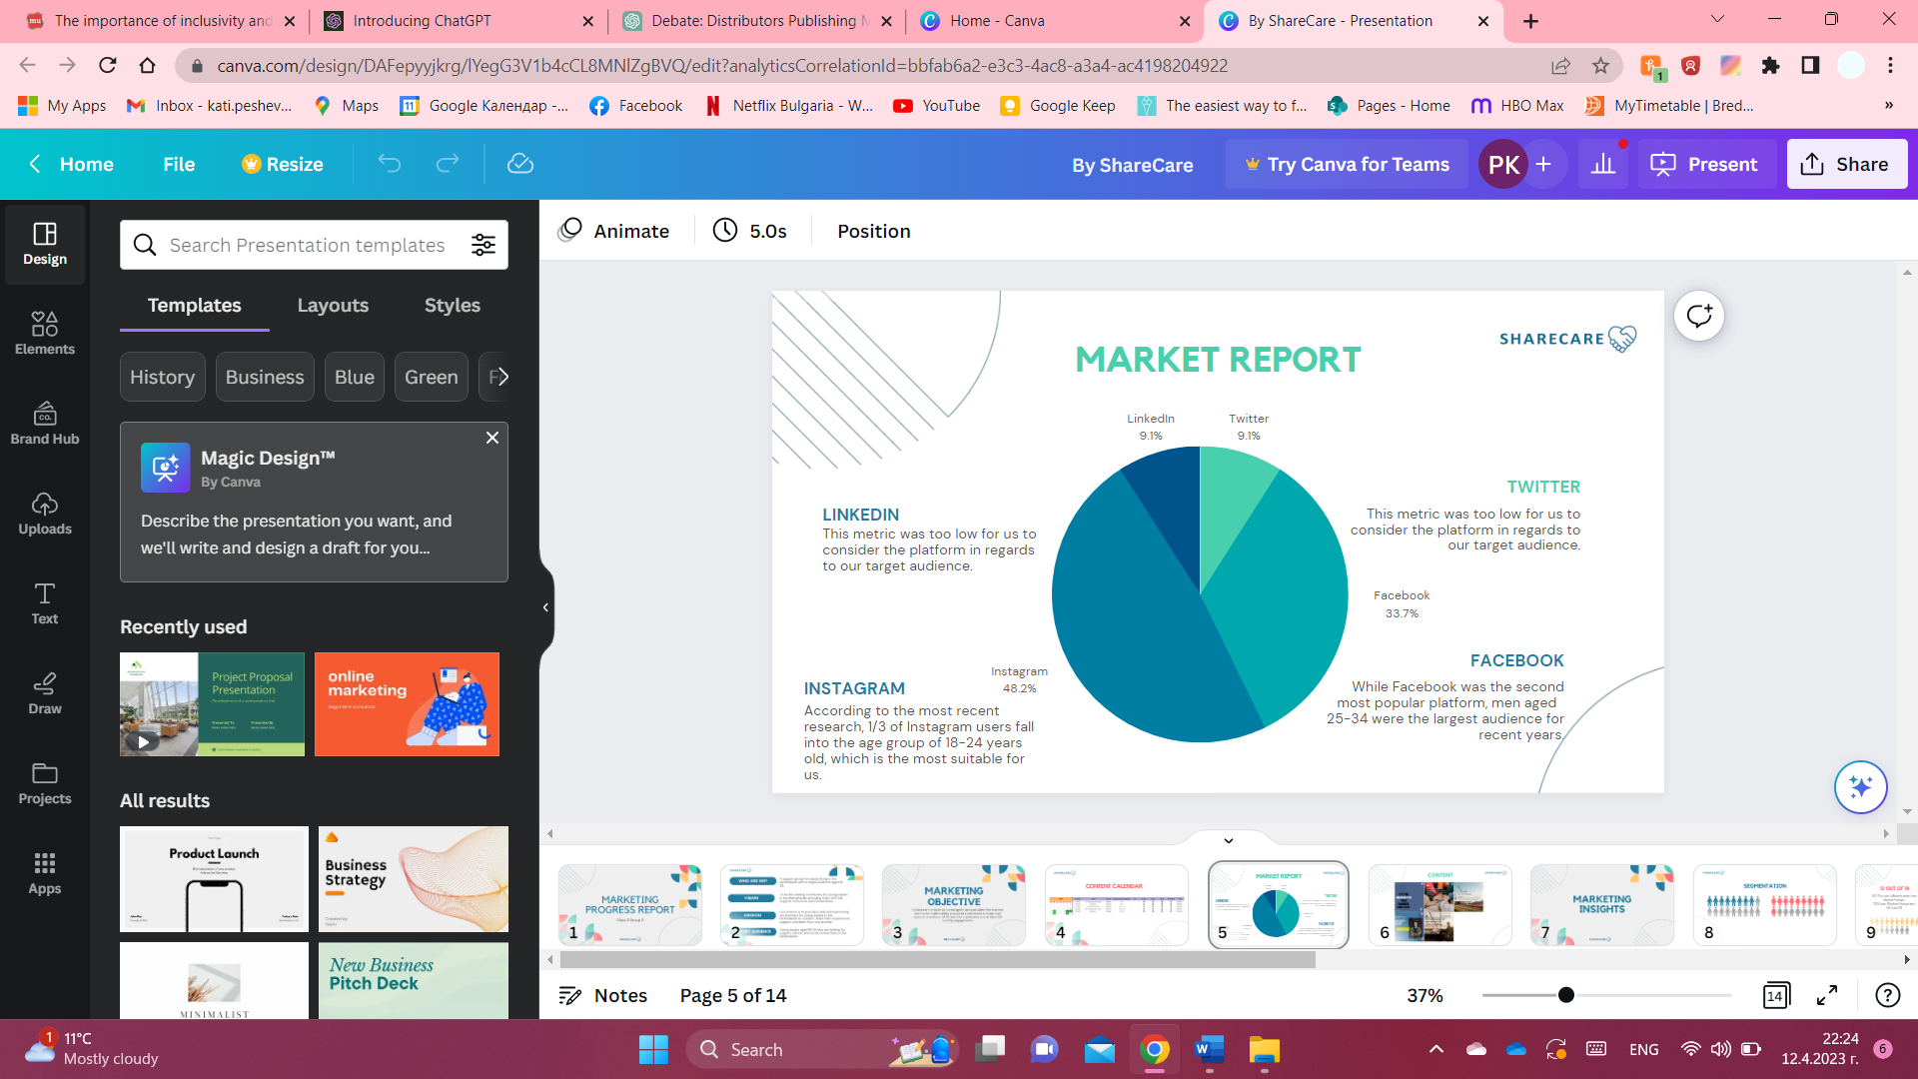

**Reach objectives**

Our objective is to increase the reach of our Instagram account within March and April, by implementing a targeted social media strategy that results in a minimum of 125 accounts reached and at least 100 monthly engagements.

**Affect objectives**

To create a deep sense of belonging and connection among expats in the Netherlands, making them feel seen, heard, and valued in a foreign country.

**Response objective**

Our objective is to increase awareness and engagement with our brand among expats in the Netherlands. We aim to attract new members to our support groups and events, and to establish our brand as a trusted resource for expat support. Specifically, we hope to achieve the following outcomes:

Increase website traffic: We aim to increase traffic to our website by 25% through targeted social media ads and content marketing.

Boost event attendance: We hope to increase attendance at our support group meetings and events by 50% by providing engaging and informative content and promoting them through various channels.

Grow membership: We aim to increase membership in our support groups by 30% by offering a valuable, relevant, and meaningful experience for expats in the Netherlands.

Establish brand recognition: We hope to establish our brand as a trusted and reliable resource for expat support in the Netherlands.

**Outcomes**

By achieving these outcomes, we hope to establish our brand as the go-to resource for expat support in the Netherlands, and to create a thriving and engaged community of expats who feel seen, heard, and supported in their new home.

**Learning points**

We picked up helpful tips concerning our marketing campaign while the project was still ongoing. While employing hashtags enabled us to connect with more members of our target audience, we discovered that accomplishing our marketing objective in such a short amount of time was difficult. The most engaging and enjoyable content for our audience, according to our research, was reels and the more personal posts (expat stories). As we expected, most of the people we reached were expats coming from Eastern Europe, which made us more confident in our choice of persona. And finally, in terms of what worked and what didn't, we discovered that Instagram reels and hashtags were very effective for our audience’s engagement but despite our best efforts, we fell short of achieving our complete marketing goal before the deadline. We reached 135 accounts, which was 10 more than our initial goal, so even though the reach was successful and it helped us and showed us we were setting realistic goals, the number of accounts who were actively engaging with our posts was 32, relatively low for the reach, but still an appropriate number considering the total number of followers was 35. More specifically, the number of followers and reach gre with 32.8% which was due to us increasing the number of posts and stories we would post and engaging more with similar accounts. Overall, this was a very valuable experience, we enjoyed producing content and managing our own social media page and looking forward we will take a lot of knowledge for future projects. In conclusion, we also learned that expats are a quite difficult demographic to cater to since they all come from different cultural and social backgrounds and a variety of stories. With a target audience as such, it is important to have a personalized approach and keep those differences in mind.

Based on our current experience, if we had the chance to start the marketing assignment over, we would probably focus on reels instead, engage more with other similar accounts in order to reach a bigger audience and establish ourselves as experts in the field. More specifically, in concerns to the content with would try to include also some positive trends/jokes which would evoke a feeling of comfort, community and compassion in the viewer. All 3 of which are our brand values.

In retrospect, the post that performed the best would be the ones that talk about expats’ emotions and why talking and sharing are good for your mental health and also the “fun facts” about the Netherlands, who took a more humoristic approach and according to the user testings were seen as “relatable” in expats.

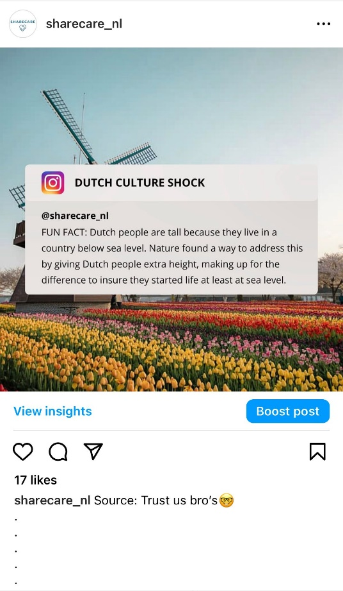

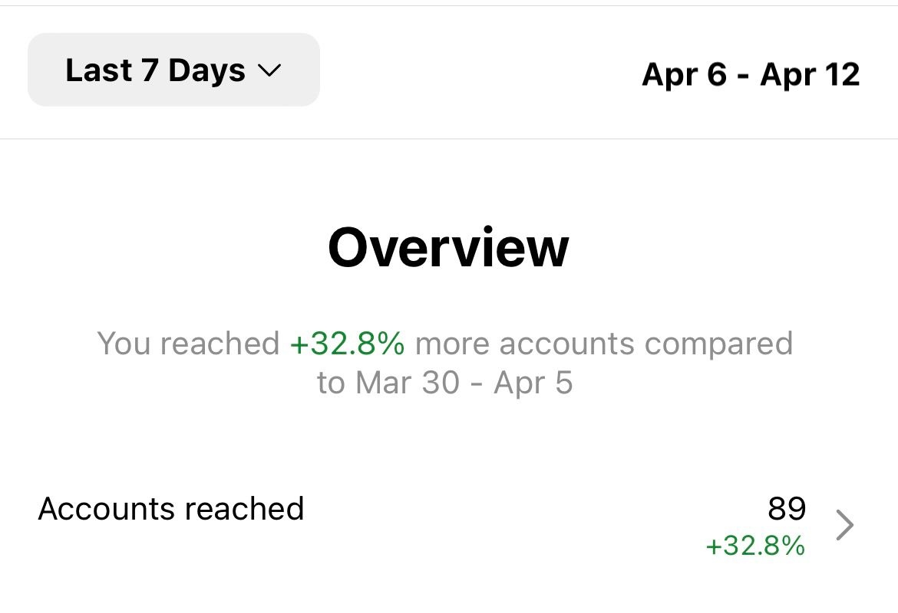

**Future planning**

When we look back on what we've accomplished so far, we're pleased with the progress we've made in expanding the ShareCare community and interacting with our target audience. On the other hand, there is always room for development. If the project were to go through, we would concentrate on creating a more thorough social media strategy that combines both written and visual content, as well as extending our reach through partnerships with other expat groups and influencers in the Netherlands.

Future suggestions include investigating new ways to reach our target audience, including targeted web advertising, and organizing more live events to strengthen the sense of community among our participants. Also, we would place a high priority on gathering member input in order to continuously enhance the ShareCare membership experience and make sure we are living up to their wants and needs. Here are some more detailed steps we could take in order to further develop our marketing campaign:

Expand on content marketing: While social media advertising can help attract new members, content marketing is key to establishing our brand as a thought leader in expat support. We could develop a blog, newsletter, or podcast that addresses common challenges and concerns facing expats in the Netherlands, and provide tips and advice for overcoming them. This content could be promoted through social media and email marketing, and could also be used to attract new members to our support groups and events.

User-generated content: Since our latest user-testing interviews and reach insights on Instagram showed us video content was more successful in comparison to static content, we would make the “expat story” posts in the form of short, but engaging reels.

Analysis: In order to keep a clean overview of the performance of the campaign we should regularly measure and analyze the performance of our marketing campaign to determine what's working and what's not. This includes tracking website traffic, event attendance, membership growth, and brand recognition. Based on these insights, we can adjust our marketing strategy and tactics to achieve our desired outcomes more effectively.

**References:**

Lin, Y. (2023). Instagram Age Demographics [Updated Mar 2023] | Oberlo. *Instagram Age Demographics*. https://www.oberlo.com/statistics/instagram-age-demographics