PRJ4 – Production

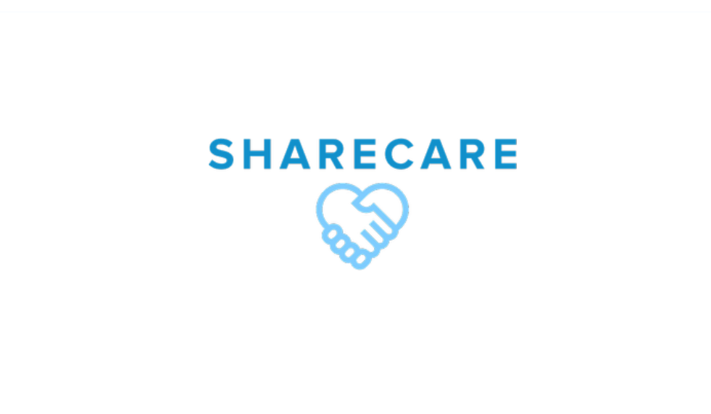

ShareCare - Context of campaign and promotional activities

# Website justifications

The color palette comes from the brand concept's first version of ShareCare, the old lean canvas. The current color codes can be found under this text with the color codes. Montserrat font was chosen as the brand font for our young expat support group for its modern yet approachable aesthetic. Its clean lines and simplicity convey a sense of stability and reliability, while its contemporary style speaks to the youthfulness and adaptability of our organization. When deciding on the color palette we took into consideration how these colors affect the look and feel of the website, which is why we looked at the color emotion wheel and color psychology wheel. We wanted to evoque feelings of

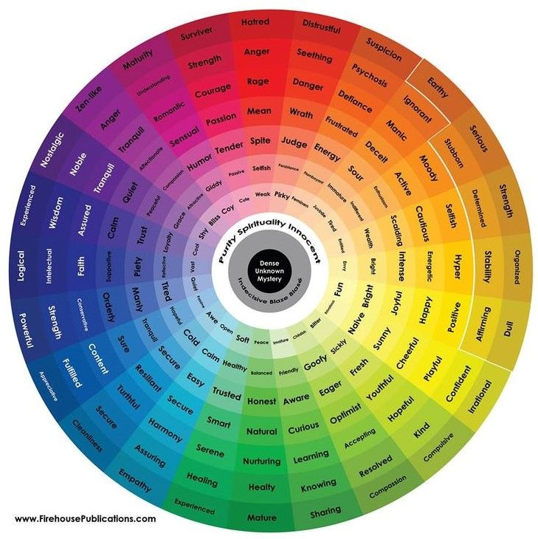

Furthermore, we decided to look at the color emotion wheel in order to specifically see how the shades of each color are perceived in order to find the color combination that would fit us best and would align with our vision, mission and values.

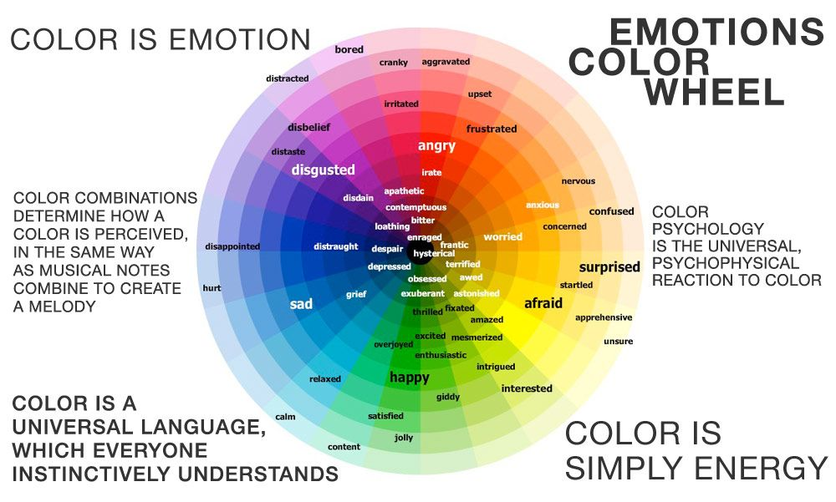

From our findings, while darker colors symbolize faith, wisdom and strength, it’s very easy to evoque emotions of sadness and grief if you don’t choose the right shades. Which is why, we decide to go for a more toned-down version of dark blue for a relaxed and calm tone of voice. Furthermore, we decided to compliment these shades of blue with bright and uplifting green colors, which would provoque feelings of happiness and enthusiasm in our audience. In order to tie everything together and create a completed and touching color palette that would convey our values, we decided to tie everything together with a beautiful light gray color, that can be used for background or accent icons/images. We had some struggles when it came to creating the logo, but overall, decided for a non-serif font for a simpler and more memorable look. The signature icon in the logo consists of two holding hands in the shape of a heart representing the sense of community, care and compassion. Below can be found a visual representation of our style guide that we followed throughout the project to create a consistent and strong visual and convey our beliefs into the website efficiently.

We put the menu at the top for the user interface elements to give it a modern and up-to-date design. It reflects our young brand and our target group of young expats between 18-25. For mobile, we would combine the three menu buttons so it wouldn't feel overcrowded in the top bar, and the clean design would be consistently reflected.

The text is mainly centered in the middle, so it reflects the balance we want to bring to the lives of expats seeking help from others with the same problem. The centered text on our website reflects our goal to balance the lives of expats seeking help from our support group. It conveys a sense of stability and symmetry, which aligns with our mission to create a supportive community where individuals can find balance and harmony in their new surroundings.

We incorporated a video on our website to give expats an immersive experience and showcase its modernity. Accompanied by a clear slogan, our audience can easily understand our message. We chose to avoid excessive use of images as our strength lies in simplicity. So many pictures can overwhelm expats seeking refuge from busy lives, but our minimalist approach provides a clear and calming space for them to seek help. Instead, we rely on carefully chosen visuals that enhance our message and add value to our content.

# Organization of navigation and content

Our website has been thoughtfully designed to provide a seamless experience for first-time expats who need information and guidance. We understand that navigating a new country can be overwhelming, and we aim to ensure they can easily access the information they need to make informed decisions. We have carefully selected simple menu buttons to achieve this and placed them strategically on the homepage. Along with our contact section at the end of the page, navigating our website is a breeze. The page is structured to present all the necessary information in a calm and organized manner. With a simple scroll down, first-time expats can quickly and easily get all the essential information. Our homepage is structured to start by introducing our company and what we stand for, followed by a clear presentation of our values. This helps them get a feel for what we're all about. We then introduce them to our team of professionals and highlight our strong connections with funders, assuring them that we are a legitimate and trustworthy company. And finally, for those seeking help, we have made it easy for them to contact us.

We have designed our 'About Us' page to provide a straightforward introduction to our company. This page is an essential resource for young expats who are looking to learn more about us and what we do. The content is structured along the way with the presented text. We have kept it concise and easy to follow, so they can quickly learn who we are and decide if we fit them. Our website has been designed with the needs of young expats in mind. We have used UX design principles to ensure that navigating our site is easy and stress-free. We want to ensure that they have a positive experience and can quickly find the information they need to make informed decisions. With our clear presentation of information and easy-to-use navigation, we can provide the support and guidance that first-time expats need.

# Website as a part for marketing

Our brand, ShareCare, is committed to providing a safe and welcoming environment for young expats in the Netherlands. This approach is reflected in our social media campaign, which features helpful and sometimes humorous posts. Maintaining consistency in our posts aims to create a sense of familiarity and safety for our target audience. This is particularly important as many expats may feel stressed and overwhelmed when searching for support.

Our website design further reinforces this welcoming environment, with consistent use of font styles and simplicity. This design choice is intentional; we want to create a seamless and comforting experience for our users. The welcoming feeling, we aim to create is like extending an arm to potential clients, making them feel at home in our community. Our Instagram marketing campaign complements this approach, as we use it to reach and engage with our target audience. By combining a supportive brand vision, welcoming website design, and engaging social media strategy, we can create a cohesive marketing campaign that reflects our mission to support young expats in the Netherlands.

# Testing Report

User testing is a great way to analyze a brand’s already existing strategy and evaluate the success of design choices, but also give insights into users’ opinions’ and how they perceive the content. After creating the first version of the website, we conducted 8 interviews in total (2 per team member) in the form of think-a-loud methods and interview question, as well as posing tasks connected with navigating on the website to the participants. Participants were asked to look around the site and perform tasks such as – finding our values, finding the company address, identifying the councilors and more. This helped us apply the learning point gathered into improving the navigation flow of the site and create a better version of it.

User testing is a great way to analyze a brand’s already existing strategy and evaluate the success of design choices, but also give insights into users’ opinions’ and how they perceive the content. After creating the first version of the website, we conducted 8 interviews in total (2 per team member) and 3 interviews in the form of think-a-loud methods and interview question, as well as posing tasks connected with navigating on the website to the participants. Participants were asked to look around the site and perform tasks such as – finding our values, finding the company address and Instagram page, identifying the councillors and more. This helped us apply the learning point gathered into improving the navigation flow of the site and create a better version of it.

User testing participants:

Participant 1

• John Dancaet, Romanian, 20-years-old (matches our target audience), setting- on campus

Participant 2

• Yana Hristova, Bulgarian, 20-years-old (matches target audience), setting- on campus

Participant 3

• Ivayla Marinova, Bulgarian, 22-years-old (matches target audience), setting- on campus

Issues and positive points that have been identified, ranked by importance:

• Issues: The only issue our participants noticed was the home page video, it wasn’t working properly, it was shown as a paused YouTube video.

• Positive points:

1. All of the participants acknowledged the simplicity of the website design;

2. They mentioned that the funders’ part makes the website look more professional;

3. They liked that the Instagram link actually leads to ShareCare’s Instagram page;

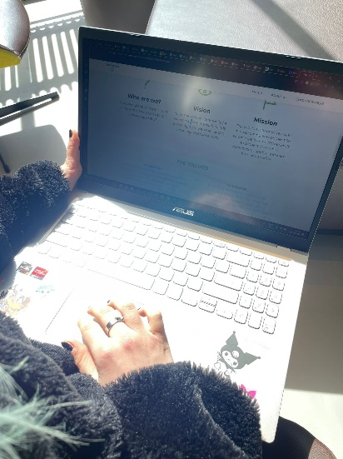 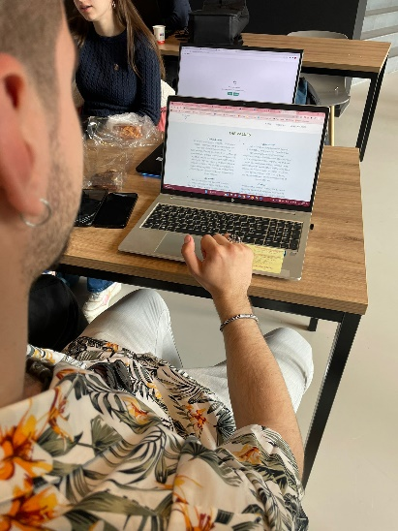

# Improvements

From these findings can be concluded that the vision, values and beliefs are easily recognizable and emotionally touching for our audience. We were suggested to add some information about the counselling team, which would provide a more personal approach when contacting our counselors and adding photos would help the audience connect the name to a face and make the company seem more trustworthy. Furthermore, on the home page initially our slogan was put over a photo, however we decided to embed a video instead to make the content more engaging and livelier, this made a huge difference on how the index page was perceived by users and elevated the look of our site. Looking into the future, if the project were to continue, we would add more blog posts on the website that discuss the importance of talking about your feelings and promote events. If we had the chance to develop the website even further, we would go for parallax scrolling and animations for a more professional and modern look and feel. We gained insights into the industry; a lot of the group members enjoyed it and would definitely be continuing our professional development in the field. Overall, it was a great opportunity to develop our coding skills and a positive experience for all.