**1. Combining, Bagging and Random Forests**

1a. All three doctors correct = 0.8^3 = 0.512

At least two doctors correct = 0.8^2 = 0.64

Thus, the probability that the group is correct using majority voting is 3 * (0.2*0.8*0.8) + 0.8^2 = 0.896

1b. We did not find a direct formula, see answer c. for the code implementation.

1c. See the file “majority.py”. The probability that the majority of medical students in example c. are right is roughly 0.78.

1d.

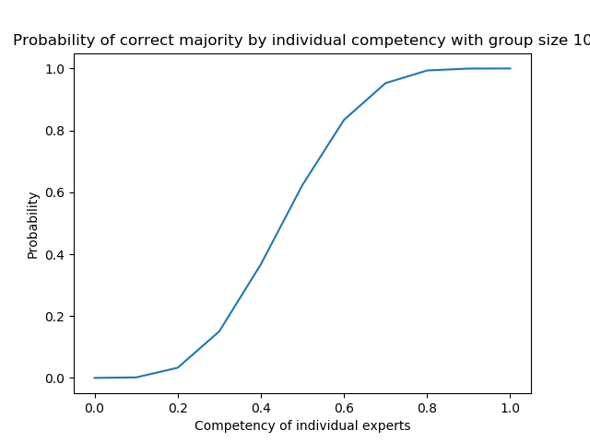

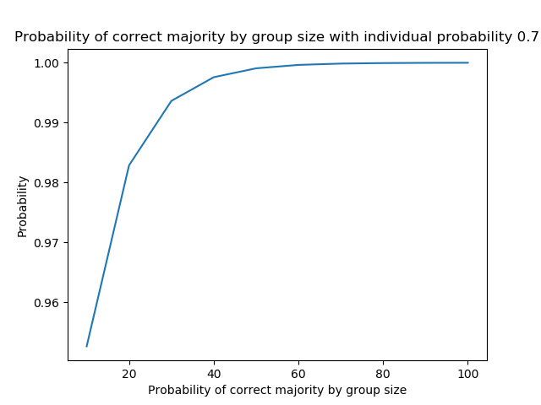

1e. As of now, the three experts have the highest chance. The student group seems to have a higher probability after they gain more than 20/25 students (see code).