**JBI100 Visualization Group 33 2020/2021 Tool starting guide**

*This readme provides documentation regarding how to start the visualization tool of group 33*.

The tool can be started 2 ways:

1. Opening the webpage
2. Running the python script

**Opening the tool using the JBI100_GUI.html file**

To open the webpage, navigate to the downloaded folder, and locate the JBI100_GUI.html file. Clicking it will open the tool in a new browser tab using your default internet browser.

Should certain function of the tool not appear to operate, or should any visual bugs occur, please make sure your browser supports html-5. If the issue persists, the tool should be opened through the python script.

**Opening the tool using the JBI100_GUI.py file**

Opening the tool through the python script will (re)create the JBI100_GUI.html file, and open it in a new browser tab. Before running this file, make sure that python 3.7 or higher has been installed (<https://www.python.org/downloads/>). Furthermore, the script requires additional python modules. Below the installation steps is a table listing all prerequisite modules, their install command, and usage.

To install the required python modules, follow the following steps:

1. Open a new command terminal by searching for cmd in the windows search bar.  
   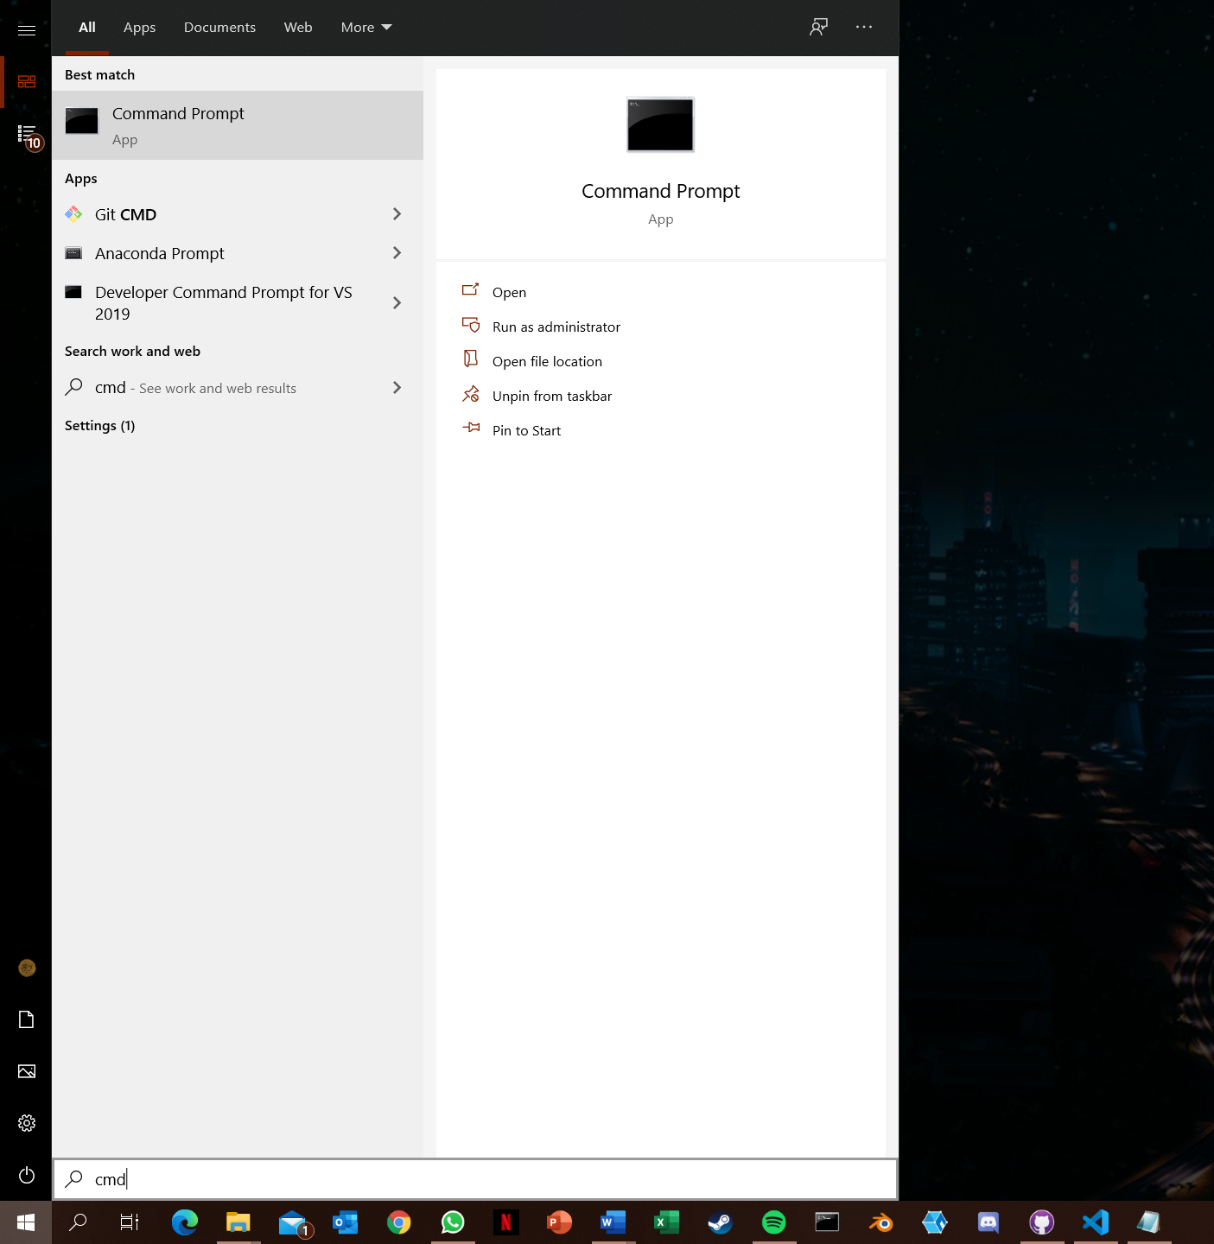
2. Execute the commands listed in the table below. These follow the structure of pip install [module name] and will require an internet connection.  
   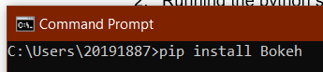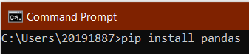  
   Running these commands will result in pip fetching and installing the modules and their depencies. Note that pip may throw error (as it also did in the picture below), but this is fine as long as it concludes with successfully installed [module name]  
   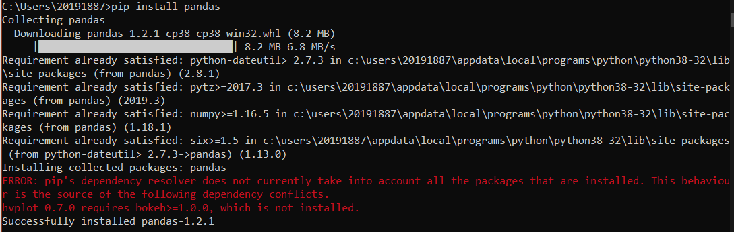  
   Pip will also notify you when a module is already installed, with a dumb of messages similar to Requirement already satisfied: [requirement for module] in [path] [optional: module]  
   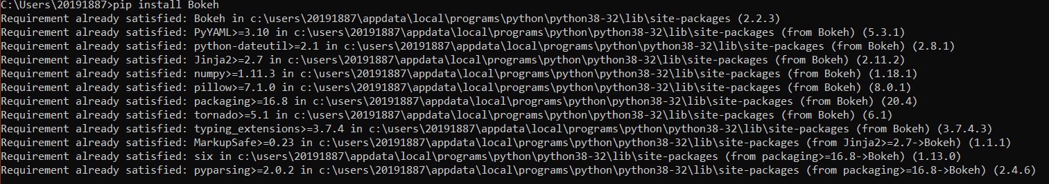
3. Verify that both modules have been installed by running the pip list command, and confirming that both modules are listed in the shown list.  
   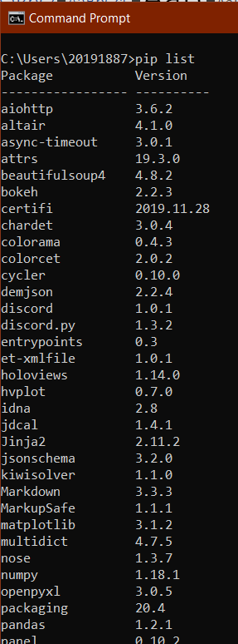  
   Note that both pandas (last entry) and Bokeh (6th entry) are present.

*A list of all prerequisite modules for the tool:*

|  |  |  |  |
| --- | --- | --- | --- |
|  | Module name | Install command | Usage |
| Non-standard modules (require manual installation through ‘pip’) | | | |
| 0 | Bokeh | pip install Bokeh | framework for the visualization tool in python |
| 1 | pandas | pip install pandas | toolkit for parsing and processing data in python |
| Python standard library (automatically installed prerequisites) | | | |
| 2 | math | pip install math | toolkit for advanced calculation in python |
| 3 | numpy | pip install numpy | library of different constants and types of numbers |
| 4 | itertools | pip install itertools | toolkit for working with iterables in python |

Dependencies for dependent modules should have been handled by pip.

After python, the bokeh library and the pandas library have been installed, locate the JBI100_GUI.py file. When clicking on it, a new terminal will open and after a few seconds, a new browser tab will be opened that is loading the tool.