**Changes to Color Match Game for Twitch**

a. Find line: PapertrailLogHandler **papertailHandler**("192.168.102.205", 4888, "RemoteColorMatch"); and change to your IP address

b. To find your IP address in Windows, open ***cmd*** *window* and type **ipconfig**. Your computer IP address is listed for IPv4 address, in my case it is 192.168.102.205. The example comes with a different one.

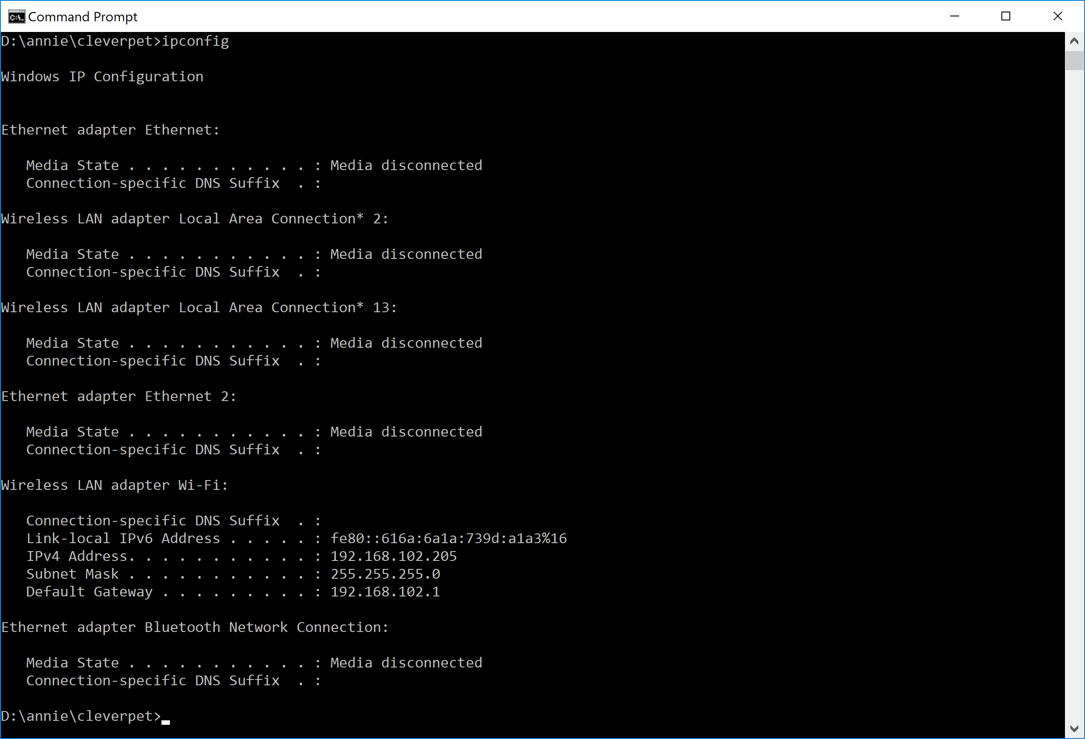

c. Find the line: const char PLAYER_NAME[] = "Tornado Ellie";

and change the quoted text (in green above) to your player’s name

d. Adjust some settings to your player’s preference. For example, my player is a speedy eater, so I reduce the amount of time that the food treat door is open. I also changed the REINFORCEMENT_PERCENT and few other settings to move things faster. Ellie is not very patient. I also changed

const int DEFAULT_NUM_STATES = 3;*//maximum number of touchpad/button color states*

This enables three colors–yellow, blue AND white— otherwise you get just yellow and blue. Which is a good place to start!

… AND that’s it!! Compile and Flash as before. If you need a refresher on how to do that, take a look at the tutorials in the forum.