**Changes to your Player Twitch Profile**

**THERE ARE NO RULES!!! LIMITS OR RESTRICTIONS! BUT** if you want to reuse Salk’s profile settings, and I did, because, well, is easy to copy and paste, here are recommendations on how to do it. Assuming that you already have created a twitch account for your player.

1. Edit the profile, look for Edit Panel switch and turn it on

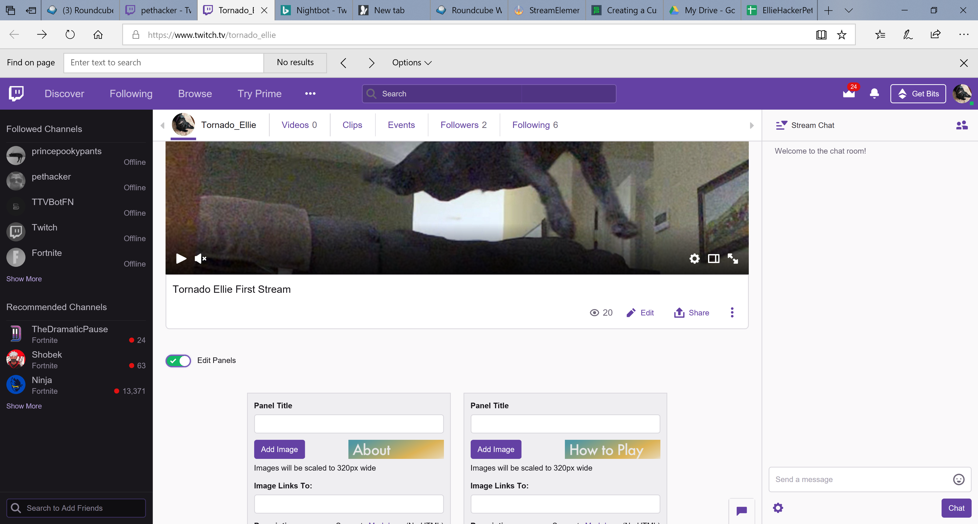

1. Click on the + sign

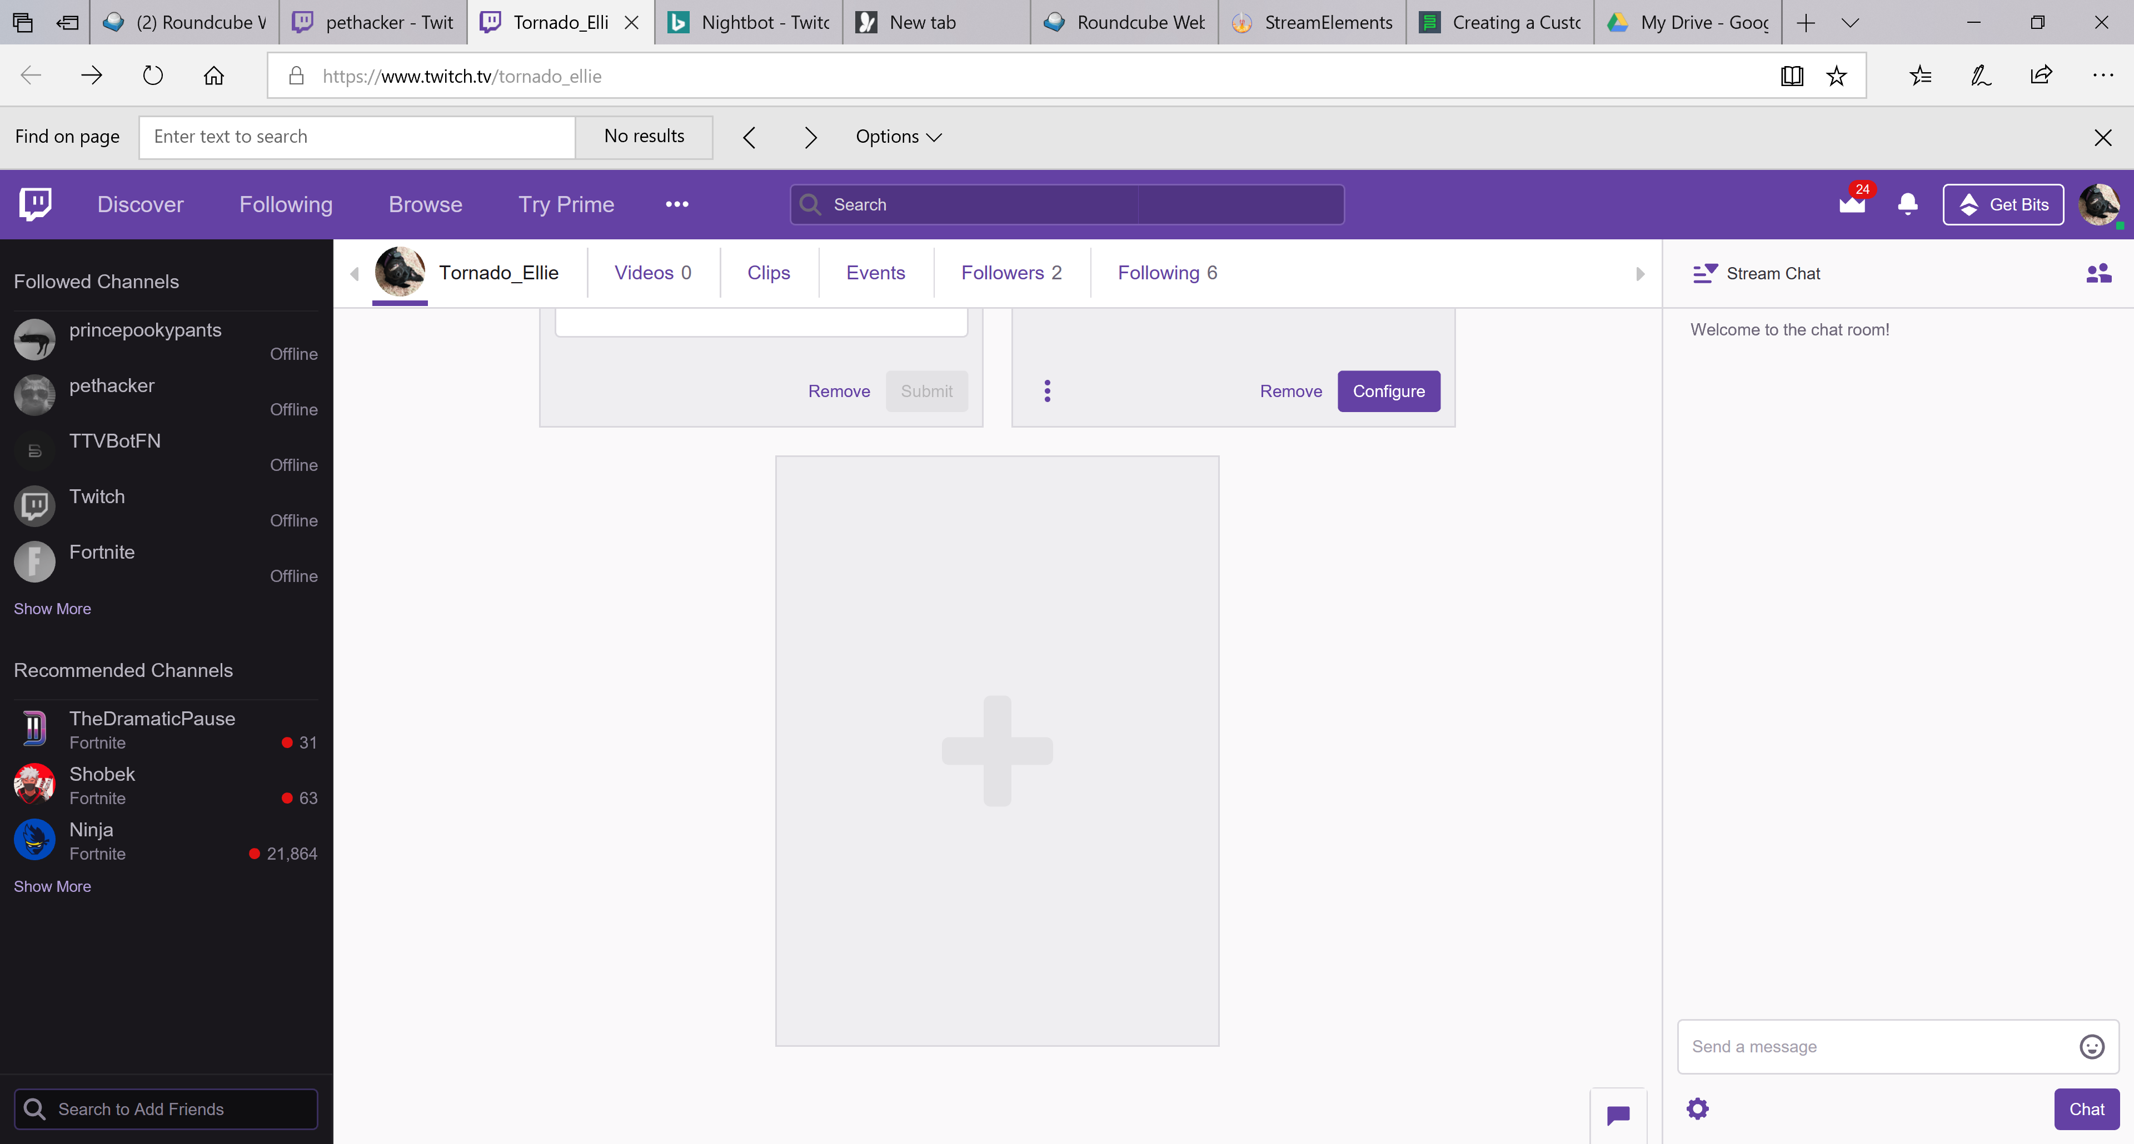

1. Click on the add image

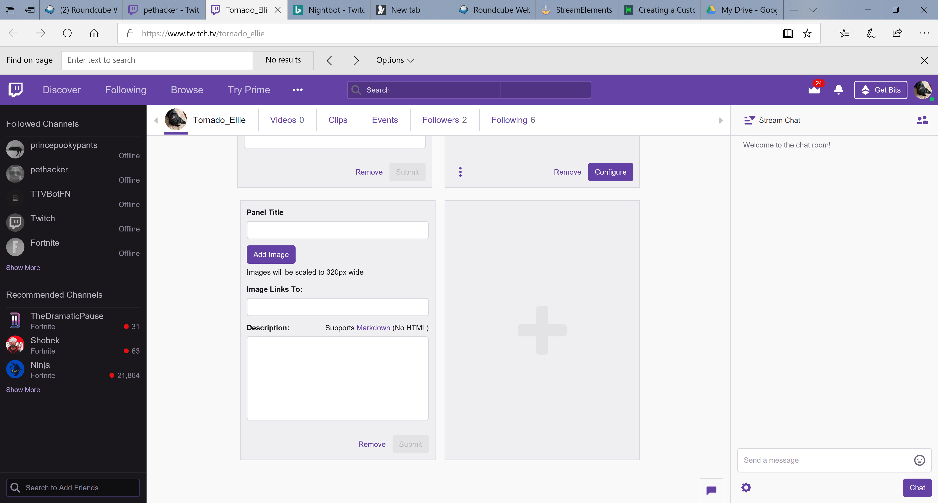

You don’t need to add a panel title if you use on the images from the zip file attached.

1. From here on just copy and paste each of the sections from https://www.twitch.tv/pethacker
2. You can move around the panels by just dragging one on top of the other to achieve the desired layout
3. If you add a link to your Google Sheets with Raw Data, you will need to get the read-only link from the Google Sheets Share option.

**Other suggestions**

1. Consider adding Nightbot to help manage people that might post abusive language
2. Under Twitch settings fill Tags and Categories
3. Download Streamlabs OBS