COMPILER DESIGN
UNIT-5
Optimization is a program transformation technique, which tries to improve the code by making it consume less resources (i.e. CPU, Memory) and deliver high speed.
In optimization, high-level general programming constructs are replaced by very efficient low-level programming codes. A code optimizing process must follow the three rules given below:
- The output code must not, in any way, change the meaning of the program.
- Optimization should increase the speed of the program and if possible, the program should demand less number of resources.
- Optimization should itself be fast and should not delay the overall compiling process.
Efforts for an optimized code can be made at various levels of compiling the process.
- At the beginning, users can change/rearrange the code or use better algorithms to write the code.
- After generating intermediate code, the compiler can modify the intermediate code by address calculations and improving loops.
- While producing the target machine code, the compiler can make use of memory hierarchy and CPU registers.
Optimization can be categorized broadly into two types : machine independent and machine dependent.

Machine-independent Optimization
In this optimization, the compiler takes in the intermediate code and transforms a part of the code that does not involve any CPU registers and/or absolute memory locations. For example:
do
{
item = 10;
value = value + item;
} while(value<100);

This code involves repeated assignment of the identifier item, which if we put this way:
Item = 10;
do
{
value = value + item;
} while(value<100);
should not only save the CPU cycles, but can be used on any processor.

Machine-dependent Optimization
Machine-dependent optimization is done after the target code has been generated and when the code is transformed according to the target machine architecture. It involves CPU registers and may have absolute memory references rather than relative references. Machine-dependent optimizers put efforts to take maximum advantage of memory hierarchy.

Basic Blocks
Source codes generally have a number of instructions, which are always executed in sequence and are considered as the basic blocks of the code. These basic blocks do not have any jump statements among them, i.e., when the first instruction is executed, all the instructions in the same basic block will be executed in their sequence of appearance without losing the flow control of the program.
A program can have various constructs as basic blocks, like IF-THEN-ELSE, SWITCH-CASE conditional statements and loops such as DO-WHILE, FOR, and REPEAT-UNTIL, etc.

Basic block identification
We may use the following algorithm to find the basic blocks in a program:
- Search header statements of all the basic blocks from where a basic block starts:
  - First statement of a program.
  - Statements that are target of any branch (conditional/unconditional).
  - Statements that follow any branch statement.
- Header statements and the statements following them form a basic block.
- A basic block does not include any header statement of any other basic block.

Basic blocks are important concepts from both code generation and optimization point of view.
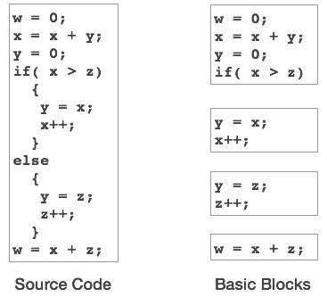
Basic blocks play an important role in identifying variables, which are being used more than once in a single basic block. If any variable is being used more than once, the register memory allocated to that variable need not be emptied unless the block finishes execution.

Control Flow Graph
Basic blocks in a program can be represented by means of control flow graphs. A control flow graph depicts how the program control is being passed among the blocks. It is a useful tool that helps in optimization by help locating any unwanted loops in the program.
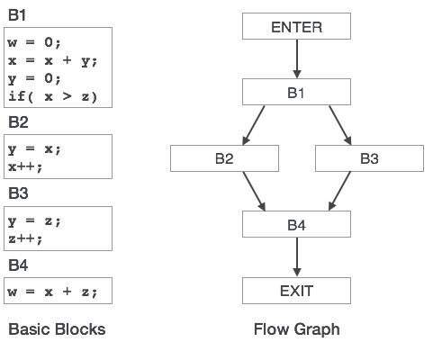

Loop Optimization
Most programs run as a loop in the system. It becomes necessary to optimize the loops in order to save CPU cycles and memory. Loops can be optimized by the following techniques:
- Invariant code : A fragment of code that resides in the loop and computes the same value at each iteration is called a loop-invariant code. This code can be moved out of the loop by saving it to be computed only once, rather than with each iteration.
- Induction analysis : A variable is called an induction variable if its value is altered within the loop by a loop-invariant value.
- Strength reduction : There are expressions that consume more CPU cycles, time, and memory. These expressions should be replaced with cheaper expressions without compromising the output of expression. For example, multiplication (x * 2) is expensive in terms of CPU cycles than (x << 1) and yields the same result.

Dead-code Elimination
Dead code is one or more than one code statements, which are:
- Either never executed or unreachable,
- Or if executed, their output is never used.
Thus, dead code plays no role in any program operation and therefore it can simply be eliminated.

Partially dead code
There are some code statements whose computed values are used only under certain circumstances, i.e., sometimes the values are used and sometimes they are not. Such codes are known as partially dead-code.
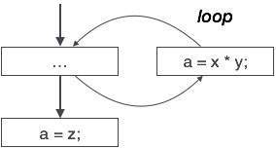
The above control flow graph depicts a chunk of program where variable ‘a’ is used to assign the output of expression ‘x * y’. Let us assume that the value assigned to ‘a’ is never used inside the loop.Immediately after the control leaves the loop, ‘a’ is assigned the value of variable ‘z’, which would be used later in the program. We conclude here that the assignment code of ‘a’ is never used anywhere, therefore it is eligible to be eliminated.
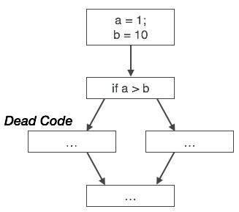
Likewise, the picture above depicts that the conditional statement is always false, implying that the code, written in true case, will never be executed, hence it can be removed.

Partial Redundancy
Redundant expressions are computed more than once in parallel path, without any change in operands.whereas partial-redundant expressions are computed more than once in a path, without any change in operands. For example,
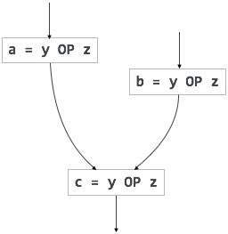  [redundant expression] | 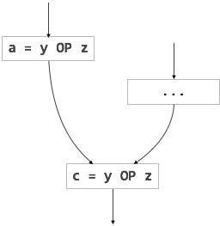  [partially redundant expression]
Loop-invariant code is partially redundant and can be eliminated by using a code-motion technique.
Another example of a partially redundant code can be:
If (condition)
{
a = y OP z;
}
else
{
...
}
c = y OP z;
We assume that the values of operands (y and z) are not changed from assignment of variable a to variable c. Here, if the condition statement is true, then y OP z is computed twice, otherwise once. Code motion can be used to eliminate this redundancy, as shown below:
If (condition)
{
...
tmp = y OP z;
a = tmp;
...
}
else
{
...
tmp = y OP z;
}
c = tmp;
Here, whether the condition is true or false; y OP z should be computed only once.
The code optimization in the synthesis phase is a program transformation technique, which tries to improve the intermediate code by making it consume fewer resources (i.e. CPU, Memory) so that faster-running machine code will result. Compiler optimizing process should meet the following objectives :
- The optimization must be correct, it must not, in any way, change the meaning of the program.
- Optimization should increase the speed and performance of the program.
- The compilation time must be kept reasonable.
- The optimization process should not delay the overall compiling process.
When to Optimize?
Optimization of the code is often performed at the end of the development stage since it reduces readability and adds code that is used to increase the performance.
Types of Code Optimization –The optimization process can be broadly classified into two types :
- Machine Independent Optimization – This code optimization phase attempts to improve the intermediate code to get a better target code as the output. The part of the intermediate code which is transformed here does not involve any CPU registers or absolute memory locations.
- Machine Dependent Optimization – Machine-dependent optimization is done after the target code has been generated and when the code is transformed according to the target machine architecture. It involves CPU registers and may have absolute memory references rather than relative references. Machine-dependent optimizers put efforts to take maximum advantage of the memory hierarchy.
Code Optimization is done in the following different ways :
- Compile Time Evaluation :
(i) A = 2*(22.0/7.0)*r
Perform 2*(22.0/7.0)*r at compile time.
(ii) x = 12.4
y = x/2.3
Evaluate x/2.3 as 12.4/2.3 at compile time.
- Copy Code
- Variable Propagation :
//Before Optimization
c = a * b
x = a
till
d = x * b + 4

//After Optimization
c = a * b
x = a
till
d = a * b + 4
- Copy Code
- Hence, after variable propagation, a*b and x*b will be identified as common sub-expression.
- Dead code elimination : Variable propagation often leads to making assignment statement into dead code
c = a * b
x = a
till
d = a * b + 4

//After elimination :
c = a * b
till
d = a * b + 4
- Copy Code
- Code Motion :
• Reduce the evaluation frequency of expression.
• Bring loop invariant statements out of the loop.

a = 200;
while(a>0)
{
b = x + y;
if (a % b == 0}
printf(“%d”, a);
}

//This code can be further optimized as
a = 200;
b = x + y;
while(a>0)
{
if (a % b == 0}
printf(“%d”, a);
}
Copy Code
- Induction Variable and Strength Reduction :
• An induction variable is used in loop for the following kind of assignment i = i + constant.
• Strength reduction means replacing the high strength operator by the low strength.
i = 1;
while (i<10)
{
y = i * 4;
}

//After Reduction
i = 1
t = 4
{
while( t<40)
y = t;
t = t + 4;
}
Let assume that, you have a c program, then you give the C program to compiler and compiler will produce the output in assembly code.Now, that assembly language code will give to the assembler and assembler is going to produce you some code. That is known as Object Code.
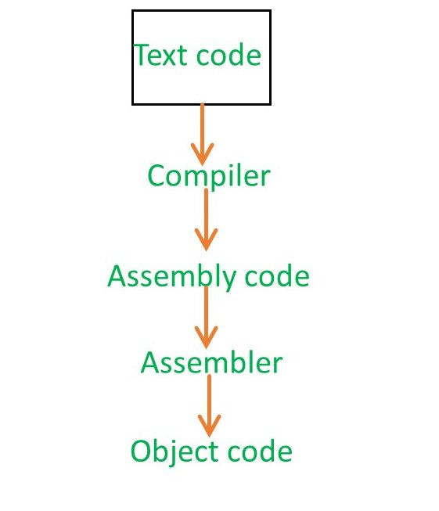
But, when you compile a program, then you are not going to use both compiler and assembler.You just take the program and give it to the compiler and compiler will give you the directly executable code. The compiler is actually combined inside the assembler along with loader and linker.So all the module kept together in the compiler software itself. So when you calling gcc, you are actually not just calling the compiler, you are calling the compiler, then assembler, then linker and loader.
Once you call the compiler, then your object code is going to present in Hard-disk. This object code contains various part –
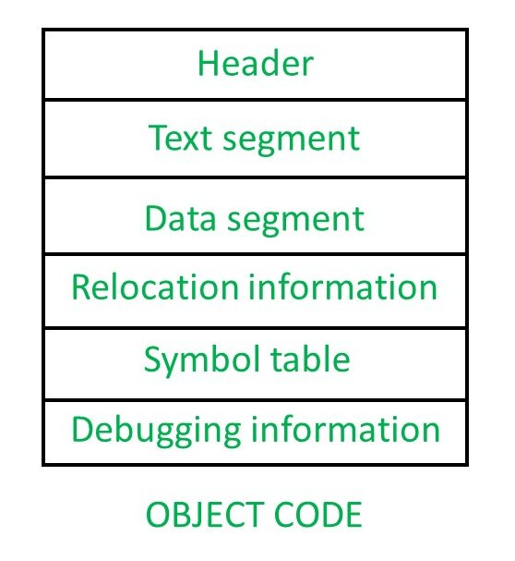

- Header –
The header will say what are the various parts present in this object code and then point that parts.So header will say where the text segment is going to start and a pointer to it and where the data segment going to start and it say where the relocation information and symbol information there.
It is nothing but like an index, like you have a textbook, there an index page will contains at what page number each topic present. Similarly, the header will tell you, what are the palaces at which each information is present.So that later for other software it will be useful to directly go into those segment.
- Text segment –
It is nothing but the set of instruction.
- Data segment –
Data segment will contain whatever data you have used.For example, you might have used something constraint, then that going to be present in the data segment.
- Relocation Information –
Whenever you try to write a program, we generally use symbol to specify anything.Let us assume you have instruction 1, instruction 2, instruction 3, instruction 4,….
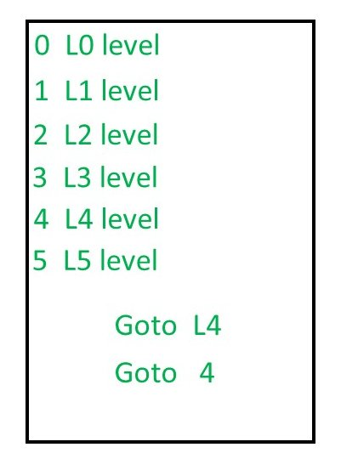
Now if you say somewhere Goto L4 (Even if you don’t write Goto statement in the high-level language, the output of the compiler will write it), then that code will be converted into object code and L4 will be replaced by Goto 4. Now Goto 4 for the level L4 is going to work fine, as long as the program is going to be loaded starting at address no 0. But most of the cases, the initial part of the RAM is going to be dedicated to the operating system. Even if it is not dedicated to the operating system, then might be some other process which will already be running at address no 0. So, when you are going to load the program into memory, means if the program has to be load in the main memory, it might be loaded anywhere.Let us say 1000 is the new starting address, then all the addresses has to be changed, that is known as Reallocation.
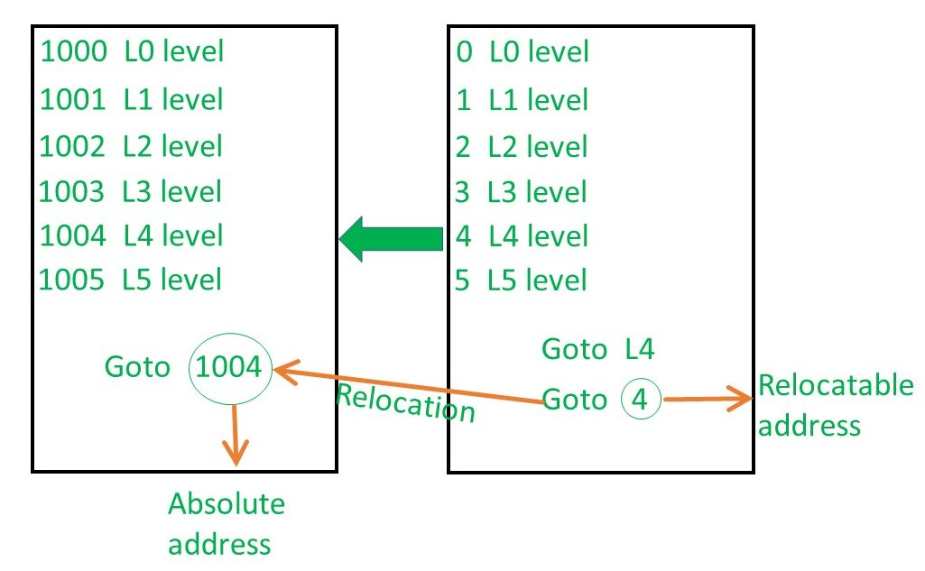
The original address is known as Relocatable address and the final address which we get after loading the program into main memory is known as the Absolute address.

Symbol table –
It contains every symbol that you have in your program.for example, int a, b, c then, a, b, c are the symbol.it will show what are the variables that your program contains.

Code generation can be considered as the final phase of compilation. Through post code generation, optimization process can be applied on the code, but that can be seen as a part of code generation phase itself. The code generated by the compiler is an object code of some lower-level programming language, for example, assembly language. We have seen that the source code written in a higher-level language is transformed into a lower-level language that results in a lower-level object code, which should have the following minimum properties:
- It should carry the exact meaning of the source code.
- It should be efficient in terms of CPU usage and memory management.
We will now see how the intermediate code is transformed into target object code (assembly code, in this case).

Directed Acyclic Graph
Directed Acyclic Graph (DAG) is a tool that depicts the structure of basic blocks, helps to see the flow of values flowing among the basic blocks, and offers optimization too. DAG provides easy transformation on basic blocks. DAG can be understood here:
- Leaf nodes represent identifiers, names or constants.
- Interior nodes represent operators.
- Interior nodes also represent the results of expressions or the identifiers/name where the values are to be stored or assigned.
Example:
t₀ = a + b
t₁ = t₀ + c
d = t₀ + t₁
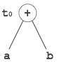  [t₀ = a + b] | 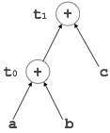  [t₁ = t₀ + c] | 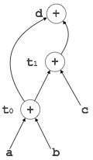  [d = t₀ + t₁]

Peephole Optimization
This optimization technique works locally on the source code to transform it into an optimized code. By locally, we mean a small portion of the code block at hand. These methods can be applied on intermediate codes as well as on target codes. A bunch of statements is analyzed and are checked for the following possible optimization:

Redundant instruction elimination
At source code level, the following can be done by the user:
int add_ten(int x)  {  int y, z;  y = 10;  z = x + y;  return z;  } | int add_ten(int x)  {  int y;  y = 10;  y = x + y;  return y;  } | int add_ten(int x)  {  int y = 10;  return x + y;  } | int add_ten(int x)  {  return x + 10;  }
At compilation level, the compiler searches for instructions redundant in nature. Multiple loading and storing of instructions may carry the same meaning even if some of them are removed. For example:
- MOV x, R0
- MOV R0, R1
We can delete the first instruction and re-write the sentence as:
MOV x, R1

Unreachable code
Unreachable code is a part of the program code that is never accessed because of programming constructs. Programmers may have accidently written a piece of code that can never be reached.
Example:
void add_ten(int x)
{
return x + 10;
printf(“value of x is %d”, x);
}
In this code segment, the printf statement will never be executed as the program control returns back before it can execute, hence printf can be removed.

Flow of control optimization
There are instances in a code where the program control jumps back and forth without performing any significant task. These jumps can be removed. Consider the following chunk of code:
...
MOV R1, R2
GOTO L1
...
L1 : GOTO L2
L2 : INC R1
In this code,label L1 can be removed as it passes the control to L2. So instead of jumping to L1 and then to L2, the control can directly reach L2, as shown below:
...
MOV R1, R2
GOTO L2
...
L2 : INC R1

Algebraic expression simplification
There are occasions where algebraic expressions can be made simple. For example, the expression a = a + 0 can be replaced by a itself and the expression a = a + 1 can simply be replaced by INC a.

Strength reduction
There are operations that consume more time and space. Their ‘strength’ can be reduced by replacing them with other operations that consume less time and space, but produce the same result.
For example, x * 2 can be replaced by x << 1, which involves only one left shift. Though the output of a * a and a² is same, a²is much more efficient to implement.

Accessing machine instructions
The target machine can deploy more sophisticated instructions, which can have the capability to perform specific operations much efficiently. If the target code can accommodate those instructions directly, that will not only improve the quality of code, but also yield more efficient results.

Code Generator
A code generator is expected to have an understanding of the target machine’s runtime environment and its instruction set. The code generator should take the following things into consideration to generate the code:
- Target language : The code generator has to be aware of the nature of the target language for which the code is to be transformed. That language may facilitate some machine-specific instructions to help the compiler generate the code in a more convenient way. The target machine can have either CISC or RISC processor architecture.
- IR Type : Intermediate representation has various forms. It can be in Abstract Syntax Tree (AST) structure, Reverse Polish Notation, or 3-address code.
- Selection of instruction : The code generator takes Intermediate Representation as input and converts (maps) it into target machine’s instruction set. One representation can have many ways (instructions) to convert it, so it becomes the responsibility of the code generator to choose the appropriate instructions wisely.
- Register allocation : A program has a number of values to be maintained during the execution. The target machine’s architecture may not allow all of the values to be kept in the CPU memory or registers. Code generator decides what values to keep in the registers. Also, it decides the registers to be used to keep these values.
- Ordering of instructions : At last, the code generator decides the order in which the instruction will be executed. It creates schedules for instructions to execute them.

Descriptors
The code generator has to track both the registers (for availability) and addresses (location of values) while generating the code. For both of them, the following two descriptors are used:
- Register descriptor : Register descriptor is used to inform the code generator about the availability of registers. Register descriptor keeps track of values stored in each register. Whenever a new register is required during code generation, this descriptor is consulted for register availability.
- Address descriptor : Values of the names (identifiers) used in the program might be stored at different locations while in execution. Address descriptors are used to keep track of memory locations where the values of identifiers are stored. These locations may include CPU registers, heaps, stacks, memory or a combination of the mentioned locations.
Code generator keeps both the descriptor updated in real-time. For a load statement, LD R1, x, the code generator:
- updates the Register Descriptor R1 that has value of x and
- updates the Address Descriptor (x) to show that one instance of x is in R1.

Code Generation
Basic blocks comprise of a sequence of three-address instructions. Code generator takes these sequence of instructions as input.
Note : If the value of a name is found at more than one place (register, cache, or memory), the register’s value will be preferred over the cache and main memory. Likewise cache’s value will be preferred over the main memory. Main memory is barely given any preference.
getReg : Code generator uses getReg function to determine the status of available registers and the location of name values. getReg works as follows:
- If variable Y is already in register R, it uses that register.
- Else if some register R is available, it uses that register.
- Else if both the above options are not possible, it chooses a register that requires minimal number of load and store instructions.
For an instruction x = y OP z, the code generator may perform the following actions. Let us assume that L is the location (preferably register) where the output of y OP z is to be saved:
- Call function getReg, to decide the location of L.
- Determine the present location (register or memory) of yby consulting the Address Descriptor of y. If y is not presently in register L, then generate the following instruction to copy the value of y to L:
MOV y’, L
where y’ represents the copied value of y.
- Determine the present location of z using the same method used in step 2 for y and generate the following instruction:
OP z’, L
where z’ represents the copied value of z.
- Now L contains the value of y OP z, that is intended to be assigned to x. So, if L is a register, update its descriptor to indicate that it contains the value of x. Update the descriptor of x to indicate that it is stored at location L.
- If y and z has no further use, they can be given back to the system.
Other code constructs like loops and conditional statements are transformed into assembly language in general assembly way.

Question 1
1.Some code optimizations are carried out on the intermediate code because
A.they enhance the portability of the compiler to other target processors
B.program analysis is more accurate on intermediate code than on machine code
C.the information from dataflow analysis cannot otherwise be used for optimization
D.the information from the front end cannot otherwise be used for optimization
Question 2
In a simplified computer the instructions are: The computer has only two registers, and OP is either ADD or SUB. Consider the following basic block: Assume that all operands are initially in memory. The final value of the computation should be in memory. What is the minimum number of MOV instructions in the code generated for this basic block?
A.2
B.3
C.5
D.6
Question 3
Which one of the following is FALSE?
A.A basic block is a sequence of instructions where control enters the sequence at the beginning and exits at the end.
B.Available expression analysis can be used for common subexpression elimination.
C.Live variable analysis can be used for dead code elimination.
D.x = 4 ∗ 5 => x = 20 is an example of common subexpression elimination.
Question 4
One of the purposes of using intermediate code in compilers is to
A.make parsing and semantic analysis simpler.
B.improve error recovery and error reporting.
C.increase the chances of reusing the machine-independent code optimizer in other compilers.
D.improve the register allocation.
Question 5
Consider the following C code segment.
for (i = 0, i<n; i++)
{
for (j=0; j<n; j++)
{
if (i%2)
{
x += (4*j + 5*i);
y += (7 + 4*j);
}
}
}
Which one of the following is false?
A.The code contains loop invariant computation
B.There is scope of common sub-expression elimination in this code
C.There is scope of strength reduction in this code
D.There is scope of dead code elimination in this code
Question 6
Consider the grammar rule E → E1 - E2 for arith­metic expressions. The code generated is targeted to a CPU having a single user register. The sub­traction operation requires the first operand to be in the register. If E1 and E2 do not have any com­mon sub expression, in order to get the shortest possible code
A.E1 should be evaluated first
B.E2 should be evaluated first
C.Evaluation of E1 and E2 should necessarily be interleaved
D.Order of evaluation of E1 and E2 is of no consequence

Question 7
Consider the intermediate code given below:
1. i = 1
2. j = 1
3. t1 = 5 * i
4. t2 = t1 + j
5. t3 = 4 * t2
6. t4 = t3
7. a[t4] = –1
8. j = j + 1
9. if j <= 5 goto(3)
10. i = i + 1
11. if i < 5 goto(2)
The number of nodes and edges in the control-flow-graph constructed for the above code, respectively, are
A.5 and 7
B.6 and 7
C.5 and 5
D.7 and 8
Question 8
Consider the following code segment.
x = u - t;
y = x * v;
x = y + w;
y = t - z;
y = x * y;
The minimum number of total variables required to convert the above code segment to static single assignment form is Note : This question was asked as Numerical Answer Type.
A.6
B.8
C.9
D.10
Question 9
A grammar that is both left and right recursive for a non-terminal is
A.Ambiguous
B.Unambiguous
C.Information is not sufficient to decide whether it is ambiguous or Unambiguous.
D.None of the above
Question 10
Let synthesized attribute val give the value of the binary number generated by S in the following grammar. For example, on output 101.101, S.val=5.625 S → LL | L L → LB | B B → 0 | 1 Write S-attributed values corresponding to each of the productions to find S.val.
Question 11
In a resident- OS computer, which of the following system software must reside in the main memory under all situations?
A.Assembler
B.Linker
C.Loader
D.Compiler
Question 12
A linker reads four modules whose lengths are 200, 800, 600 and 500 words respectively. If they are loaded in that order, what are the relocation constants?
A.0, 200, 500, 600
B.0, 200, 1000, 1600
C.200, 500, 600, 800
D.200, 700, 1300, 2100
Question 13
A language L allows declaration of arrays whose sizes are not known during compilation. It is required to make efficient use of memory. Which of the following is true?
A.A compiler using static memory allocation can be written for L
B.A compiler cannot be written for L, an interpreter must be used
C.A compiler using dynamic memory allocation can be written for L
D.None of the above
Question 14
The condition expansion facility of macro processors is provided to
A.test a condition during the execution of the expanded program
B.to expand certain model statements depending upon the value of a condition during the execution of the expanded program
C.to implement recursion
D.to expand certain model statements depending upon the value of a condition during the process of macros expansion
Question 15
The expression (a*b)* c op........ where 'op' is one of '+', '*' and '↑' (exponentiation) can be evaluated on a CPU with a single register without storing the value of (a * b) if
A.‘op’ is ‘+’ or ‘*’
B.'op’ is ‘↑’ or ‘*’
C.'op’ is ‘↑’ or ‘+’
D.not possible to evaluate without storing
Question 16
Consider the grammar
S→ bSe
S→ PQR
P→ bPc
P→ ε
Q→ cQd
Q→ ε
R→ dRe
R→ ε
where S,P,Q,R are non-terminal symbols with S being the start symbol; b,c,d,e are terminal symbols and ‘ε’ is the empty string. This grammar generates strings of the form bi, cj, dk, em for some i, j, k, m ≥ 0. a. What is the condition on the values of i, j, k, m ? b. Find the smallest string that has two parse trees.
Question 17
The pass number for each of the following activities i. object code generation ii. literals added to literal table iii. listing printed iv. address resolution of local symbols That occur in a two pass assembler respectively are
A.1, 2, 1, 2
B.2, 1, 2, 1
C.2, 1, 1, 2
D.1, 2, 2, 2
Question 18
Which of the following macros can put a micro assembler into an infinite loop? (i)
.MACRO M1 X
.IF EQ, X ;if X=0 then
M1 X + 1
.ENDC
.IF NE X ;IF X≠0 then
.WORD X ;address (X) is stored here
.ENDC
.ENDM
(ii)
.MACRO M2 X
.IF EQ X
M2 X
.ENDC
.IF NE, X
.WORD X+1
.ENDC
.ENDM
A.(ii) only
B.(i) only
C.Both (i) and (ii)
D.None of the above
Question 19
Consider the following expression
u*v+a-b*c
Which one of the following corresponds to a static single assignment from the above expressions
A.x1 = a - b y1 = p * c x2 = u * v y2 = p + q
B.x 1 = a - b y1 = x2 * c x3 = u * v y2 = x4 + y3
C.x1 = a - b y2 = x1 * c x2 = u * v y3 = x2 + y2
D.p = a - b q = p * c p = u * v q = p + q
Question 20
Consider the following source code :
c = a + b
d = c
c = c – e
a = d – e
b = b * e
b = d/b
Which of the following is correct optimization of given code?
A.c = a + b
t = b * e
a = d – e
b = d/t
c = a
B.c = a + b
d = c
c = c – e
a = d – e
b = d/b
C.d = c
c = c – e
a = d – e
b = b * e
b = d/b
D.None of the above
Question 22
Consider the code segment
int i, j, x, y, m, n;
n=20;
for (i = 0, i < n; i++)
{
for (j = 0; j < n; j++)
{
if (i % 2)
{
x + = ((4*j) + 5*i);
y += (7 + 4*j);
}
}
}
m = x + y;
Which one of the following is false
A.The code contains loop invariant computation
B.There is scope of common sub-expression elimination in this code
C.There is scope of strength reduction in this code
D.There is scope of dead code elimination in this code
Question 23
Peephole optimization is form of
A.Loop optimization
B.Local optimization
C.Constant folding
D.Data flow analysis
Question 24
Which of the following is NOT represented in a subroutine's activation record frame for a stack-based programming language?
A.Values of local variables
B.Return address
C.Heap area
D.Information needed to access non local variables
Question 25
In compiler terminology reduction in strength means
A.Replacing run time computation by compile time computation
B.Removing loop invariant computation
C.Removing common subexpressions
D.replacing a costly operation by a relatively cheaper one
Question 26
Which of the following statements about peephole optimization is False?
A.It is applied to a small part of the code
B.It can be used to optimize intermediate code
C.To get the best out of this, it has to be applied repeatedly
D.It can be applied to the portion of the code that is not contiguous
Question 27
The use of multiple register windows with overlap causes a reduction in the number of memory accesses for I. Function locals and parameters II. Register saves and restores III. Instruction fetches
A.I only
B.II only
C.III only
D.I, II and III
Question 28
Substitution of values for names (whose values are constants) is done in
A.Local optimization
B.Loop optimization
C.Constant folding
D.Strength reduction
Question 29
Relative to the program translated by a compiler, the same program when interpreted runs
A.Faster
B.Slower
C.At the same speed
D.May be faster or slower
Question 30
In a resident – OS computer, which of the following systems must reside in the main memory under all situations?
A.Assembler
B.Linker
C.Loader
D.Compiler

    - Explain about the principal sources of optimization
    - Explain Optimization of basic blocks with an example.
    - Discuss about Basic blocks with an example.
    - Define Flow graphs.
    - Describe Loops in flow graphs with an example.
    - Explain Data-flow analysis of flow graphs.
    - Discuss about DAG representation of flow graphs.
    - What are the Issues in the design of a code generator?
    - Explain about the target machine code.
    - Discuss about the Next-use information.
    - What is the use of a simple code generator?
    - Write and explain Code-generation algorithm.
    - Explain the role of DAG in target code generation?
    - Explain how the following techniques help code optimization:
i) Constant Propagation ii) Redundancy Elimination
15. Construct DAG representation scheme for the following expression
((a + b) - c) * d –e
16. Define the following.
a) Copy Propagation
b) Dead-Code Elimination
c) Reaching Definitions in Data Flow analysis
17. Explain the following with suitable examples.
i. Constant Propagation
ii. Strength Reduction
iii. Induction Variables
iv. Code Motion
  - What DAG? Explain its applications.
  - Explain how the following expression can be converted into a DAG:
a + b * (a+b) + c+d
  - Explain dataflow analysis of structured programs?
  - Describe various register allocation optimization techniques?
  - Explain the concept of object code forms.
  - Compose three address code for the following statement
While a < b do
if c < d then
x := y + z
else
x := y - z
  - Give a detailed account on loop optimization techniques.

