UNIT-IV
Intermediate Code Generation
CONSTRUCTING SYNTAX TREES FOR EXPRESSIONS.
Each node in a syntax tree for an (arithmetic) expression is a record with several fields.
- In the node for an operator, one field identifies the operator and the remaining fields contain pointers to the nodes of the operands. The operator is often called the label of the node.
- In the leaf for an identifier, one field (the label) indicates that this is an identifier and another field is a pointer to the symbol-table entry for this identifier.
- In the leaf for a value, one field (the label) indicates that this is a value (may be this field gives the type of the value) and another field is the value (or a pointer to this value).
We use here the following functions to create the nodes of syntax trees for expressions with binary operators. Each function returns a pointer to a newly created node.
make_node
(op, left, right) creates an operator node with label op and two fields containing pointers to left and right.
make_leaf
(id, entry) creates an identifier leaf with label id and a field containing entry a pointer to the symbol-table entry for the identifier.
make_leaf
(num, val) creates a number leaf with label num and a field containing val.
Example 7 The following syntax-directed definition allows the construction of a syntax tree for a binary infix arithmetic expression. The synthesized attributes E.ptr, T.ptr and F.ptr keep track of the pointers returned by the function calls.
Production | Semantic Rule
E 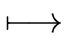 E₁ + T | E.ptr := make_node( +, E₁.ptr, T.ptr)
E E₁ - T | E.ptr := make_node( -, E₁.ptr, T.ptr)
E T | E.ptr := T.ptr
T T₁*F | T.ptr := make_node( *, T₁.ptr, F.ptr)
T F | T.ptr := F.ptr
F (E) | F.ptr := E.ptr
F id | F.ptr := make_leaf(id, id.entry)
F num | F.ptr := make_leaf(num, num.val)
USING DAGS FOR SYNTAX TREES OF EXPRESSIONS.
- A dag for an expression identifies the common subexpressions in the expression.
- Like a syntax tree, a dag has a node for every subexpression of the expression.
- The difference is that a node in a dag representing a common subexpression has more than one parent.
- Thus, before constructing a node with label op and fields with pointers to left and right, the operation make_node(op, left, right) checks if such a node has already been constructed.
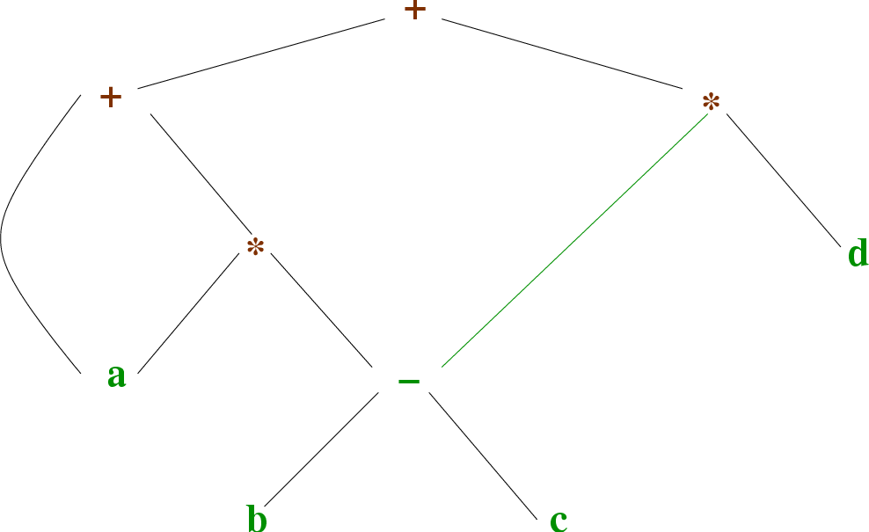
Figure 10: A dag for the expression a + a*(b - c) + (b - c)*d.
A source code can directly be translated into its target machine code, then why at all we need to translate the source code into an intermediate code which is then translated to its target code? Let us see the reasons why we need an intermediate code.
Intermediate Code
If a compiler translates the source language to its target machine language without having the option for generating intermediate code, then for each new machine, a full native compiler is required.
Intermediate code eliminates the need of a new full compiler for every unique machine by keeping the analysis portion same for all the compilers.
The second part of compiler, synthesis, is changed according to the target machine.
It becomes easier to apply the source code modifications to improve code performance by applying code optimization techniques on the intermediate code.
Intermediate Representation
Intermediate codes can be represented in a variety of ways and they have their own benefits.
High Level IR - High-level intermediate code representation is very close to the source language itself. They can be easily generated from the source code and we can easily apply code modifications to enhance performance. But for target machine optimization, it is less preferred.
Low Level IR - This one is close to the target machine, which makes it suitable for register and memory allocation, instruction set selection, etc. It is good for machine-dependent optimizations.
Intermediate code can be either language specific (e.g., Byte Code for Java) or language independent (three-address code).
Three-Address Code
Intermediate code generator receives input from its predecessor phase, semantic analyzer, in the form of an annotated syntax tree. That syntax tree then can be converted into a linear representation, e.g., postfix notation. Intermediate code tends to be machine independent code. Therefore, code generator assumes to have unlimited number of memory storage (register) to generate code.

For example:
a = b + c * d;
The intermediate code generator will try to divide this expression into sub-expressions and then generate the corresponding code.
r1 = c * d;
r2 = b + r1;
a = r2
r being used as registers in the target program.
A three-address code has at most three address locations to calculate the expression. A three-address code can be represented in two forms : quadruples and triples.
Quadruples
Each instruction in quadruples presentation is divided into four fields: operator, arg1, arg2, and result. The above example is represented below in quadruples format:
Op | arg₁ | arg₂ | Result
* | C | d | r1
+ | B | r1 | r2
+ | r2 | r1 | r3
= | r3 |  | A
Triples
Each instruction in triples presentation has three fields : op, arg1, and arg2.The results of respective sub-expressions are denoted by the position of expression. Triples represent similarity with DAG and syntax tree. They are equivalent to DAG while representing expressions.

Op | arg₁ | arg₂
* | c | D
+ | b | (0)
+ | (1) | (0)
= | (2)
Triples face the problem of code immovability while optimization, as the results are positional and changing the order or position of an expression may cause problems.
Indirect Triples
This representation is an enhancement over triples representation. It uses pointers instead of position to store results. This enables the optimizers to freely re-position the sub-expression to produce an optimized code.

Declarations
A variable or procedure has to be declared before it can be used. Declaration involves allocation of space in memory and entry of type and name in the symbol table. A program may be coded and designed keeping the target machine structure in mind, but it may not always be possible to accurately convert a source code to its target language.
Taking the whole program as a collection of procedures and sub-procedures, it becomes possible to declare all the names local to the procedure. Memory allocation is done in a consecutive manner and names are allocated to memory in the sequence they are declared in the program. We use offset variable and set it to zero {offset = 0} that denote the base address.
The source programming language and the target machine architecture may vary in the way names are stored, so relative addressing is used. While the first name is allocated memory starting from the memory location 0 {offset=0}, the next name declared later, should be allocated memory next to the first one.
Example:

We take the example of C programming language where an integer variable is assigned 2 bytes of memory and a float variable is assigned 4 bytes of memory.

int a;
float b;

Allocation process:
{offset = 0}

int a;
id.type = int
id.width = 2

offset = offset + id.width
{offset = 2}

float b;
id.type = float
id.width = 4

offset = offset + id.width
{offset = 6}
To enter this detail in a symbol table, a procedure enter can be used. This method may have the following structure:

enter(name, type, offset)
This procedure should create an entry in the symbol table, for variable name, having its type set to type and relative address offset in its data area.
Runtime Environments:-

Static and Dynamic Scoping:- The scope of a variable x is the region of the program in which uses of x refers to its declaration. One of the basic reasons of scoping is to keep variables in different parts of program distinct from one another. Since there are only a small number of short variable names, and programmers share habits about naming of variables (e.g., i for an array index), in any program of moderate size the same variable name will be used in multiple different scopes.
Scoping is generally divided into two classes:
1.Static Scoping
2.Dynamic Scoping
Static Scoping:
Static scoping is also called lexical scoping. In this scoping a variable always refers to its top level environment. This is a property of the program text and unrelated to the run time call stack. Static scoping also makes it much easier to make a modular code as programmer can figure out the scope just by looking at the code. In contrast, dynamic scope requires the programmer to anticipate all possible dynamic contexts.
In most of the programming languages including C, C++ and Java, variables are always statically (or lexically) scoped i.e., binding of a variable can be determined by program text and is independent of the run-time function call stack.
For example, output for the below program is 10, i.e., the value returned by f() is not dependent on who is calling it (Like g() calls it and has a x with value 20). f() always returns the value of global variable x.
// A C program to demonstrate static scoping.
#include<stdio.h>
int x = 10;

// Called by g()
int f()
{
return x;
}

// g() has its own variable
// named as x and calls f()
int g()
{
int x = 20;
return f();
}

int main()
{
printf("%d", g());
printf("\n");
return 0;
}
To sum up in static scoping the compiler first searches in the current block, then in the surrounding blocks successively and finally in the global variables.
Dynamic Scoping:
With dynamic scope, a global identifier refers to the identifier associated with the most recent environment, and is uncommon in modern languages. In technical terms, this means that each identifier has a global stack of bindings and the occurrence of a identifier is searched in the most recent binding.
In simpler terms, in dynamic scoping the compiler first searches the current block and then successively all the calling functions.
// Since dynamic scoping is very uncommon in
// the familiar languages, we consider the
// following pseudo code as our example. It
// prints 20 in a language that uses dynamic
// scoping.
int x = 10;
// Called by g()
int f()
{
return x;
}
// g() has its own variable
// named as x and calls f()
int g()
{
int x = 20;
return f();
}
main()
{
printf(g());
}
Static Vs Dynamic Scoping
In most of the programming languages static scoping is dominant. This is simply because in static scoping it’s easy to reason about and understand just by looking at code. We can see what variables are in the scope just by looking at the text in the editor.
Dynamic scoping does not care how the code is written, but instead how it executes. Each time a new function is executed, a new scope is pushed onto the stack.
A program as a source code is merely a collection of text (code, statements etc.) and to make it alive, it requires actions to be performed on the target machine. A program needs memory resources to execute instructions. A program contains names for procedures, identifiers etc., that require mapping with the actual memory location at runtime.
By runtime, we mean a program in execution. Runtime environment is a state of the target machine, which may include software libraries, environment variables, etc., to provide services to the processes running in the system.
Runtime support system is a package, mostly generated with the executable program itself and facilitates the process communication between the process and the runtime environment. It takes care of memory allocation and de-allocation while the program is being executed.

Activation Trees
A program is a sequence of instructions combined into a number of procedures. Instructions in a procedure are executed sequentially. A procedure has a start and an end delimiter and everything inside it is called the body of the procedure. The procedure identifier and the sequence of finite instructions inside it make up the body of the procedure.
The execution of a procedure is called its activation. An activation record contains all the necessary information required to call a procedure. An activation record may contain the following units (depending upon the source language used).
Temporaries | Stores temporary and intermediate values of an expression.
Local Data | Stores local data of the called procedure.
Machine Status | Stores machine status such as Registers, Program Counter etc., before the procedure is called.
Control Link | Stores the address of activation record of the caller procedure.
Access Link | Stores the information of data which is outside the local scope.
Actual Parameters | Stores actual parameters, i.e., parameters which are used to send input to the called procedure.
Return Value | Stores return values.
Whenever a procedure is executed, its activation record is stored on the stack, also known as control stack. When a procedure calls another procedure, the execution of the caller is suspended until the called procedure finishes execution. At this time, the activation record of the called procedure is stored on the stack.
We assume that the program control flows in a sequential manner and when a procedure is called, its control is transferred to the called procedure. When a called procedure is executed, it returns the control back to the caller. This type of control flow makes it easier to represent a series of activations in the form of a tree, known as the activation tree.

Example:
. . .
printf(“Enter Your Name: “);
scanf(“%s”, username);
show_data(username);
printf(“Press any key to continue…”);
. . .
int show_data(char *user)
{
printf(“Your name is %s”, username);
return 0;
}
. . .
Below is the activation tree of the code given.
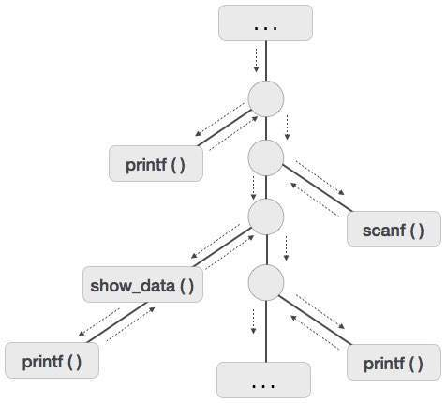
Now we understand that procedures are executed in depth-first manner, thus stack allocation is the best suitable form of storage for procedure activations.

Storage Allocation
Runtime environment manages runtime memory requirements for the following entities:
- Code : It is known as the text part of a program that does not change at runtime. Its memory requirements are known at the compile time.
- Procedures : Their text part is static but they are called in a random manner. That is why, stack storage is used to manage procedure calls and activations.
- Variables : Variables are known at the runtime only, unless they are global or constant. Heap memory allocation scheme is used for managing allocation and de-allocation of memory for variables in runtime.

Static Allocation
In this allocation scheme, the compilation data is bound to a fixed location in the memory and it does not change when the program executes. As the memory requirement and storage locations are known in advance, runtime support package for memory allocation and de-allocation is not required.

Stack Allocation
Procedure calls and their activations are managed by means of stack memory allocation. It works in last-in-first-out (LIFO) method and this allocation strategy is very useful for recursive procedure calls.

Heap Allocation
Variables local to a procedure are allocated and de-allocated only at runtime. Heap allocation is used to dynamically allocate memory to the variables and claim it back when the variables are no more required.
Except statically allocated memory area, both stack and heap memory can grow and shrink dynamically and unexpectedly. Therefore, they cannot be provided with a fixed amount of memory in the system.
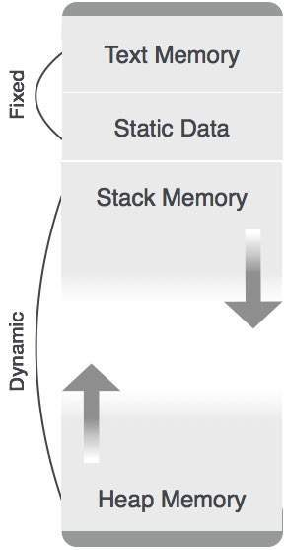
As shown in the image above, the text part of the code is allocated a fixed amount of memory. Stack and heap memory are arranged at the extremes of total memory allocated to the program. Both shrink and grow against each other.

Parameter Passing
The communication medium among procedures is known as parameter passing. The values of the variables from a calling procedure are transferred to the called procedure by some mechanism. Before moving ahead, first go through some basic terminologies pertaining to the values in a program.

r-value
The value of an expression is called its r-value. The value contained in a single variable also becomes an r-value if it appears on the right-hand side of the assignment operator. r-values can always be assigned to some other variable.

l-value
The location of memory (address) where an expression is stored is known as the l-value of that expression. It always appears at the left hand side of an assignment operator.
For example:
day = 1;
week = day * 7;
month = 1;
year = month * 12;
From this example, we understand that constant values like 1, 7, 12, and variables like day, week, month and year, all have r-values. Only variables have l-values as they also represent the memory location assigned to them.
For example:
7 = x + y;
is an l-value error, as the constant 7 does not represent any memory location.

Formal Parameters
Variables that take the information passed by the caller procedure are called formal parameters. These variables are declared in the definition of the called function.

Actual Parameters
Variables whose values or addresses are being passed to the called procedure are called actual parameters. These variables are specified in the function call as arguments.
Example:
fun_one()
{
int actual_parameter = 10;
call fun_two(int actual_parameter);
}
fun_two(int formal_parameter)
{
print formal_parameter;
}
Formal parameters hold the information of the actual parameter, depending upon the parameter passing technique used. It may be a value or an address.

Pass by Value
In pass by value mechanism, the calling procedure passes the r-value of actual parameters and the compiler puts that into the called procedure’s activation record. Formal parameters then hold the values passed by the calling procedure. If the values held by the formal parameters are changed, it should have no impact on the actual parameters.

Pass by Reference
In pass by reference mechanism, the l-value of the actual parameter is copied to the activation record of the called procedure. This way, the called procedure now has the address (memory location) of the actual parameter and the formal parameter refers to the same memory location. Therefore, if the value pointed by the formal parameter is changed, the impact should be seen on the actual parameter as they should also point to the same value.

Pass by Copy-restore
This parameter passing mechanism works similar to ‘pass-by-reference’ except that the changes to actual parameters are made when the called procedure ends. Upon function call, the values of actual parameters are copied in the activation record of the called procedure. Formal parameters if manipulated have no real-time effect on actual parameters (as l-values are passed), but when the called procedure ends, the l-values of formal parameters are copied to the l-values of actual parameters.
Example:
int y;
calling_procedure()
{
y = 10;
copy_restore(y); //l-value of y is passed
printf y; //prints 99
}
copy_restore(int x)
{
x = 99; // y still has value 10 (unaffected)
y = 0; // y is now 0
}
When this function ends, the l-value of formal parameter x is copied to the actual parameter y. Even if the value of y is changed before the procedure ends, the l-value of x is copied to the l-value of y making it behave like call by reference.

Pass by Name
Languages like Algol provide a new kind of parameter passing mechanism that works like preprocessor in C language. In pass by name mechanism, the name of the procedure being called is replaced by its actual body. Pass-by-name textually substitutes the argument expressions in a procedure call for the corresponding parameters in the body of the procedure so that it can now work on actual parameters, much like pass-by-reference.
A translation needs to relate the static source text of a program to the dynamic actions that must occur at runtime to implement the program. The program consists of names for procedures, identifiers etc., that require mapping with the actual memory location at runtime.
Runtime environment is a state of the target machine, which may include software libraries, environment variables, etc., to provide services to the processes running in the system.
SOURCE LANGUAGE ISSUES
Activation Tree
A program consist of procedures, a procedure definition is a declaration that, in its simplest form, associates an identifier (procedure name) with a statement (body of the procedure). Each execution of procedure is referred to as an activation of the procedure. Lifetime of an activation is the sequence of steps present in the execution of the procedure. If ‘a’ and ‘b’ be two procedures then their activations will be non-overlapping (when one is called after other) or nested (nested procedures). A procedure is recursive if a new activation begins before an earlier activation of the same procedure has ended. An activation tree shows the way control enters and leaves activations.
Properties of activation trees are :-
- Each node represents an activation of a procedure.
- The root shows the activation of the main function.
- The node for procedure ‘x’ is the parent of node for procedure ‘y’ if and only if the control flows from procedure x to procedure y.

Example – Consider the following program of Quicksort
main() {

Int n;
readarray();
quicksort(1,n);
}

quicksort(int m, int n) {

Int i= partition(m,n);
quicksort(m,i-1);
quicksort(i+1,n);
}
The activation tree for this program will be:
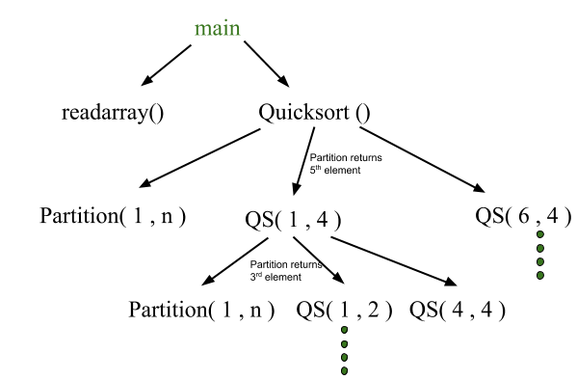
First main function as root then main calls readarray and quicksort. Quicksort in turn calls partition and quicksort again. The flow of control in a program corresponds to the depth first traversal of activation tree which starts at the root.
CONTROL STACK AND ACTIVATION RECORDS
Control stack or runtime stack is used to keep track of the live procedure activations i.e the procedures whose execution have not been completed. A procedure name is pushed on to the stack when it is called (activation begins) and it is popped when it returns (activation ends). Information needed by a single execution of a procedure is managed using an activation record or frame. When a procedure is called, an activation record is pushed into the stack and as soon as the control returns to the caller function the activation record is popped.
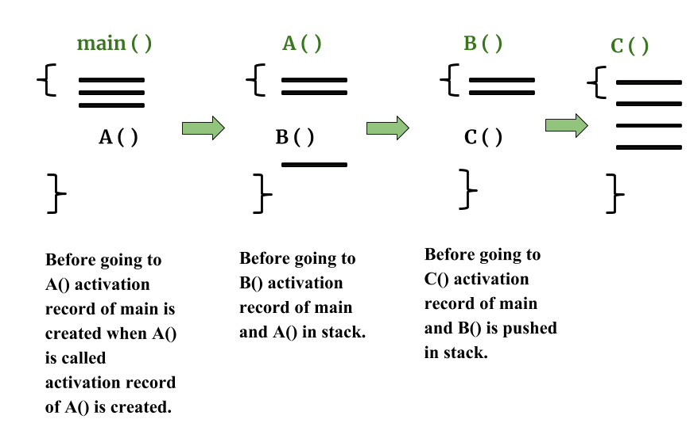
A general activation record consist of the following things:
- Local variables: hold the data that is local to the execution of the procedure.
- Temporary values: stores the values that arise in the evaluation of an expression.
- Machine status: holds the information about status of machine just before the function call.
- Access link (optional): refers to non-local data held in other activation records.
- Control link (optional): points to activation record of caller.
- Return value: used by the called procedure to return a value to calling procedure
- Actual parameters
Control stack for the above quicksort example:
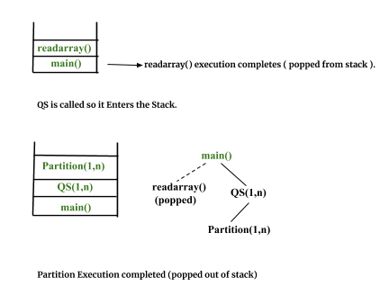
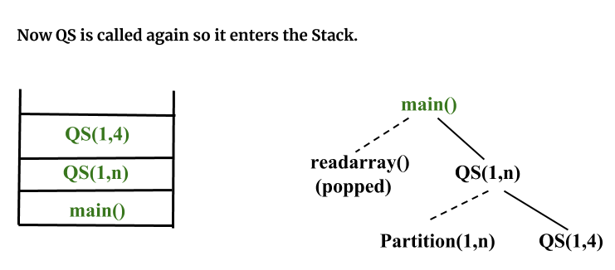
SUBDIVISION OF RUNTIME MEMORY
Runtime storage can be subdivide to hold :
- Target code- the program code , it is static as its size can be determined at compile time
- Static data objects
- Dynamic data objects- heap
- Automatic data objects- stack
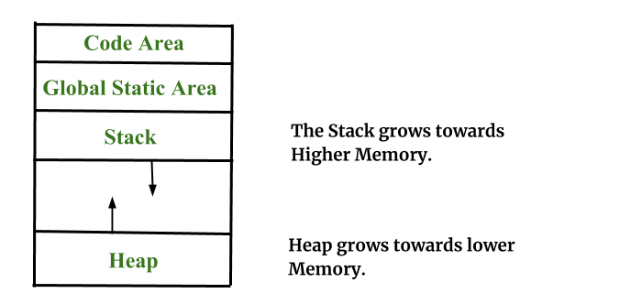
STORAGE ALLOCATION TECHNIQUES
I. Static Storage Allocation
  - For any program if we create memory at compile time, memory will be created in the static area.
  - For any program if we create memory at compile time only, memory is created only once.
  - It don’t support dynamic data structure i.e memory is created at compile time and deallocated after program completion.
  - The drawback with static storage allocation is recursion is not supported.
  - Another drawback is size of data should be known at compile time
Eg- FORTRAN was designed to permit static storage allocation.
II. Stack Storage Allocation
- Storage is organised as a stack and activation records are pushed and popped as activation begin and end respectively. Locals are contained in activation records so they are bound to fresh storage in each activation.
- Recursion is supported in stack allocation
III. Heap Storage Allocation
- Memory allocation and deallocation can be done at any time and at any place depending on the requirement of the user.
- Heap allocation is used to dynamically allocate memory to the variables and claim it back when the variables are no more required.
- Recursion is supported.
PARAMETER PASSING
The communication medium among procedures is known as parameter passing. The values of the variables from a calling procedure are transferred to the called procedure by some mechanism.
Basic terminology :
- R- value: The value of an expression is called its r-value. The value contained in a single variable also becomes an r-value if its appear on the right side of the assignment operator. R-value can always be assigned to some other variable.
- L-value: The location of the memory(address) where the expression is stored is known as the l-value of that expression. It always appears on the left side if the assignment operator.
i.Formal Parameter: Variables that take the information passed by the caller procedure are called formal parameters. These variables are declared in the definition of the called function.
ii.Actual Parameter: Variables whose values and functions are passed to the called function are called actual parameters. These variables are specified in the function call as arguments.
Different ways of passing the parameters to the procedure
- Call by Value
In call by value the calling procedure pass the r-value of the actual parameters and the compiler puts that into called procedure’s activation record. Formal parameters hold the values passed by the calling procedure, thus any changes made in the formal parameters does not affect the actual parameters.
- Call by ReferenceIn call by reference the formal and actual parameters refers to same memory location. The l-value of actual parameters is copied to the activation record of the called function. Thus the called function has the address of the actual parameters. If the actual parameters does not have a l-value (eg- i+3) then it is evaluated in a new temporary location and the address of the location is passed. Any changes made in the formal parameter is reflected in the actual parameters (because changes are made at the address).
- Call by Copy Restore
In call by copy restore compiler copies the value in formal parameters when the procedure is called and copy them back in actual parameters when control returns to the called function. The r-values are passed and on return r-value of formals are copied into l-value of actuals.
- Call by Name
In call by name the actual parameters are substituted for formals in all the places formals occur in the procedure. It is also referred as lazy evaluation because evaluation is done on parameters only when needed.

Symbol table
Symbol table is an important data structure created and maintained by compilers in order to store information about the occurrence of various entities such as variable names, function names, objects, classes, interfaces, etc. Symbol table is used by both the analysis and the synthesis parts of a compiler.
A symbol table may serve the following purposes depending upon the language in hand:
- To store the names of all entities in a structured form at one place.
- To verify if a variable has been declared.
- To implement type checking, by verifying assignments and expressions in the source code are semantically correct.
- To determine the scope of a name (scope resolution).
A symbol table is simply a table which can be either linear or a hash table. It maintains an entry for each name in the following format:
<symbol name, type, attribute>
For example, if a symbol table has to store information about the following variable declaration:
static int interest;
then it should store the entry such as:
<interest, int, static>
The attribute clause contains the entries related to the name.

Implementation
If a compiler is to handle a small amount of data, then the symbol table can be implemented as an unordered list, which is easy to code, but it is only suitable for small tables only. A symbol table can be implemented in one of the following ways:
- Linear (sorted or unsorted) list
- Binary Search Tree
- Hash table
Among all, symbol tables are mostly implemented as hash tables, where the source code symbol itself is treated as a key for the hash function and the return value is the information about the symbol.

Operations
A symbol table, either linear or hash, should provide the following operations.

insert()
This operation is more frequently used by analysis phase, i.e., the first half of the compiler where tokens are identified and names are stored in the table. This operation is used to add information in the symbol table about unique names occurring in the source code. The format or structure in which the names are stored depends upon the compiler in hand.
An attribute for a symbol in the source code is the information associated with that symbol. This information contains the value, state, scope, and type about the symbol. The insert() function takes the symbol and its attributes as arguments and stores the information in the symbol table.
For example:
int a;
should be processed by the compiler as:

insert(a, int);

lookup()
lookup() operation is used to search a name in the symbol table to determine:
- if the symbol exists in the table.
- if it is declared before it is being used.
- if the name is used in the scope.
- if the symbol is initialized.
- if the symbol declared multiple times.
The format of lookup() function varies according to the programming language. The basic format should match the following:
lookup(symbol)
This method returns 0 (zero) if the symbol does not exist in the symbol table. If the symbol exists in the symbol table, it returns its attributes stored in the table.

Scope Management
A compiler maintains two types of symbol tables: a global symbol table which can be accessed by all the procedures and scope symbol tables that are created for each scope in the program.
To determine the scope of a name, symbol tables are arranged in hierarchical structure as shown in the example below:
. . .
int value=10;

void pro_one()
{
int one_1;
int one_2;

{ \
int one_3; |_ inner scope 1
int one_4; |
} /

int one_5;

{ \
int one_6; |_ inner scope 2
int one_7; |
} /
}

void pro_two()
{
int two_1;
int two_2;

{ \
int two_3; |_ inner scope 3
int two_4; |
} /

int two_5;
}
. . .
The above program can be represented in a hierarchical structure of symbol tables:
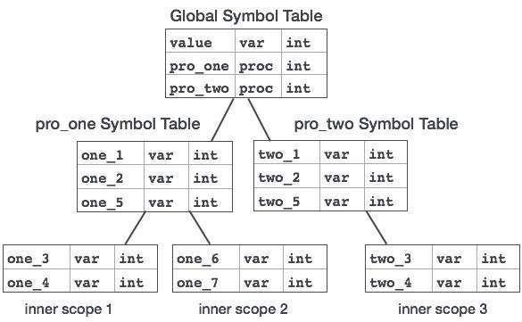
The global symbol table contains names for one global variable (int value) and two procedure names, which should be available to all the child nodes shown above. The names mentioned in the pro_one symbol table (and all its child tables) are not available for pro_two symbols and its child tables.
This symbol table data structure hierarchy is stored in the semantic analyzer and whenever a name needs to be searched in a symbol table, it is searched using the following algorithm:
- first a symbol will be searched in the current scope, i.e. current symbol table.
- if a name is found, then search is completed, else it will be searched in the parent symbol table until,
- either the name is found or global symbol table has been searched for the name.

- Explain the role of Intermediate Code Generation phase in compiler.
- Discuss about Construction of syntax trees with an example.
- Construct syntax tree for the following expression
a=b+c-d*e/f%g^h
- Construct syntax tree for the following expression
int a,b,sum,total,avg;
- Define Directed acyclic graph.
- Construct DAG for the following expression
a=b+c-(b+c)*(b+c)/b
- Define three address codes.
- Represent intermediate codes for the following expression
a=b+c-d*e/f%g^h
- Discuss about Translation of Declarations.
- Discuss about Translation of Assignment statements.
- Discuss about Translation of Boolean Expressions.
- Explain bout Back patching.
- What are the Source language issues and discuss.
- How Storage organization can be done using compiler.
- What are the Storage-allocation strategies and discuss.
- Define Symbol tables.
- Define Activation record. And discuss about every field of activation record with an example.
- Define Activation tree. Draw Activation tree for quick sort.
- What are the different types of parameter passing techniques.
- Discuss about Dynamic storage allocation techniques.

1.
E -> number Eval number val
E E .val E .VAL E .val
E # E E .val E .VAL E .val
;
The above grammar and the semantic rules are fed to a yacc tool (which is an LALR (1) parser generator) for parsing and evaluating arithmetic expressions. Which one of the following is true about the action of yacc for the given grammar?
a) It detects recursion and eliminates recursion
b) It detects reduce-reduce conflict, and resolves
c) It detects shift-reduce conflict, and resolves the conflict in favor of a shift over a reduce action
d) It detects shift-reduce conflict, and resolves the conflict in favor of a reduce over a shift action
2.
E -> number Eval number val
E E .val E .VAL E .val
E # E E .val E .VAL E .val
;
Assume the conflicts part (a) of this question are resolved and an LALR (1) parser is generated for parsing arithmetic expressions as per the given grammar.
Consider an expression 3 # 2 + 1. What precedence and associativity properties does the generated parser realize?
a) Equal precedence and left associativity; expression is evaluated to 7
b) Equal precedence and right associativity, expression is evaluated to 9
c) Precedence of ‘x’ is higher than that of ‘+’, and both operators are left associative; expression is evaluated to 7
d) Precedence of ‘ # ‘ is higher than that of ‘#’, and both operators are left associative; expression is evaluated to 9

3. Consider the following grammar.

S -> S * E
S -> E
E -> F + E
E -> F
F -> id
Consider the following LR (0) items corresponding to the grammar above.
(i) S -> S * .E
(ii) E -> F. + E
(iii) E “F + .E
Given the items above, which two of them will appear in the same set in the canonical sets-of-items for the grammar?
a) (ii)
b) (i) and (iii)
c) (iii)
d) None of these

4. Consider the following grammar

S -> FR
R -> * S | ε
F -> id
In the predictive parser table, M, of the grammar the entries M [S, id] and M [R, $] respectively
a) {S ” FR} and {R ” ε}
b) {S ” FR} and {}
c) {S ” FR} and {R ” * S}
d) {F ” id} and {R ” ε}

5. Consider the following translation scheme.

S -> ER
R -> * E{print{’ * ’);
R | f
E -> F + E{print(’ + ’); | F
F -> (S) | id{print(id.value);}
Here id is a taken that represents an integer and id. value represents the corresponding integer value. For an input ‘2 * 3 + 4’, this translation scheme prints
a) 2 * 3 + 4
b) 2 * + 3 4
c) 2 3 * 4 +
d) 2 3 4 + *

6. Consider the following C code segment.
for for if i # i } } }
Which one to the following false?
a) The code contains loop-in variant computation
b) There is scope of common sub-expression elimination in this code
c) There is scope strength reduction in this code
d) There is scope of dead code elimination in this code

7. Which one of the following grammars generates the language
L = (a i b i | i ! j}?
a)

advertisement

S ->AC | CB
b)

S -> aS | Sb | a | b
C -> aCb | a | b
A -> aA | ε
B -> Bb | ε
c)

S -> ACCB
d)

S -> AC | CB
C -> aCb |!
C -> aCb |!
A -> aA |!
A -> aA | a
B -> Bb |!
B -> bB | b

8. In the correct grammar above, what is the length of the derivation (number of steps starting from S to generate the string a l b m with l ! m?
a) max (l, m) + 2
b) l+m+2
c) l + m + 3
d) max (l, m) + 3

9. Which one of the following is a top-down parser?
a) Recursive descent parser
b) Operator precedence parser
c) An LR(k) parser
d) An LALR(k) parser

10. Consider the grammar with non-terminals

N = {S , C , S}, terminals T = {a, b , i , t, e}, with S as the start symbol, and the following of rules
S -> iCtSS1 | a
S1 -> eS | ε
C -> b
The grammar is NOTLL(1) because:
a) It is left recursive
b) It is right recursive
c) It is ambiguous
d) It is not context-free

11. Consider the following two statements:
P: Every regular grammar is LL(1)
Q: Every regular set has LR(1) grammar
Which of the following is TRUE?
a) Both P and Q are true
b) P is true and Q is false
c) P is false and Q is true
d) Both P and Q are false

12. In a simplified computer the instructions are:
OP R j , Ri − Performs Rj OP Ri and stores the result in register Ri
OP m, Ri − Performs val OP Ri abd stores the result in Ri. value
denotes the content of memory location m.
MCVm, Ri −Moves the content off memory loction m to register Ri .
MCVm, Ri , m −Moves the content of register Ri to memory location m.
The computer has only two registers, and OP is either ADD or SUB. Consider the following basic block:
t1 = a + b
t2 = c + d
t 3 = e − t2
t 4 = t 1 − t2
Assume that all operands are initially in memory. The final value of the computation should be in memory. What is the minimum number of MOV instructions in the code generated for this basic block?
a) 2
b) 3
c) 5
d) 6

13. S->bA S->aB
A->a B->b
A->aS B->bS
A->bAA B->aBB
Which of the following strings is generated by the grammar?
a) aaaabb
b) aabbbb
c) aabbab
d) abbbba

14. S->bA S->aB
A->a B->b
A->aS B->bS
A->bAA B->aBB

how many derivation trees are there?
a) 1
b) 2
c) 3
d) 4

15. Which of the following describes a handle (as applicable to LR-parsing) appropriately?
a) It is the position in a sentential form where the next shift or reduce operation will occur
b) It is a non-terminal whose production will be used for reduction in the next step
c) It is a production that may be used for reduction in a future step along with a position in the sentential form where the next shift or reduce operation will occur.
d) It is the production p that will be used for reduction in the next step along with a position in the sentential form where the right hand side of the production may be found

16. Some code optimizations are carried out on the intermediate code because
a) They enhance the portability of the complier to other target processors
b) Program analysis is name accurate on intermediate code than on machine code
c) The information from data flow analysis cannot otherwise be used for optimization
d) The information from the front end cannot otherwise be used for optimization

17. Which of the following are true?
(i) A programming language option does not permit global variables of any king and has no nesting of procedures/functions, but permits recursion can be implemented with static storage allocation
(ii) Multi-level access link (or display) arrangement is needed to arrange activation records-only if the programming language being implemented has nesting of procedures/function
(iii) Recursion in programming languages cannot be implemented with dynamic storage allocation
(iv) Nesting of procedures/functions and recursion require a dynamic heap allocation scheme and cannot be implemented with a stack-based allocation scheme for activation records
(v) Languages which permit a function to return a function as its result cannot be implemented with a stack-based storage allocation scheme for activation records
a) (ii) and (v) only
b) (i), (iii) and (iv) only
c) (i), (ii) and (v)
d) (ii), (iii) and (v) only

18. An LALR(1) parser for a grammar can have shift-reduce (S-R) conflicts if and only if
a) The SLR(1) parser for G has S-R conflicts
b) The LR(1) parser for G has S-R conflicts
c) The LR(0) parser for G has S-R conflicts
d) The LALR(1) parser for G has reduce-reduce conflicts

19. Which of the following statements are TRUE ?
I There exist parsing algorithms for some programming languages hose complex are less than θ(n 3 )
II A programming language which allows recursion can be implemented with static storage allocation
III No L-attributed definition can be evaluated in the framework of bottom-up parsing
IV Code improving transformations can be performed at both source language and intermediate code level
a) I and II
b) I and IV
c) III and IV
d) I, III and IV

20. What data structure in a complier is used for managing information about variables and their attributes?
a) Abstract syntax tree
b) Symbol table
c) Semantic stack
d) Parse table

21. Which languages necessarily need heap allocation in the runtime environment?
a) Those that support recursion
b) Those that use dynamic scoping
c) Allow dynamic data structure
d) Those that use global variables

22. Given the language L-{ab, aa, baa}, which of the following strings are in LG?
1) abaabaaabaa
2) aaaabaaaa
3) baaaaabaaaab
4) baaaaabaa
a) 1,2 and 3
b) 2,3 and 4
c) 1,2 and 4
d) 1,3 and 4

23. A simple two-pass assembler does which of the following in the first pass
a) Space for the literals
b) Total length of the program
c) It builds the symbol table for the symbols and their values.
d) All of the mentioned

24. _________ or scanning is the process where the stream of characters making up the source program is read from left to right and grouped into tokens.
a) Lexical
b) Diversion
c) Modelling
d) None of the mentioned

25. Which of the following is used for grouping of characters into tokens?
a) Parser
b) Code optimization
c) Code generator
d) Lexical analyzer

26. The lexical analyzer takes _________as input and produces a stream of _______as output.
a) Source program, tokens
b) Token, source program
c) Either A and B
d) None of the mentioned

27. The action of parsing the source program into proper syntactic classes is called
a) Syntax analysis
b) Lexical analysis
c) Interpretation analysis
d) General syntax analysis

28. Task of the lexical analysis
a) None of the mentioned
b) To build a literal and identifier table
c) To build a uniform symbol table
d) Both

29. The output of lexical analyzer is A
a) Set of regular expressions
b) Syntax tree
c) Set of tokens
d) Strings of character

30. The output of a lexical analyzer is
a) Machine code
b) Intermediate code
c) Stream of tokens
d) Parse tree

31. In a two pass assembler, adding literals to literal table and address resolution of local symbols are done using
a) First pass and second respectively
b) Both second pass
c) Second pass and first respectively
d) Both first pass

32. In Two pass assembler the object code generation is done during the
a) Second pass
b) First pass
c) Zeroth pass
d) Not done by assembler

33. Pick the machine independent phase of the compiler
a) Syntax analysis
b) Code generation
c) Lexical analysis
d) A, C and D

34. A system program that combines the separately compiled modules of a program into a form suitable for execution
a) Assembler
b) Linking loader
c) Cross compiler
d) Load and Go

35. Which of the following type of software should be used if you need to create, edit and print document?
a) Word processing
b) Spreadsheet
c) Desktop publishing
d) UNIX

36. Output file of the Lex is _________ is the input file is Sam.
a) sam
b) sam.yy.c
c) sam.lex
d) sam.obj

37. Type checking is normally done during
a) Lexical analysis
b) Syntax analysis
c) Syntax directed translation
d) Code generation

38. Yacc is available as a command on the
a) MINIX
b) UNIX
c) DOS
d) None of the mentioned

39.Loading process can be divided into two programs. The first is binder the other is
a) Linkage editor
b) Module Loader
c) Relocate
d) None of the mentioned

40. In Lex, a class is complemented by first placing
a) ^
b) OR
c) –
d) NOT

