Compiler Design
UNIT-1
A compiler translates the code written in one language to some other language without changing the meaning of the program. It is also expected that a compiler should make the target code efficient and optimized in terms of time and space.
Compiler design principles provide an in-depth view of translation and optimization process. Compiler design covers basic translation mechanism and error detection & recovery. It includes lexical, syntax, and semantic analysis as front end, and code generation and optimization as back-end.

Language Processing System
We have learnt that any computer system is made of hardware and software. The hardware understands a language, which humans cannot understand. So we write programs in high-level language, which is easier for us to understand and remember. These programs are then fed into a series of tools and OS components to get the desired code that can be used by the machine. This is known as Language Processing System.
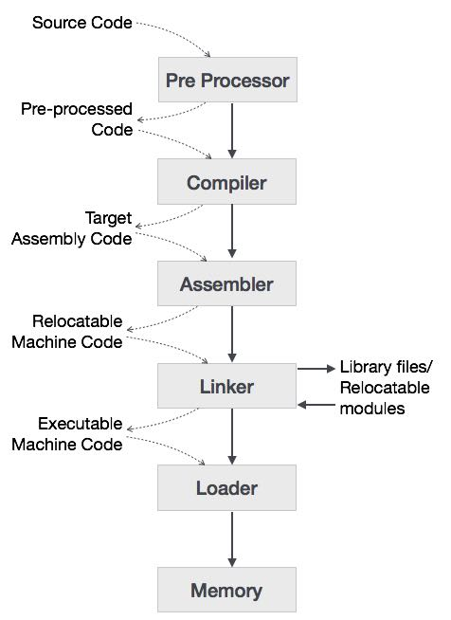
The high-level language is converted into binary language in various phases. A compiler is a program that converts high-level language to assembly language. Similarly, an assembler is a program that converts the assembly language to machine-level language.
Let us first understand how a program, using C compiler, is executed on a host machine.
- User writes a program in C language (high-level language).
- The C compiler, compiles the program and translates it to assembly program (low-level language).
- An assembler then translates the assembly program into machine code (object).
- A linker tool is used to link all the parts of the program together for execution (executable machine code).
- A loader loads all of them into memory and then the program is executed.
Before diving straight into the concepts of compilers, we should understand a few other tools that work closely with compilers.

Preprocessor
A preprocessor, generally considered as a part of compiler, is a tool that produces input for compilers. It deals with macro-processing, augmentation, file inclusion, language extension, etc.

Interpreter
An interpreter, like a compiler, translates high-level language into low-level machine language. The difference lies in the way they read the source code or input. A compiler reads the whole source code at once, creates tokens, checks semantics, generates intermediate code, executes the whole program and may involve many passes. In contrast, an interpreter reads a statement from the input, converts it to an intermediate code, executes it, then takes the next statement in sequence. If an error occurs, an interpreter stops execution and reports it. whereas a compiler reads the whole program even if it encounters several errors.

Assembler
An assembler translates assembly language programs into machine code.The output of an assembler is called an object file, which contains a combination of machine instructions as well as the data required to place these instructions in memory.

Linker
Linker is a computer program that links and merges various object files together in order to make an executable file. All these files might have been compiled by separate assemblers. The major task of a linker is to search and locate referenced module/routines in a program and to determine the memory location where these codes will be loaded, making the program instruction to have absolute references.

Loader
Loader is a part of operating system and is responsible for loading executable files into memory and execute them. It calculates the size of a program (instructions and data) and creates memory space for it. It initializes various registers to initiate execution.

Cross-compiler
A compiler that runs on platform (A) and is capable of generating executable code for platform (B) is called a cross-compiler.

Source-to-source Compiler
A compiler that takes the source code of one programming language and translates it into the source code of another programming language is called a source-to-source compiler.
A compiler can broadly be divided into two phases based on the way they compile.

Analysis Phase
Known as the front-end of the compiler, the analysis phase of the compiler reads the source program, divides it into core parts and then checks for lexical, grammar and syntax errors. The analysis phase generates an intermediate representation of the source program and symbol table, which should be fed to the Synthesis phase as input.
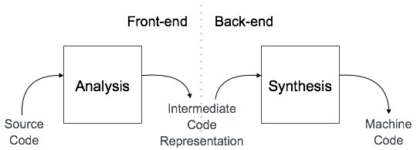

Synthesis Phase
Known as the back-end of the compiler, the synthesis phase generates the target program with the help of intermediate source code representation and symbol table.
A compiler can have many phases and passes.
- Pass : A pass refers to the traversal of a compiler through the entire program.
- Phase : A phase of a compiler is a distinguishable stage, which takes input from the previous stage, processes and yields output that can be used as input for the next stage. A pass can have more than one phase.
- The compilation process is a sequence of various phases. Each phase takes input from its previous stage, has its own representation of source program, and feeds its output to the next phase of the compiler. Let us understand the phases of a compiler.
- 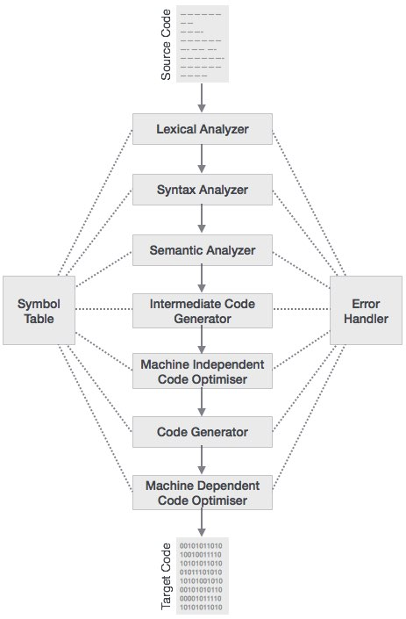

Lexical Analysis
- The first phase of scanner works as a text scanner. This phase scans the source code as a stream of characters and converts it into meaningful lexemes. Lexical analyzer represents these lexemes in the form of tokens as:
- <token-name, attribute-value>

Syntax Analysis
- The next phase is called the syntax analysis or parsing. It takes the token produced by lexical analysis as input and generates a parse tree (or syntax tree). In this phase, token arrangements are checked against the source code grammar, i.e. the parser checks if the expression made by the tokens is syntactically correct.

Semantic Analysis
- Semantic analysis checks whether the parse tree constructed follows the rules of language. For example, assignment of values is between compatible data types, and adding string to an integer. Also, the semantic analyzer keeps track of identifiers, their types and expressions; whether identifiers are declared before use or not etc. The semantic analyzer produces an annotated syntax tree as an output.

Intermediate Code Generation
- After semantic analysis the compiler generates an intermediate code of the source code for the target machine. It represents a program for some abstract machine. It is in between the high-level language and the machine language. This intermediate code should be generated in such a way that it makes it easier to be translated into the target machine code.

Code Optimization
- The next phase does code optimization of the intermediate code. Optimization can be assumed as something that removes unnecessary code lines, and arranges the sequence of statements in order to speed up the program execution without wasting resources (CPU, memory).

Code Generation
- In this phase, the code generator takes the optimized representation of the intermediate code and maps it to the target machine language. The code generator translates the intermediate code into a sequence of (generally) re-locatable machine code. Sequence of instructions of machine code performs the task as the intermediate code would do.

Symbol Table
- It is a data-structure maintained throughout all the phases of a compiler. All the identifier's names along with their types are stored here. The symbol table makes it easier for the compiler to quickly search the identifier record and retrieve it. The symbol table is also used for scope management.
Error Handling in Compiler Design
- The tasks of the Error Handling process are to detect each error, report it to the user, and then make some recover strategy and implement them to handle error. During this whole process processing time of program should not be slow. An Error is the blank entries in the symbol table.
- Types or Sources of Error –
- There are two types of error: run-time and compile-time error:
- A run-time error is an error which takes place during the execution of a program, and usually happens because of adverse system parameters or invalid input data. The lack of sufficient memory to run an application or a memory conflict with another program and logical error are example of this. Logic errors, occur when executed code does not produce the expected result. Logic errors are best handled by meticulous program debugging.
- Compile-time errors rises at compile time, before execution of the program. Syntax error or missing file reference that prevents the program from successfully compiling is the example of this.
- Classification of Compile-time error –
- Lexical : This includes misspellings of identifiers, keywords or operators
- Syntactical : missing semicolon or unbalanced parenthesis
- Semantical : incompatible value assignment or type mismatches between operator and operand
- Logical : code not reachable, infinite loop.
- Finding error or reporting an error – Viable-prefix is the property of a parser which allows early detection of syntax errors.
- Goal: detection of an error as soon as possible without further consuming unnecessary input
- How: detect an error as soon as the prefix of the input does not match a prefix of any string in the
language.
- Example: for(;), this will report an error as for have two semicolons inside braces.
- Error Recovery –
The basic requirement for the compiler is to simply stop and issue a message, and cease compilation. There are some common recovery methods that are follows.
- Panic mode recovery: This is the easiest way of error-recovery and also, it prevents the parser from developing infinite loops while recovering error. The parser discards the input symbol one at a time until one of the designated (like end, semicolon) set of synchronizing tokens (are typically the statement or expression terminators) is found. This is adequate when the presence of multiple errors in same statement is rare. Example: Consider the erroneous expression- (1 + + 2) + 3. Panic-mode recovery: Skip ahead to next integer and then continue. Bison: use the special terminal error to describe how much input to skip.
- E->int|E+E|(E)|error int|(error)
- Phase level recovery: Perform local correction on the input to repair the error. But error correction is difficult in this strategy.
- Error productions: Some common errors are known to the compiler designers that may occur in the code. Augmented grammars can also be used, as productions that generate erroneous constructs when these errors are encountered. Example: write 5x instead of 5*x
- Global correction: Its aim is to make as few changes as possible while converting an incorrect input string to a valid string. This strategy is costly to implement.
Lexical Analyzer
- The first phase of compiler is also called as Scanner.
- This phase scans the source code as a stream of characters and converts it into meaningful lexemes.
- Lexical analyzer represents these lexemes in the form of tokens as
- <token-name, attribute-value>
- Tokens are defined by regular expressions which are understood by the lexical analyzer.
- It also removes white-spaces and comments.
- Ex:- e=a+b-c*d;
- int a,b,c;
- Lexical analysis is the first phase of a compiler. It takes the modified source code from language preprocessors that are written in the form of sentences. The lexical analyzer breaks these syntaxes into a series of tokens, by removing any whitespace or comments in the source code.
- If the lexical analyzer finds a token invalid, it generates an error. The lexical analyzer works closely with the syntax analyzer. It reads character streams from the source code, checks for legal tokens, and passes the data to the syntax analyzer when it demands.
- 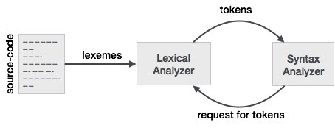

Tokens
- Lexemes are said to be a sequence of characters (alphanumeric) in a token. There are some predefined rules for every lexeme to be identified as a valid token. These rules are defined by grammar rules, by means of a pattern. A pattern explains what can be a token, and these patterns are defined by means of regular expressions.
- In programming language, keywords, constants, identifiers, strings, numbers, operators and punctuations symbols can be considered as tokens.
- For example, in C language, the variable declaration line
- int value = 100;
- contains the tokens:
- int (keyword), value (identifier), = (operator), 100 (constant) and ; (symbol).

Specifications of Tokens
- Let us understand how the language theory undertakes the following terms:

Alphabets
- Any finite set of symbols {0,1} is a set of binary alphabets, {0,1,2,3,4,5,6,7,8,9,A,B,C,D,E,F} is a set of Hexadecimal alphabets, {a-z, A-Z} is a set of English language alphabets.

Strings
- Any finite sequence of alphabets is called a string. Length of the string is the total number of occurrence of alphabets, e.g., the length of the string tutorialspoint is 14 and is denoted by |tutorialspoint| = 14. A string having no alphabets, i.e. a string of zero length is known as an empty string and is denoted by ε (epsilon).

Special Symbols
- A typical high-level language contains the following symbols:-
Arithmetic Symbols | Addition(+), Subtraction(-), Modulo(%), Multiplication(*), Division(/)
Punctuation | Comma(,), Semicolon(;), Dot(.), Arrow(->)
Assignment | =
Special Assignment | +=, /=, *=, -=
Comparison | ==, !=, <, <=, >, >=
Preprocessor | #
Location Specifier | &
Logical | &, &&, |, ||, !
Shift Operator | >>, >>>, <<, <<<

Language
- A language is considered as a finite set of strings over some finite set of alphabets. Computer languages are considered as finite sets, and mathematically set operations can be performed on them. Finite languages can be described by means of regular expressions.

Longest Match Rule
- When the lexical analyzer read the source-code, it scans the code letter by letter; and when it encounters a whitespace, operator symbol, or special symbols, it decides that a word is completed.
- For example:
- int intvalue;
- While scanning both lexemes till ‘int’, the lexical analyzer cannot determine whether it is a keyword int or the initials of identifier int value.
- The Longest Match Rule states that the lexeme scanned should be determined based on the longest match among all the tokens available.
- The lexical analyzer also follows rule priority where a reserved word, e.g., a keyword, of a language is given priority over user input. That is, if the lexical analyzer finds a lexeme that matches with any existing reserved word, it should generate an error.
The lexical analyzer needs to scan and identify only a finite set of valid string/token/lexeme that belong to the language in hand. It searches for the pattern defined by the language rules.
Regular expressions have the capability to express finite languages by defining a pattern for finite strings of symbols. The grammar defined by regular expressions is known as regular grammar. The language defined by regular grammar is known as regular language.
Regular expression is an important notation for specifying patterns. Each pattern matches a set of strings, so regular expressions serve as names for a set of strings. Programming language tokens can be described by regular languages. The specification of regular expressions is an example of a recursive definition. Regular languages are easy to understand and have efficient implementation.
There are a number of algebraic laws that are obeyed by regular expressions, which can be used to manipulate regular expressions into equivalent forms.

Operations
The various operations on languages are:
- Union of two languages L and M is written as
L U M = {s | s is in L or s is in M}
- Concatenation of two languages L and M is written as
LM = {st | s is in L and t is in M}
- The Kleene Closure of a language L is written as
L* = Zero or more occurrence of language L.

Notations
If r and s are regular expressions denoting the languages L(r) and L(s), then
- Union : (r)|(s) is a regular expression denoting L(r) U L(s)
- Concatenation : (r)(s) is a regular expression denoting L(r)L(s)
- Kleene closure : (r)* is a regular expression denoting (L(r))*
- (r) is a regular expression denoting L(r)

Precedence and Associativity
- *, concatenation (.), and | (pipe sign) are left associative
- * has the highest precedence
- Concatenation (.) has the second highest precedence.
- | (pipe sign) has the lowest precedence of all.

Representing valid tokens of a language in regular expression
If x is a regular expression, then:
- x* means zero or more occurrence of x.
i.e., it can generate { e, x, xx, xxx, xxxx, … }
- x+ means one or more occurrence of x.
i.e., it can generate { x, xx, xxx, xxxx … } or x.x*
- x? means at most one occurrence of x
i.e., it can generate either {x} or {e}.
[a-z] is all lower-case alphabets of English language.
[A-Z] is all upper-case alphabets of English language.
[0-9] is all natural digits used in mathematics.

Representing occurrence of symbols using regular expressions
letter = [a – z] or [A – Z]
digit = 0 | 1 | 2 | 3 | 4 | 5 | 6 | 7 | 8 | 9 or [0-9]
sign = [ + | - ]

Representing language tokens using regular expressions
Decimal = (sign)?(digit)⁺
Identifier = (letter)(letter | digit)*
The only problem left with the lexical analyzer is how to verify the validity of a regular expression used in specifying the patterns of keywords of a language. A well-accepted solution is to use finite automata for verification.
Finite automata is a state machine that takes a string of symbols as input and changes its state accordingly. Finite automata is a recognizer for regular expressions. When a regular expression string is fed into finite automata, it changes its state for each literal. If the input string is successfully processed and the automata reaches its final state, it is accepted, i.e., the string just fed was said to be a valid token of the language in hand.
The mathematical model of finite automata consists of:
- Finite set of states (Q)
- Finite set of input symbols (Σ)
- One Start state (q0)
- Set of final states (qf)
- Transition function (δ)
The transition function (δ) maps the finite set of state (Q) to a finite set of input symbols (Σ), Q × Σ ➔ Q

Finite Automata(FA) is the simplest machine to recognize patterns.
A Finite Automata consists of the following :
Q : Finite set of states.
∑ : set of Input Symbols.
q : Initial state.
F : set of Final States.
δ : Transition Function.
Formal specification of machine is
{ Q, ∑, q, F, δ }.
FA is characterized into two types:
1) Deterministic Finite Automata (DFA)

DFA consists of 5 tuples {Q, ∑, q, F, δ}.
Q : set of all states.
∑ : set of input symbols. ( Symbols which machine takes as input )
q : Initial state. ( Starting state of a machine )
F : set of final state.
δ : Transition Function, defined as δ : Q X ∑ --> Q.
In a DFA, for a particular input character, the machine goes to one state only. A transition function is defined on every state for every input symbol. Also in DFA null (or ε) move is not allowed, i.e., DFA cannot change state without any input character.
For example, below DFA with ∑ = {0, 1} accepts all strings ending with 0.
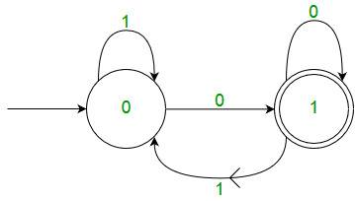
One important thing to note is, there can be many possible DFAs for a pattern. A DFA with minimum number of states is generally preferred.
2) Nondeterministic Finite Automata(NFA)
NFA is similar to DFA except following additional features:
1. Null (or ε) move is allowed i.e., it can move forward without reading symbols.
2. Ability to transmit to any number of states for a particular input.
However, these above features don’t add any power to NFA. If we compare both in terms of power, both are equivalent.
Due to above additional features, NFA has a different transition function, rest is same as DFA.
δ: Transition Function
δ: Q X (∑ U ϵ ) --> 2 ^ Q.
As you can see in transition function is for any input including null (or ε), NFA can go to any state number of states.
For example, below is a NFA for above problem
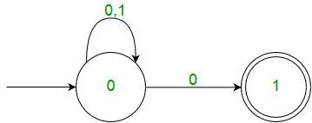
One important thing to note is, in NFA, if any path for an input string leads to a final state, then the input string accepted. For example, in above NFA, there are multiple paths for input string “00”. Since, one of the paths leads to a final state, “00” is accepted by above NFA.
Some Important Points:
1. Every DFA is NFA but not vice versa.
2. Both NFA and DFA have same power and each NFA can be translated into a DFA.
3. There can be multiple final states in both DFA and NFA.
3. NFA is more of a theoretical concept.
4. DFA is used in Lexical Analysis in Compiler.

Finite Automata Construction
Let L(r) be a regular language recognized by some finite automata (FA).
- States : States of FA are represented by circles. State names are written inside circles.
- Start state : The state from where the automata starts, is known as the start state. Start state has an arrow pointed towards it.
- Intermediate states : All intermediate states have at least two arrows; one pointing to and another pointing out from them.
- Final state : If the input string is successfully parsed, the automata is expected to be in this state. Final state is represented by double circles. It may have any odd number of arrows pointing to it and even number of arrows pointing out from it. The number of odd arrows are one greater than even, i.e. odd = even+1.
- Transition : The transition from one state to another state happens when a desired symbol in the input is found. Upon transition, automata can either move to the next state or stay in the same state. Movement from one state to another is shown as a directed arrow, where the arrows points to the destination state. If automata stays on the same state, an arrow pointing from a state to itself is drawn.
Example : We assume FA accepts any three digit binary value ending in digit 1. FA = {Q(q₀, q_{f}), Σ(0,1), q₀, q_{f}, δ}
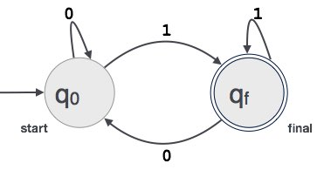
Compiler writing tools
- Scanner Generator:-
- It generates lexical analyzers from the input that consists of regular expression description based on tokens of a language.
It generates a finite automation to recognize the regular expression.
Example: Lex
The compiler writer can use some specialized tools that help in implementing various phases of a compiler. These tools assist in the creation of an entire compiler or its parts. Some commonly used compiler construction tools include:
- Parser Generator –
It produces syntax analyzers (parsers) from the input that is based on a grammatical description of programming language or on a context-free grammar. It is useful as the syntax analysis phase is highly complex and consumes more manual and compilation time.
Example:PIC, EQM
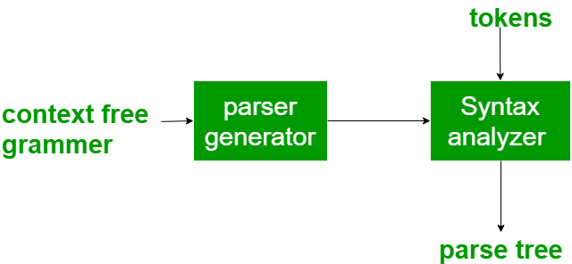

- Scanner Generator –
It generates lexical analyzers from the input that consists of regular expression description based on tokens of a language. It generates a finite automation to recognize the regular expression.
Example: Lex
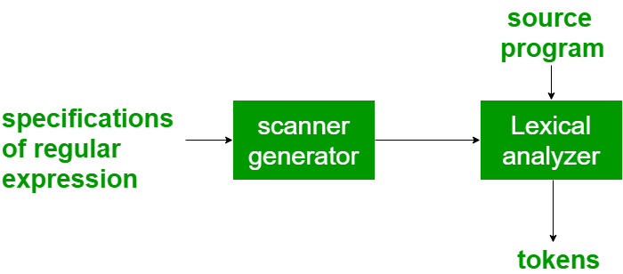
- Syntax directed translation engines –
It generates intermediate code with three address format from the input that consists of a parse tree. These engines have routines to traverse the parse tree and then produces the intermediate code. In this, each node of the parse tree is associated with one or more translations.
- Automatic code generators –
It generates the machine language for a target machine. Each operation of the intermediate language is translated using a collection of rules and then is taken as an input by the code generator. Template matching process is used. An intermediate language statement is replaced by its equivalent machine language statement using templates.
- Data-flow analysis engines –
It is used in code optimization. Data flow analysis is a key part of the code optimization that gathers the information, that is the values that flow from one part of a program to another.
- Compiler construction toolkits –
It provides an integrated set of routines that aids in building compiler components or in the construction of various phases of compiler.

Short Answer Questions
- Distinguish between compiler and interpreter.
- Define regular expression?
- Explain the terms a) Token b) Pattern c) Lexeme.
- Explain the role of Lexical Analyzer in compilation process.
- Compute NFA that accepts aa* | bb*
- Compute regular expressions for the following language over the alphabet {0, 1} such that all strings containing exactly two 0’s
- Compute regular expressions for the following language over the alphabet {0, 1} such that all Strings that begin or end with 00 or 11
- Compute regular expressions for the following language over the alphabet {0, 1} such that all Strings that contain even number of 1’s
- Construct FA from the following regular expression (00+1)*(11+0)*
- Give the general format of a LEX program.
- Explain how LEX program perform lexical analysis for comments and identifiers.
- Draw a block diagram of phases of a compiler and discuss the main function of analysis part.
- Draw a block diagram of phases of a compiler and indicate the main functions of synthesis part.
- Give the minimized DFA for regular expression (a/b)*abb.
- Showing the output of each phase, using the example of the following statement: Position:= initial + rate * 60.
- Construct FiniteAutomata for the given Regular Expression (a+b)*ab(a+b)*.
- Write the compiler construction tools.
- Differentiate Pass and Phase.
- Differentiate DFA and NFA.
- Differentiate compiler and assembler.
- Write cousins of compiler.
- Write the process of execution of a source program.
- Discuss the concept of Loaders, Linkers.
- Define Input buffering.
- Define Specification of tokens.
- Define how Recognition of tokens from FA.
- Define the language for specifying lexical Analyzers.
- Define Finite Automata.
- Discuss the design of a lexical analyzer.
- Discuss optimization of DFA-based pattern matchers.

Objective Type Questions
- In compiler, grouping of characters into tokens is done by [ ]
- Parser B) Code generator C) Scanner D) Code optimizer
- Which of the following is wrong pattern for the regular expression is [+-*]?[0-9]+ [ ]
a) +123 b)-456 c)*789 d)None
- If “abc” is a string of terminals, then FIRST(abc) = [ ]
- {a,b} B) {a} C) {a,b,c} D)
- The blanks separating the characters of tokens would normally be eliminated during [ ]
- Lexical analysis B) syntax analysis C) semantic analysis D) None
- The equivalent regular expression for (a | b)* is [ ]
- (a*b)* B) (ab*)* C) (ab)* D) (a*b*)*
- The special character that identifies the end of a string is called as_______ ( )
a. end pointer b. sentinel c. lexeme d. token
- LEX specification consists of__________parts. ( )
a. 1 b. 2 c.3 d. 4
- In compiler, grouping of characters into tokens is done by [ ]
- Parser B) Code generator C) Scanner D)Code optimizer
- The Regular Expression a+ denotes ___________ ( )
a. Set of all string of one (or) more number of a’s
b. Set of all string of zero (or) more number of a’s
c. Set of all string of two consecutive a’s
d. All the above
- The sequence of characters in the program that is matched by pattern for a token is known as____________________.
- The linker [ ]
a) Is similar to interpreter b) Uses source code as its input
c) I s required to create a load module d) None of the mentioned
- The number of tokens in the following C statement is
printf("i = %d, &i = %x", i, &i);
a. 3 b. 26 c. 10 d. 21
14. In a compiler, keywords of a language are recognized during
a.parsing of the program b.the code generation
c.the lexical analysis of the program d.dataflow analysis
15. The lexical analysis for a modern computer language such as Java needs the power of which one of the following machine models in a necessary and sufficient sense?
a. Finite state automata
b. Deterministic pushdown automata
c. Non-Deterministic pushdown automata
d. Turing Machine
16.Compiler translates the source code to
A. Executable code
B. Machine code
C. Binary code
D. Both B and C

17.Compiler should report the presence of __________ in the source program, in translation process.
A. Classes
B. Objects
C. Errors
D. Text

18. What is the output of lexical analyzer?
A. parse tree
B. A list of tokens
C. Intermediate code
D. Machine code

19.How many parts of compiler are there?
A. 1
B. 2
C. 4
D. 8

20.Compiler can check ________ error.
A. Logical
B. Syntax
C. Content
D. Both A and B

21.Lexical analysis is about breaking a sequence of characters into
A. Groups
B. Packets
C. Lines
D. Tokens

22. ________ is considered as a sequence of characters in a token.
A. Texeme
B. Pattern
C. Lexeme
D. Mexeme

23.What is the name of the process that determining whether a string of tokens can be generated by a grammar?
A. Analysing
B. Recognizing
C. Translating
D. Parsing

24. A _________ is a software utility that translates code written in higher language into a low level language.
A. Converter
B. Compiler
C. Text editor
D. Code optimizer

25.Which code is known as machine code that is processed or executed by the processor?
A.Source code
B.Object code
C.MSIL code
D.Byte Code

26.Low level language is also called as __________.
A.Machine language
B.Binary language
C.A and B are same
D.High level language

27.Which programming language use symbolic codes called MNEMONICS for developing the program?
A.Machine language
B.Low level language
C.High level language
D.Assembly language

28.Which program allows text to be entered and changed?
A.Editor
B.Translator
C.Compiler
D.Interpreter

29.Which program is known as translator , which read the whole code written in high level language at once and then convert it into machine language?
A.Editor
B.Linker
C.Compiler
D.Interpreter

30.Which is a translator program, which read the code written in high level language line by line convert it into machine language?
A.Linker
B.Editor
C.Compiler
D.Interpreter

31.Which program combine two or more object modules into a single object module or into an executable file?
A.Linker
B.Interpreter
C.Assembler
D.Compiler

32.Which program is also called as loader?
A.Interpreter
B.Linker
C.Javac
D.Compiler

33.A __________ is responsible for the task of collecting different modules of a skeletal source program.
A.linker
B.loader
C.preprocessor
D.processor

34.Which program is used to translates from low level language to higher one?
A.Parse generator
B.Decompiler
C.Cross compiler
D.Scanner

35.__________ accept the stream of character as input and produces stream of token as output.
A. Parser
B. Lexical analyzer
C. Scanner
D. B and C are same

36.The sequences of character that give rise to token are called __________.
A.Intermediate code
B.Stream
C.Lexemes
D.Semantic

37.The syntactical analyzer is also called __________.
A.lexemes
B.parser
C.lexical analyzer
D.scanner

38.What is refer to checking context dependent datatype?
A.Lexical analysis
B.Parser
C.Semantic analysis
D.Syntactical analyzer

39.What is responsible to produce faster and smaller object program by performing some improvements over intermediate code?
A. Intermediate code generator
B. Code generator
C. Interpreter
D. Code optimizer

40.What is responsible for generation of final machine code tailored to target system?
A.Interpreter
B.Semantic analyzer
C.Code generator
D.Code optimizer

41.Which programming language use compiler as well as interpreter to produce output?
A.C language
B.C++
C.Cobol
D.Java

42.Which data structure is used for book keeping?
A.Lookup table
B.Symbol table
C.Inode table
D.Tree

43.Which tool is used to construct compiler?
A.Compiler - Compiler
B.Compiler - generator
C.NELIAC
D.A and B is same

44. the lexical analyzer produce tokens, which are stored in a buffer until they are consumed by the __________.
A.linker
B.loader
C.parser
D.preprocessor

45.What is called lexical analysis?
A.Parallel analysis
B.Linear analysis
C.Parser
D.Token
46.Which operation is used for searching a lexical entry in the ymbol table?
A.Insert
B.Lookup
C.Select
D.Scanner

47.The additional information along with a token is called its __________.
A.lexeme
B.keyword
C.attributes
D.subset

48.A lexical analyzer filter out __________ and __________.
A.comment, keyword
B.whitespace, comment
C.character, number
D.operator, operand

49.Token refer to a set of __________.
A.string
B.keyword
C.pattern
D.lexem

50.An intermediate code form is
A.postfix notation
B.syntax trees
C.three address codes
D.all of these

51.Three address code invloves
A.exactly 3 address
B.at the most 3 address
C.no unary operators
D.none of these
52.Token refer to a set of __________.
A.string
B.keyword
C.pattern
D.lexem

Long Answer Questions
- Explain about Analysis of the source program.
- Explain different phases of compiler by showing the output of each phase using following statement
position := initial + rate * 60
- Construct a DFA for (a * + b *) abb
- Construct NFA equivalent to regular expression r=(a+b)*(ab + ba)(a+b)*
- Discuss in detail about various phases of compiler with an example.
- List out the Cousins of the compiler and explain.
- Explain different phases of compiler by showing the output of each phase using following statement
float m,n; m=m*55 + n + 3;
- Differentiate the Concepts of Loaders and Linkers.
- Suppose we have two types of tokens:
a. The keywords if and while
b. Identifiers, which are strings of letters and digits other than if and while. Construct a DFA for accepting these tokens.
- Explain about the grouping of phases.
- Explain about Compiler writing tools.
- Write about the role of the Lexical Analyzer.
- Mention the language for specifying lexical Analyzers with example.
- Explain about Finite Automata.
- Explain about Design of a lexical analyzer in compiler construction.

