COMPILER DESIGN
UNIT-2

Syntax Analyzers:-
A syntax analyzer or parser takes the input from a lexical analyzer in the form of token streams. The parser analyzes the source code (token stream) against the production rules to detect any errors in the code. The output of this phase is a parse tree.
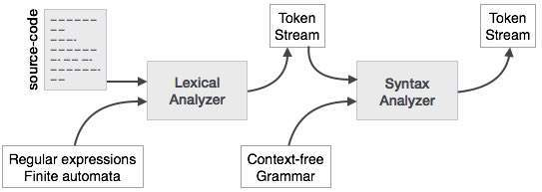
This way, the parser accomplishes two tasks, i.e., parsing the code, looking for errors and generating a parse tree as the output of the phase.
Parsers are expected to parse the whole code even if some errors exist in the program.
A context-free grammar has four components:
- A set of non-terminals (V). Non-terminals are syntactic variables that denote sets of strings. The non-terminals define sets of strings that help define the language generated by the grammar.
- A set of tokens, known as terminal symbols (Σ). Terminals are the basic symbols from which strings are formed.
- A set of productions (P). The productions of a grammar specify the manner in which the terminals and non-terminals can be combined to form strings. Each production consists of a non-terminal called the left side of the production, an arrow, and a sequence of tokens and/or on- terminals, called the right side of the production.
- One of the non-terminals is designated as the start symbol (S); from where the production begins.
The strings are derived from the start symbol by repeatedly replacing a non-terminal (initially the start symbol) by the right side of a production, for that non-terminal.

Example
We take the problem of palindrome language, which cannot be described by means of Regular Expression. That is, L = { w | w = w^{R} } is not a regular language. But it can be described by means of CFG, as illustrated below:
G = ( V, Σ, P, S )
Where:
V = { Q, Z, N }
Σ = { 0, 1 }
P = { Q → Z | Q → N | Q → ℇ | Z → 0Q0 | N → 1Q1 }
S = { Q }
This grammar describes palindrome language, such as: 1001, 11100111, 00100, 1010101, 11111, etc.

Derivation
A derivation is basically a sequence of production rules, in order to get the input string. During parsing, we take two decisions for some sentential form of input:
- Deciding the non-terminal which is to be replaced.
- Deciding the production rule, by which, the non-terminal will be replaced.
To decide which non-terminal to be replaced with production rule, we can have two options.

Left-most Derivation
If the sentential form of an input is scanned and replaced from left to right, it is called left-most derivation. The sentential form derived by the left-most derivation is called the left-sentential form.

Right-most Derivation
If we scan and replace the input with production rules, from right to left, it is known as right-most derivation. The sentential form derived from the right-most derivation is called the right-sentential form.
Example
Production rules:
E → E + E
E → E * E
E → id
Input string: id + id * id
The left-most derivation is:
E → E * E
E → E + E * E
E → id + E * E
E → id + id * E
E → id + id * id
Notice that the left-most side non-terminal is always processed first.
The right-most derivation is:
E → E + E
E → E + E * E
E → E + E * id
E → E + id * id
E → id + id * id

Parse Tree
A parse tree is a graphical depiction of a derivation. It is convenient to see how strings are derived from the start symbol. The start symbol of the derivation becomes the root of the parse tree.
We take the left-most derivation of a + b * c
The left-most derivation is:
E → E * E
E → E + E * E
E → id + E * E
E → id + id * E
E → id + id * id
Step 1:
E → E * E | 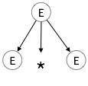
Step 2:
E → E + E * E | 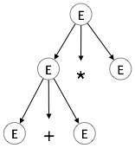
Step 3:
E → id + E * E | 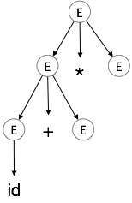
Step 4:
E → id + id * E | 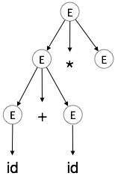
Step 5:
E → id + id * id | 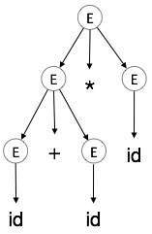
In a parse tree:
- All leaf nodes are terminals.
- All interior nodes are non-terminals.
- In-order traversal gives original input string.
A parse tree depicts associativity and precedence of operators. The deepest sub-tree is traversed first, therefore the operator in that sub-tree gets precedence over the operator which is in the parent nodes.

Ambiguity
A grammar G is said to be ambiguous if it has more than one parse tree (left or right derivation) for at least one string.
Example
E → E + E
E → E – E
E → id
For the string id + id – id, the above grammar generates two parse trees:
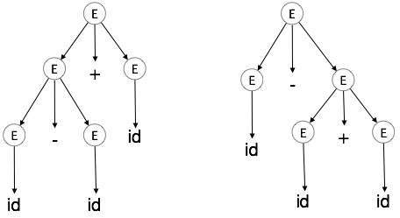
The language generated by an ambiguous grammar is said to be inherently ambiguous. Ambiguity in grammar is not good for a compiler construction. No method can detect and remove ambiguity automatically, but it can be removed by either re-writing the whole grammar without ambiguity, or by setting and following associativity and precedence constraints.

Associativity
If an operand has operators on both sides, the side on which the operator takes this operand is decided by the associativity of those operators. If the operation is left-associative, then the operand will be taken by the left operator or if the operation is right-associative, the right operator will take the operand.
Example
Operations such as Addition, Multiplication, Subtraction, and Division are left associative. If the expression contains:
id op id op id
it will be evaluated as:
(id op id) op id
For example, (id + id) + id
Operations like Exponentiation are right associative, i.e., the order of evaluation in the same expression will be:
id op (id op id)
For example, id ^ (id ^ id)

Precedence
If two different operators share a common operand, the precedence of operators decides which will take the operand. That is, 2+3*4 can have two different parse trees, one corresponding to (2+3)*4 and another corresponding to 2+(3*4). By setting precedence among operators, this problem can be easily removed. As in the previous example, mathematically * (multiplication) has precedence over + (addition), so the expression 2+3*4 will always be interpreted as:
2 + (3 * 4)
These methods decrease the chances of ambiguity in a language or its grammar.

Left Recursion
A grammar becomes left-recursive if it has any non-terminal ‘A’ whose derivation contains ‘A’ itself as the left-most symbol. Left-recursive grammar is considered to be a problematic situation for top-down parsers. Top-down parsers start parsing from the Start symbol, which in itself is non-terminal. So, when the parser encounters the same non-terminal in its derivation, it becomes hard for it to judge when to stop parsing the left non-terminal and it goes into an infinite loop.
Example:
(1) A => Aα | β

(2) S => Aα | β
A => Sd
(1) is an example of immediate left recursion, where A is any non-terminal symbol and α represents a string of non-terminals.
(2) is an example of indirect-left recursion.
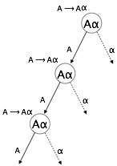
A top-down parser will first parse the A, which in-turn will yield a string consisting of A itself and the parser may go into a loop forever.

Removal of Left Recursion
One way to remove left recursion is to use the following technique:
The production
A => Aα | β
is converted into following productions
A => βA'
A'=> αA' | ε
This does not impact the strings derived from the grammar, but it removes immediate left recursion.
Second method is to use the following algorithm, which should eliminate all direct and indirect left recursions.
START

Arrange non-terminals in some order like A1, A2, A3,…, A_{n}

for each i from 1 to n
{
for each j from 1 to i-1
{
replace each production of form A_{i} ⟹Aj𝜸
with A_{i} ⟹ δ1𝜸 | δ2𝜸 | δ3𝜸 |…| 𝜸
where A_{j} ⟹ δ₁ | δ₂|…| δ_{n} are current A_{j} productions
}
}
eliminate immediate left-recursion

END
Example
The production set
S => Aα | β
A => Sd
after applying the above algorithm, should become
S => Aα | β
A => Aαd | βd
and then, remove immediate left recursion using the first technique.
A => βdA'
A' => αdA' | ε
Now none of the production has either direct or indirect left recursion.

Left Factoring
If more than one grammar production rules has a common prefix string, then the top-down parser cannot make a choice as to which of the production it should take to parse the string in hand.
Example
If a top-down parser encounters a production like
A ⟹ αβ | α𝜸 | …
Then it cannot determine which production to follow to parse the string as both productions are starting from the same terminal (or non-terminal). To remove this confusion, we use a technique called left factoring.
Left factoring transforms the grammar to make it useful for top-down parsers. In this technique, we make one production for each common prefixes and the rest of the derivation is added by new productions.
Example
The above productions can be written as
A => αA'
A'=> β | 𝜸 | …
Now the parser has only one production per prefix which makes it easier to take decisions.

First( ) and Follow( ) Sets
An important part of parser table construction is to create first and follow sets. These sets can provide the actual position of any terminal in the derivation. This is done to create the parsing table where the decision of replacing T[A, t] = α with some production rule.

First( ) Set
FIRST(X) for a grammar symbol X is the set of terminals that begin the strings derivable from X.
Rules to compute FIRST set:
- If x is a terminal, then FIRST(x) = { ‘x’ }
- If x-> Є, is a production rule, then add Є to FIRST(x).
- If X->Y1 Y2 Y3….Yn is a production,
  - FIRST(X) = FIRST(Y1)
  - If FIRST(Y1) contains Є then FIRST(X) = { FIRST(Y1) – Є } U { FIRST(Y2) }
  - If FIRST (Yi) contains Є for all i = 1 to n, then add Є to FIRST(X).
Example 1:
Production Rules of Grammar
E -> TE’
E’ -> +T E’|Є
T -> F T’
T’ -> *F T’ | Є
F -> (E) | id

FIRST sets
FIRST(E) = FIRST(T) = { ( , id }
FIRST(E’) = { +, Є }
FIRST(T) = FIRST(F) = { ( , id }
FIRST(T’) = { *, Є }
FIRST(F) = { ( , id }
Example 2:
Production Rules of Grammar
S -> ACB | Cbb | Ba
A -> da | BC
B -> g | Є
C -> h | Є

FIRST sets
FIRST(S) = FIRST(A) U FIRST(B) U FIRST(C)
= { d, g, h, Є, b, a}
FIRST(A) = { d } U FIRST(B) = { d, g , h, Є }
FIRST(B) = { g , Є }
FIRST(C) = { h , Є }
Notes:
- The grammar used above is Context-Free Grammar (CFG). Syntax of most of the programming language can be specified using CFG.
- CFG is of the form A -> B , where A is a single Non-Terminal, and B can be a set of grammar symbols ( i.e. Terminals as well as Non-Terminals)

Follow( ) Set
Follow(X) to be the set of terminals that can appear immediately to the right of Non-Terminal X in some sentential form.
Example:
S ->Aa | Ac
A ->b

S S
/ \ / \
A a A C
| |
b b

Here, FOLLOW (A) = {a, c}

Rules to compute FOLLOW set:

1) FOLLOW(S) = { $ } // where S is the starting Non-Terminal

2) If A -> pBq is a production, where p, B and q are any grammar symbols,
then everything in FIRST(q) except Є is in FOLLOW(B.

3) If A->pB is a production, then everything in FOLLOW(A) is in FOLLOW(B).

4) If A->pBq is a production and FIRST(q) contains Є,
then FOLLOW(B) contains { FIRST(q) – Є } U FOLLOW(A)
Example 1:
Production Rules:
E -> TE’
E’ -> +T E’|Є
T -> F T’
T’ -> *F T’ | Є
F -> (E) | id

FIRST set
FIRST(E) = FIRST(T) = { ( , id }
FIRST(E’) = { +, Є }
FIRST(T) = FIRST(F) = { ( , id }
FIRST(T’) = { *, Є }
FIRST(F) = { ( , id }

FOLLOW Set
FOLLOW(E) = { $ , ) } // Note ')' is there because of 5th rule
FOLLOW(E’) = FOLLOW(E) = { $, ) } // See 1st production rule
FOLLOW(T) = { FIRST(E’) – Є } U FOLLOW(E’) = { + , $ , ) }
FOLLOW(T’) = FOLLOW(T) = { + , $ , ) }
FOLLOW(F) = { FIRST(T’) – Є } U FOLLOW(T’) = { *, +, $, ) }

Example 2:
Production Rules:
S -> ACB|Cbb|Ba
A -> da|BC
B-> g|Є
C-> h| Є

FIRST set
FIRST(S) = FIRST(A) U FIRST(B) U FIRST(C) = { d, g, h, Є, b, a}
FIRST(A) = { d } U FIRST(B) = { d, g, h, Є }
FIRST(B) = { g, Є }
FIRST(C) = { h, Є }

FOLLOW Set
FOLLOW(S) = { $ }
FOLLOW(A) = { h, g, $ }
FOLLOW(B) = { a, $, h, g }
FOLLOW(C) = { b, g, $, h }
Note :
- Є as a FOLLOW doesn’t mean anything (Є is an empty string).
- $ is called end-marker, which represents the end of the input string, hence used while parsing to indicate that the input string has been completely processed.
- The grammar used above is Context-Free Grammar (CFG). The syntax of a programming language can be specified using CFG.
- CFG is of the form A -> B , where A is a single Non-Terminal, and B can be a set of grammar symbols ( i.e. Terminals as well as Non-Terminals)
- FIRST
- 1. If X is terminal, then FIRST(X) IS {X}.
- 2. If X → ε is a production, then add ε to FIRST(X).
- 3. If X is non terminal and X → Y1,Y2..Yk is a production, then place a in FIRST(X) if for some i , a is in FIRST(Yi) , and ε is in all of FIRST(Y1),…FIRST(Yi-1);
- FOLLOW
- 1. Place $ in FOLLOW(S),where S is the start symbol and $ is the input right endmarker.
- 2. If there is a production A → αBβ, then everything in FIRST(β) except for ε is placed in FOLLOW(B).
- 3. If there is a production A → αB, or a production A→ αBβ where FIRST(β) contains ε , then everything in FOLLOW(A) is in FOLLOW(B).

Limitations of Syntax Analyzers
Syntax analyzers receive their inputs, in the form of tokens, from lexical analyzers. Lexical analyzers are responsible for the validity of a token supplied by the syntax analyzer. Syntax analyzers have the following drawbacks -
- it cannot determine if a token is valid,
- it cannot determine if a token is declared before it is being used,
- it cannot determine if a token is initialized before it is being used,
- it cannot determine if an operation performed on a token type is valid or not.
These tasks are accomplished by the semantic analyzer, which we shall study in Semantic Analysis.
Syntax analyzers follow production rules defined by means of context-free grammar. The way the production rules are implemented (derivation) divides parsing into two types : top-down parsing and bottom-up parsing.

Parsing is classified into two categories, i.e. Top Down Parsing and Bottom-Up Parsing. Top-Down Parsing is based on Left Most Derivation whereas Bottom Up Parsing is dependent on Reverse Right Most Derivation.
The process of constructing the parse tree which starts from the root and goes down to the leaf is Top-Down Parsing.
- Top-Down Parsers constructs from the Grammar which is free from ambiguity and left recursion.
- Top Down Parsers uses leftmost derivation to construct a parse tree.
- It allows a grammar which is free from Left Factoring.
Classification of Top-Down Parsing –
- With Backtracking: Brute Force Technique or Recursive Descent Parsing
- Without Backtracking: Predictive Parsing or Non-Recursive Parsing or LL(1) Parsing or Table Driver Parsing
Brute Force Technique or Recursive Descent Parsing –
- Whenever a Non-terminal spend first time then go with the first alternative and compare with the given I/P String
- If matching doesn’t occur then go with the second alternative and compare with the given I/P String.
- If matching again not found then go with the alternative and so on.
- Moreover, If matching occurs for at least one alternative, then the I/P string is parsed successfully.
Example:-
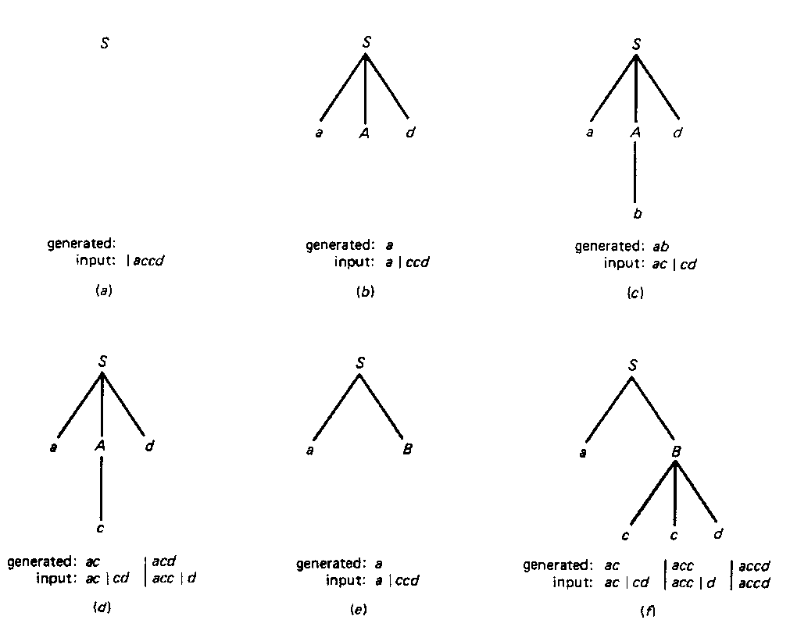

LL(1) or Table Driver or Predictive Parser –
- In LL(1), 1 stands for Look Ahead Symbol, 1st L stands for Left Most Derivation whereas Second L stands for Left to right scan of strings.
- LL(1) parsing is constructed from the grammar which is free from left recursion, common prefix, and ambiguity.
- LL(1) parser depends on 1 look ahead symbol to predict the production to expand the parse tree.
- This parser is Non-Recursive.
.
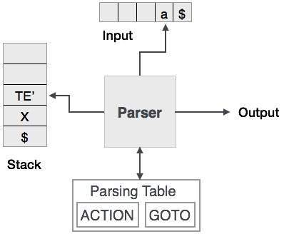
Predictive parsing uses a stack and a parsing table to parse the input and generate a parse tree. Both the stack and the input contains an end symbol $ to denote that the stack is empty and the input is consumed. The parser refers to the parsing table to take any decision on the input and stack element combination.
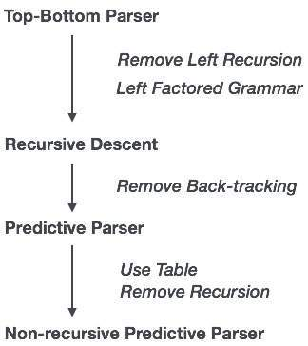
In recursive descent parsing, the parser may have more than one production to choose from for a single instance of input, whereas in predictive parser, each step has at most one production to choose. There might be instances where there is no production matching the input string, making the parsing procedure to fail.

LL Parser
An LL Parser accepts LL grammar. LL grammar is a subset of context-free grammar but with some restrictions to get the simplified version, in order to achieve easy implementation. LL grammar can be implemented by means of both algorithms namely, recursive-descent or table-driven.
LL parser is denoted as LL(k). The first L in LL(k) is parsing the input from left to right, the second L in LL(k) stands for left-most derivation and k itself represents the number of look aheads. Generally k = 1, so LL(k) may also be written as LL(1).
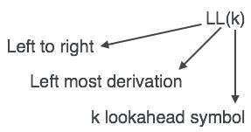

LL Parsing Algorithm
We may stick to deterministic LL(1) for parser explanation, as the size of table grows exponentially with the value of k. Secondly, if a given grammar is not LL(1), then usually, it is not LL(k), for any given k.
Given below is an algorithm for LL(1) Parsing:
Input:
string ω
parsing table M for grammar G

Output:
If ω is in L(G) then left-most derivation of ω,
error otherwise.

Initial State : $S on stack (with S being start symbol)
ω$ in the input buffer

SET ip to point the first symbol of ω$.

repeat
let X be the top stack symbol and a the symbol pointed by ip.

if X∈ Vt or $
if X = a
POP X and advance ip.
else
error()
endif
else /* X is non-terminal */
if M[X,a] = X → Y1, Y2,... Yk
POP X
PUSH Yk, Yk-1,... Y1 /* Y1 on top */
Output the production X → Y1, Y2,... Yk
else
error()
endif
endif
until X = $ /* empty stack */
A grammar G is LL(1) if A → α | β are two distinct productions of G:
- for no terminal, both α and β derive strings beginning with a.
- at most one of α and β can derive empty string.
- if β → t, then α does not derive any string beginning with a terminal in FOLLOW(A).
Constructing LL(1) Parsing Tables:-
- Construct a parsing table T for CFG G ν For each production A → α in G do:
- For each terminal t ∈ First(α) do
T[A, t] = α
- If ε ∈ First(α), for each t ∈ Follow(A) do
T[A, t] = α
- If ε ∈ First(α) and $ ∈ Follow(A) do
T[A, $] = α

Bottom-up Parsing
As the name suggests, bottom-up parsing starts with the input symbols and tries to construct the parse tree up to the start symbol.
Example:
Input string : a + b * c
Production rules:
S → E
E → E + T
E → E * T
E → T
T → id
Let us start bottom-up parsing
a + b * c
Read the input and check if any production matches with the input:
a + b * c
T + b * c
E + b * c
E + T * c
E * c
E * T
E
S

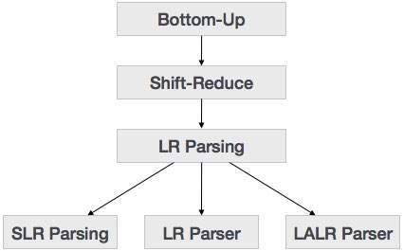

Shift-Reduce Parsing
Shift Reduce parser attempts for the construction of parse in a similar manner as done in bottom up parsing i.e. the parse tree is constructed from leaves(bottom) to the root(up). A more general form of shift reduce parser is LR parser.
This parser requires some data structures i.e.
- A input buffer for storing the input string.
- A stack for storing and accessing the production rules.
Basic Operations –
- Shift: This involves moving of symbols from input buffer onto the stack.
- Reduce: If the handle appears on top of the stack then, its reduction by using appropriate production rule is done i.e. RHS of production rule is popped out of stack and LHS of production rule is pushed onto the stack.
- Accept: If only start symbol is present in the stack and the input buffer is empty then, the parsing action is called accept. When accept action is obtained, it is means successful parsing is done.
- Error: This is the situation in which the parser can neither perform shift action nor reduce action and not even accept action.
Example 1 – Consider the grammar
S –> S + S
S –> S * S
S –> id
Perform Shift Reduce parsing for input string “id + id + id”.
Example 2 – Consider the grammar
E –> 2E2
E –> 3E3
E –> 4
Perform Shift Reduce parsing for input string “32423”.

Operator precedence parsing
Operator precedence grammar is kinds of shift reduce parsing method. It is applied to a small class of operator grammars.
A grammar is said to be operator precedence grammar if it has two properties:
- No R.H.S. of any production has a∈.
- No two non-terminals are adjacent.
Operator precedence can only established between the terminals of the grammar. It ignores the non-terminal.

There are the three operator precedence relations:
a ⋗ b means that terminal "a" has the higher precedence than terminal "b".
a ⋖ b means that terminal "a" has the lower precedence than terminal "b".
a ≐ b means that the terminal "a" and "b" both have same precedence.

Precedence table:
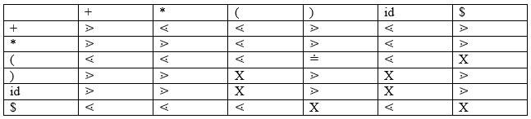

Parsing Action
- Both end of the given input string, add the $ symbol.
- Now scan the input string from left right until the ⋗ is encountered.
- Scan towards left over all the equal precedence until the first left most ⋖ is encountered.
- Everything between left most ⋖ and right most ⋗ is a handle.
- $ on $ means parsing is successful.

Example
Grammar:
- E → E+T/T
- T → T*F/F
- F → id
Given string:
- w = id + id * id
Let us consider a parse tree for it as follows:
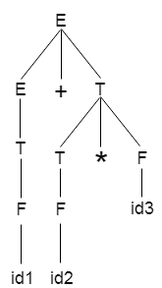
On the basis of above tree, we can design following operator precedence table:
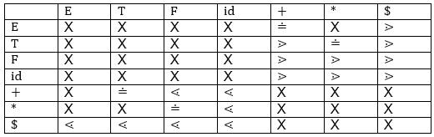
Now let us process the string with the help of the above precedence table:

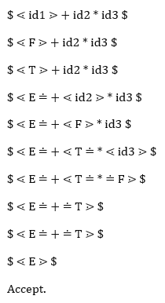

LR Parser
The LR parser is a non-recursive, shift-reduce, bottom-up parser. It uses a wide class of context-free grammar which makes it the most efficient syntax analysis technique. LR parsers are also known as LR(k) parsers, where L stands for left-to-right scanning of the input stream; R stands for the construction of right-most derivation in reverse, and k denotes the number of lookahead symbols to make decisions.
There are three widely used algorithms available for constructing an LR parser:
- SLR(1) – Simple LR Parser:
  - Works on smallest class of grammar
  - Few number of states, hence very small table
  - Simple and fast construction
- LR(1) – LR Parser:
  - Works on complete set of LR(1) Grammar
  - Generates large table and large number of states
  - Slow construction
- LALR(1) – Look-Ahead LR Parser:
  - Works on intermediate size of grammar
  - Number of states are same as in SLR(1)

LR Parsing Algorithm
Here we describe a skeleton algorithm of an LR parser:
token = next_token()
repeat forever
s = top of stack
if action[s, token] = “shift si” then
PUSH token
PUSH si
token = next_token()
else if action[s, token] = “reduce A::= β“ then
POP 2 * |β| symbols
s = top of stack
PUSH A
PUSH goto[s,A]
else if action[s, token] = “accept” then
return
else
error()

LR Parser
LR parsing is one type of bottom up parsing. It is used to parse the large class of grammars.
In the LR parsing, "L" stands for left-to-right scanning of the input.
"R" stands for constructing a right most derivation in reverse.
"K" is the number of input symbols of the look ahead used to make number of parsing decision.
LR parsing is divided into four parts: LR (0) parsing, SLR parsing, CLR parsing and LALR parsing.
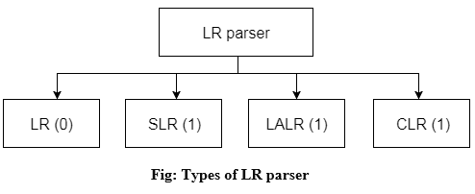

LR algorithm:
The LR algorithm requires stack, input, output and parsing table. In all type of LR parsing, input, output and stack are same but parsing table is different.
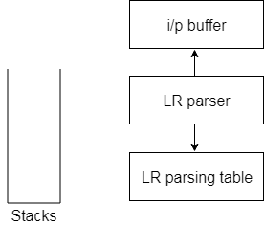
Fig: Block diagram of LR parser
Input buffer is used to indicate end of input and it contains the string to be parsed followed by a $ Symbol.
A stack is used to contain a sequence of grammar symbols with a $ at the bottom of the stack.
Parsing table is a two dimensional array. It contains two parts: Action part and Go To part.

LR (1) Parsing
Various steps involved in the LR (1) Parsing:
- For the given input string write a context free grammar.
- Check the ambiguity of the grammar.
- Add Augment production in the given grammar.
- Create Canonical collection of LR (0) items.
- Draw a data flow diagram (DFA).
- Construct a LR (1) parsing table.

Augment Grammar
Augmented grammar G` will be generated if we add one more production in the given grammar G. It helps the parser to identify when to stop the parsing and announce the acceptance of the input.

Example
Given grammar
- S → AA
- A → aA | b
The Augment grammar G` is represented by
- S`→ S
- S → AA
- A → aA | b

Canonical Collection of LR(0) items
An LR (0) item is a production G with dot at some position on the right side of the production.
LR(0) items is useful to indicate that how much of the input has been scanned up to a given point in the process of parsing.
In the LR (0), we place the reduce node in the entire row.

Example
Given grammar:
- S → AA
- A → aA | b
Add Augment Production and insert '•' symbol at the first position for every production in G
- S` → •S
- S → •AA
- A → •aA
- A → •b

I0 State:
Add Augment production to the I0 State and Compute the Closure

I0 = Closure (S` → •S)
Add all productions starting with S in to I0 State because "•" is followed by the non-terminal. So, the I0 State becomes
I0 = S` → •S
S → •AA
Add all productions starting with "A" in modified I0 State because "•" is followed by the non-terminal. So, the I0 State becomes.
I0= S` → •S
S → •AA
A → •aA
A → •b
I1= Go to (I0, S) = closure (S` → S•) = S` → S•
Here, the Production is reduced so close the State.
I1= S` → S•
I2= Go to (I0, A) = closure (S → A•A)
Add all productions starting with A in to I2 State because "•" is followed by the non-terminal. So, the I2 State becomes
I2 =S→A•A
A → •aA
A → •b
Go to (I2,a) = Closure (A → a•A) = (same as I3)
Go to (I2, b) = Closure (A → b•) = (same as I4)
I3= Go to (I0,a) = Closure (A → a•A)
Add productions starting with A in I3.
A → a•A
A → •aA
A → •b
Go to (I3, a) = Closure (A → a•A) = (same as I3)
Go to (I3, b) = Closure (A → b•) = (same as I4)
I4= Go to (I0, b) = closure (A → b•) = A → b•
I5= Go to (I2, A) = Closure (S → AA•) = SA → A•
I6= Go to (I3, A) = Closure (A → aA•) = A → aA•

Drawing DFA:
The DFA contains the 7 states I0 to I6.
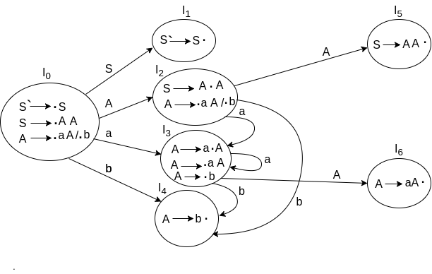

LR(0) Table
- If a state is going to some other state on a terminal then it correspond to a shift move.
- If a state is going to some other state on a variable then it correspond to go to move.
- If a state contain the final item in the particular row then write the reduce node completely.
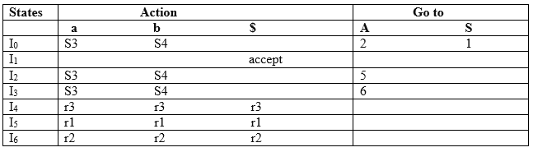
Explanation:
- I0 on S is going to I1 so write it as 1.
- I0 on A is going to I2 so write it as 2.
- I2 on A is going to I5 so write it as 5.
- I3 on A is going to I6 so write it as 6.
- I0, I2and I3on a are going to I3 so write it as S3 which means that shift 3.
- I0, I2 and I3 on b are going to I4 so write it as S4 which means that shift 4.
- I4, I5 and I6 all states contains the final item because they contain • in the right most end. So rate the production as production number.

Productions are numbered as follows:
- S → AA ... (1)
- A → aA ... (2)
- A → b ... (3)
- I1 contains the final item which drives(S` → S•), so action {I1, $} = Accept.
- I4 contains the final item which drives A → b• and that production corresponds to the production number 3 so write it as r3 in the entire row.
- I5 contains the final item which drives S → AA• and that production corresponds to the production number 1 so write it as r1 in the entire row.
- I6 contains the final item which drives A → aA• and that production corresponds to the production number 2 so write it as r2 in the entire row.

SLR (1) Parsing
SLR (1) refers to simple LR Parsing. It is same as LR(0) parsing. The only difference is in the parsing table.To construct SLR (1) parsing table, we use canonical collection of LR (0) item.
In the SLR (1) parsing, we place the reduce move only in the follow of left hand side.
Various steps involved in the SLR (1) Parsing:
- For the given input string write a context free grammar
- Check the ambiguity of the grammar
- Add Augment production in the given grammar
- Create Canonical collection of LR (0) items
- Draw a data flow diagram (DFA)
- Construct a SLR (1) parsing table

SLR (1) Table Construction
The steps which use to construct SLR (1) Table is given below:
If a state (I_{i}) is going to some other state (I_{j}) on a terminal then it corresponds to a shift move in the action part.
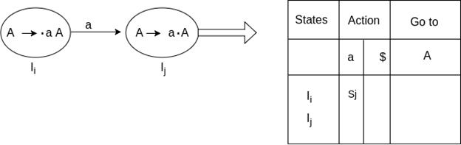
If a state (I_{i}) is going to some other state (I_{j}) on a variable then it correspond to go to move in the Go to part.
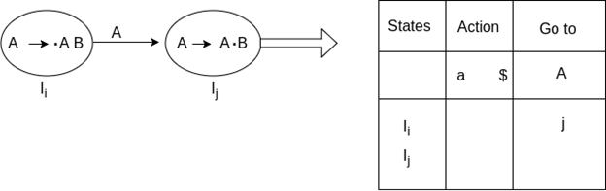
If a state (I_{i}) contains the final item like A → ab• which has no transitions to the next state then the production is known as reduce production. For all terminals X in FOLLOW (A), write the reduce entry along with their production numbers.

Example
- S -> •Aa
- A->αβ•
- Follow(S) = {$}
- Follow (A) = {a}
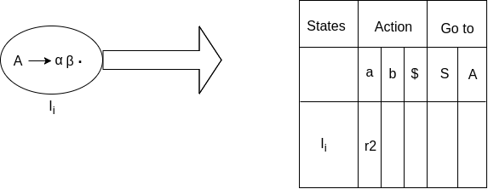

SLR ( 1 ) Grammar
S → E
E → E + T | T
T → T * F | F
F → id
Add Augment Production and insert '•' symbol at the first position for every production in G
S` → •E
E → •E + T
E → •T
T → •T * F
T → •F
F → •id
I0 State:
Add Augment production to the I0 State and Compute the Closure
I0 = Closure (S` → •E)
Add all productions starting with E in to I0 State because "." is followed by the non-terminal. So, the I0 State becomes
I0 = S` → •E
E → •E + T
E → •T
Add all productions starting with T and F in modified I0 State because "." is followed by the non-terminal. So, the I0 State becomes.
I0= S` → •E
E → •E + T
E → •T
T → •T * F
T → •F
F → •id
I1= Go to (I0, E) = closure (S` → E•, E → E• + T)
I2= Go to (I0, T) = closure (E → T•T, T• → * F)
I3= Go to (I0, F) = Closure ( T → F• ) = T → F•
I4= Go to (I0, id) = closure ( F → id•) = F → id•
I5= Go to (I1, +) = Closure (E → E +•T)
Add all productions starting with T and F in I5 State because "." is followed by the non-terminal. So, the I5 State becomes
I5 = E → E +•T
T → •T * F
T → •F
F → •id
Go to (I5, F) = Closure (T → F•) = (same as I3)
Go to (I5, id) = Closure (F → id•) = (same as I4)
I6= Go to (I2, *) = Closure (T → T * •F)
Add all productions starting with F in I6 State because "." is followed by the non-terminal. So, the I6 State becomes
I6 = T → T * •F
F → •id
Go to (I6, id) = Closure (F → id•) = (same as I4)
I7= Go to (I5, T) = Closure (E → E + T•) = E → E + T•
I8= Go to (I6, F) = Closure (T → T * F•) = T → T * F•

Drawing DFA:
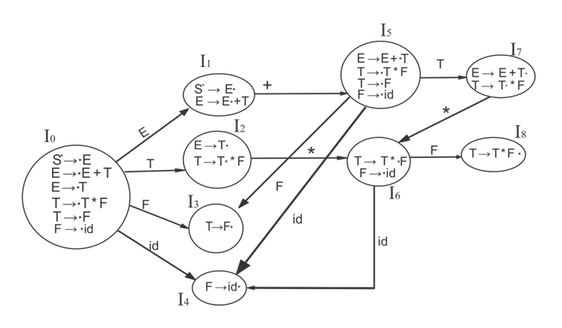

SLR (1) Table
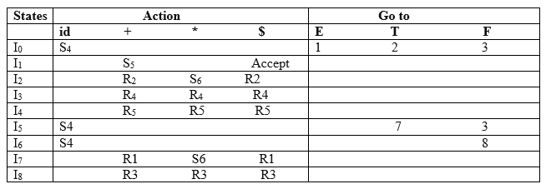

Explanation:
First (E) = First (E + T) ∪ First (T)
First (T) = First (T * F) ∪ First (F)
First (F) = {id}
First (T) = {id}
First (E) = {id}
Follow (E) = First (+T) ∪ {$} = {+, $}
Follow (T) = First (*F) ∪ First (F)
= {*, +, $}
Follow (F) = {*, +, $}
- I1 contains the final item which drives S → E• and follow (S) = {$}, so action {I1, $} = Accept
- I2 contains the final item which drives E → T• and follow (E) = {+, $}, so action {I2, +} = R2, action {I2, $} = R2
- I3 contains the final item which drives T → F• and follow (T) = {+, *, $}, so action {I3, +} = R4, action {I3, *} = R4, action {I3, $} = R4
- I4 contains the final item which drives F → id• and follow (F) = {+, *, $}, so action {I4, +} = R5, action {I4, *} = R5, action {I4, $} = R5
- I7 contains the final item which drives E → E + T• and follow (E) = {+, $}, so action {I7, +} = R1, action {I7, $} = R1
- I8 contains the final item which drives T → T * F• and follow (T) = {+, *, $}, so action {I8, +} = R3, action {I8, *} = R3, action {I8, $} = R3.

CLR (1) Parsing
CLR refers to canonical lookahead. CLR parsing use the canonical collection of LR (1) items to build the CLR (1) parsing table. CLR (1) parsing table produces the more number of states as compare to the SLR (1) parsing.
In the CLR (1), we place the reduce node only in the lookahead symbols.
Various steps involved in the CLR (1) Parsing:
- For the given input string write a context free grammar
- Check the ambiguity of the grammar
- Add Augment production in the given grammar
- Create Canonical collection of LR (0) items
- Draw a data flow diagram (DFA)
- Construct a CLR (1) parsing table
LR (1) item
LR (1) item is a collection of LR (0) items and a look ahead symbol.
LR (1) item = LR (0) item + look ahead
The look ahead is used to determine that where we place the final item.
The look ahead always add $ symbol for the argument production.

Example
CLR ( 1 ) Grammar
- S → AA
- A → aA
- A → b
Add Augment Production, insert '•' symbol at the first position for every production in G and also add the lookahead.
- S` → •S, $
- S → •AA, $
- A → •aA, a/b
- A → •b, a/b
I0 State:
Add Augment production to the I0 State and Compute the Closure
I0 = Closure (S` → •S)
Add all productions starting with S in to I0 State because "." is followed by the non-terminal. So, the I0 State becomes
I0 = S` → •S, $
S → •AA, $
Add all productions starting with A in modified I0 State because "." is followed by the non-terminal. So, the I0 State becomes.
I0= S` → •S, $
S → •AA, $
A → •aA, a/b
A → •b, a/b
I1= Go to (I0, S) = closure (S` → S•, $) = S` → S•, $
I2= Go to (I0, A) = closure ( S → A•A, $ )
Add all productions starting with A in I2 State because "." is followed by the non-terminal. So, the I2 State becomes
I2= S → A•A, $
A → •aA, $
A → •b, $
I3= Go to (I0, a) = Closure ( A → a•A, a/b )
Add all productions starting with A in I3 State because "." is followed by the non-terminal. So, the I3 State becomes
I3= A → a•A, a/b
A → •aA, a/b
A → •b, a/b
Go to (I3, a) = Closure (A → a•A, a/b) = (same as I3)
Go to (I3, b) = Closure (A → b•, a/b) = (same as I4)
I4= Go to (I0, b) = closure ( A → b•, a/b) = A → b•, a/b
I5= Go to (I2, A) = Closure (S → AA•, $) =S → AA•, $
I6= Go to (I2, a) = Closure (A → a•A, $)
Add all productions starting with A in I6 State because "." is followed by the non-terminal. So, the I6 State becomes
I6 = A → a•A, $
A → •aA, $
A → •b, $
Go to (I6, a) = Closure (A → a•A, $) = (same as I6)
Go to (I6, b) = Closure (A → b•, $) = (same as I7)
I7= Go to (I2, b) = Closure (A → b•, $) = A → b•, $
I8= Go to (I3, A) = Closure (A → aA•, a/b) = A → aA•, a/b
I9= Go to (I6, A) = Closure (A → aA•, $) = A → aA•, $

Drawing DFA:
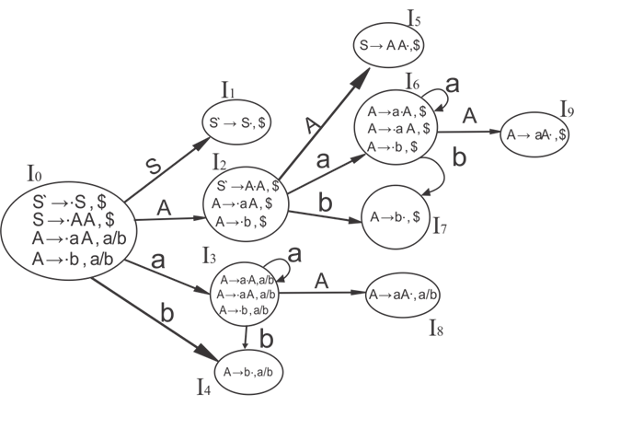

CLR (1) Parsing table:
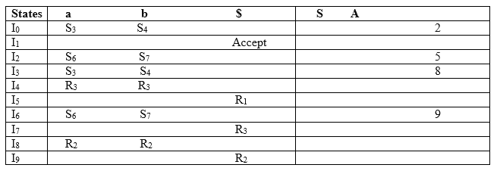
Productions are numbered as follows:
- S → AA ... (1)
- A → aA ....(2)
- A → b ... (3)
The placement of shift node in CLR (1) parsing table is same as the SLR (1) parsing table. Only difference in the placement of reduce node.
I4 contains the final item which drives ( A → b•, a/b), so action {I4, a} = R3, action {I4, b} = R3.
I5 contains the final item which drives ( S → AA•, $), so action {I5, $} = R1.
I7 contains the final item which drives ( A → b•,$), so action {I7, $} = R3.
I8 contains the final item which drives ( A → aA•, a/b), so action {I8, a} = R2, action {I8, b} = R2.
I9 contains the final item which drives ( A → aA•, $), so action {I9, $} = R2.

LALR (1) Parsing:
LALR refers to the lookahead LR. To construct the LALR (1) parsing table, we use the canonical collection of LR (1) items.
In the LALR (1) parsing, the LR (1) items which have same productions but different look ahead are combined to form a single set of items
LALR (1) parsing is same as the CLR (1) parsing, only difference in the parsing table.

Example
LALR ( 1 ) Grammar
- S → AA
- A → aA
- A → b
Add Augment Production, insert '•' symbol at the first position for every production in G and also add the look ahead.
- S` → •S, $
- S → •AA, $
- A → •aA, a/b
- A → •b, a/b
I0 State:
Add Augment production to the I0 State and Compute the ClosureL
I0 = Closure (S` → •S)
Add all productions starting with S in to I0 State because "•" is followed by the non-terminal. So, the I0 State becomes
I0 = S` → •S, $
S → •AA, $
Add all productions starting with A in modified I0 State because "•" is followed by the non-terminal. So, the I0 State becomes.
I0= S` → •S, $
S → •AA, $
A → •aA, a/b
A → •b, a/b
I1= Go to (I0, S) = closure (S` → S•, $) = S` → S•, $
I2= Go to (I0, A) = closure ( S → A•A, $ )
Add all productions starting with A in I2 State because "•" is followed by the non-terminal. So, the I2 State becomes
I2= S → A•A, $
A → •aA, $
A → •b, $
I3= Go to (I0, a) = Closure ( A → a•A, a/b )
Add all productions starting with A in I3 State because "•" is followed by the non-terminal. So, the I3 State becomes
I3= A → a•A, a/b
A → •aA, a/b
A → •b, a/b
Go to (I3, a) = Closure (A → a•A, a/b) = (same as I3)
Go to (I3, b) = Closure (A → b•, a/b) = (same as I4)
I4= Go to (I0, b) = closure ( A → b•, a/b) = A → b•, a/b
I5= Go to (I2, A) = Closure (S → AA•, $) =S → AA•, $
I6= Go to (I2, a) = Closure (A → a•A, $)
Add all productions starting with A in I6 State because "•" is followed by the non-terminal. So, the I6 State becomes
I6 = A → a•A, $
A → •aA, $
A → •b, $
Go to (I6, a) = Closure (A → a•A, $) = (same as I6)
Go to (I6, b) = Closure (A → b•, $) = (same as I7)
I7= Go to (I2, b) = Closure (A → b•, $) = A → b•, $
I8= Go to (I3, A) = Closure (A → aA•, a/b) = A → aA•, a/b
I9= Go to (I6, A) = Closure (A → aA•, $) A → aA•, $
If we analyze then LR (0) items of I3 and I6 are same but they differ only in their lookahead.
I3 = { A → a•A, a/b
A → •aA, a/b
A → •b, a/b
}
I6= { A → a•A, $
A → •aA, $
A → •b, $
}
Clearly I3 and I6 are same in their LR (0) items but differ in their lookahead, so we can combine them and called as I36.
I36 = { A → a•A, a/b/$
A → •aA, a/b/$
A → •b, a/b/$
}
The I4 and I7 are same but they differ only in their look ahead, so we can combine them and called as I47.
I47 = {A → b•, a/b/$}
The I8 and I9 are same but they differ only in their look ahead, so we can combine them and called as I89.
I89 = {A → aA•, a/b/$}

Drawing DFA:
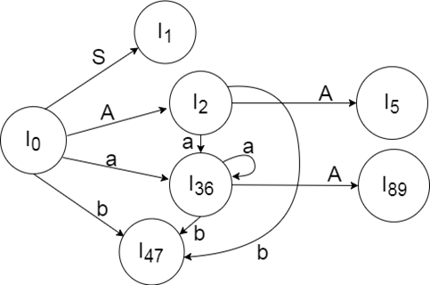

LALR (1) Parsing table:

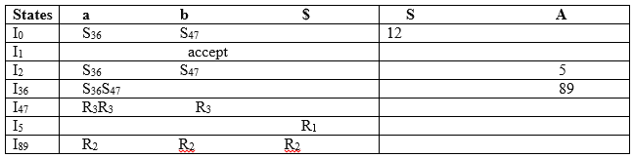

LL vs. LR
LL | LR
Does a leftmost derivation. | Does a rightmost derivation in reverse.
Starts with the root nonterminal on the stack. | Ends with the root nonterminal on the stack.
Ends when the stack is empty. | Starts with an empty stack.
Uses the stack for designating what is still to be expected. | Uses the stack for designating what is already seen.
Builds the parse tree top-down. | Builds the parse tree bottom-up.
Continuously pops a nonterminal off the stack, and pushes the corresponding right hand side. | Tries to recognize a right hand side on the stack, pops it, and pushes the corresponding nonterminal.
Expands the non-terminals. | Reduces the non-terminals.
Reads the terminals when it pops one off the stack. | Reads the terminals while it pushes them on the stack.
Pre-order traversal of the parse tree. | Post-order traversal of the parse tree.
A parser should be able to detect and report any error in the program. It is expected that when an error is encountered, the parser should be able to handle it and carry on parsing the rest of the input. Mostly it is expected from the parser to check for errors but errors may be encountered at various stages of the compilation process. A program may have the following kinds of errors at various stages:
- Lexical : name of some identifier typed incorrectly
- Syntactical : missing semicolon or unbalanced parenthesis
- Semantical : incompatible value assignment
- Logical : code not reachable, infinite loop
There are four common error-recovery strategies that can be implemented in the parser to deal with errors in the code.

Panic mode
When a parser encounters an error anywhere in the statement, it ignores the rest of the statement by not processing input from erroneous input to delimiter, such as semi-colon. This is the easiest way of error-recovery and also, it prevents the parser from developing infinite loops.

Statement mode
When a parser encounters an error, it tries to take corrective measures so that the rest of inputs of statement allow the parser to parse ahead. For example, inserting a missing semicolon, replacing comma with a semicolon etc. Parser designers have to be careful here because one wrong correction may lead to an infinite loop.

Error productions
Some common errors are known to the compiler designers that may occur in the code. In addition, the designers can create augmented grammar to be used, as productions that generate erroneous constructs when these errors are encountered.

Global correction
The parser considers the program in hand as a whole and tries to figure out what the program is intended to do and tries to find out a closest match for it, which is error-free. When an erroneous input (statement) X is fed, it creates a parse tree for some closest error-free statement Y. This may allow the parser to make minimal changes in the source code, but due to the complexity (time and space) of this strategy, it has not been implemented in practice yet.

Abstract Syntax Trees
Parse tree representations are not easy to be parsed by the compiler, as they contain more details than actually needed. Take the following parse tree as an example:
If watched closely, we find most of the leaf nodes are single child to their parent nodes. This information can be eliminated before feeding it to the next phase. By hiding extra information, we can obtain a tree as shown below:
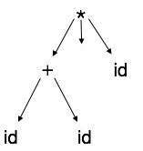
Abstract tree can be represented as:
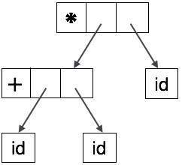
ASTs are important data structures in a compiler with least unnecessary information. ASTs are more compact than a parse tree and can be easily used by a compiler.

1. Which phase of compiler is Syntax Analysis
a) First
b) Second
c) Third
d) None of the mentioned
2. What is Syntax Analyser also known as
a) Hierarchical Analysis
b) Hierarchical Parsing
c) None of the mentioned
d) Hierarchical Analysis & Parsing
3. Syntax Analyser takes Groups Tokens of source Program into Grammatical Production
a) True
b) False
4. From where it take its input from?
a) Lexical analyser
b) Syntactic Analyser
c) Semantic Analyser
d) None of the mentioned
5. Parsers are expected to parse the whole code
a) True
b) False
6. A grammar for a programming language is a formal description of
a) Syntax
b) Semantics
c) Structure
d) Library
7. Which of these is not true about Symbol Table?
a) All the labels of the instructions are symbols
b) Table has entry for symbol name address value
c) Perform the processing of the assembler directives
d) Created during pass 1
8. Which of these features of assembler are Machine-Dependent
a) Instruction formats
b) Addressing modes
c) Program relocation
d) All of the mentioned
9. A compiler can check?
a) Logical Error
b) Syntax Error
c) Both Logical and Syntax Error
d) Not Logical and Syntax Error
10. The fourth Generation computer was made up of?
a) Transistor
b) Vacuum tubes
c) Chips
d) Microprocessor chips
11. Select a Machine Independent phase of the compiler
a) Syntax Analysis
b) Intermediate Code generation
c) Lexical Analysis
d) All of the mentioned
12. A system program that combines the separately compiled modules of a program into a form suitable for execution?
a) Assembler
b) Compiler
c) Linking Loader
d) Interpreter
13. Which of the following system software resides in the main memory always
a) Text Editor
b) Assembler
c) Linker
d) Loader
14. Output file of Lex is _____ the input file is Myfile?
a) Myfile.e
b) Myfile.yy.c
c) Myfile.lex
d) Myfile.obj
15. Type checking is normally done during?
a) Lexical Analysis
b) Syntax Analysis
c) Syntax Directed Translation
d) Code generation
16. Suppose One of the Operand is String and other is Integer then it does not throw error as it only checks whether there are two operands associated with ‘+’ or not .
a) True
b) False
17. In Short Syntax Analysis Generates Parse Tree
a) True
b) False
18. By whom is the symbol table created?
a) Compiler
b) Interpreter
c) Assembler
d) None of the mentioned
19. What does a Syntactic Analyser do?
a) Maintain Symbol Table
b) Collect type of information
c) Create parse tree
d) None of the mentioned
20. Semantic Analyser is used for?
a) Generating Object code
b) Maintaining symbol table
c) Generating Object code & Maintaining symbol table
d) None of the mentioned
21. Assume the statements S1 and S2 given as:
S1: Given a context free grammar, there exists an algorithm for determining whether L (G) is infinite.
S2: There exists an algorithm to determine whether two context free grammars generate the same language.
Which of the following is true?
a) S1 is correct and S2 is not correct
b) Both S1 and S2 are correct
c) Both S1 and S2 are not correct
d) S1 is not correct and S2 is correct
22. If P & R are regular and also given that if PQ=R, then
a) Q has to be regular
b) Q cannot be regular
c) Q need not be regular
d) Q has to be a CFL
23. Which of the following conversion is not possible (algorithmically)?
a) Regular grammar to CFG
b) NDFA to DFA
c) NDPDA to DPDA
d) NDTM to DTM
24. Consider the grammar given below E? E+E | E*E | E-E | E/E | E^E | (E) | id Assume that + and ^ have the same but least precedence, * and / have the next higher precedence but the same precedence and finally ^ has the highest precedence. Assume + and ^ associate to the left like * and / and that ^ associates to the right. Choose the correct for the ordered pairs (^,^) , (-,-) , (+,+) , (*,*) in the operator precedence table constructed for the grammar
a) All <
b) All >
c) < > , =
d) < > > >
25. Recursively enumerable languages are not closed under:
a) Union
b) Intersection
c) Complementation
d) Concatenation
26. Grammar that produce more than one Parse tree for same sentence is:
a) Ambiguous
b) Unambiguous
c) Complementation
d) Concatenation Intersection
27. Automaton accepting the regular expression of any number of a ‘ s is:
a) a*
b) ab*
c) (a/b)*
d) a*b*c
28. Grammars that can be translated to DFAs:
a) Left linear grammar
b) Right linear grammar
c) Generic grammar
d) All of the mentioned
View Answer
29. The language accepted by a Push down Automata:
a) Type0
b) Type1
c) Type2
d) Type3
30. Given the following statements: (i) Recursive enumerable sets are closed under complementation. (ii) Recursive sets are closed under complements. Which is/are the correct statements?
a) I only
b) II only
c) Both I and II
d) Neither I nor II
31. Assume statements S1 and S2 defined as: S1: L2-L1 is recursive enumerable where L1 and L2 are recursive and recursive enumerable respectively. S2: The set of all Turing machines is countable. Which of the following is true?
a) S1 is correct and S2 is not correct
b) Both S1 and S2 are correct
c) Both S1 and S2 are not correct
d) S1 is not correct and S2 is correct
32. A context free language is called ambiguous if
a) It has 2 or more left derivations for some terminal string ѡ є L (G)
b) It has 2 or more right derivations for some terminal string ѡ є L (G)
c) Both of the mentioned
d) None of the mentioned
33. Which of the following statement is false?
a) The CFG can be converted to Chomsky normal form
b) The CFG can be converted to Greibach normal form
c) CFG is accepted by pushdown automata
d) None of the mentioned
34. The context free grammar S → A111|S1, A → A0 | 00 is equivalent to
a) {0ⁿ1ᵐ | n=2, m=3}
b) {0ⁿ1ᵐ | n=1, m=5}
c) {0ⁿ1ᵐ | n should be greater than two and m should be greater than four}
d) None of the mentioned
35. The context free grammar S → SS | 0S1 | 1S0 | ɛ generates
a) Equal number of 0’s and 1’s
b) Unequal number of 0’s and 1’s
c) Number of 0’s followed by any number of 1’s
d) None of the mentioned
36. Which of the following statement is false?
a) In derivation tree, the label of each leaf node is terminal
b) In derivation tree, the label of all nodes except leaf nodes is a variable
c) In derivation tree, if the root of a sub tree is X then it is called –tree
d) None of the mentioned
37. Push down automata accepts which language
a) Context sensitive language
b) Context free language
c) Recursive language
d) None of the mentioned
38. A regular Grammar is a?
a) CFG
b) Non CFG
c) English Grammar
d) None of the mentioned
39. A CFG is closed under
a) Union
b) Kleene star
c) Concatenation
d) None of the mentioned
40. Which of these does not belong to CFG
a) Terminal Symbol
b) Non terminal Symbol
c) Start symbol
d) End Symbol

- Write The role of a parser.
- Define Context-free grammars
- Write the rule for Writing a grammar
- Define Parsing
- Define Ambiguous grammar
- Write the procedure for Elimination of Ambiguity from grammar
- Write the Classification of parsing techniques.
- Define Top down parsing
- What are the types of Top down parsing.
- Define Back Tracking,
- Define Recursive Descent parsing,
- Define First function.
- Define Follow function.
- Define LL(1) Grammars.
- Define Non-Recursive descent parsing.
- Write the procedure for Error recovery in predictive parsing.
- Define LR grammars.
- Define Bottom Up parsing.
- What are the types of Bottom up parsing techniques.
- Write the use of LR Parser.
- Draw the Model of an LR Parsers
- Define SR parsing
- Define Operator Precedence Parsing.
- Define SLR parsing.
- Define CLR parsing
- Define LALR parsing,
- Write the types of Error recovery techniques in LR Parsing.
- Explain how to handling ambiguous grammars.
- Construct FIRST() function for the following grammar
EE+T/T
TT*F/F
F(E)/id
- Construct FOLLOW() function for the following grammar
EE+T/T
TT*F/F
F(E)/id

