**System: An app called Top Five where software engineers can post listing top 5 research results for a specific domain of software development**

**Requirements Elicitation (via survey with open-ended responses):**

1. Which features from other social media platforms would you want to see in this app?

RB: I want to message researchers who post that feature, like LinkedIn or Instagram. I believe facilitating the conversation past the post will build comradery and bonding with one-to-many researchers. Also, I want to see a similar comment-based system like Reddit where other users can be upvoted or downvoted based on their responses.

FO: I would like researchers to be able to edit their posts as this feature is found on LinkedIn, Facebook, Twitter, and WhatsApp. So, that wrong post can be edited to carry out the correct meaning.

1. How would you like to see posts presented to you? [Examples: chronological, popularity, filters]

FO: I want posts from the researcher to be filtered based on chronological from the recent post.

RB: I would like to see the posts presented to be based on popularity, but I don’t want the algorithm to “shadow ban” posts / discriminate viewership from certain profiles.

1. How do you want to interact with other users on the platform? [Examples: friends, followers, groups]

RB: I would like this app to have multiple groups where initially, users can choose if they want their profile to be public or private. Then, users can create groups (either public or private) that they can share with other users. Users should also be able to have followers in any visibility account (private or public).

FO: I would like the app to have no limit on the number of people who can join a public group and follow a public personality.

1. What sort of information would you want stored on your personal profile?

RB: Since this is more of a research app, users can have the option if they want to show their academia-oriented email public or private. I also want the ability to store my first name, last name (either of these with initials), school or company affiliations.

FO: Users should be able to upload profile pictures, link to their personal website.

1. What current social media app is most similar to what you would want this system to look like? What features of this app do you like?

RB: I think making this a mix of Reddit and StackOverFlow/StackExchange would be pretty cool. I would like to see upvoted / downvoted comments and be able to click and understand more about the poster.

**Features:**

* Message researchers
* Comments
* Ability to Upvote or Downvote comments
* Edit posts
* Sort: Option between chronological and popular and category/group (HCI, hardware, Software dev, gamification, etc)
* Choice between public or private profiles
* Create public or private groups, with some pre created public groups based on category
* User profiles: academic oriented email, first and last name, school or company, feed of posts they’ve made, message feature

**Requirements Diagram:**

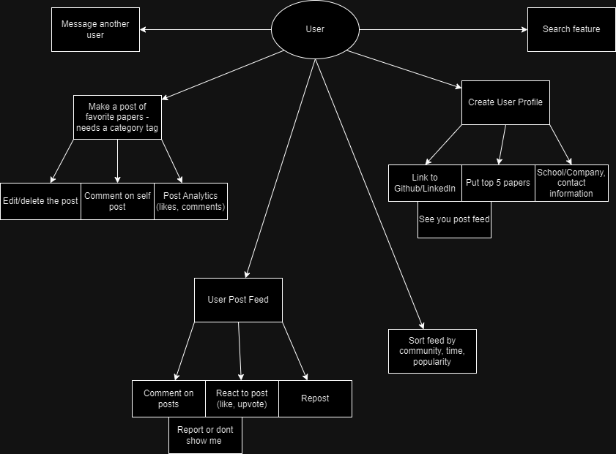

**User Stories:**

* User Story 1 – Researcher: I want to be able to see how others are using the papers I’ve written and what fields they find it to apply to most.
* User Story 2 – Learner: I am new to my field and I want to see what are some of the most informative papers in that field, so I can quickly get caught up to speed.
* User Story 3 – Networker: I have been in my field for a while and I am familiar with papers, but I want to connect and network with other people in this field nationwide.