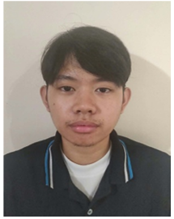
JEREMIE L. CASPILLO
Brgy. Canabajan, Calinog, Iloilo
jeremiecaspillo16@gmail.com | 09765533660

PROFESSIONAL SUMMARY
An Information Technology student with strong communication, critical thinking, and conflict-resolution skills. Committed to providing excellent client service, optimizing communication processes, and fostering a supportive team atmosphere in fast-paced environments.

EDUCATION Bachelor of Science in Technology
PHINMA University of Iloilo 2024 – Present

General Academic Strand (GAS)
Calinog Comprehensive National High School 2022 – 2024
CORE COMPETENCIES & SKILLS
- Customer Service & Soft Skills: Interpersonal Communication, Conflict Resolution, Behavioral Cognitive Analysis, Adaptability, Ethical Compliance, Critical Thinking.
- Technical Skills: MS Office Proficiency, General Computer Operations, Linux System Administration (KDE Plasma, GNOME).
- Languages: Hiligaynon, Filipino, and English.
SEMINARS & TRAINING
- AI Ready ASEAN Hour of Code | October 2025
- CID 2025: Level Up Glitch Tower | September 2025
- Information Session: PNPKI for Everyone (DICT) | April 2026
- Computing Now: From Code to Cloud to Career | May 2026
- PROTECTING DIGITAL TRANSACTION AND PERSONAL DATA (DICT) | June 2026
- CITEDAY: CITEBOX 2026 Debugging (3rd Place) | October 2026
- HackforGov2026 (Top 6) | October 2026
ACTIVITIES
F1STACKMIND - MEMBER | 2024 - Present
- Spoke at Cyber Security Bulbs, an event under F1 Stackmind that tackles cyber security including threats, malwares, viruses etc.

