**SURIGAO DEL NORTE STATE UNIVERSITY**

**Narciso St., 8400, Surigao City,**

**Surigao del Norte**

**City Campus**

**THE JOURNAL:**

**Food Inventory System**

In partial Fulfillment of the Requirements for the Subject SOFTWARE DESIGN & DATABASE MANAGEMENT SYSTEM

**By:**

**JEMAN C. LUMANCAS**

**BSCPE 2B**

**Abstract:** The "Food Inventory System" offers an efficient solution for managing food supplies, incorporating user-friendly functionalities for seamless inventory tracking. With features such as "Add Item," "Update Item," and "Delete Item," the system ensures precise and up-to-date inventory records. Additionally, the "Log In" and "Log Out" functionalities enhance security and user management. This innovative system not only improves inventory accuracy and reduces food wastage but also streamlines operations, enabling users to maintain a well-organized food inventory and achieve greater efficiency.

1. **INTRODUCTION**

Introducing the "Food Inventory System" – a state-of-the-art solution transforming food inventory management. Designed with efficiency and simplicity in mind, this web application streamlines the often complex process of managing food supplies, specifically tailored for the needs of various food-related businesses.

At the core of this system are seamless functionalities such as "Add Item," "Update Item," and "Delete Item," allowing administrators to effortlessly maintain accurate and up-to-date inventory records. Additionally, the "Log In" and "Log Out" features enhance security and ensure that only authorized users can access and manage the inventory.

Gone are the days of manual inventory tracking methods prone to errors and inefficiencies. With the Food Inventory System, users can efficiently oversee their inventory, reduce food wastage, and streamline their operations with unmatched ease and precision. Join us in embracing the future of food inventory management with the Food Inventory System.

1. **OBJECTIVES**

The objectives of the Food Inventory System are as follows:

1. **Efficient Inventory Management**:
   * Provide a user-friendly platform for adding, updating, and deleting food items.
   * Maintain accurate and up-to-date inventory records to minimize errors.
2. **Reduction of Food Wastage**:
   * Track food supplies effectively to reduce spoilage and wastage.
3. **Enhanced Security**:
   * Implement secure log in and log out features to restrict access to authorized personnel.
4. **Streamlined Operations**:
   * Automate and simplify inventory management processes to save time and resources.
   * Provide real-time updates and reports on inventory status for better decision-making.
5. **Improved User Experience**:
   * Design an intuitive and accessible interface catering to the needs of food-related businesses.
   * Offer comprehensive support and easy navigation for users.
6. **Scalability and Adaptability**:
   * Build a system capable of scaling with business growth and adapting to various food-related operations.
7. **METHODOLOGY**

The methodology of the Food Inventory System refers to the systematic processes and techniques used in designing, developing, and maintaining the system.

1. **Requirement Analysis**
   * **Objective**: Define the goal of creating an Inventory Management System for efficient management and monitoring of product inventory within the organization.
   * **Stakeholder Interviews**: Gather detailed requirements from stakeholders to understand specific needs.
   * **Use Cases**: Document various use cases and scenarios focusing on CRUD operations and inventory management functionalities.
2. **Technology Selection**
   * **Web Server**: N/A (Desktop application)
   * **Programming Language**: Python
   * **Database**: SQLite
   * **Frontend Technologies**: Tkinter (Python GUI toolkit)
   * **Back-end Technologies**: SQLite (Embedded database)
3. **System Design**
   * **Architectural Design**: Define system architecture, separating user interface, business logic, and data access layers.
   * **Database Design**: Design the database schema to store product details, supplier information, and inventory data.
   * **User Interface Design**: Create wireframes and prototypes to ensure a responsive and intuitive user interface.
4. **Front-end Development (HTML/CSS)**
   * **Responsive Design**: Build a responsive layout using HTML and CSS.
   * **Styling**: Utilize frameworks like Bootstrap for consistent styling.
   * **Data Presentation**: Implement dynamic data presentation using libraries like DataTables.
5. **Back-end Development (Programming Language/Database)**
   * **CRUD Operations**: Develop scripts to handle Create, Read, Update, and Delete operations for products and suppliers.
   * **Business Logic**: Implement logic for inventory tracking, quantity updates, and status monitoring.
   * **Security**: Implement authentication and authorization mechanisms for secure access.
6. **Testing and Quality Assurance**
   * **Unit Testing**: Test individual components to ensure correct functionality.
   * **Integration Testing**: Verify interaction between different modules.
   * **User Acceptance Testing (UAT)**: Conduct testing with actual users to validate against requirements.
7. **Deployment and Integration**
   * **Server Setup**: Configure the server environment for hosting the application.
   * **Deployment**: Deploy the application on the server with correct dependencies and configurations.
   * **Continuous Integration/Continuous Deployment (CI/CD)**: Implement CI/CD pipelines for automated deployment.
8. **Training and Support**
   * **User Training**: Provide training sessions or materials for system usage.
   * **Documentation**: Maintain comprehensive documentation for setup, usage, and troubleshooting.
9. **Feedback Collection and Iteration**
   * **User Feedback**: Regularly collect feedback for continuous improvement.
   * **Iterative Development**: Use Agile methodologies for iterative development based on feedback.
10. **Maintenance and Updates**
    * **Bug Fixing**: Address reported issues and bugs promptly.
    * **System Updates**: Periodically update the system to add new features or improve existing functionalities.
    * **Performance Monitoring**: Monitor system performance and optimize as needed.
    * **Security Audits**: Conduct regular security audits to identify and address vulnerabilities.
11. **RESULTS AND DISCUSSION**

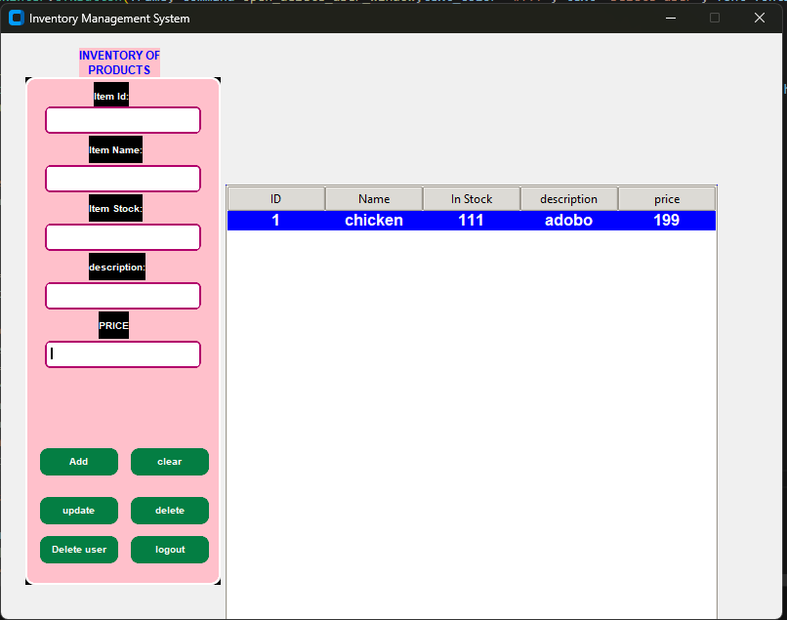

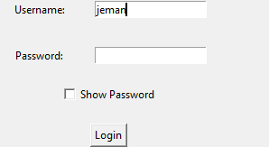

**Admin Features:**

**Login and Logout:**

* The Food Inventory System incorporates a secure login mechanism to authenticate administrators and grant access to system functionalities. Upon successful authentication, administrators can access various features for inventory management. Additionally, the system facilitates secure logout to terminate active sessions and ensure data confidentiality and system security.

**Add Functionality:**

* The "Add" functionality enables administrators to input new product details into the system's inventory database. By providing a user-friendly interface to enter product information such as ID, name, stock, description, and price, this feature allows for seamless integration of new products into the inventory catalog.

**Delete Functionality:**

* The "Delete" functionality empowers administrators to remove existing product entries from the inventory database. Administrators can select specific products either from the displayed list or by entering the product ID, triggering the deletion process. This feature ensures efficient management of inventory data by eliminating obsolete or redundant product entries.

**Update Functionality:**

* The "Update" functionality facilitates administrators in modifying existing product details within the inventory database. By offering fields to edit product attributes such as name, stock, description, and price, this feature allows for real-time updates to product information. Administrators can seamlessly revise product details to reflect changes in stock levels, pricing, or descriptions.

**Clear Functionality:**

* The "Clear" functionality provides administrators with a convenient way to reset input fields and clear any entered data. With a single click, administrators can erase content from input fields, facilitating the input of new product information or the correction of errors. This feature enhances user experience and ensures accuracy when inputting product details.

**Delete User Functionality:**

* The "Delete User" functionality enables administrators to remove user accounts from the system, enhancing user management capabilities. Administrators can specify the user ID of the account to be deleted, triggering the removal process. This feature ensures efficient user account management and data security by revoking access for inactive or unauthorized users.

Overall, these functionalities empower administrators to efficiently manage inventory data, perform essential CRUD (Create, Read, Update, Delete) operations, and maintain user accounts within the Food Inventory System. With intuitive interfaces and comprehensive features, the system enhances productivity, accuracy, and security in inventory management processes.

1. **CONCLUSION**

The "Food Inventory System" signifies a groundbreaking advancement in inventory management tailored specifically for the culinary industry. This cutting-edge system redefines how food establishments monitor their inventory and manage their workforce. With key functionalities such as "Add Item" for effortless inventory updates and "Real-Time Tracking" for precise record-keeping, it ensures a seamless and accurate inventory management experience. The system's user-centric design simplifies operations while fortifying security and accountability. In essence, the Food Inventory System epitomizes the fusion of innovation and practicality, empowering culinary businesses to optimize their processes and achieve unparalleled success in their endeavors.