Chapter Two
Introduction to Algorithm and Algorithm Analysis
  - Algorithms
An algorithm is a well-defined computational procedure that takes some value or a set of values as input and produces some value or a set of values as output. Data structures model the static part of the world. They are unchanging while the world is changing. In order to model the dynamic part of the world we need to work with algorithms. Algorithms are the dynamic part of a program‘s world model.
An algorithm transforms data structures from one state to another state in two ways:
- An algorithm may change the value held by a data structure
- An algorithm may change the data structure itself
The quality of a data structure is related to its ability to successfully model the characteristics of the world. Similarly, the quality of an algorithm is related to its ability to successfully simulate the changes in the world.
However, independent of any particular world model, the quality of data structure and algorithms is determined by their ability to work together well. Generally speaking, correct data structures lead to simple and efficient algorithms and correct algorithms lead to accurate and efficient data structures.
    - Properties of an algorithm
- Finiteness: Algorithm must complete after a finite number of steps
- Definiteness: Each step must be clearly defined, having one and only one interpretation. At each point in computation, one should be able to tell exactly what happens next
- Sequence: Each step must have a unique defined preceding and succeeding step. The first step (start step) and last step (halt step) must be clearly noted
- Feasibility: It must be possible to perform each instruction
- Correctness: It must compute correct answer for all possible legal inputs
- Language Independence: It must not depend on any one programming language
- Completeness: It must solve the problem completely
- Effectiveness: It must be possible to perform each step exactly and in a finite amount of time
- Efficiency: It must solve with the least amount of computational resources such as time and space
- Generality: Algorithm should be valid on all possible inputs
- Input/output: There must be a specified number of input values, and one or more result values
    - Algorithm Analysis Concepts
Algorithm analysis refers to the process of determining the amount of computing time and storage space required by different algorithms. In other words, it‘s a process of predicting the resource requirement of algorithms in a given environment.
In order to solve a problem, there are many possible algorithms. One has to be able to choose the best algorithm for the problem at hand using some scientific method. To classify some data structures and algorithms as good, we need precise ways of analyzing them in terms of resource requirement. The main resources are:
- Running Time
- Memory Usage
- Communication Bandwidth

Running time is usually treated as the most important since computational time is the most precious resource in most problem domains. There are two approaches to measure the efficiency of algorithms:
- Empirical: Programming competing algorithms and trying them on different instances.
- Theoretical: Determining the quantity of resources required mathematically (Execution time, memory space, etc.) needed by each algorithm.

However, it is difficult to use actual clock-time as a consistent measure of an algorithm‘s efficiency, because clock-time can vary based on many things. For example,
- Specific processor speed
- Current processor load
- Specific data for a particular run of the program
- Input Size
- Input Properties
- Operating Environment

Accordingly, we can analyze an algorithm according to the number of operations required, rather than according to an absolute amount of time involved. This can show how an algorithm‘s efficiency changes according to the size of the input.

    - Complexity Analysis
Complexity Analysis is the systematic study of the cost of computation, measured either in time units or in operations performed, or in the amount of storage space required.
The goal is to have a meaningful measure that permits comparison of algorithms independent of operating platform. There are two things to consider:
- Time Complexity: Determine the approximate number of operations required to solve a problem of size n
- Space Complexity: Determine the approximate memory required to solve a problem of size n
Complexity analysis involves two distinct phases:
- Algorithm Analysis: Analysis of the algorithm or data structure to produce a function T (n) that describes the algorithm in terms of the operations performed in order to measure the complexity of the algorithm
- Order of Magnitude Analysis: Analysis of the function T (n) to determine the general complexity category to which it belongs

There is no generally accepted set of rules for algorithm analysis. However, an exact count of operations is commonly used.

Analysis Rules:
1. We assume an arbitrary time unit.
2. Execution of one of the following operations takes time 1:
- Assignment Operation
- Single Input/output Operation
- Single Boolean Operations
- Single Arithmetic Operations
- Function Return
3. Running time of a selection statement (if, switch) is the time for the condition evaluation + the maximum of the running times for the individual clauses in the selection.
4. Loops: Running time for a loop is equal to the running time for the statements inside the loop * number of iterations.

The total running time of a statement inside a group of nested loops is the running time of the statements multiplied by the product of the sizes of all the loops.
For nested loops, analyze inside out.
- Always assume that the loop executes the maximum number of iterations possible
5. Running time of a function call is 1 for setup + the time for any parameter calculations + the time required for the execution of the function body.
Examples:

1. int count(){
int k=0;
cout<< ―Enter an integer‖;
cin>>n;
for (i=0;i<n;i++)
k=k+1;
return 0;}
Time Units to Compute
-------------------------------------------------
1 for the assignment statement: int k=0
1 for the output statement.1 for the input statement.
In the for loop:
1 assignment, n+1 tests, and n increments.
n loops of 2 units for an assignment, and an addition.
1 for the return statement.
-------------------------------------------------------------------
T (n)= 1+1+1+(1+n+1+n)+2n+1 = 4n+6 = O(n)
2. int total(int n)
{
int sum=0;
for (int i=1;i<=n;i++)
sum=sum+1;
return sum;
}
Time Units to Compute
-------------------------------------------------
1 for the assignment statement: int sum=0
In the for loop:
1 assignment, n+1 tests, and n increments.
n loops of 2 units for an assignment, and an addition.
1 for the return statement.
-------------------------------------------------------------------
T (n)= 1+ (1+n+1+n)+2n+1 = 4n+4 = O(n)

3. void func()
{
int x=0;
int i=0;
int j=1;
cout<< ―Enter an Integer value‖;
cin>>n;
while (i<n){
x++;
i++;
}
while (j<n)
{
j++;
}
}
Time Units to Compute
-------------------------------------------------
1 for the first assignment statement: x=0;
1 for the second assignment statement: i=0; 10
1 for the third assignment statement: j=1;
1 for the output statement
1 for the input statement
In the first while loop:
n+1 tests
n loops of 2 units for the two increment (addition) operations
In the second while loop:
n tests
n-1 increments
-------------------------------------------------------------------
T (n)= 1+1+1+1+1+n+1+2n+n+n-1 = 5n+5 = O(n)
4. int sum (int n)
{
int partial_sum = 0;
for (int i = 1; i <= n; i++)
partial_sum = partial_sum +(i * i * i);
return partial_sum;
}
Time Units to Compute
-------------------------------------------------
1 for the assignment
1 assignment, n+ 1 test, and n increments
n loops of 4 units for an assignment, an addition, and two multiplications
1 for the return statement
-------------------------------------------------------------------

T (n) = 1+(1+n+1+n)+4n+1 = 6n+4 = O(n)
Formal Approach to Analysis
In the above examples we have seen that analysis is a bit complex. However, it can be simplified by using some formal approach in which case we can ignore initializations, loop control, and book keeping.
For Loops: Formally
In general, a for loop translates to a summation. The index and bounds of the summation are the same as the index and bounds of the for loop.
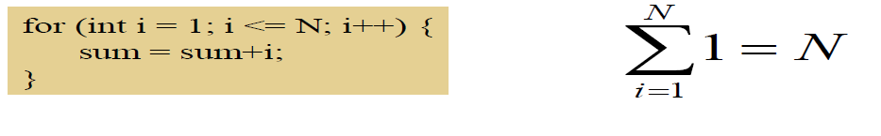
Suppose we count the number of additions that are done. There is 1 addition per iteration of the loop, hence N additions in total.

Nested Loops: Formally
Nested for loops translate into multiple summations, one for each for loop.
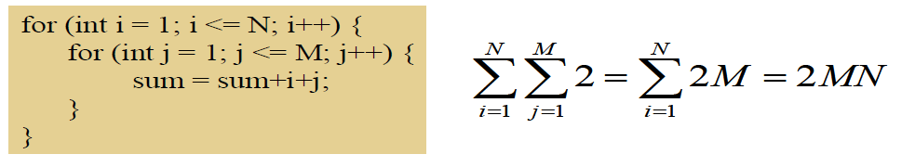
Again, count the number of additions. The outer summation is for the outer for loop.
Consecutive Statements: Formally
Add the running times of the separate blocks of your code
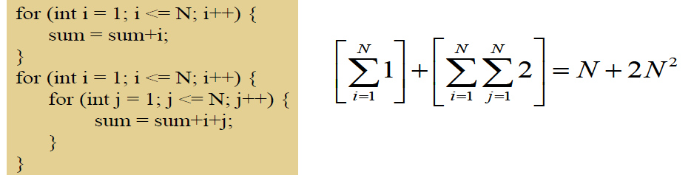
Conditionals: Formally
If (test) s1 else s2: Compute the maximum of the running time for s1 and s2.
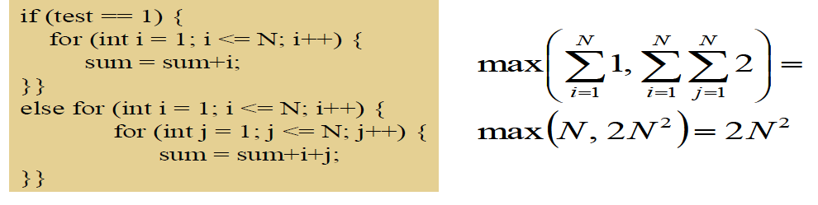
Example:
Suppose we have hardware capable of executing 10⁶ instructions per second. How long would it take to execute an algorithm whose complexity function was:
T (n) = 2n² on an input size of n=10⁸?
The total number of operations to be performed would be T (10⁸):
T (10⁸) = 2*(108)² =2*10¹⁶
The required number of seconds
required would be given by
T (10⁸)/10⁶ so:
Running time =2*10¹⁶/10⁶ = 2*10¹⁰
The number of seconds per day is 86,400 so this is about 231,480 days (634 years).

Exercises
Determine the run time equation and complexity of each of the following code segments.
- for (i=0;i<n;i++)
for (j=0;j<n; j++)
sum=sum+i+j;
- for(int i=1; i<=n; i++)
for (int j=1; j<=i; j++)
sum++;
What is the value of the sum if n=20?
- int k=0;
for (int i=0; i<n; i++)
for (int j=i; j<n; j++)
k++;
What is the value of k when n is equal to 20?
- int k=0;
for (int i=1; i<n; i*=2)
for(int j=1; j<n; j++)
k++;
What is the value of k when n is equal to 20?
- int x=0;
for(int i=1;i<n;i=i+5)
x++;
What is the value of x when n=25?

- int x=0;
for(int k=n;k>=n/3;k=k-5)
x++;
What is the value of x when n=25?
- int x=0;
for (int i=1; i<n;i=i+5)
for (int k=n;k>=n/3;k=k-5)
x++;
What is the value of x when n=25?
- int x=0;
for(int i=1;i<n;i=i+5)
for(int j=0;j<i;j++)
for(int k=n;k>=n/2;k=k-3)
x++;
What is the correct big-Oh Notation for the above code segment?

  - Asymptotic Analysis
Asymptotic analysis is concerned with how the running time of an algorithm increases with the size of the input in the limit, as the size of the input increases without bound.
There are five notations used to describe a running time function. These are:
- Big-Oh Notation (O)
- Big-Omega Notation (Ω)
- Theta Notation (Θ)
- Little-o Notation (o)
- Little-Omega Notation (ω)
    - The Big-Oh Notation
Big-Oh notation is a way of comparing algorithms and is used for computing the complexity of algorithms; i.e., the amount of time that it takes for computer program to run. It‘s only concerned with what happens for very a large value of n. Therefore only the largest term in the expression (function) is needed. For example, if the number of operations in an algorithm is n² – n, n is insignificant compared to n² for large values of n. Hence the n term is ignored. Of course, for small values of n, it may be important. However, Big-Oh is mainly concerned with large values of n.
Formal Definition: f (n) = O (g (n)) if there exist c, k ε R⁺ such that for all n≥ k, f (n) ≤ c.g (n).
Examples: The following points are facts that you can use for Big-Oh problems:
- 1<=n for all n>=1
- n<=n² for all n>=1
- 2^{n} <=n! for all n>=4
- log₂n<=n for all n>=2
- n<=nlog₂n for all n>=2

- f(n)=10n+5 and g(n)=n. Show that f(n) is O(g(n)).
To show that f(n) is O(g(n)) we must show that constants c and k such that
f(n) <=c.g(n) for all n>=k
Or 10n+5<=c.n for all n>=k
Try c=15. Then we need to show that 10n+5<=15n
Solving for n we get: 5<5n or 1<=n.
So f(n) =10n+5 <=15.g(n) for all n>=1.
(c=15,k=1).
- f(n) = 3n² +4n+1. Show that f(n)=O(n²).
4n <=4n² for all n>=1 and 1<=n² for all n>=1
3n² +4n+1<=3n²+4n²+n² for all n>=1
<=8n² for all n>=1
So we have shown that f(n)<=8n² for all n>=1
Therefore, f (n) is O (n²) (c=8,k=1)
Typical Orders
Here is a table of some typical cases. This uses logarithms to base 2, but these are simply proportional to logarithms in other base.
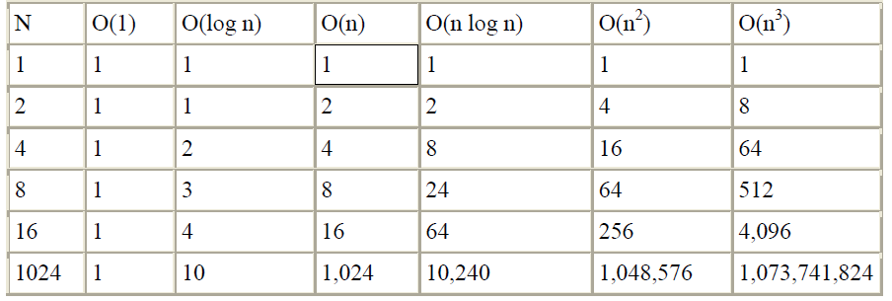
Demonstrating that a function f(n) is big-O of a function g(n) requires that we find specific constants c and k for which the inequality holds (and show that the inequality does in fact hold).
Big-O expresses an upper bound on the growth rate of a function, for sufficiently large values of n.
An upper bound is the best algorithmic solution that has been found for a problem.
What is the best that we know we can do?
Exercise:
f(n) = (3/2)n²+(5/2)n-3
Show that f(n)= O(n²)
In simple words, f (n) =O (g(n)) means that the growth rate of f(n) is less than or equal to g(n).
      - Big-O Theorems
For all the following theorems, assume that f(n) is a function of n and that k is an arbitrary constant.
Theorem 1: k is O (1)
Theorem 2: A polynomial is O (the term containing the highest power of n).
Polynomial‘s growth rate is determined by the leading term
- If f (n) is a polynomial of degree d, then f(n) is O(n^{d})

In general, f (n) is big-O of the dominant term of f (n).
Theorem 3: k*f (n) is O (f(n))
Constant factors may be ignored
E.g. f (n) =7n⁴+3n²+5n+1000 is O (n⁴)
Theorem 4(Transitivity): If f(n) is O(g(n))and g(n) is O(h(n)), then f(n) is O(h(n)).
Theorem 5: For any base b, log_{b}(n) is O(logn).
All logarithms grow at the same rate
log _{b} n is O(log_{d} n) b, d > 1
Theorem 6: Each of the following functions is big-O of its successors:
k
log_{b}n
n
nlog_{b}n
n²
n to higher powers
2^{n}
3^{n}
Larger constants to the nth power
n!
n^{n}
f (n)= 3nlog_{b}n + 4 log_{b}n+2 is O(nlog_{b}n) and )(n²) and O(2^{n})
      - Properties of the O Notation
Higher powers grow faster
•n^{r} O ( n^{s}) if 0 <= r <= s

Fastest growing term dominates a sum
• If f (n) is O (g (n)), then f (n) + g (n) is O (g)

E.g. 5n⁴ + 6n³ is O (n⁴)
Exponential functions grow faster than powers, i.e. is O (b^{n}). For all b > 1 and k >= 0 E.g. n²⁰ is O (1.05^{n})
Logarithms grow more slowly than powers
- log _{b} n is O(n^{k}) for all b>1 and K>=0
e.g. log₂n is O (n^{0.5})

    - Big-Omega Notation
Just as O-notation provides an asymptotic upper bound on a function,  notation provides an asymptotic lower bound.
Formal Definition: A function f(n) is Ω( g (n)) if there exist constants c and k ε ℛ+ such that
f (n) >=c. g(n) for all n>=k.
f(n)= Ω( g (n)) means that f(n) is greater than or equal to some constant multiple of g(n) for all values of n greater than or equal to some k.
Example: If f(n) =n², then f(n)= Ω( n)
In simple terms, f(n)= Ω ( g (n)) means that the growth rate of f(n) is greater that or equal to g(n).
    - Theta Notation
A function f (n) belongs to the set of Θ (g(n)) if there exist positive constants c1 and c2 such that it can be sandwiched between c1.g(n) and c2.g(n), for sufficiently large values of n.
Formal Definition: A function f (n) is Θ (g (n)) if it is both O (g (n)) and Ω (g (n)). In other words, there exist constants c1, c2, and k >0 such that c1.g (n) <=f(n)<=c2. g (n) for all n >= k
If f(n)=  (g(n)), then g(n) is an asymptotically tight bound for f(n).
In simple terms, f (n)= Θ (g(n)) means that f(n) and g(n) have the same rate of growth.
Example:
1. If f (n) =2n+1, then f(n) = Θ (n)
2. f(n) =2n² then
f (n)=O(n⁴)
f(n)=O(n³)
f(n)=O(n²)
All these are technically correct, but the last expression is the best and tight one. Since 2n2 and n2 have the same growth rate, it can be written as f(n)= (n2).
    - Little-o Notation
Big-Oh notation may or may not be asymptotically tight, for example: 2n² = O(n²)
=O(n³)
f(n)=o(g(n)) means for all c>0 there exists some k>0 such that f(n)<c.g(n) for all n>=k. Informally, f(n)=o(g(n)) means f(n) becomes insignificant relative to g(n) as n approaches infinity.
Example: f(n)=3n+4 is o(n²)
In simple terms, f(n) has less growth rate compared to g(n).
g(n)= 2n² g(n) =o(n³), O(n²), g(n) is not o(n²).
1.4.5. Little-Omega (ω notation)
Little-omega (ω) notation is to big-omega (Ω) notation as little-o notation is to Big-Oh notation. We use ω notation to denote a lower bound that is not asymptotically tight.
Formal Definition: f(n)= ω (g(n)) if there exists a constant no>0 such that 0<= c. g(n)<f(n) for all n>=k.
Example: 2n²= ω (n) but it‘s not ω (n2).

  - Relational Properties of the Asymptotic Notations
