RAC Project Phase 1 – Test Plan and Test Results

During RAC Project Phase 1, hardware and software will be installed, DexCom services and support systems will be unavailable, and access to those services and support systems will be re-established.

After Phase 1 changes are implemented, the DexCom IT Applications team (hereafter, the “DexCom team”) will test the ability to use the newly installed hardware and software to access the DexCom support systems that were temporarily unavailable during this phase. If the newly installed hardware and software are used to successfully access the support systems, the tests are successful.

This FT attachment describes the tests and criteria for test success.

**Note**: See attachment *RAC_Project1_Change_Implementation.docx* for change details.

# Services and Support System Access and Processing

During RAC Project Phase 1, the DexCom team will temporarily shutdown access to the services and support system listed below. After the primary phase tasks are complete (installing the required hardware and software) the team will reestablish access to these services and support systems.

* Actian Data Integrator
* Tableau
* Agile
* myDexCom
* Single Sign On (SSO)
* Shipping Warehouse
* Oracle EBS
* Oracle Apex Reporting
* Oracle Hyperion
* FedEx Ship Manager
* QC Hold System
* DocuClass
* PayPal PayFlow
* EDI

The planned tests and expected test results for these support systems are described in the following sections.

## Actian Data Integrator

To test Actian Data Integrator access:

1. Run evs prod to connect to the DexCom database. For example:

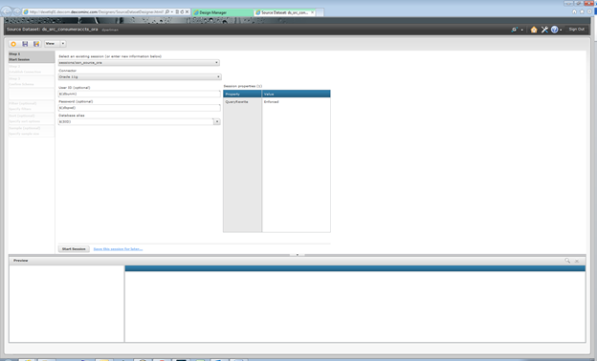

1. Click “Start Session.” For example:

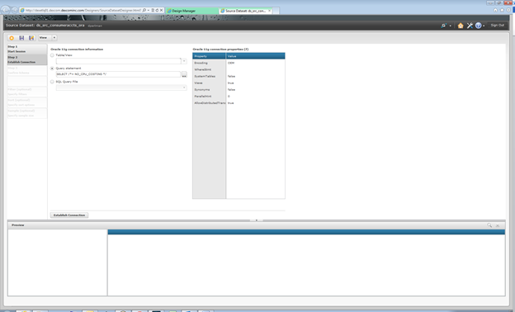

1. Click “Establish Connection.”

For example:

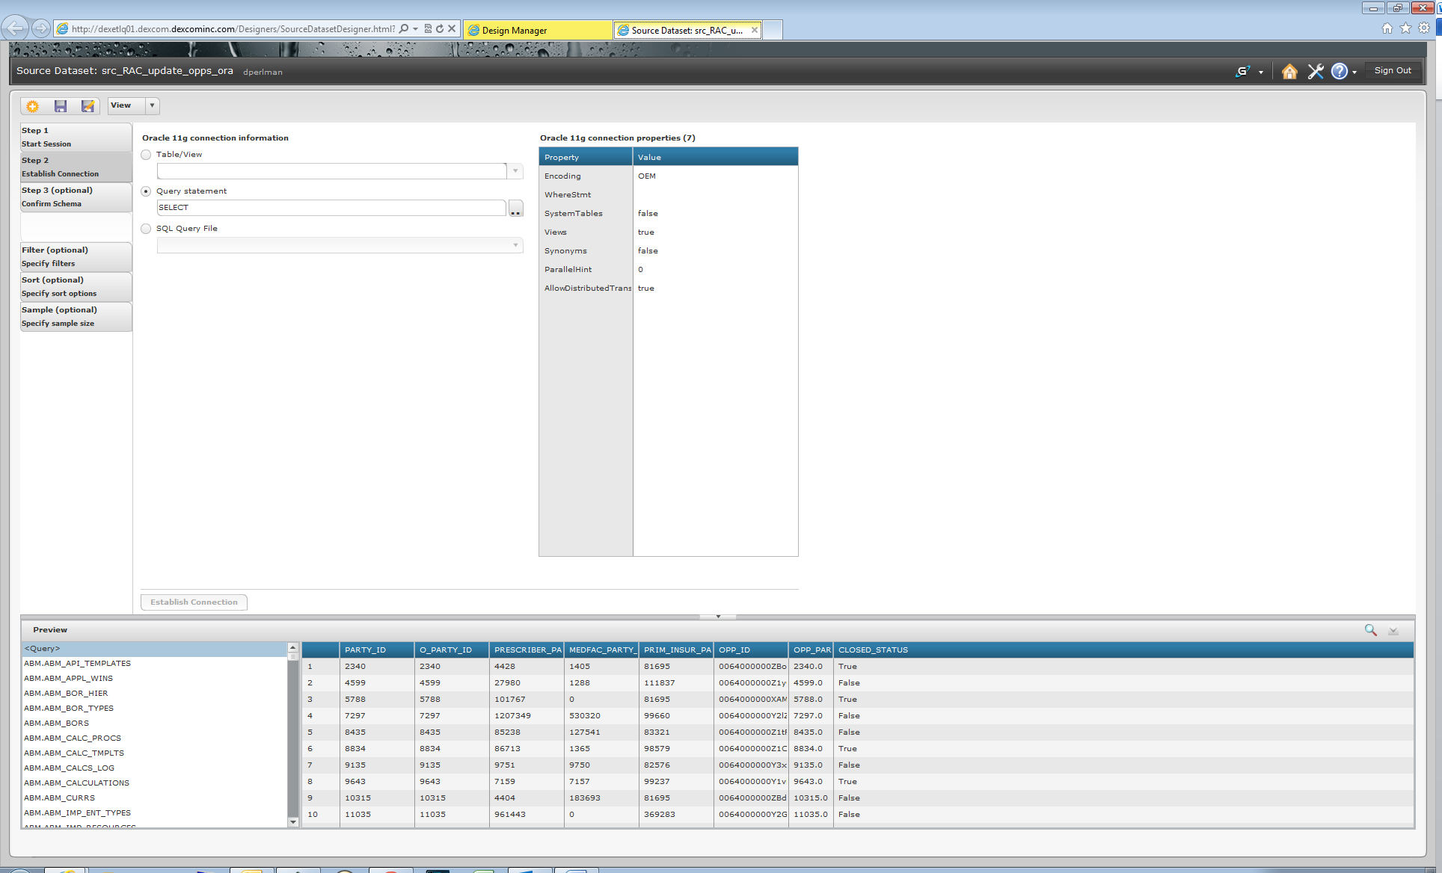

Here’s another example:

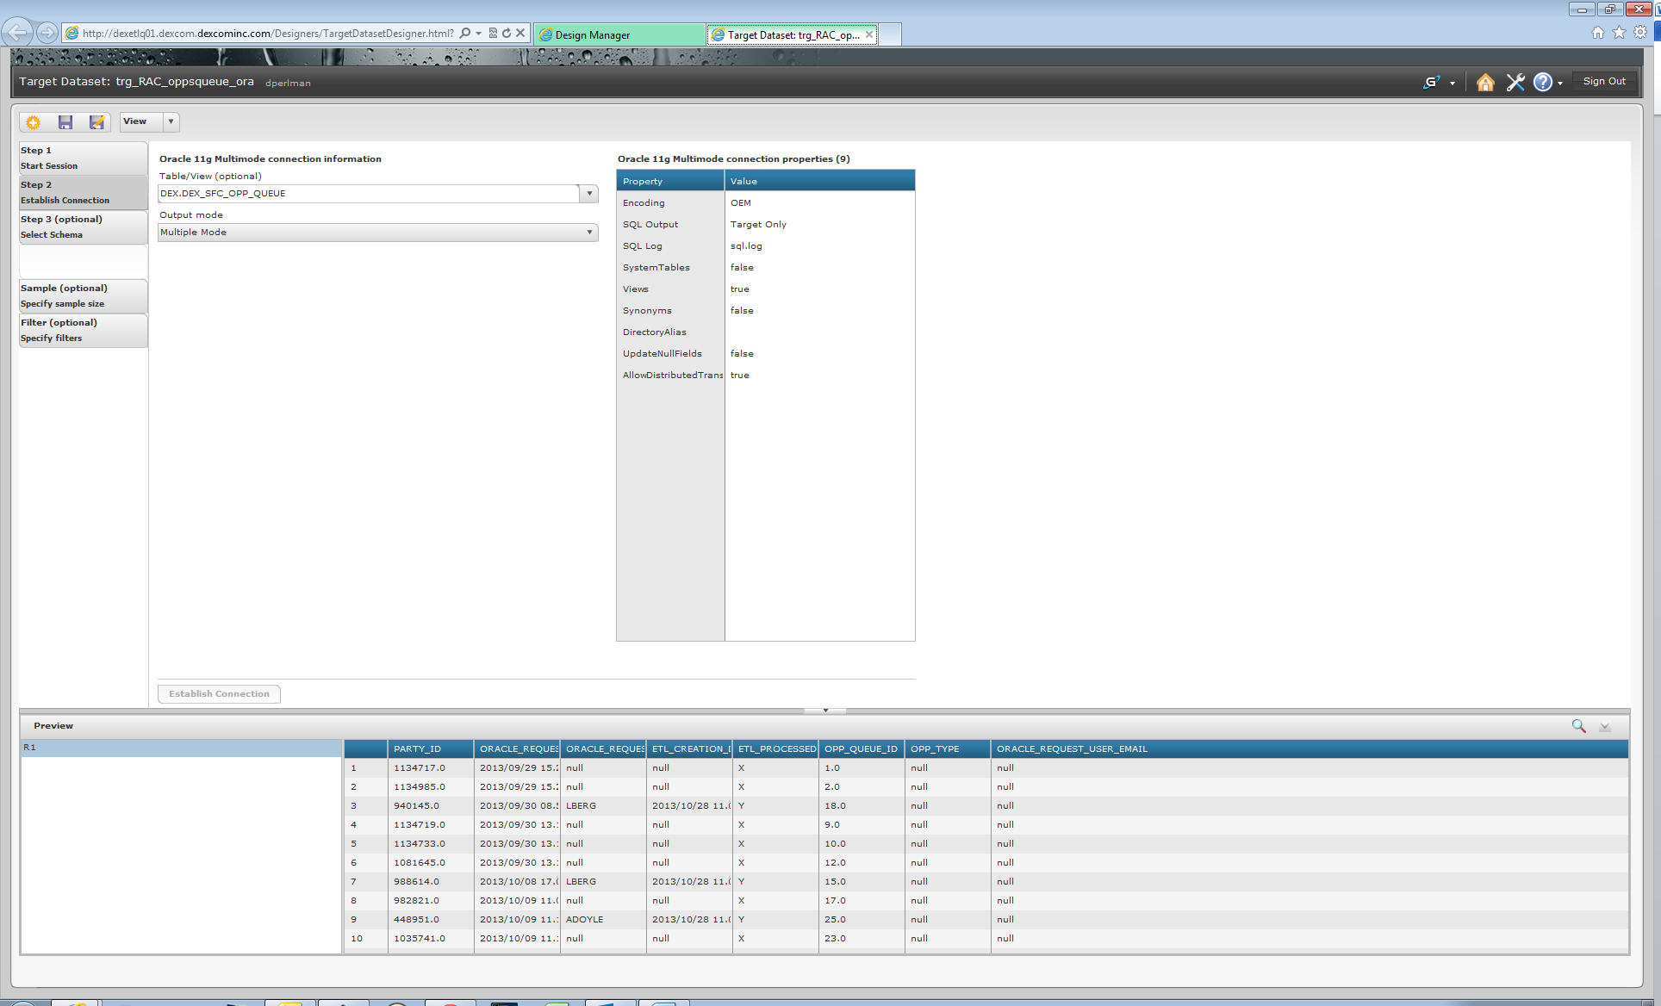

After the data display, the data set is returned in the preview pane.

## Tableau

Three Tableau-related DexCom repointed connections will have to be tested:

1. Data Warehouse (DW) to the DexCom Database
2. Tableau to Oracle
3. DexCom Website to DexCom Database.

Test Plan A:

To test DW access:

* Submit a Data Warehouse request for specific data to the instance of the DexCom EBS R12 Database connected to RAC. (Requested data must be available in the database.)

The test is successful, if the requested data is displayed.

Test Plan B:

To test Tableau to Oracle access:

* From Tableau, attempt to access Oracle.

The test is successful, if an Oracle page appears.

Test Plan C:

To test DexCom Website to DexCom Database access:

* On the DexCom Website, click a link to a DexCom service.

The test is successful, if the requested DexCom service page opens.

## Agile

To test Agile data retrieval:

* From Agile, request specific data from the DexCom Oracle Database.

If the test is successful, the requested data is displayed.

## myDexCom

To test myDexCom access:

* In a browser, attempt to connect to myDexCom.

If the test is successful, the myDexCom HTML page opens.

## Single Sign On (SSO)

To test SSO access:

* Attempt to connect to SSO.

If the test is successful, the SSO HTML page opens.

## Shipping Warehouse

To test Shipping Warehouse processes:

1. From dexbar1, browse to the Shipping site.
2. Run a database query.
   * Select DatabaseName.

For example:

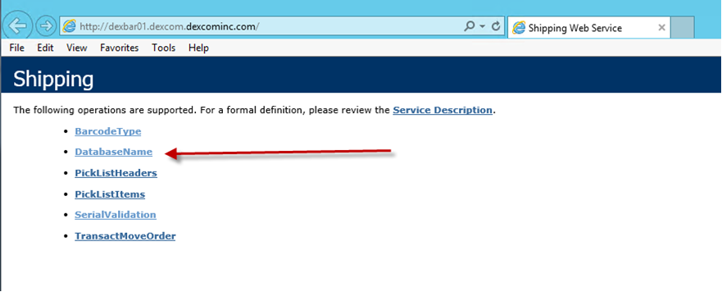

* + Under DatabaseName Test, click Invoke.

For example:

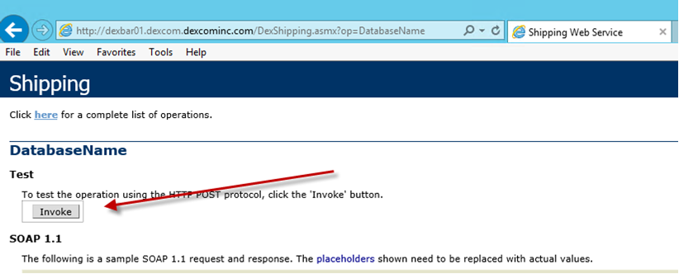

The test is successful, if the displayed XML shows the database currently targeted by the system.

For example, here the EBSQA database is targeted:

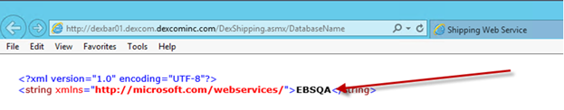

## Oracle EBS

The DexCom team test for the Oracle EBS Database system will focus on accessing the system and testing modules.

### Access Test

To test the accessibility of the Oracle EBS:

1. Try to access the HTML page for Oracle EBS system at <http://oracleebs.dexcom.dexcominc.com:8000>
2. Login to the application.

For example:

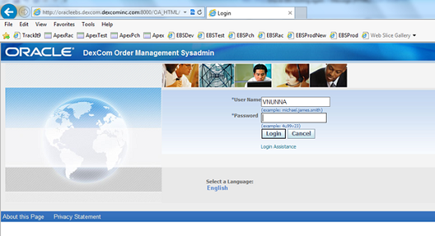

* Click a link to one of the forms that runs a JAVA applet.

The form opens in a separate window.

For example:

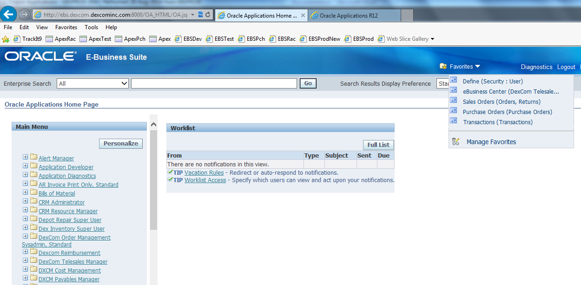

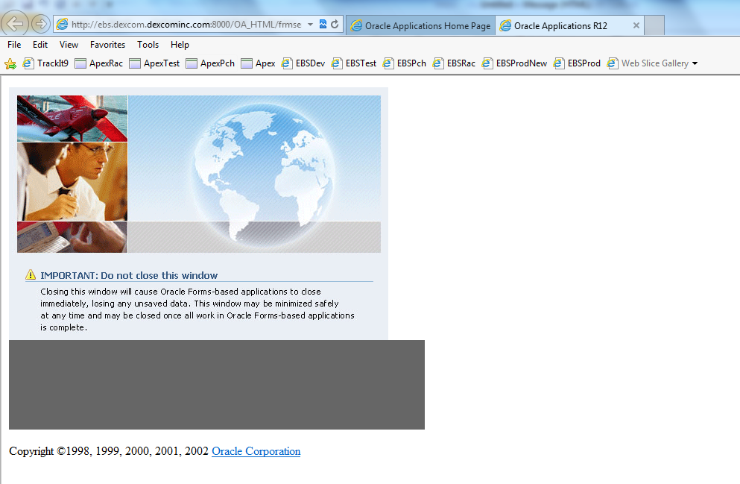

1. Try to run any one of the reports or concurrent programs.

The access test is successful, if:

* Oracle Intranet HTML page or form and the JAVA page appear.
* The JAVA page allows us to switch between different modules and submit requests or print reports.

For example:

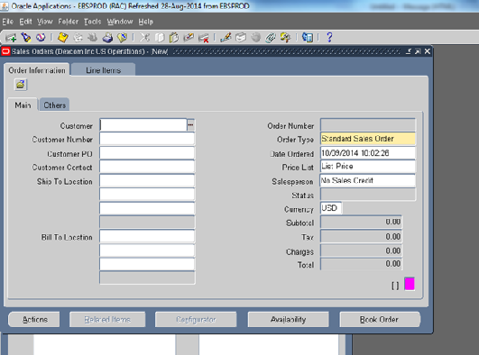

After the general access test (shown above), the DexCom team will continue with the module tests described in the following sections.

### Order Management Test

To test Order Management:

1. Create an order.

If the test step is successful, the new order is listed.

For example:

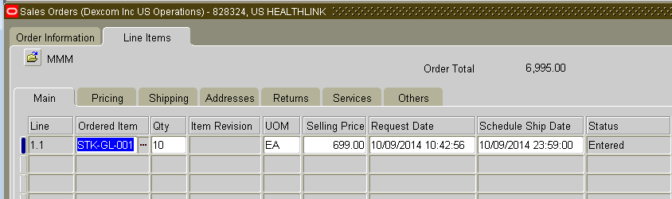

1. Book the order.

If the test step is successful, a message appears indicating that the order was booked.

For example:

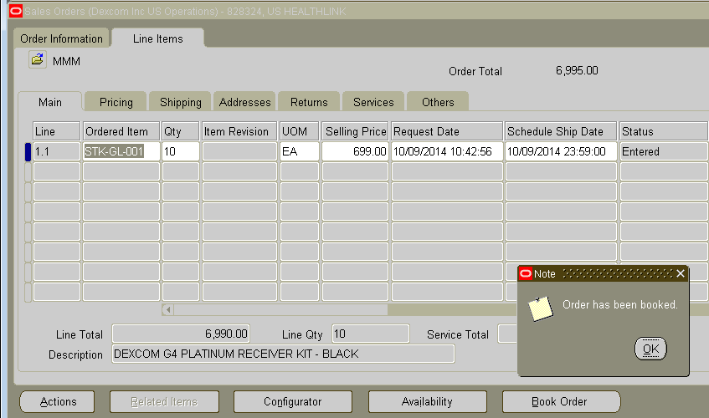

### Credit Card Processing Test

Next, the team will test the ability to process a credit card payment for the order created and booked in the previous test. To test Credit Card processing:

1. Enter the credit card payment.

The payment is approved. This step assumes:

* + DexCom communications with the card processing agency are working.
  + Card processing agency actually approves the credit card payment.

If this test step is successful, the Approval Code field is automatically filled.

For example:

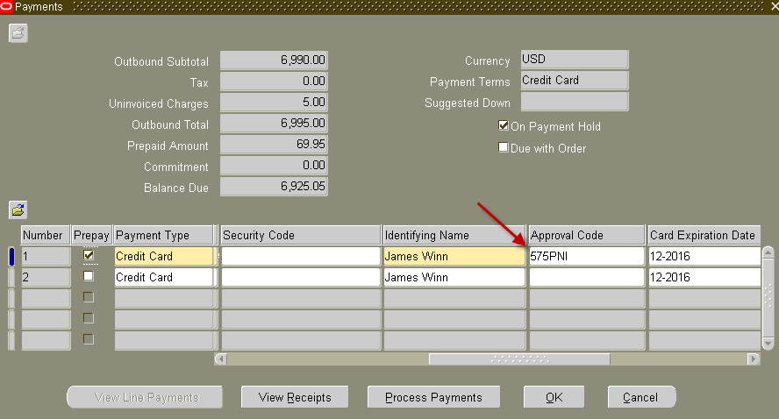

1. The approved credit card order is automatically booked.

If this test step is successful, the order is booked.

For example:

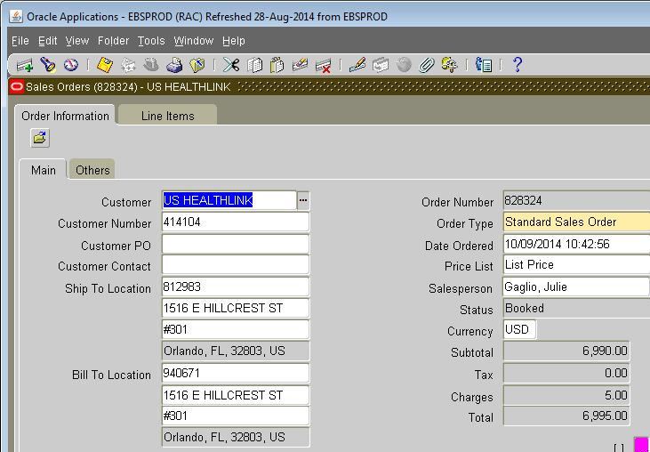

### Payable Process Test

To test Payable Processing:

1. Book an invoice.

If the test step is successful, the order is listed with a PO Number.

For example:

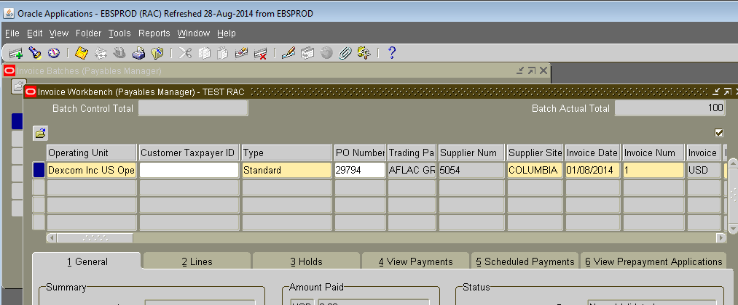  
The Account is automatically created.

If the test step passes, a message appears indicating that Accounting is successful.

For example:

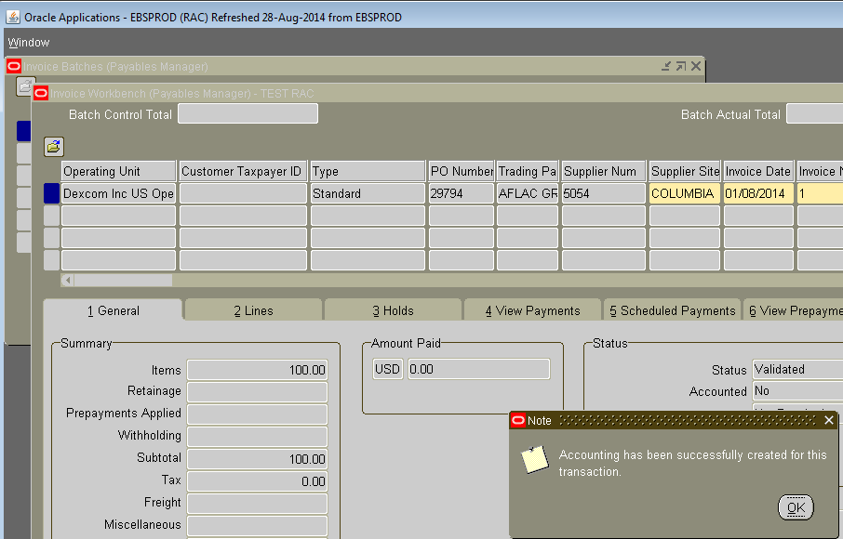

### Payment Process

To test the Payment Process:

1. In the Payment Processing window, check Create Accounting.
2. Select an accounting type.

For example:

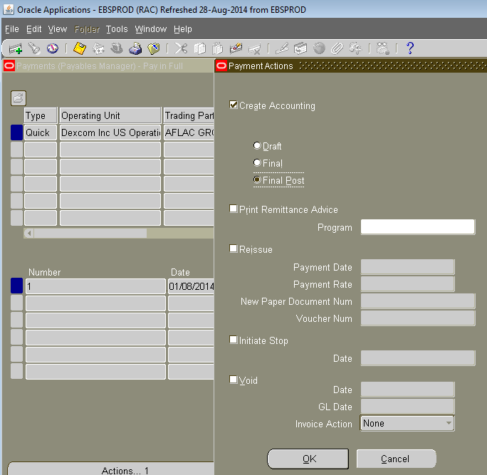

1. Click OK.

If the test step is successful, the Payment Overview shows the Amount Paid.

For example:

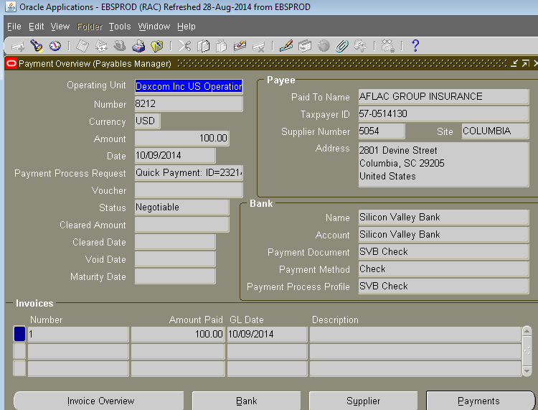

### Payable Concurrent Program – Trail Balance

The DexCom team will also test for a payable trial balance for a payable concurrent program.

To test this processing:

1. Run a payable trial balance.

If the test step is successful, Accounts Trial Balance is listed.

For example:

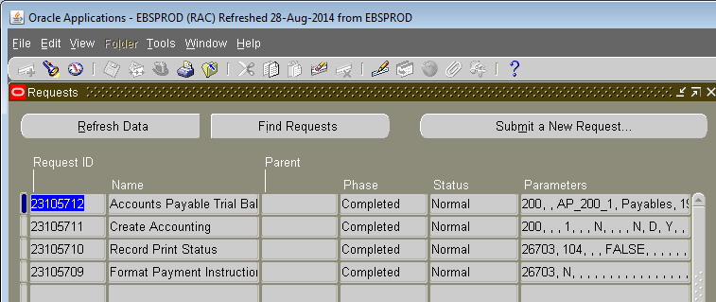

1. Generate a trail balance.

If the test step is successful, a Payables Trial Balance Report appears.

For example:

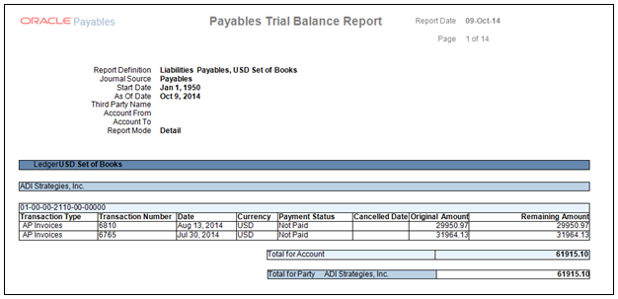

### General Ledger Test

To test the General Ledger:

1. Create a journal entry.

If the test step is successful, a Journals entry is listed.

For example:

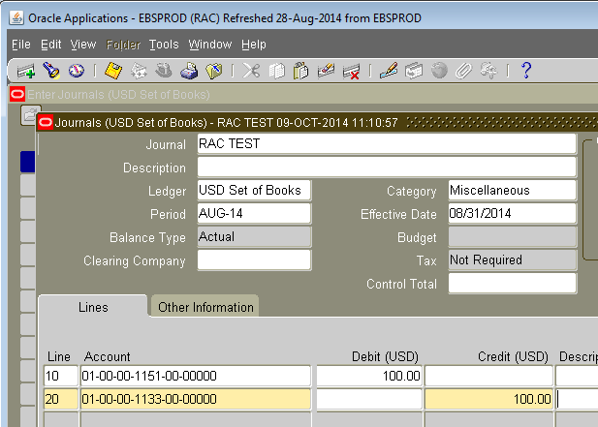

1. Post to the General Ledger.

If the test step is successful, a prompt message appears providing the request ID number.

For example:

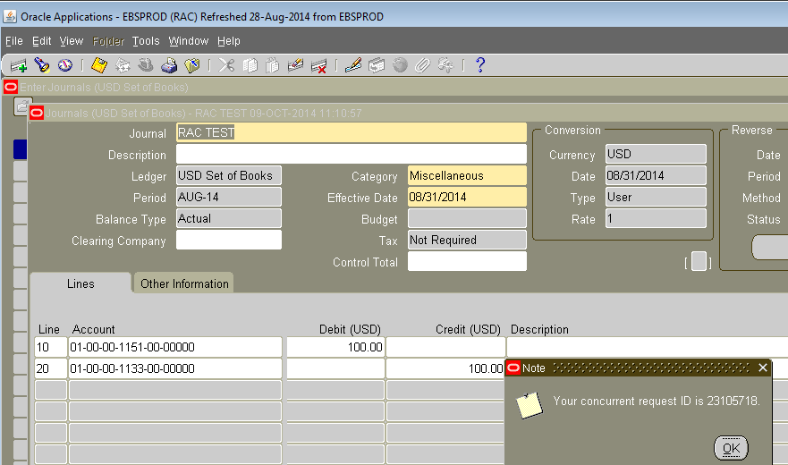

1. Click OK in the prompt to save the Journal entry.

If the test step is successful, a message appears indicating that the transaction is complete.

For example:

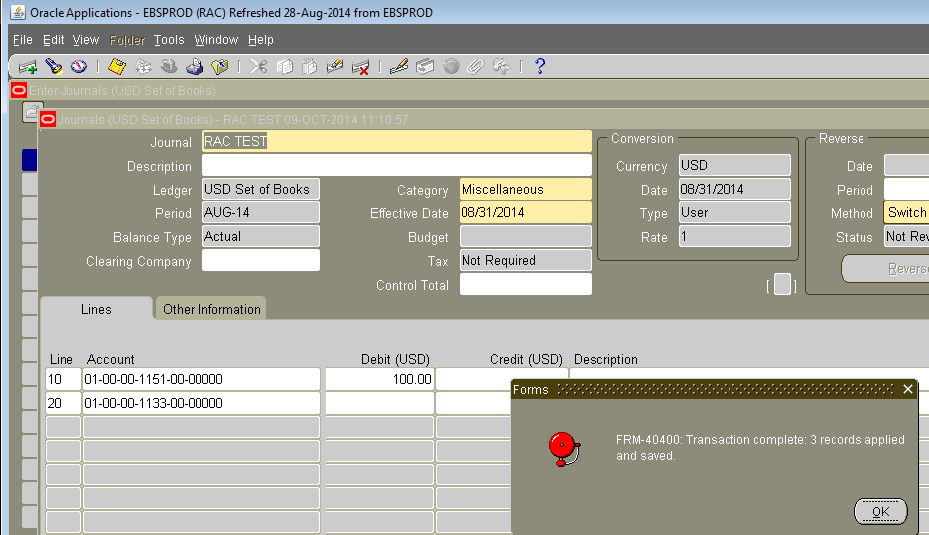

1. The posting process is completed automatically.

If the test step is successful, the Valid Journal Entry Batches report shows the batch entry for the request.

For example:

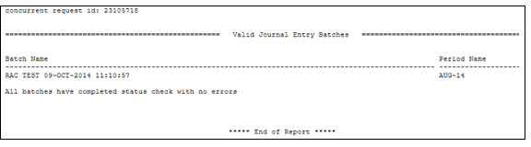

### Financial Statement Concurrent Report

To test Financial Statement reporting:

* Run a single report.

If the test step is successful, the Run Single Report Set screen appears listing all Ledger entries.

For example:

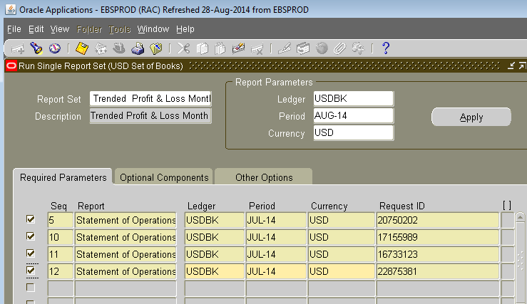

### Chart of Account Report

To test Chart of Account Reporting:

* Request a report.

If the test step is successful, the report appears.

For example:

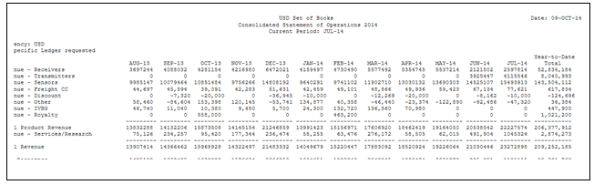

## Oracle Apex Reporting

To test Oracle Apex Reporting access:

1. Point the Apex application to the instance of the EBS R12 database connected to RAC.
2. Try to access the HTML page for Oracle Apex Reporting.
3. Login to the application and try to run different reports under different tabs.

The test is successful, if the application allows us to switch between different tabs and see the output of the reports.

For example:

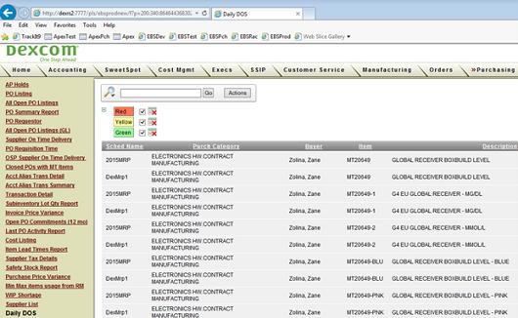

## Oracle Hyperion

To test Oracle Hyperion access:

* From a DexCom HTML page, select Navigate > Administer > Data Management > Source System.

If connection details are display, the test is successful.

The connection details are displayed.

For example:

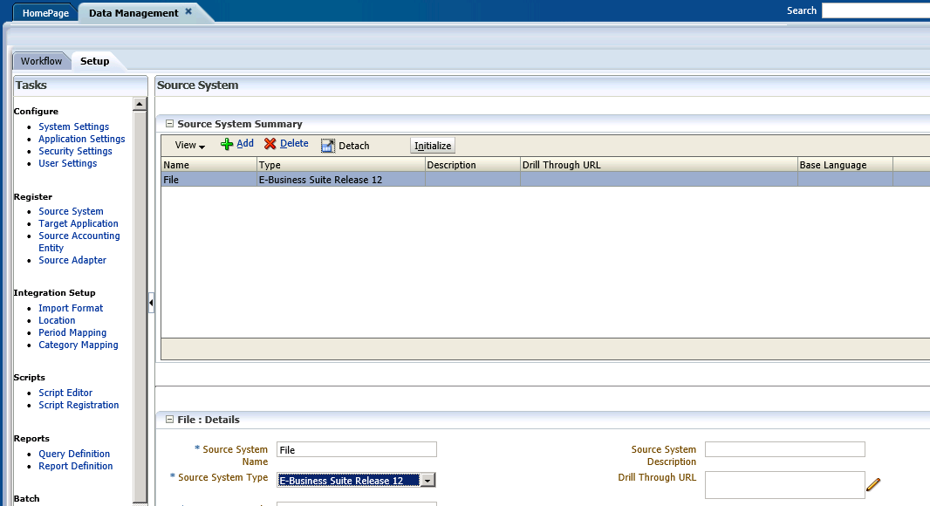

The test is successful.

## FedEx Ship Manager

To test FedEx Ship Manager access:

1. Open ODBC (32bit) on the local shipping PC.
2. Change the ODBC entry from Fedex Ship Manager Integration.

For example:

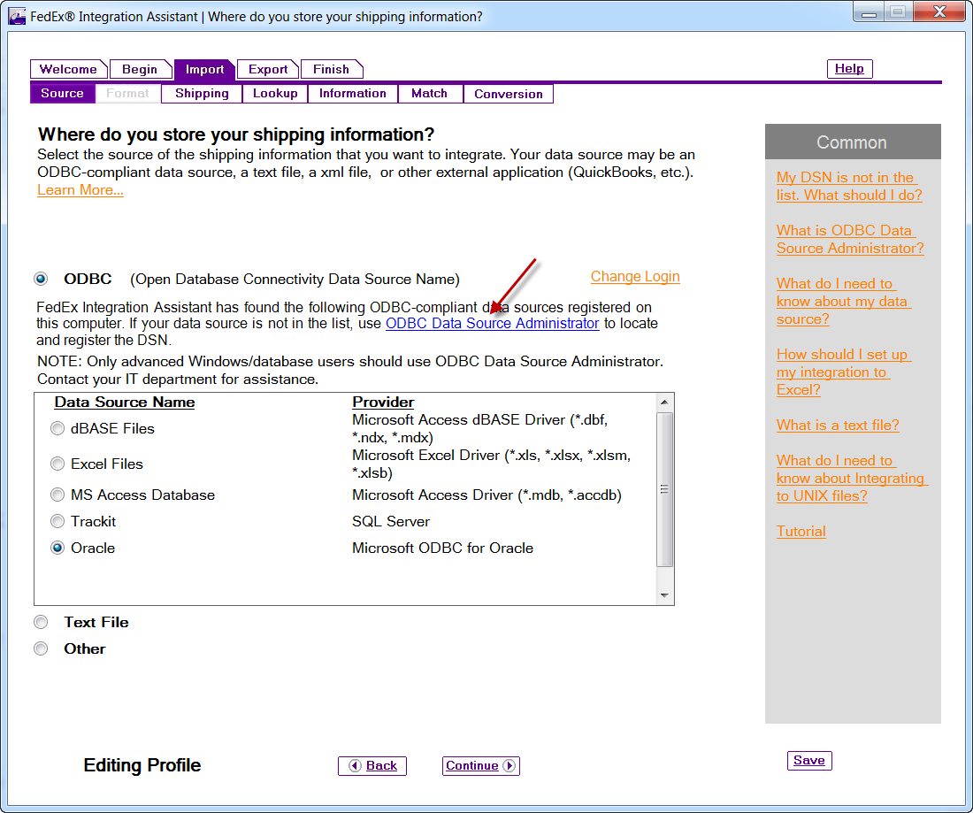

1. Select the System DSN tab.
2. Click Configure.

For example:

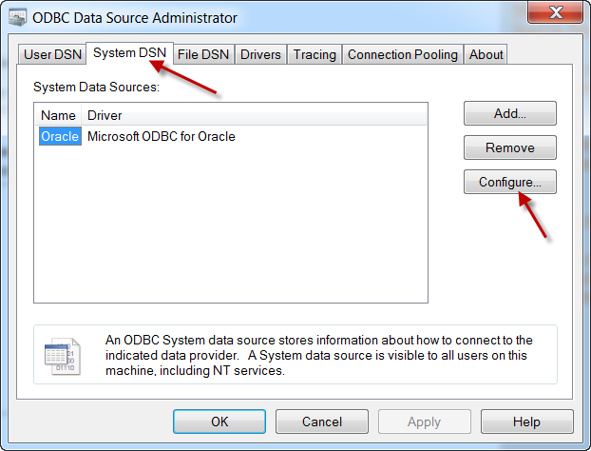

1. Enter the Server name.

For example:

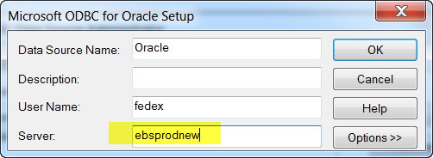

1. Click OK.
2. Open FedEx Ship Manager.
3. Click on Change Login.
4. Enter your User Name and Password.

For example:

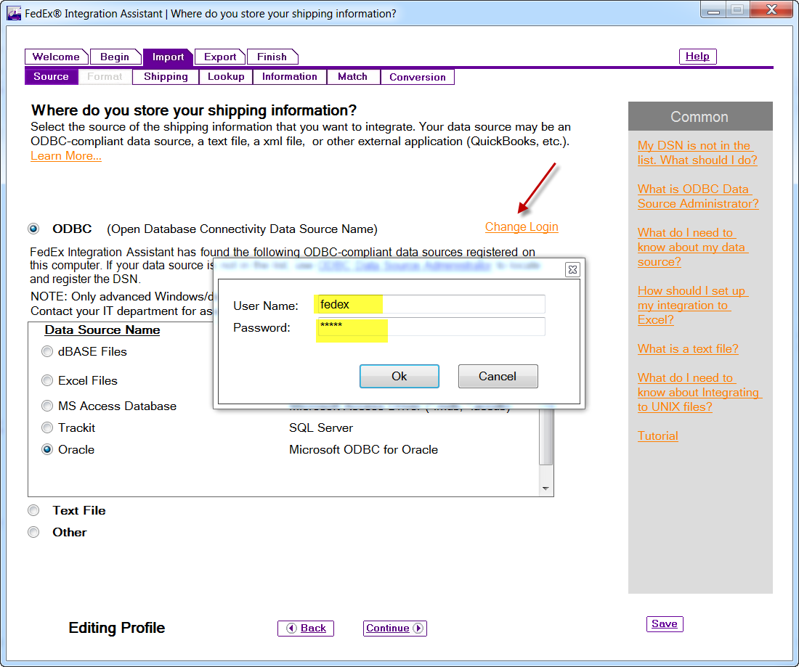

1. Login to Oracle and release an existing SO 82823 to inventory to ship.

For example:

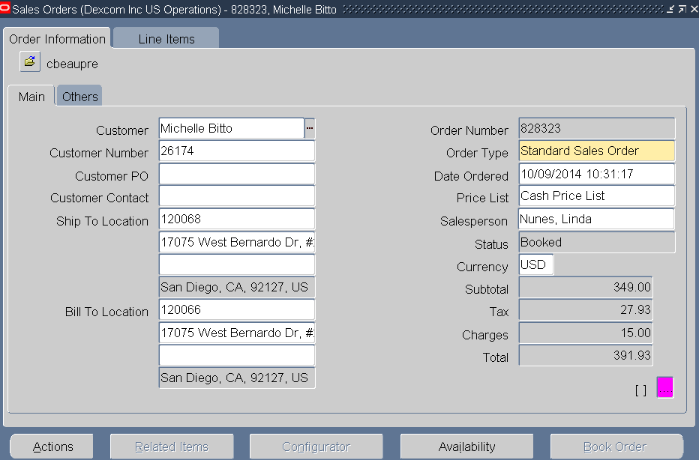

1. Print the C3 Pick Slip. Delivery: 5797957, Pick Slip No: 1401843.

For example:

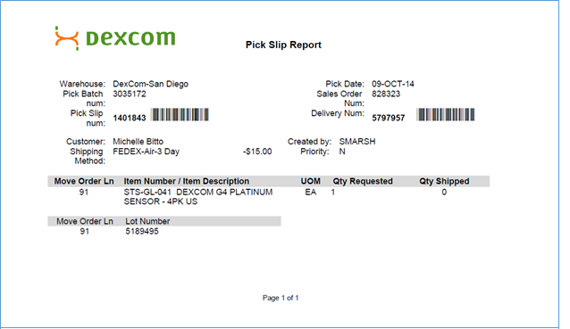

1. In the Fedex Ship Manager, enter the delivery in the Lookup field.

For example:

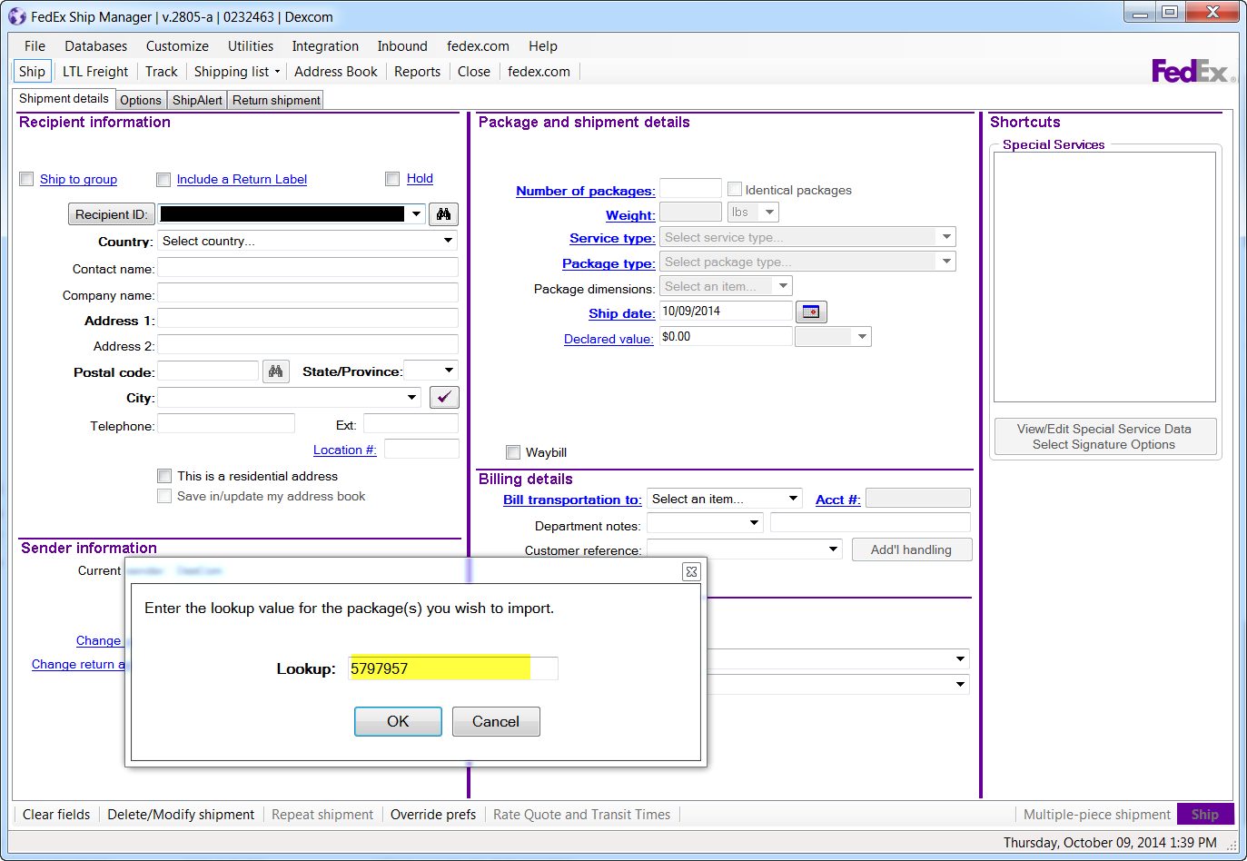

1. Validate the information against the Pick Slip.

For example:

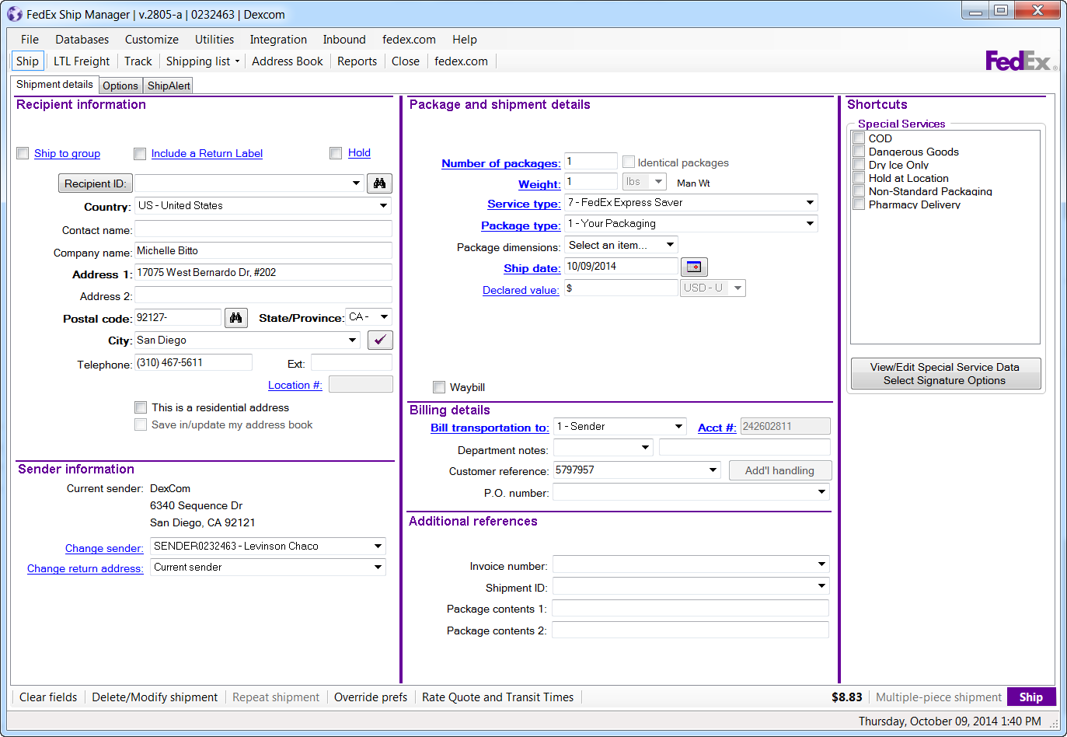

1. Click on the Ship button to complete the shipment and print the label.

For example:

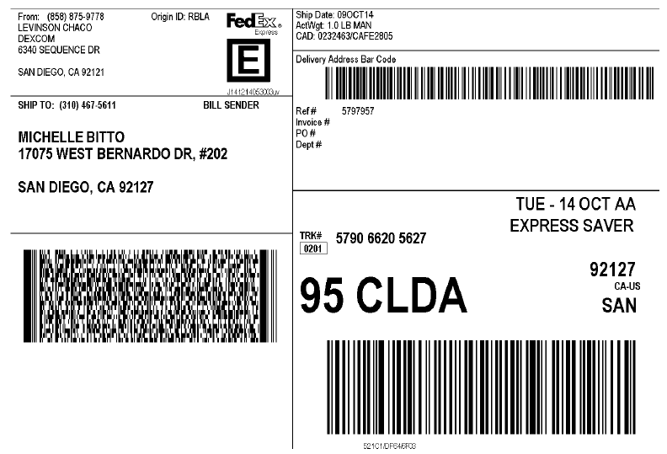

1. Verify that the information is sent to Oracle with Toad.

Query the C3.C3_FEDEX_SHIPMENTS table:

SELECT *

FROM c3.c3_fedex_shipments

WHERE delivery_name = '5797957'

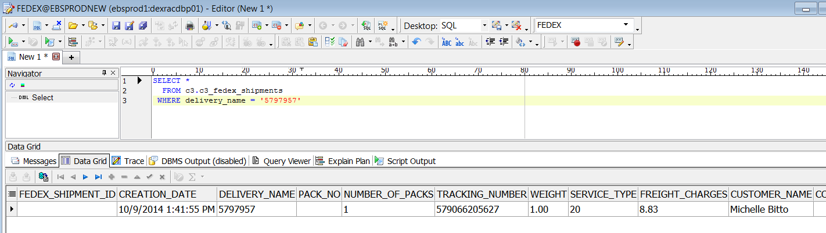

The test is successful, if the tester:

* Validates the information against the Pick Slip (step 13, above).
* Prints a correct shipping label (step 14, above).
* Verifies that the Information is sent to Oracle (step 15, above.

## QC Hold System

To test QC Hold System access:

1. Using a browser, go to DEV:

<https://qchold-dev/QCHoldPage.html>

1. When prompted, enter your user name/password,

The test is successful, if the requested page opens.

For example:

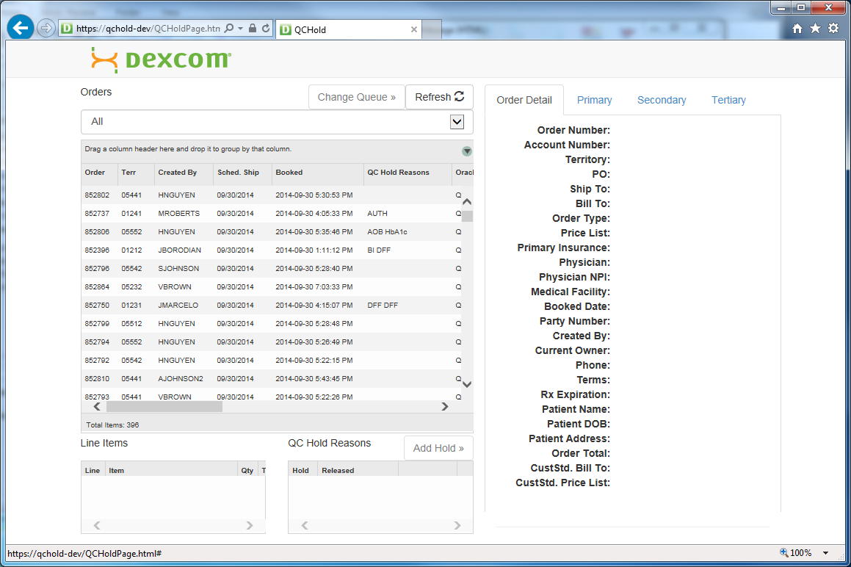

## DocuClass

To test DocuClass access:

1. Login into the DocuClass system and the configuration application.
2. Click on external database queries.

For example:

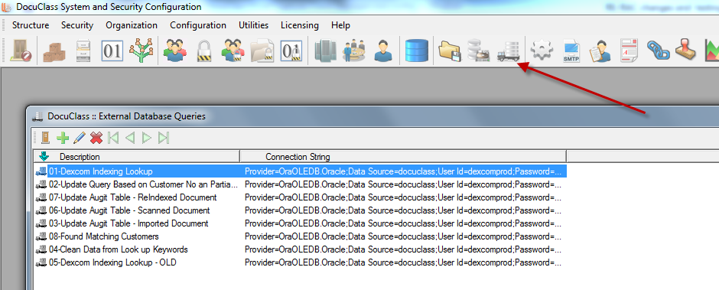

1. Select the query "01-Dexcom Indexing Lookup".
2. Click the test connection.

For example:

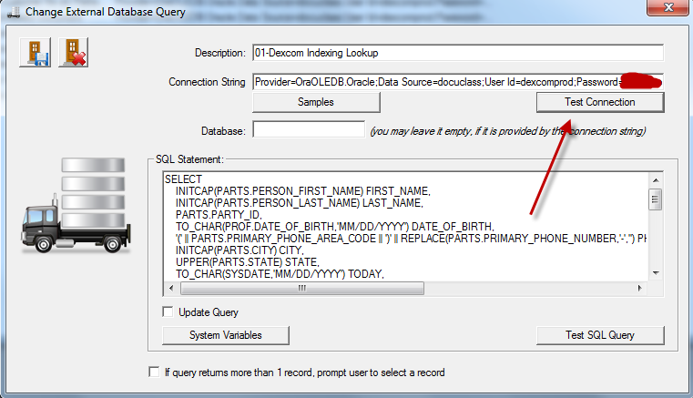

The test is successful, if the query displays the image shown below.

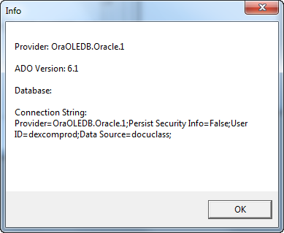

## PayPal PayFlow

To test PayPal PayFlow:

1. Open the Oracle EBS R12 and navigate to Order Management (Order Organizer).

For example:

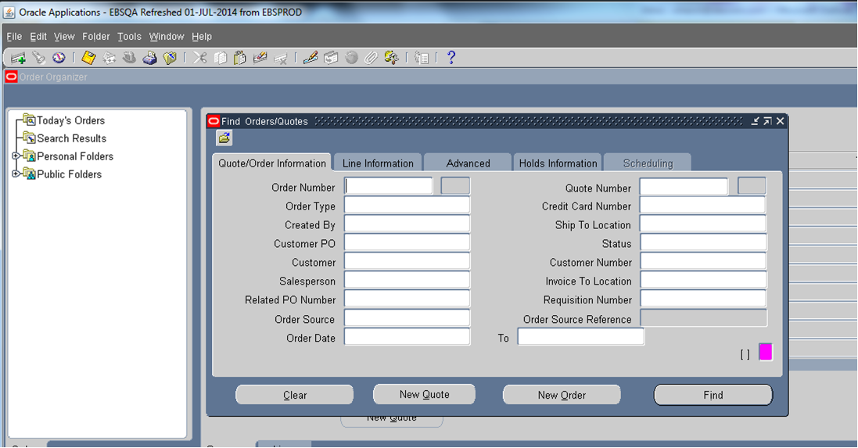

1. Click New Order.
2. When the Order Information tab appears, create an order that requires a credit card payment.
   * Fill in the tabs.

For example:

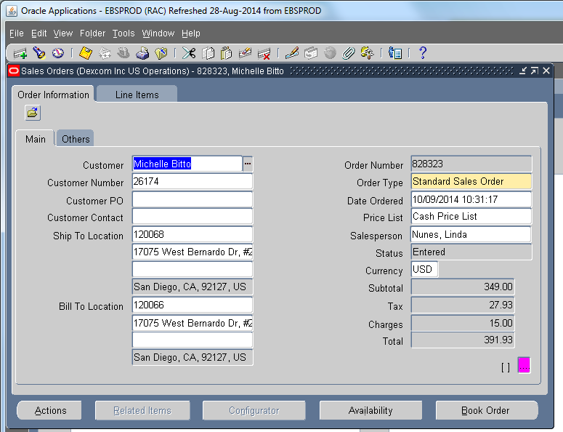

1. Select Actions > Payments.
2. On the Payments screen, enter the credit card information for American Express account number "378282246310005".
3. Click OK.

The Order screen reappears.

1. On the Order screen, click Book Order.
2. Return to the Payments screen and click Process Payments.
3. On the Payments screen, scroll to the right to see the Approval Code column.

The test is successful the field shows an Approval Code.

For example:

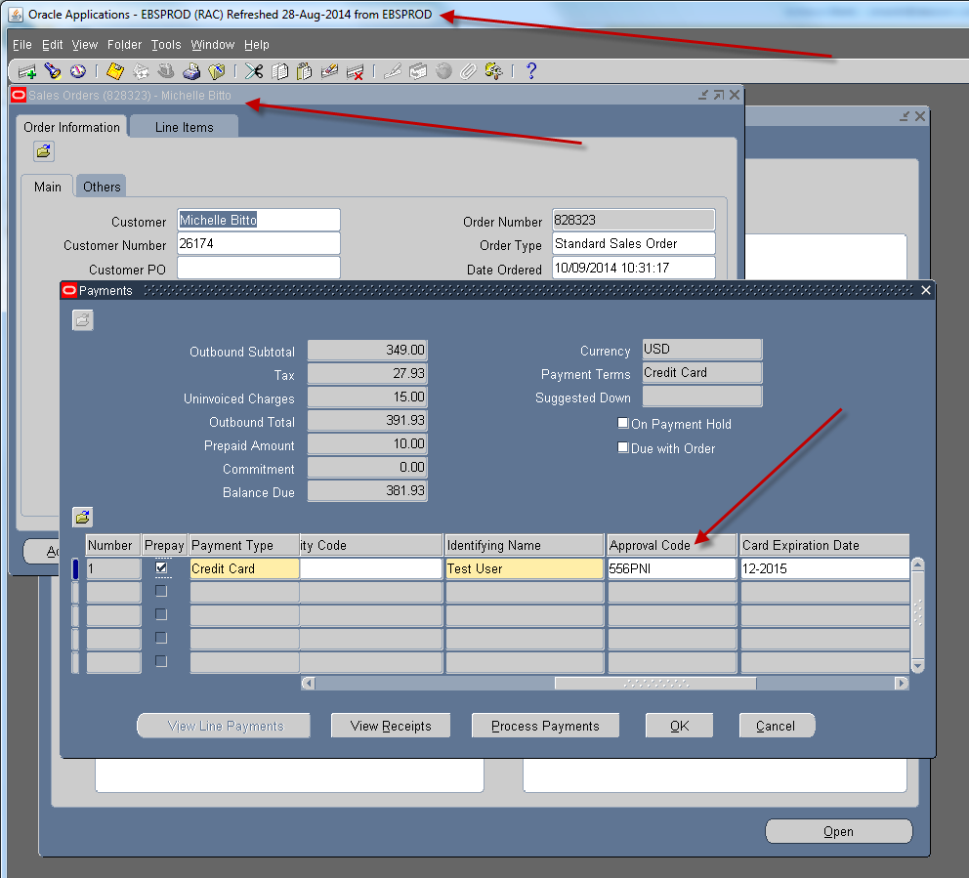

## EDI

To test EDI:

* Monitor EDI Concurrent Jobs to determine if they are run successfully

The test is successful, if the related program sends data files to the destination location.

**Note**: These results are expected for communications with Finance applications Pverify, LockBox, and Positive Pay.