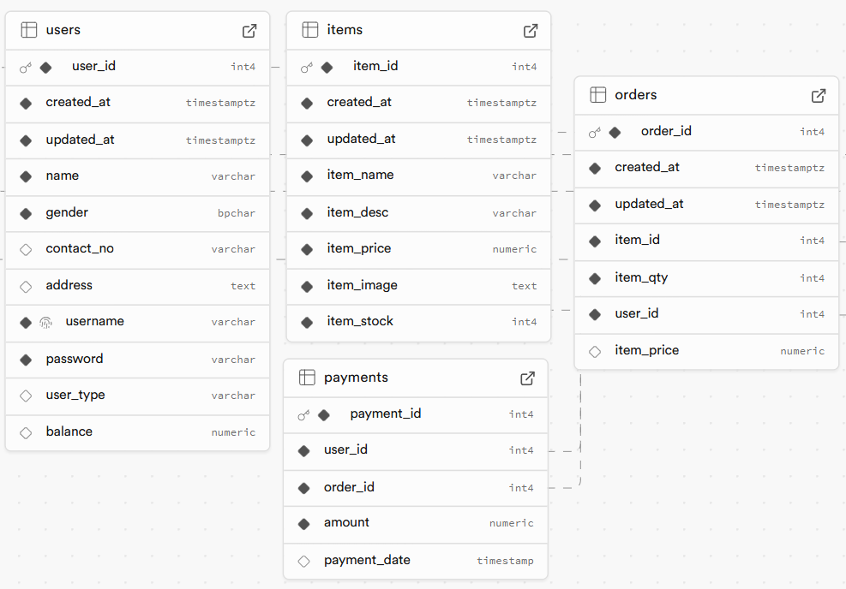

create table

  users (

    user_id int not null,

    created_at TIMESTAMPTZ DEFAULT CURRENT_TIMESTAMP not null,

    updated_at TIMESTAMPTZ DEFAULT CURRENT_TIMESTAMP not null,

    name varchar(255) not null,

    gender char(1) not null,

    contact_no varchar(55),

    address varchar(255),

    username varchar(55) not null,

    password varchar(55) not null,

    user_type varchar(55) not null,

    balance numeric

  );

create table

  items (

    item_id serial primary key,

    created_at TIMESTAMPTZ DEFAULT CURRENT_TIMESTAMP not null,

    updated_at TIMESTAMPTZ DEFAULT CURRENT_TIMESTAMP not null,

    item_name varchar(55) not null,

    item_desc varchar(255) not null,

    item_price decimal(6, 2) not null

  );

create table

  orders (

    orders_id serial primary key,

    created_at TIMESTAMPTZ DEFAULT CURRENT_TIMESTAMP not null,

    updated_at TIMESTAMPTZ DEFAULT CURRENT_TIMESTAMP not null,

    item_id int not null,

    item_qty int not null,

    cus_id int not null,

    constraint fk_item_id foreign key (item_id) references items (item_id) on delete cascade,

    constraint fk_customer_id foreign key (cus_id) references customer_profile (cus_id) on delete cascade

  );

CREATE TABLE

  payments (

    payment_id serial PRIMARY KEY,

    user_id INT NOT NULL,

    order_id INT NOT NULL,

    amount DECIMAL(10, 2) NOT NULL,

    payment_date TIMESTAMP DEFAULT CURRENT_TIMESTAMP,

    FOREIGN KEY (user_id) REFERENCES users (user_id),

    FOREIGN KEY (order_id) REFERENCES orders (order_id)

  );