MAPREDUCE
1a.Is the number of petitions with Data Engineer job title increasing over time?

import java.io.IOException;
import org.apache.hadoop.conf.Configuration;
import org.apache.hadoop.fs.Path;
import org.apache.hadoop.io.IntWritable;
import org.apache.hadoop.io.LongWritable;
import org.apache.hadoop.io.Text;
import org.apache.hadoop.mapreduce.Job;
import org.apache.hadoop.mapreduce.Mapper;
import org.apache.hadoop.mapreduce.Reducer;
import org.apache.hadoop.mapreduce.lib.input.FileInputFormat;
import org.apache.hadoop.mapreduce.lib.output.FileOutputFormat;

public class one {
public static class datamap extends Mapper<LongWritable,Text,Text,IntWritable> {

public void map(LongWritable key,Text value,Context context)throws IOException,InterruptedException {
String[] word = value.toString().split("\t");
String word1 = word[4] +','+ word[7];
if(word[4].contains("DATA ENGINEER")) {

context.write(new Text(word1), new IntWritable(1));
}
}
}
public static class datared extends Reducer<Text,IntWritable,Text,IntWritable> {

public void reduce(Text key,Iterable<IntWritable> values,Context context)throws IOException,InterruptedException {

int count=0;

for (IntWritable i :values)
{
count++;
}
context.write(key,new IntWritable(count));
}
}
public static void main(String args[]) throws IOException, ClassNotFoundException, InterruptedException{
Configuration conf= new Configuration();
Job job=Job.getInstance(conf, "");
job.setJarByClass(one.class);
job.setMapperClass(datamap.class);
job.setReducerClass(datared.class);
job.setNumReduceTasks(1);
job.setMapOutputKeyClass(Text.class);
job.setMapOutputValueClass(IntWritable.class);
FileInputFormat.addInputPath(job,new Path(args[0]));
FileOutputFormat.setOutputPath(job,new Path(args[1]));
System.exit(job.waitForCompletion(true) ? 0 :1);

}

}

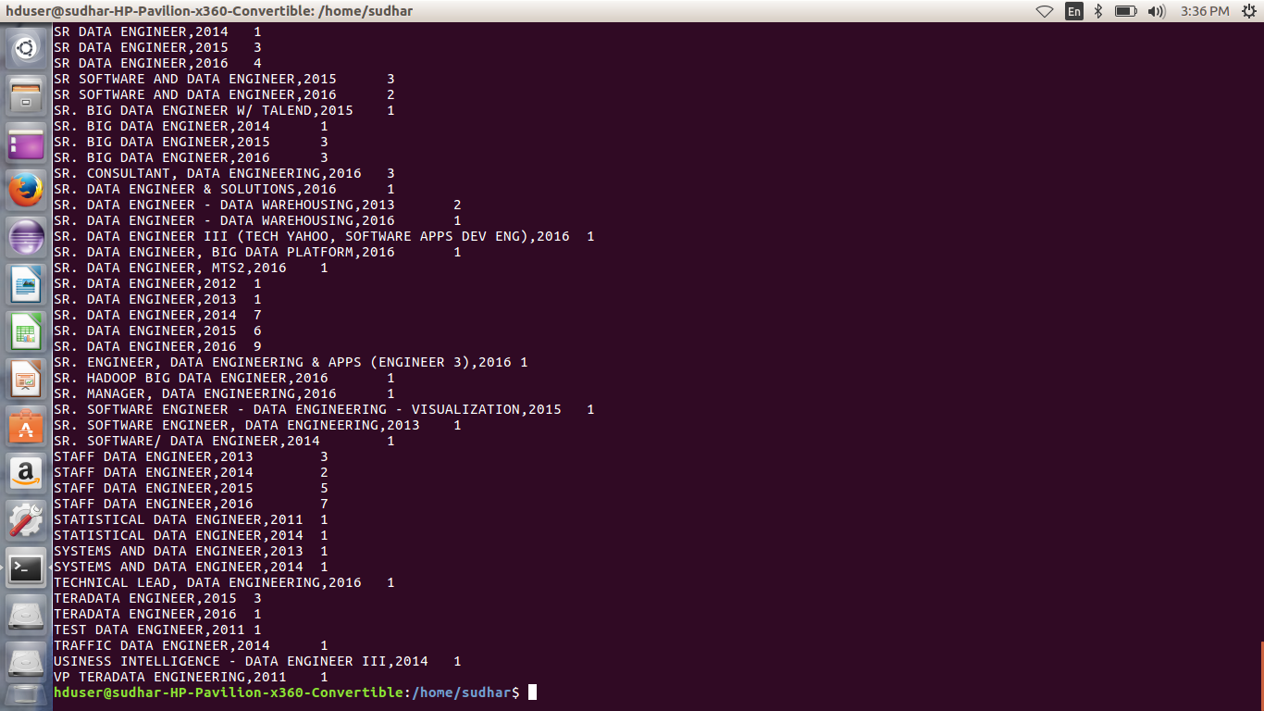

2a.Which part of the US has the most Data Engineer jobs for each year?

import java.io.IOException;
import java.util.TreeMap;

import org.apache.hadoop.conf.Configuration;
import org.apache.hadoop.fs.Path;
import org.apache.hadoop.io.IntWritable;
import org.apache.hadoop.io.LongWritable;
import org.apache.hadoop.io.NullWritable;
import org.apache.hadoop.io.Text;
import org.apache.hadoop.mapreduce.Job;
import org.apache.hadoop.mapreduce.Mapper;
import org.apache.hadoop.mapreduce.Reducer;
import org.apache.hadoop.mapreduce.lib.input.FileInputFormat;
import org.apache.hadoop.mapreduce.lib.output.FileOutputFormat;

public class two {

public static class datamap extends Mapper<LongWritable,Text,Text,IntWritable> {

public void map(LongWritable key,Text value,Context context)throws IOException,InterruptedException {
String[] word = value.toString().split("\t");
String word1 = word[4]+','+ word[7];
if(word[4].contains("DATA ENGINEER"))
{

context.write(new Text(word1), new IntWritable(1));
}
}
}
public static class datared extends Reducer<Text,IntWritable,NullWritable,Text>
{
private TreeMap<Integer,Text> repToRecordMap= new TreeMap<Integer,Text>();
public void reduce(Text key, Iterable<IntWritable> values, Context context)throws IOException, InterruptedException
{
int count=0;
String myvalue= "";
for(IntWritable val:values)
{
count++;
}
myvalue= key.toString();
String mycount= String.format("%d", count);
myvalue= myvalue + ',' + mycount;
repToRecordMap.put(new Integer(mycount), new Text(myvalue));
if(repToRecordMap.size() >10)
{
repToRecordMap.remove(repToRecordMap.firstKey());
}

}
protected void cleanup(Context context) throws IOException, InterruptedException
{
for(Text t: repToRecordMap.values())
{
context.write(NullWritable.get(), t);
}
}
}

public static void main(String args[]) throws IOException, ClassNotFoundException, InterruptedException{
Configuration conf = new Configuration();
Job job = Job.getInstance(conf, "data count");
job.setJarByClass(two.class);
job.setMapperClass(datamap.class);
job.setReducerClass(datared.class);
job.setNumReduceTasks(1);
job.setMapOutputKeyClass(Text.class);
job.setMapOutputValueClass(IntWritable.class);
FileInputFormat.addInputPath(job, new Path(args[0]));
FileOutputFormat.setOutputPath(job, new Path(args[1]));
System.exit(job.waitForCompletion(true) ? 0 :1);

}
}

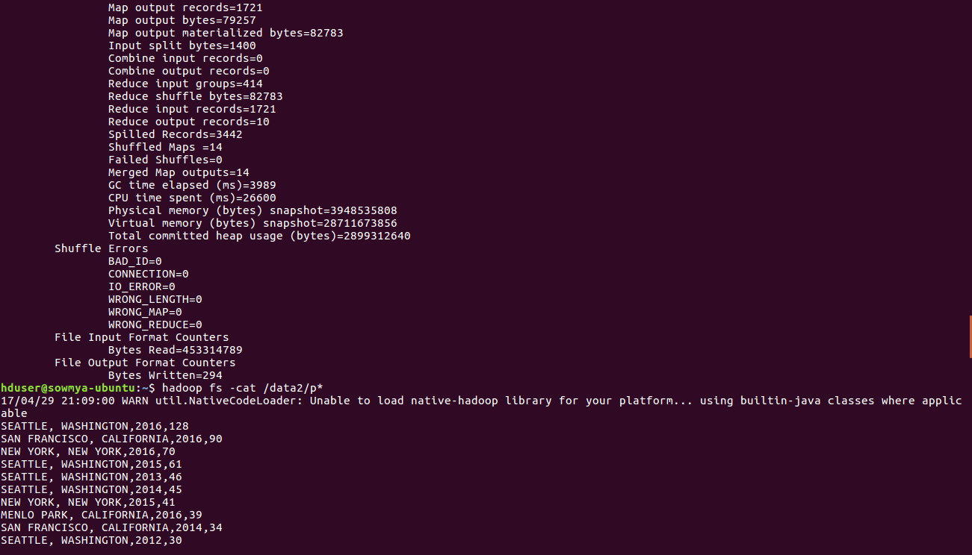

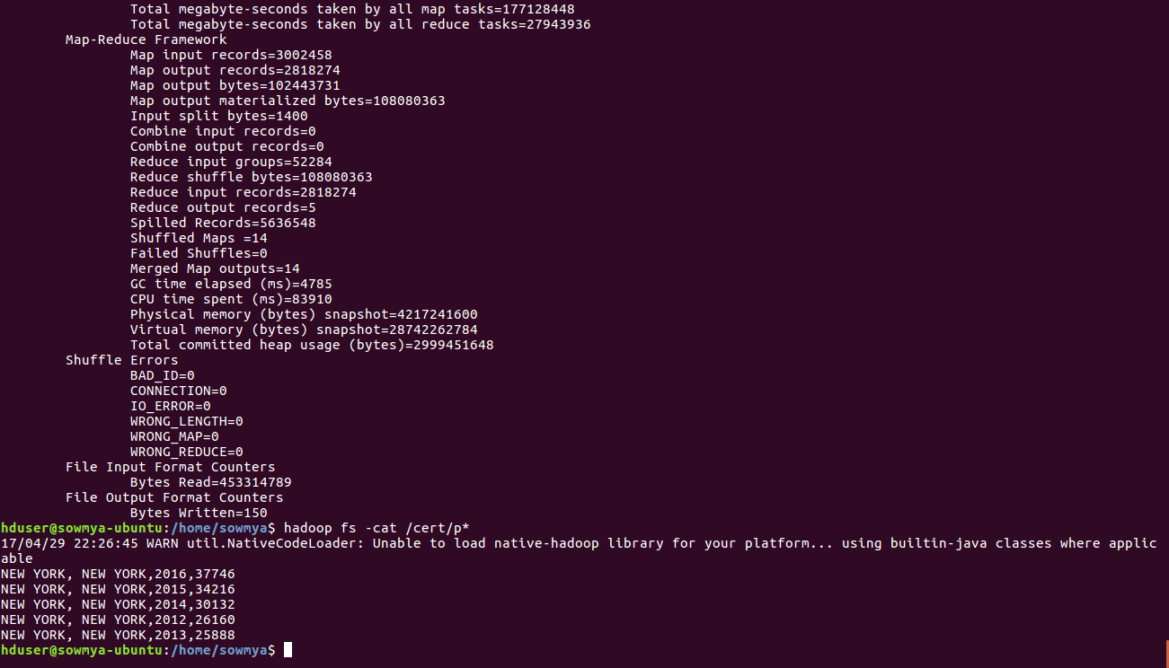

3)
import java.io.IOException;
import org.apache.hadoop.conf.Configuration;
import org.apache.hadoop.fs.Path;
import org.apache.hadoop.io.IntWritable;
import org.apache.hadoop.io.LongWritable;
import org.apache.hadoop.io.Text;
import org.apache.hadoop.mapreduce.Job;
import org.apache.hadoop.mapreduce.Mapper;
import org.apache.hadoop.mapreduce.Reducer;
import org.apache.hadoop.mapreduce.lib.input.FileInputFormat;
import org.apache.hadoop.mapreduce.lib.output.FileOutputFormat;

public class inc {
public static class MapClass extends Mapper<LongWritable,Text,Text,IntWritable> {

public void map(LongWritable key,Text value,Context context)throws IOException,InterruptedException {
String[] word = value.toString().split("\t");
String word1 = word[4] +','+ word[8] +','+ word[7];
if(word[4].contains("DATA ENGINEER")) {

context.write(new Text(word1), new IntWritable(1));
}
}
}
public static class ReduceClass extends Reducer<Text,IntWritable,Text,IntWritable> {

public void reduce(Text key,Iterable<IntWritable> values,Context context)throws IOException,InterruptedException {

int count=0;

for (IntWritable i :values)
{
count++;
}
context.write(key,new IntWritable(count));
}
}
public static void main(String args[]) throws IOException, ClassNotFoundException, InterruptedException{
Configuration conf= new Configuration();
Job job=Job.getInstance(conf, "inc");
job.setJarByClass(inc.class);
job.setMapperClass(MapClass.class);
job.setReducerClass(ReduceClass.class);
job.setNumReduceTasks(1);
job.setMapOutputKeyClass(Text.class);
job.setMapOutputValueClass(IntWritable.class);
FileInputFormat.addInputPath(job,new Path(args[0]));
FileOutputFormat.setOutputPath(job,new Path(args[1]));
System.exit(job.waitForCompletion(true) ? 0 :1);

}
}

5.Find the most popular top 10 job positions for H1B visa applications for each year?

import java.io.IOException;
import java.util.TreeMap;
import org.apache.hadoop.conf.Configuration;
import org.apache.hadoop.fs.Path;
import org.apache.hadoop.io.LongWritable;
import org.apache.hadoop.io.NullWritable;
import org.apache.hadoop.io.Text;
import org.apache.hadoop.mapreduce.Job;
import org.apache.hadoop.mapreduce.Mapper;
import org.apache.hadoop.mapreduce.Reducer;
import org.apache.hadoop.mapreduce.lib.input.FileInputFormat;
import org.apache.hadoop.mapreduce.lib.output.FileOutputFormat;

public class top10positions
public static class Top10Mapper extends Mapper<LongWritable, Text, Text, Text> {
public void map(LongWritable key, Text value, Context context) throws IOException, InterruptedException {

try {
String[] str = value.toString().split("\t");
String position= str[4];
int year= Integer.parseInt(str[7]);
String status= str[1];
String myyear= String.format("%d", year);
String myvalue= position + ',' + myyear;
context.write(new Text(myvalue),new Text(status));

}
catch(Exception e)
{
System.out.println(e.getMessage());
}
}
}

public static class Top10Reducer extends
Reducer<Text, Text, NullWritable, Text> {
private TreeMap<Long, Text> repToRecordMap = new TreeMap<Long, Text>();
public void reduce(Text key, Iterable<Text> values,
Context context) throws IOException, InterruptedException {
long count=0;
String myvalue= "";
String mycount= "";
for (Text val : values) {
//String[] token= key.toString().split(",");
count++;
}
myvalue= key.toString();
mycount= String.format("%d", count);
myvalue= myvalue + ',' + mycount;
repToRecordMap.put(new Long(mycount), new Text(myvalue));
if (repToRecordMap.size() > 10) {
repToRecordMap.remove(repToRecordMap.firstKey());
}
}

protected void cleanup(Context context) throws IOException,
InterruptedException {
for (Text t : repToRecordMap.descendingMap().values()) {
// Output our five records to the file system with a null key
context.write(NullWritable.get(), t);
}
}
}
public static void main(String[] args) throws Exception {

Configuration conf = new Configuration();
Job job = Job.getInstance(conf, "Top 10 positions");
job.setJarByClass(top10positions.class);
job.setMapperClass(Top10Mapper.class);
job.setReducerClass(Top10Reducer.class);
job.setMapOutputKeyClass(Text.class);
job.setMapOutputValueClass(Text.class);
job.setOutputKeyClass(NullWritable.class);
job.setOutputValueClass(Text.class);
FileInputFormat.addInputPath(job, new Path(args[0]));
FileOutputFormat.setOutputPath(job, new Path(args[1]));
System.exit(job.waitForCompletion(true) ? 0 : 1);
}
}
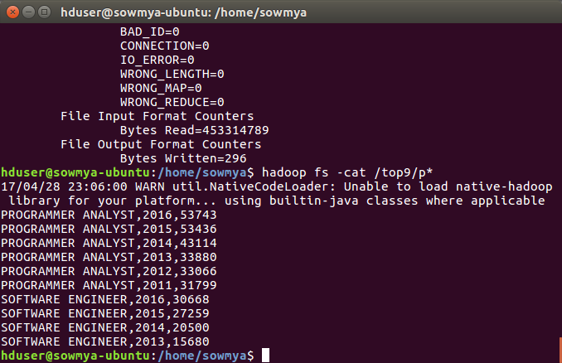
PIG
1b) Find top 5 job titles who are having highest growth in applications.

h1b= LOAD '/home/sowmya/Desktop/mapreduce' using PigStorage('\t') AS (s_no:int,case_status:chararray,employer_name:chararray,soc_name:chararray,job_title:chararray,full_time_position:chararray,prevailing_wage,year,worksite1:chararray,longitute, latitute);

groupbyyear= GROUP h1b by (year, job_title);

countcust= foreach groupbyyear generate group as year, COUNT(h1b) as headcount;

orderbycount = order countcust by $1 desc;

limit2= limit orderbycount 5;

dump limit2;
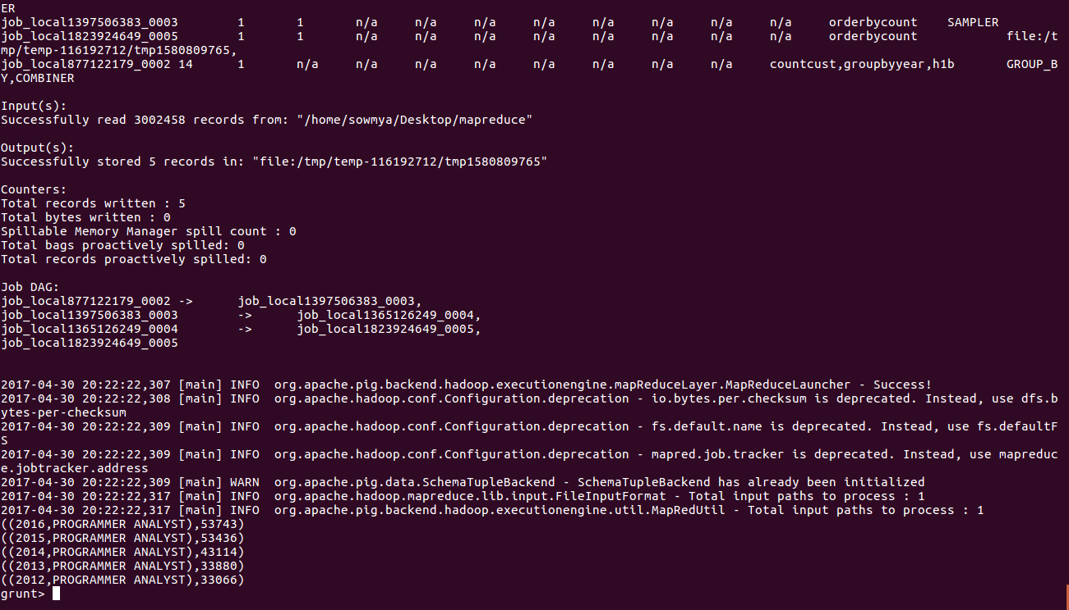
2)b)

filter_bag= filter a by case_status=='CERTIFIED';
group_all= group filter_bag by (year);
count_all= foreach group_all generate $0, COUNT(filter_bag) as headcount;
orderby= order count_all by headcount desc;
limit3= limit orderby 5;

4)

gp= group a by (year,employer_name);

ct= foreach gp generate group as year, COUNT(a) as headcount;

obc= order ct by $1 desc;

limit2= limit obc 5;

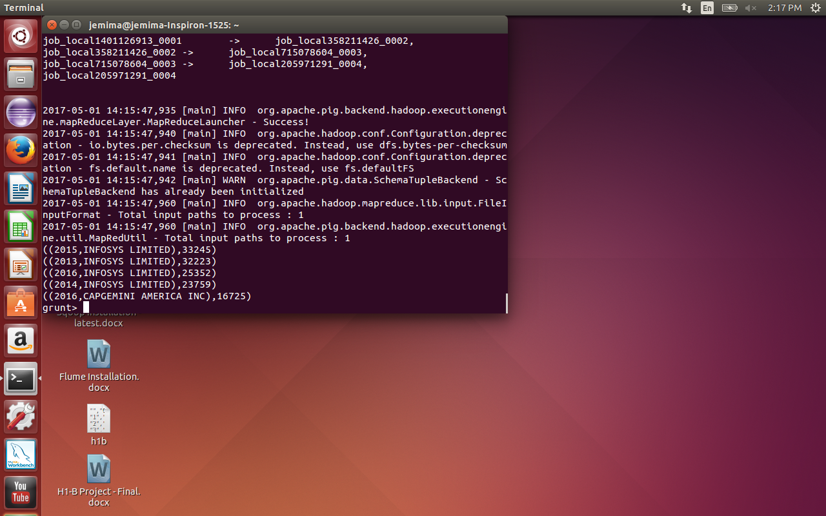

7) Create a bar graph to depict the number of applications for each year

h1b= LOAD '/home/sowmya/Desktop/mapreduce' using PigStorage('\t') AS (s_no:int,case_status:chararray,employer_name:chararray,soc_name:chararray,job_title:chararray,full_time_position:chararray,prevailing_wage,year, worksite1:chararray,longitute, latitute);

groupbyyear= GROUP h1b by year;

countapp= foreach groupbyyear generate group as year, COUNT(h1b) as headcount;

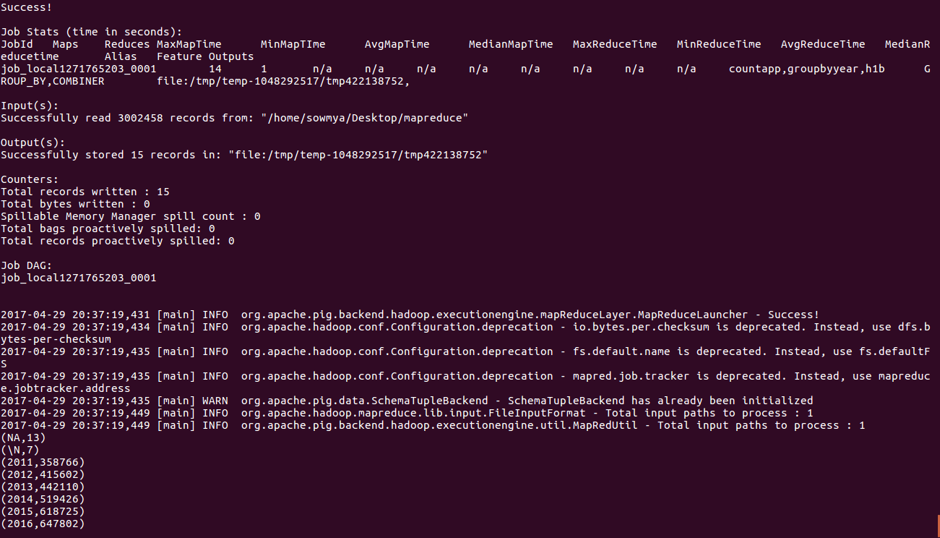
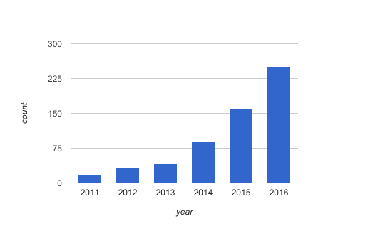

HIVE

10) Which are the top 10 job positions which have the highest success rate in petitions?

select ROUND(((count(s_no)/t.tot)*100),2) as ctn,job_title from h1b_pro,(select count(s_no) as tot from h1b_pro)t where case_status ='CERTIFIED' or case_status= 'CERTIFIED-WITHDRAWN' group by job_title,t.tot order by ctn desc limit 10;
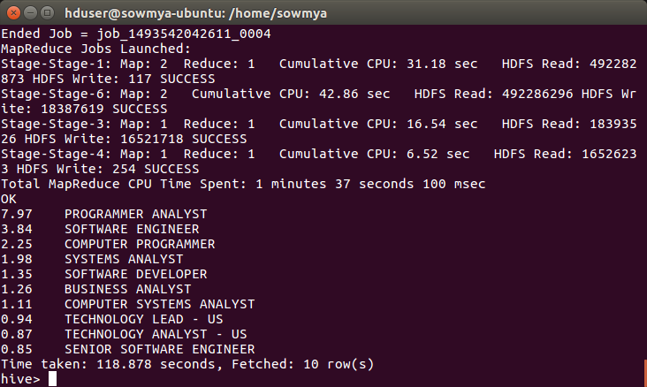

8)Find the average Prevailing Wage for each Job for each Year (take part time and full time separate)

select ROUND((AVG(prevailing_wage)),2), job_title,year,full_time_position from h1b_pro where full_time_position!='NULL' group by full_time_position,job_title,year order by full_time_position desc;

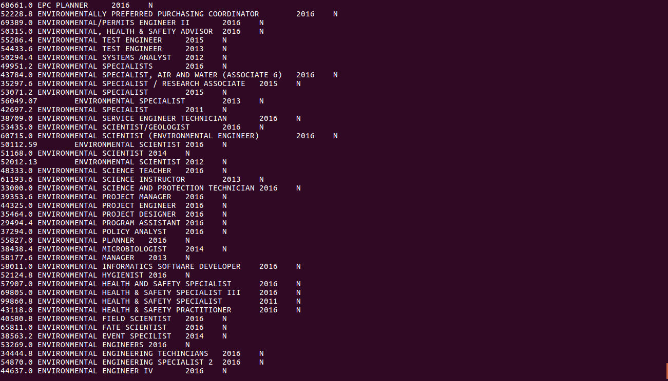
9) Which are top ten employers who have the highest success rate in petitions?

select ROUND(((count(s_no)/t.tot)*100),2) as ctn,employer_name from h1b_pro,(select count(s_no) as tot from h1b_pro)t where case_status ='CERTIFIED' or case_status= 'CERTIFIED-WITHDRAWN' group by employer_name,t.tot order by ctn desc limit 10;
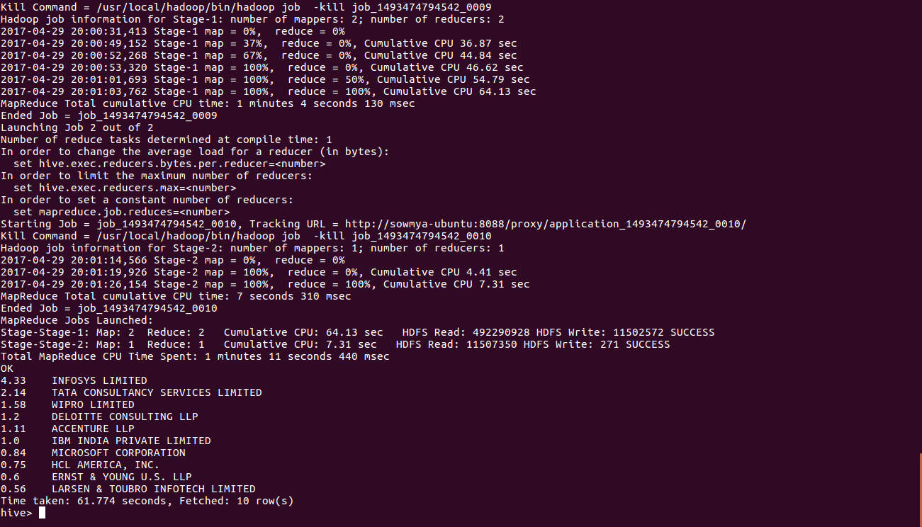

6) Find the percentage and the count of each case status on total applications for each year. Create a graph depicting the pattern of All the cases over the period of time.

select count(s_no) as count,round(((count(s_no)/t.tot)*100),2) as ctn,year,case_status from h1b_pro,(select count(s_no) as tot from h1b_pro)t where year!='NULL' or year!='NA' group by case_status,year,t.tot order by ctn desc;

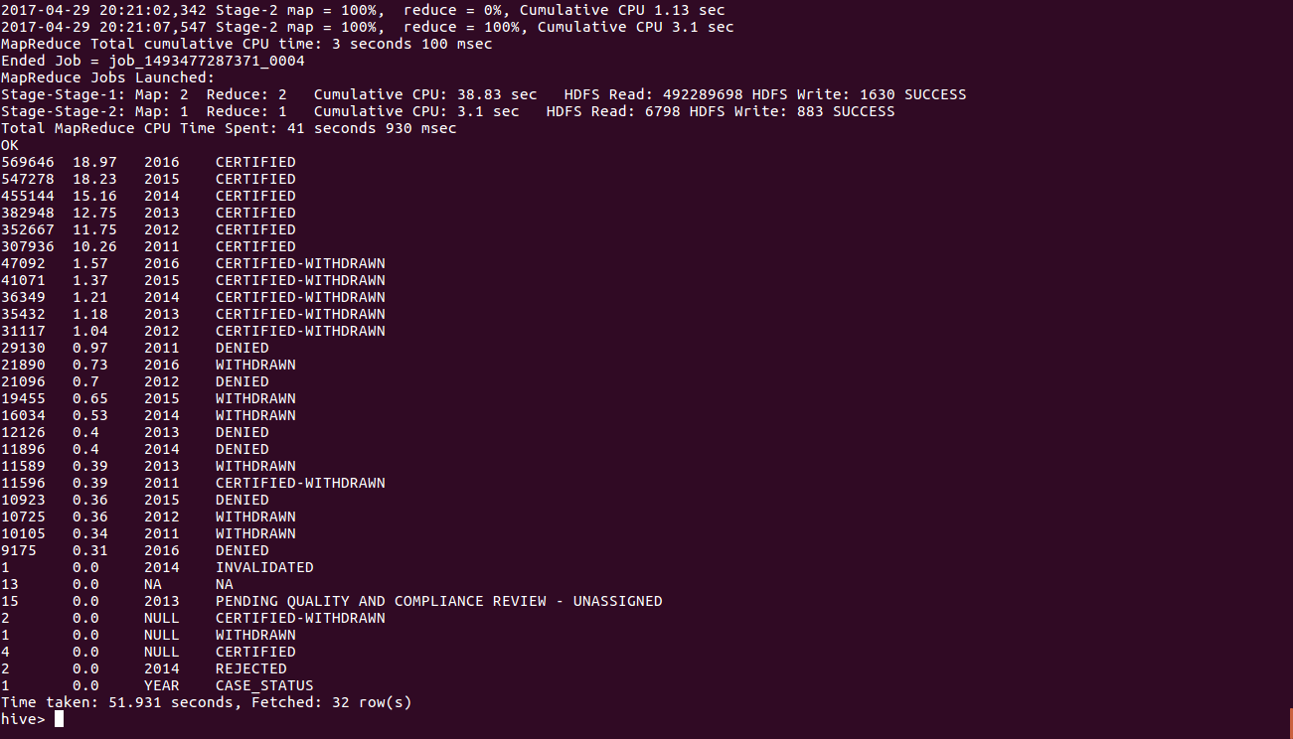

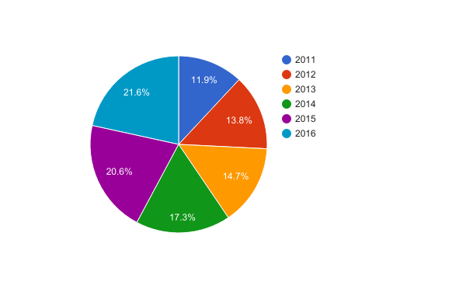

SQOOP

10) Which are the top 10 job positions which have the highest success rate in petitions?

11) Export result for question no 10 to MySql database.

Make an input file for the top 10 job positions who have highest success rate in petitions and put it in HDFS. The command for it:

hduser@sowmya-ubuntu:~$ hadoop fs -put /home/sowmya/visa.txt /niit

Enter the mysql server: mysql -u root -p

Create a table in Mysql to export data from HDFS:

create table h1b_app(
success_rate FLOAT NOT NULL,
position VARCHAR(40) NOT NULL,
status VARCHAR(40) NOT NULL,
PRIMARY KEY(success_rate));

SQOOP QUERY:

sqoop export --connect jdbc:mysql://localhost/app --username root -P --table h1b_app --update-mode allowinsert --update-key success_rate --export-dir /niit/visa.txt --input-fields-terminated-by ',';
