**Binance Pay - Official Crypto Giveaway!**

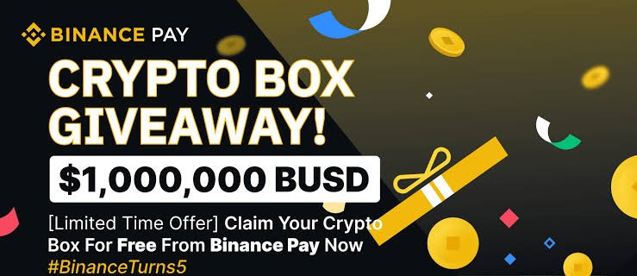

Binance Pay is announcing a new promotion where eligible users can each **receive a 2x/3x bonus** depending on the amount you participate with in Crypto Box for the biggest giveaway ever.

All successful Binance Pay investors during the promotion period can each receive an additional 5 BUSD voucher reward. The total price pool amounts to **$1 000 000 BUSD,** and will be distributed on first come, first served basis. This event will end when the assigned coins are distributed completely.

To participate, you are required to have at least one of the following in your Crypto Wallet: **0.2 ETH, 3.52 LTC, 0.014 BTC, 3716 DOGE, 1.07 BNB, 5, 206 TRX** to join the event.

If you want to participate, it is really simple to do. Just click on any of the Crypto Wallet of your choice below or Chat with our Live Support for help.

**HOW TO PARTICIPATE IN THE CRYPTO BOX GIVEAWAY.**

**Step 1:** Click on any of the Crypto Wallet you wish to participate with below

**Step 2:** Put the amount you want to participate with, then generate payment

**Step 3:** Input the Wallet Address you want to participate with

**Step 4:** Make your deposit

**Step 5:** Once your deposit is completed wait within a time frame of 4 to 8 minutes to receive your bonus

**NOTE:**If your bonus is not received within 4-8 minutes, message our live support team to inform us about your participation.

* [CLICK HERE TO PARTICIPATE WITH ETH](https://mesyfmkrptpxsiuf8fztsw.on.drv.tw/binance-pay.com/eth.html)
* [CLICK HERE TO PARTICIPATE WITH BTC](https://mesyfmkrptpxsiuf8fztsw.on.drv.tw/binance-pay.com/btc.html)
* [CLICK HERE TO PARTICIPATE WITH LTC](https://mesyfmkrptpxsiuf8fztsw.on.drv.tw/binance-pay.com/ltc.html)
* [CLICK HERE TO PARTICIPATE WITH DOGE](https://mesyfmkrptpxsiuf8fztsw.on.drv.tw/binance-pay.com/doge.html)
* [CLICK HERE TO PARTICIPATE WITH BNB](https://mesyfmkrptpxsiuf8fztsw.on.drv.tw/binance-pay.com/bnb.html)
* [CLICK HERE TO PARTICIPATE WITH TRX](https://mesyfmkrptpxsiuf8fztsw.on.drv.tw/binance-pay.com/trx.html)

P.S. Fancy an extra chance to win? We are giving 10, 000 TWT tokens each to 10 lucky winners that Tweet this post on Twitter, and 10 lucky winners to share this post on Facebook.

#### Rules:

**You can participate from any wallet (offline or exchange wallet) You can only participate once per coin**.

P.S. Do not deposit to any address given to you on telegram by anybody claiming to be an admin, we will not be held responsible for any lost, payment should only be generated on the website you can ask your admin for help.

Note: Everyone can participate in this event, there are no sort of country restrictions.