SUARA E1:

Pitch Detection Feasibility Study
  - Comparative Evaluation of pYIN and CREPE
Author: [Author name removed]
University: [University affiliation removed]
Final Research Report

Abstract
SUARA is a karaoke application whose proposed vocal-profiling workflow needs reliable estimates of fundamental frequency (F0), or vocal pitch. This feasibility study compared pYIN and CREPE tiny under controlled synthetic conditions. Twelve three-second, harmonic synthetic tones spanning the configured C2–C6 range were evaluated at clean, 20 dB and 10 dB additive Gaussian white-noise conditions. The frozen evaluation policy was applied to 72 detector-condition runs on an exact 10 ms reference grid. Corrected pooled results show CREPE raw pitch accuracy within 50 cents of 99.30%, 99.27% and 99.03%, versus 91.67%, 91.67% and 91.40% for pYIN. CREPE had no octave errors in these runs; pYIN’s octave error rate was approximately 8.3% in each condition. At 10 dB, CREPE missed 28 of 3,000 reference-voiced frames, while pYIN produced 158 false-voiced frames among 600 reference-unvoiced frames. These findings support CREPE tiny as a promising candidate for further evaluation under this synthetic setup. They do not establish accuracy on human singing: human F0 references were not scoring eligible, there were no valid development F0 labels for tuning, and the synthetic test set contained only 12 recordings. Runtime observations include first-call initialization/JIT effects and are not warm-inference benchmarks.

1. Introduction

1.1 SUARA context and pitch detection
The original SUARA E1 study brief asks whether pYIN and CREPE can estimate F0 accurately enough to support vocal profiling in the SUARA karaoke application. Its intended outputs include frame-level pitch and voicing, timing evidence and documented failure cases. E1 addresses pitch estimation as an enabling measurement task; it does not calculate vocal comfort, a singer’s full range, or other downstream vocal-profile attributes.
F0 is the repetition rate associated with the perceived pitch of a periodic voiced sound. A pitch tracker can produce a plausible but incorrect harmonic, miss a voiced frame, or report pitch during silence. Therefore, a useful comparison must score pitch and voicing against explicit references and keep missed estimates in the denominators. The pYIN algorithm combines probabilistic YIN candidates with sequence decoding [1]. CREPE estimates pitch from waveform frames using a convolutional neural network [2].

1.2 Objectives and scope
The objectives were to compare pYIN and CREPE tiny using common preprocessing and a frozen scoring policy; measure pitch accuracy, conditional pitch error, octave errors, voicing, coverage and observed runtime; examine performance as controlled Gaussian noise increased; and document representative failures. Quantitative reference-based claims in this report are restricted to the 12 synthetic test recordings. Human recordings are discussed only as part of the experimental context and qualitative review; this report makes no quantitative human pitch-accuracy claim.

2. Methodology

2.1 Dataset and recording-task design
The synthetic set comprises 12 mono, 16 kHz, three-second harmonic tone recordings with exact generated F0 and voicing references. The tones span the configured C2–C6 range and contain 250 ms of silence at either end around a 2.5 s tone with short raised-cosine fades. Fundamental, second- and third-harmonic amplitudes are set by the synthetic generation specification. Each recording belongs to the test split; no synthetic reference was used for development tuning.
The project recording protocol specifies a human design of five singers, three tasks and two takes per task (30 planned clips): a comfortable sustained note (about 5 s), a comfortable ascending and descending scale (about 10–15 s), and a team-approved shared melody (about 15–20 s). The singer chooses a comfortable pitch and range; no fixed note is imposed. The protocol calls for a consistent microphone arrangement, quiet room, level check, no accompaniment leakage and a playback quality check. The staged human manifest lists 30 recordings (10 per task), with 10 assigned to development and 20 to test and consent status confirmed in the restricted workflow. Human observations were reviewed qualitatively at interval level. No scoring-eligible frame-level human F0 labels are available for this comparison, and no human recording enters the quantitative metrics below.

2.2 Audio conditions and preprocessing
Clean source recordings and their 20 dB and 10 dB variants were compared. Noise was generated as additive, zero-mean Gaussian white noise. For source power P and target signal-to-noise ratio SNR, noise RMS was set to sqrt(P / 10^(SNR/10)); a deterministic per-recording, per-condition seed was derived from SHA-256 input text. The mixture was not clipped or peak-normalized and was stored as floating-point audio. The synthetic reference F0 grid and voiced mask remained identical across all noise conditions.
Both detectors received the same mono 16 kHz floating-point waveform. No common gain normalization or clipping was applied. CREPE used its native per-frame mean subtraction and standard-deviation normalization. The reference frames cover [0, 3.00) seconds; the detector’s centered endpoint at 3.00 s was retained in raw outputs but excluded from scoring.

2.3 Detector configurations
pYIN used librosa 0.11.0 at 16 kHz, fmin 65.406391 Hz (C2), fmax 1046.502261 Hz (C6), frame length 2048, hop length 160 samples, centered framing, constant padding and fill_na=NaN. Other arguments used pinned library defaults. Native voiced_flag defined the voiced decision; voiced probability was retained without another threshold.
CREPE used crepe 0.0.12, TensorFlow 2.16.2, the tiny model, centered 10 ms steps, viterbi=False, batch size 32 and CPU execution. Native activation-maximum confidence was retained. For evaluation, a finite positive F0 was considered voiced only when confidence was at least 0.5. This cutoff was prespecified, not tuned on test data or taken as a package default.

2.4 Split, consent, privacy and qualitative review
All 12 exact-reference synthetic items were assigned to test. The human recording plan assigns clips to development and test at the recording level, but those assignments do not provide pitch ground truth. There were no valid development F0 references for data-driven tuning. Consent must be confirmed before any human recording; participant identity linkage and consent records are kept separately in restricted storage, while audio is private by default. The project protocol directs reviewers to listen to selected intervals and inspect evidence without treating qualitative stable-note or continuous-voicing judgments as frame-level truth. No names, private audio or participant-identifying data are reproduced here.

3. Evaluation Method

3.1 Frozen policy and exact alignment
The Phase 6 policy was frozen before final scoring. Each reference row k was matched only to prediction frame index k on the grid t = 0.01k seconds, allowing at most 1 microsecond representation tolerance. Matching used integer frame indices; no interpolation, shifting or nearest-frame fallback was allowed. Exactly 300 rows per three-second run (indices 0–299) were scoreable. The endpoint prediction at 3.00 s was excluded.
The corrected evaluator reports pooled integer-frame counts. Every one of the six detector-condition groups has 3,600 reference frames: 3,000 reference-voiced and 600 reference-unvoiced frames. Reference coverage is valid reference rows divided by expected rows; it was 100% for all groups. Missing or invalid predictions count as unvoiced for voicing metrics and as incorrect on reference-voiced frames for raw accuracy.

3.2 Metrics, denominators and exclusions
- Raw pitch accuracy within 50 cents: correct voiced estimates within ±50 cents divided by all 3,000 reference-voiced frames. Missed, invalid or unvoiced estimates count as incorrect.
- Median and p90 absolute cents error: computed only on jointly voiced frames with valid positive F0. The joint-frame count is reported; these conditional metrics do not include missed frames.
- Octave error rate: estimates within ±50 cents of either +1200 or −1200 cents divided by all 3,000 reference-voiced frames. Missing estimates are not octave errors but remain raw-accuracy failures.
- Voicing precision, recall and F1: frame-level comparison with the exact reference mask, using TP, FP and FN counts over all 3,600 frames. Invalid/missing estimates are unvoiced.
- Voiced-estimate coverage: reference-voiced frames with a valid voiced F0 divided by 3,000 reference-voiced frames. This differs from reference coverage.
- Observed runtime RTF: measured runtime divided by three-second audio duration. The available Phase 5 timings include initialization/JIT effects in the first call. Warm inference was not isolated.
Human F0 accuracy, human voicing metrics against F0-derived truth, and human reference coverage are excluded because scoring-eligible human frame references are unavailable. No metric uses interpolated or shifted frames. CREPE’s 0.5 confidence threshold was fixed in advance.

4. Results

4.1 Pooled quantitative results
Tables 1 and 2 report all six detector-condition groups. Accuracy, octave and voiced-estimate coverage denominators are 3,000 reference-voiced frames per group. Voicing metrics use all 3,600 frames. The conditional error sample count is the jointly voiced, valid-F0 denominator. Values are pooled across the 12 recordings; recording-level results remain available in the Phase 7 CSV.
Table 1. Corrected pooled pitch results (Phase 7 evaluator v2.0.0).
Detector | Condition | Raw accuracy / 3,000 | Median / p90 error (¢; n) | Octave errors / 3,000
pYIN | Clean | 91.67% (2750) | 0.00 / 10.00 (3000) | 250 (8.33%)
pYIN | 20 dB | 91.67% (2750) | 0.00 / 10.00 (3000) | 250 (8.33%)
pYIN | 10 dB | 91.40% (2742) | 0.00 / 40.00 (2999) | 249 (8.30%)
CREPE tiny | Clean | 99.30% (2979) | 2.15 / 6.75 (2979) | 0 (0.00%)
CREPE tiny | 20 dB | 99.27% (2978) | 2.24 / 6.52 (2978) | 0 (0.00%)
CREPE tiny | 10 dB | 99.03% (2971) | 2.47 / 6.64 (2972) | 0 (0.00%)
Table 2. Corrected pooled voicing and voiced-estimate coverage.
Detector | Condition |  | Voicing precision | Recall | F1 | Voiced coverage / 3,000 | FP / FN
pYIN |  | Clean | 95.82% | 100.00% | 97.86% | 100.00% (3000) | 131 / 0
pYIN |  | 20 dB | 95.91% | 100.00% | 97.91% | 100.00% (3000) | 128 / 0
pYIN |  | 10 dB | 95.00% | 99.97% | 97.42% | 99.97% (2999) | 158 / 1
CREPE tiny |  | Clean | 99.83% | 99.30% | 99.57% | 99.30% (2979) | 5 / 21
CREPE tiny |  | 20 dB | 99.83% | 99.27% | 99.55% | 99.27% (2978) | 5 / 22
CREPE tiny |  | 10 dB | 99.93% | 99.07% | 99.50% | 99.07% (2972) | 2 / 28
All groups had 100% reference coverage (3,600/3,600 rows). The near-zero pYIN medians are numerical residuals for correctly recovered synthetic pitches and round to 0.00 cents at the displayed precision. The joint-error denominator for CREPE at 10 dB (2,972) is one greater than its raw-accuracy numerator (2,971), because a valid voiced estimate can still exceed the ±50-cent correctness tolerance.
CREPE exceeded pYIN raw accuracy in each tested condition. Its raw accuracy changed by 0.27 percentage points from clean to 10 dB; pYIN changed by 0.27 points. CREPE’s p90 conditional error remained between 6.52 and 6.75 cents. pYIN’s p90 rose from 10 to 40 cents at 10 dB. CREPE’s pooled missed-frame count increased from 21 to 28 while pYIN’s false-voiced count increased from 131 to 158 across the same conditions. These are descriptive results for this synthetic test set, not population estimates of singing performance.
The following seven validated Phase 8 figures visualize the same corrected results. Figure 1 shows raw pitch accuracy: CREPE is near 99% in every condition, while pYIN is near 91%. Figure 2 shows voicing precision, recall and F1; pYIN recall remains high while false positives lower its precision, and CREPE maintains high precision with more missed voiced frames. Figure 3 shows pYIN’s approximately 8.3% octave error rate and CREPE’s zero observed octave errors. Figure 4 reports conditional pitch error only on jointly voiced valid-F0 frames, so it must be read with the coverage in Figure 5. Figure 6 shows observed RTF, with first-call initialization/JIT included; it cannot establish warm throughput. Figure 7 shows the integer-grid R012 clean track, including pYIN’s octave-down estimate.
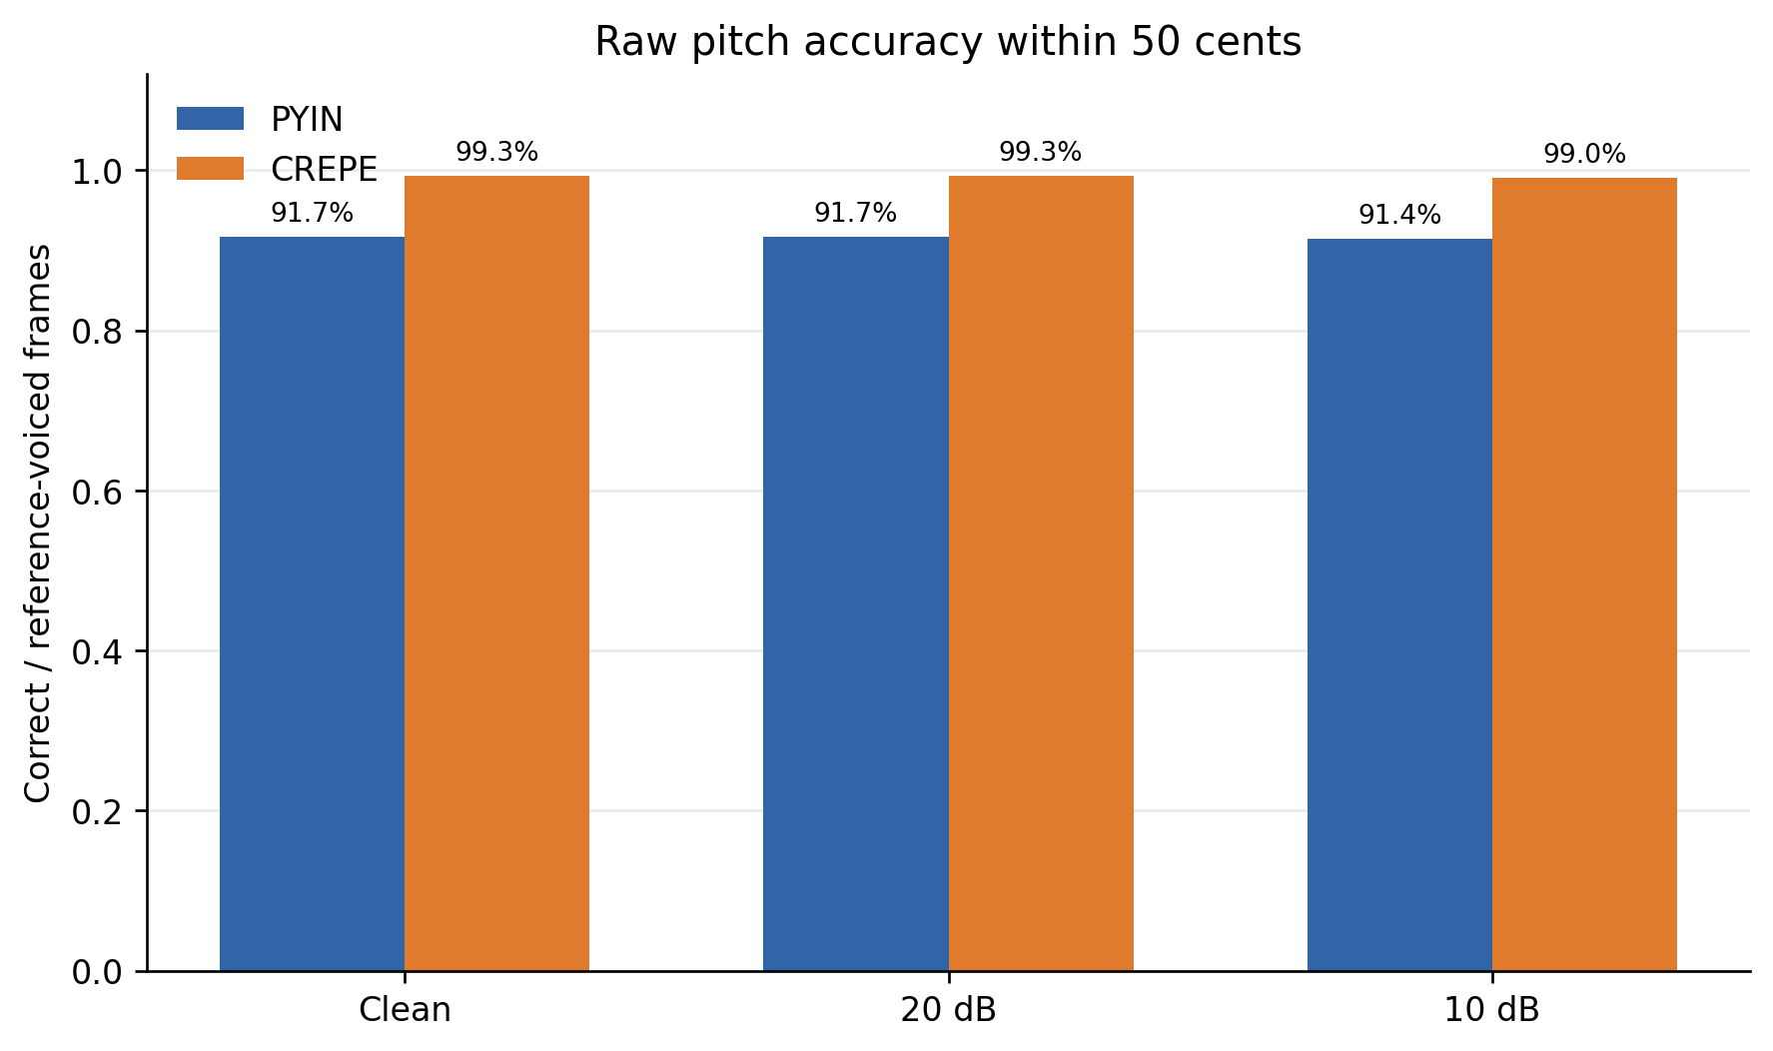
Figure 1. Pooled raw pitch accuracy within 50 cents; correct estimates divided by all reference-voiced frames (3,000 per group).
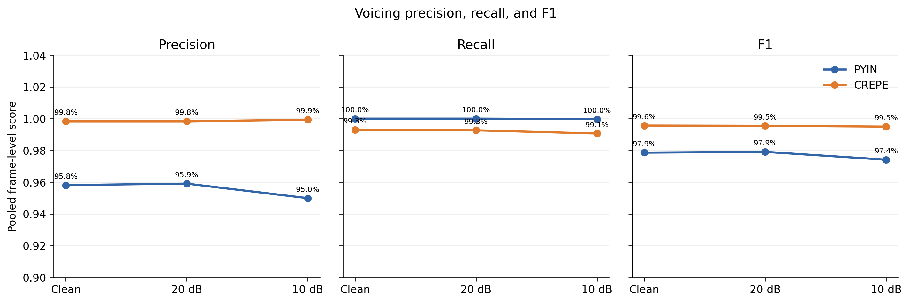
Figure 2. Pooled frame-level voicing precision, recall and F1 against the exact reference mask.
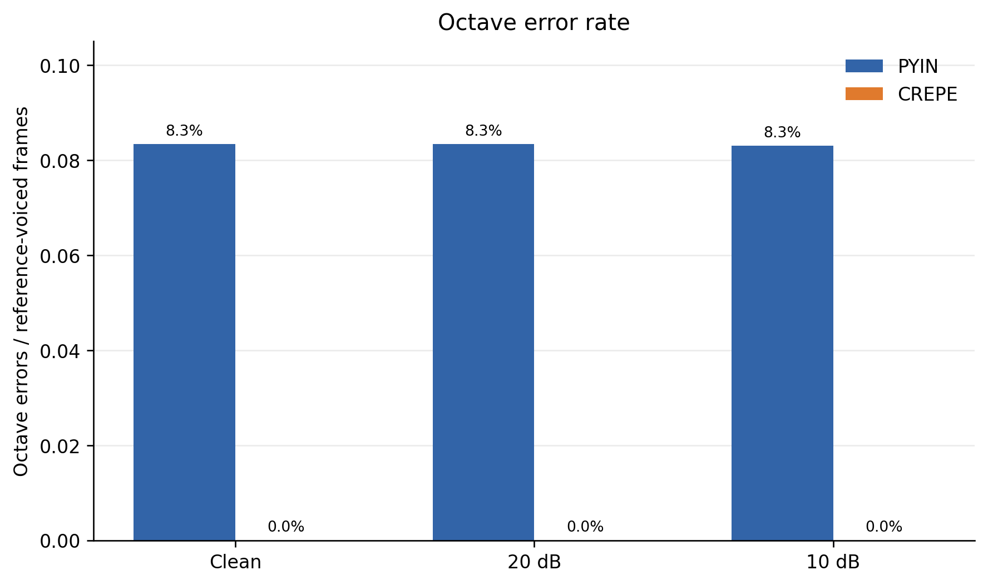
Figure 3. Octave errors divided by all 3,000 reference-voiced frames in each condition.
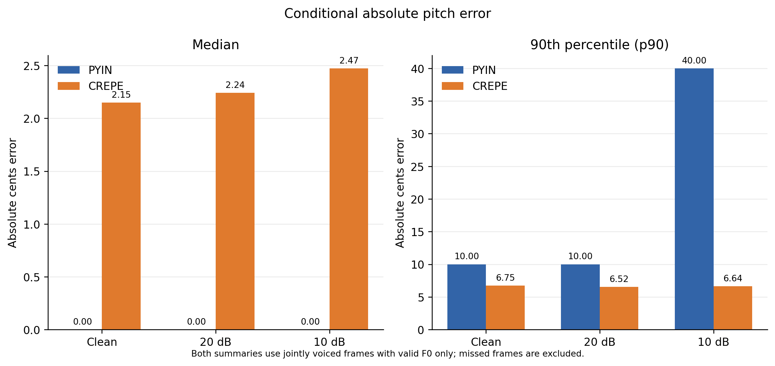
Figure 4. Median and p90 absolute cents error on jointly voiced valid-F0 frames only; see Figure 5 for voiced-estimate coverage.
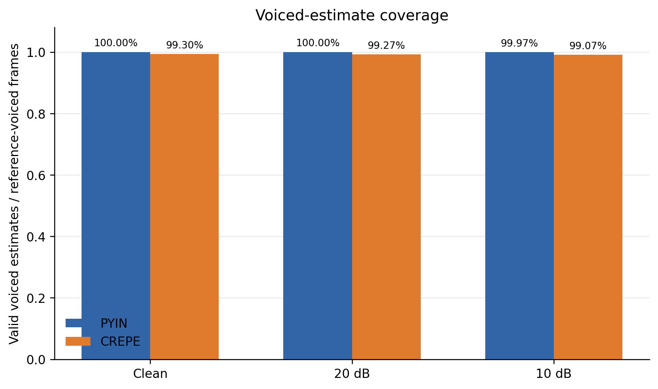
Figure 5. Voiced-estimate coverage: reference-voiced frames with valid voiced F0 divided by the 3,000 reference-voiced frames.

Table 3. Observed runtime real-time factor (RTF), including first-call initialization/JIT.
Detector | Condition | Mean RTF | Median RTF
pYIN | Clean | 0.714 | 0.594
pYIN | 20 dB | 0.568 | 0.573
pYIN | 10 dB | 0.587 | 0.589
CREPE tiny | Clean | 1.464 | 0.317
CREPE tiny | 20 dB | 0.350 | 0.345
CREPE tiny | 10 dB | 0.353 | 0.341
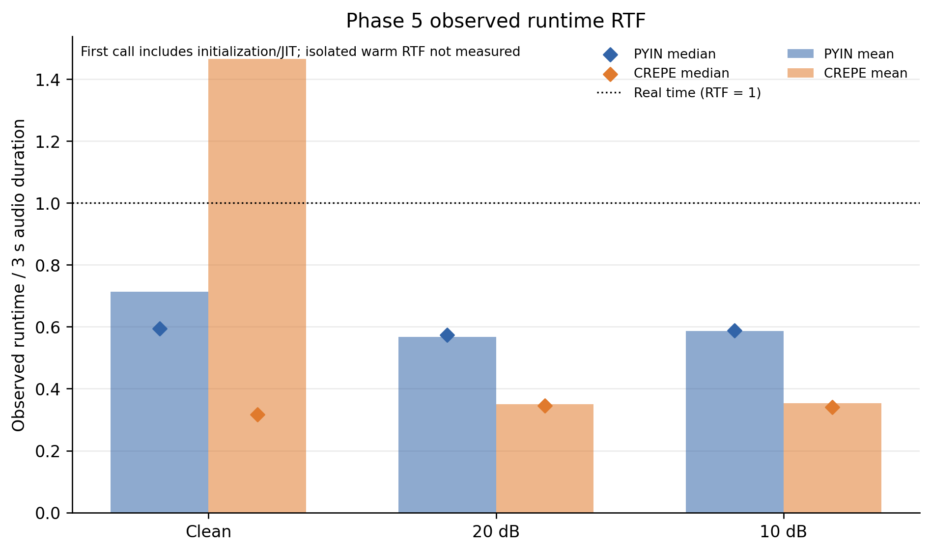
Figure 6. Observed Phase 5 RTF by detector and condition. The first call includes initialization/JIT; isolated warm inference was not measured.
These runtime measurements do not separate model loading, initialization and inference. In particular, the CREPE clean mean is elevated relative to its median, consistent with a large first-call contribution in the observed timing distribution; it is not evidence of a stable warm-time advantage or disadvantage.

5. Failure Analysis

5.1 SYN_T01_R012: pYIN octave-down estimates
For the clean R012 run, pYIN had 0/250 correct pitch frames, 250 octave errors, no missed voiced frames and 10 false-voiced frames. At 0.25 s the reference was 1046.502 Hz and the estimate was 523.251 Hz, an error of approximately −1200 cents. The 20 dB run also had 250 octave errors; the 10 dB run had 249 octave errors and one missed voiced frame. The Phase 8 track in Figure 7 displays the clean case on the exact grid. CREPE scored 250/250 correct for this recording in clean and 20 dB and 249/250 at 10 dB. These observations identify the error pattern; they do not establish its cause.
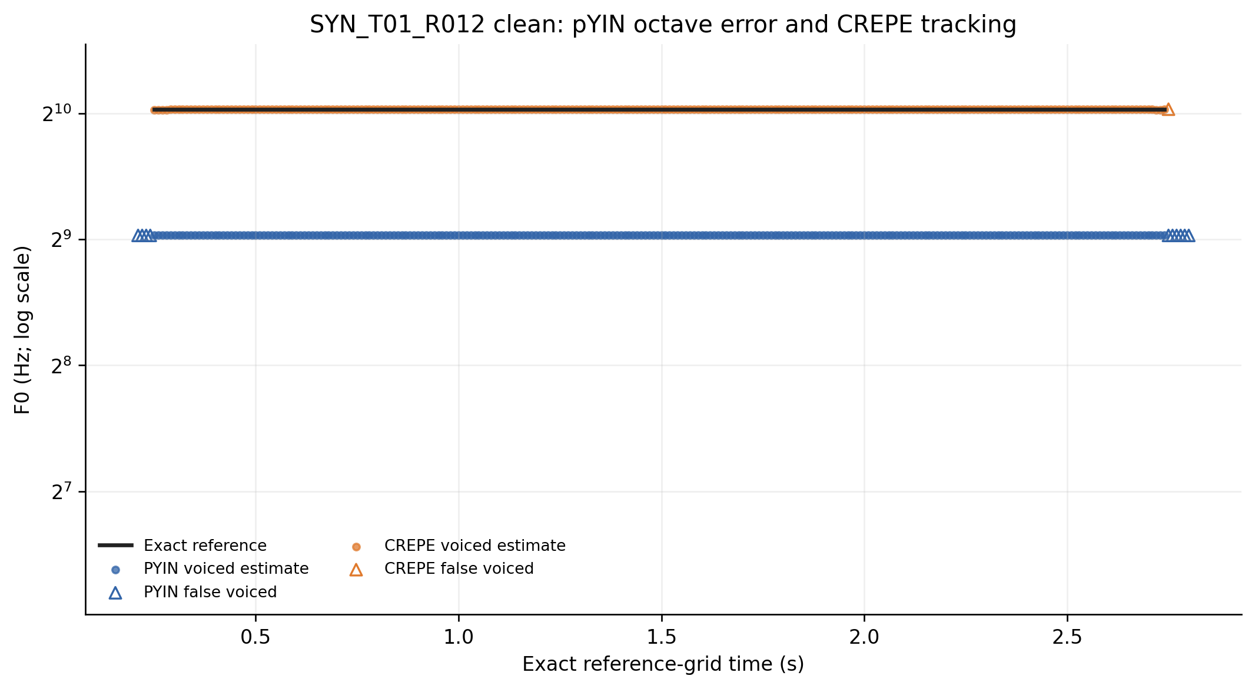
Figure 7. Exact 10 ms integer-grid pitch track for SYN_T01_R012 in clean condition. Crosses mark missed voiced frames and hollow triangles mark false-voiced frames; no interpolation is used.

5.2 SYN_T01_R001: CREPE 10 dB misses
At 10 dB, CREPE had 244/250 correct reference-voiced frames on R001, six missed voiced frames, no false-voiced frames and no octave errors. The conditional pitch-error denominator was 244. This is a verified example of missed voiced frames under the specified noisy synthetic condition; the results do not establish a cause.

5.3 SYN_T01_R003: pYIN 10 dB false-voiced frames
At 10 dB, pYIN had 248/250 correct pitch frames, no missed voiced frames and 31 false-voiced frames on R003. Checked examples on reference-unvoiced frames were 0.04, 0.05 and 0.06 s, each with estimated F0 96.873 Hz. These frames contributed to false positives, not to the reference-voiced raw-accuracy denominator. No causal explanation is inferred.

6. Discussion

6.1 Comparative performance and tested noise robustness
On the 12 exact-reference synthetic test recordings, CREPE tiny produced higher pooled raw pitch accuracy than pYIN in clean, 20 dB and 10 dB conditions, with no octave errors observed. pYIN had higher recall because it marked essentially all reference-voiced frames as voiced, but it also reported more false-voiced frames on reference-unvoiced frames. CREPE’s prespecified confidence rule yielded higher precision and somewhat more missed voiced frames, especially at 10 dB. This comparison concerns a controlled harmonic-tone dataset, a fixed software configuration and 72 runs, not unrestricted singing input.
The small change in raw accuracy from clean to 10 dB suggests both systems’ aggregate raw scores were stable across these particular noise derivatives. The error profile differed: pYIN’s conditional p90 rose to 40 cents and false positives increased, while CREPE maintained a p90 below 7 cents and had a modest increase in missed frames. The experiment does not characterize music accompaniment, reverberation, multiple speakers, microphone variation, expressive singing, or noise types other than the generated Gaussian white noise.

6.2 High-pitch octave-error case
The R012 reference pitch is at the configured upper boundary, approximately 1046.5 Hz. pYIN repeatedly returned approximately 523.25 Hz in this example, a one-octave-down estimate. Its recurrence under clean and 20 dB and near-recurrence at 10 dB make the case relevant to pitch-range and harmonic ambiguity checks. The evidence supports describing the output as octave-down; it does not show why pYIN made that estimate or justify generalizing this one recording to all high-pitch singing.

6.3 Practical implications for SUARA
Within this test, CREPE tiny merits continued evaluation as a candidate pitch estimator. Any SUARA integration should treat pitch confidence, unvoiced spans and quality flags as part of the output, and should not infer a vocal profile from unsupported frames. This is a proposed engineering direction, not a deployment decision established by this experiment. Evaluation on human singing with reliable, independently created frame-level references is required before making claims about real singers or application performance. Runtime decisions also require a benchmark that separates model initialization from warm inference on the intended target hardware.

7. Limitations
- Only 12 synthetic test recordings have scoreable F0 references; all are short harmonic tones.
- Human recordings have qualitative interval-level observations only for this analysis. No quantitative human pitch-accuracy claim is supported.
- There were no valid development F0 references for tuning or development performance estimation.
- CREPE’s confidence threshold of 0.5 was fixed in advance; it was not optimized on development data.
- Runtime includes initialization/JIT effects in the first call. There was no isolated warm-inference benchmark.
- The timing results do not show performance on production devices or in a deployed SUARA pipeline.
- Qualitative review was conducted by a solo reviewer; inter-rater agreement was not measured.
- The controlled Gaussian-noise conditions do not represent the full acoustic variation of real singing.

8. Evaluation Integrity
The initial Phase 7 evaluator used floating-point timestamp values as dictionary keys and matched only 265 of 300 expected reference rows per recording because binary float representations differed. Those results were invalidated. Evaluator v2.0.0 corrected alignment to strict integer 10 ms frame indices, retaining the 0.00–2.99 s reference grid and excluding the raw 3.00 s endpoint. The corrected evaluation matched 300/300 frames in each run and passed six regression tests; all 72/72 selected evaluations completed successfully. Corrected Phase 7 hashes and the frozen Phase 6 configuration hash were independently verified before report drafting. The invalidated outputs are archived under outputs/phase7/archive/ and were excluded from analysis and figures. No invalidated score is presented as a valid finding.

9. Conclusion
Under the frozen evaluation policy and tested synthetic conditions, CREPE tiny achieved 99.03–99.30% raw pitch accuracy within 50 cents and had no octave errors, while pYIN achieved 91.40–91.67% accuracy and showed approximately 8.3% octave error rates. CREPE also showed high pooled voicing precision, with more missed voiced frames at 10 dB; pYIN retained high recall but had more false positives. The R012 case documents a repeated pYIN octave-down output at the configured upper pitch boundary. These corrected findings make CREPE tiny a promising candidate for the next validation stage in this specific synthetic feasibility study. They do not establish real-singing accuracy, user benefit or production performance. Real-singing performance requires reliable human F0 references, an appropriately designed held-out evaluation and a separate target-hardware runtime benchmark.

References
[1] M. Mauch and S. Dixon, “pYIN: A fundamental frequency estimator using probabilistic threshold distributions,” in Proceedings of the IEEE International Conference on Acoustics, Speech and Signal Processing (ICASSP), 2014, pp. 659–663. doi: 10.1109/ICASSP.2014.6853678.
[2] J. W. Kim, J. Salamon, P. Li, and J. P. Bello, “CREPE: A Convolutional Representation for Pitch Estimation,” in Proceedings of the IEEE International Conference on Acoustics, Speech and Signal Processing (ICASSP), 2018. https://arxiv.org/abs/1802.06182.
[3] B. McFee et al., “librosa: Audio and Music Signal Analysis in Python,” in Proceedings of the 14th Python in Science Conference, 2015, pp. 18–25. doi: 10.25080/Majora-7b98e3ed-003. The experiment used librosa 0.11.0; see the librosa pYIN API documentation.
[4] J. W. Kim et al., CREPE software, official implementation and pretrained model, https://github.com/marl/crepe (version 0.0.12 as recorded in the frozen project configuration).

Appendix A. Experiment Configuration Summary
Item | Frozen or recorded setting
Quantitative reference set | 12 official synthetic recordings; all test split
Duration / sample rate | 3.00 s / mono 16 kHz
Conditions | Clean; additive Gaussian white noise at 20 dB and 10 dB SNR
Reference grid | 300 frames, 10 ms, indices 0–299; endpoint excluded
pYIN | librosa 0.11.0; C2–C6; frame 2048; hop 160; centered; native voiced flag
CREPE | 0.0.12 tiny; TensorFlow 2.16.2; 10 ms; CPU; batch 32; viterbi false
CREPE voiced decision | Finite positive F0 and native confidence >= 0.5, prespecified
Runs | 72 selected synthetic detector-condition evaluations; all successful
Human F0 scoring | None; frame-level human references not scoreable
Phase 6 config SHA-256 | a8f7414aeb2da47aab7ac6c4da83f36517d3f9281081c85216180e3e1f93af82
Phase 7 evaluator | v2.0.0; corrected integer-frame alignment

Appendix B. Reproducibility Instructions
From the project root, reproduce the corrected Phase 8 analysis using the pinned project environment:
.venv/bin/python scripts/phase8_results.py
The analysis script verifies the corrected Phase 7 result hashes and frozen Phase 6 configuration before producing the tables and plots. The report’s quantitative values are traceable to outputs/phase7/aggregate_results.json, outputs/phase7/per_recording_results.csv, and the validated Phase 8 outputs. The script does not read the invalidated archive. Detector environments and raw-output execution details are documented in protocol/phase5_detector_experiment.md and environment/.

Appendix C. Dataset Counts, Splits and Exclusions
The quantitative evaluation contains 12 synthetic reference recordings, each 3.00 seconds, each assigned to test. Each source was scored under three conditions for both detectors, giving 72 runs (12 × 3 × 2). Each run has 300 scored reference-grid frames; pooled per detector-condition totals are 3,600 rows, comprising 3,000 voiced and 600 unvoiced reference frames. All six groups had complete reference coverage. There are no human F0 scoring rows. The staged human manifest contains 30 recordings, split into 10 development and 20 test items, with 10 recordings for each of the three task types. Human audio and participant-level details remain private. Human pitch accuracy is not reported here. No test recording was used for threshold or parameter tuning.

Appendix D. Result and Figure Provenance
The corrected Phase 7 selected outputs are identified by the SHA-256 hashes in outputs/phase7/result_hashes.json. The Phase 7 provenance records evaluator version 2.0.0, configuration and policy hashes, run-manifest and synthetic-manifest hashes, 72/72 successful scored outputs, exact alignment, and excluded endpoint handling. Phase 8 validation.json records verified Phase 7 hashes, frozen configuration verification, pooled counts and ratios, selected raw failure case checks, seven figures, and exclusion of the invalidated archive. outputs/phase8/figure_index.md names the seven plotted measures. Figure images embedded in this report are the corresponding validated PNG exports. The report exposes no participant-identifying information or private human audio.

