**Hello Team!Consider the below two tables**:

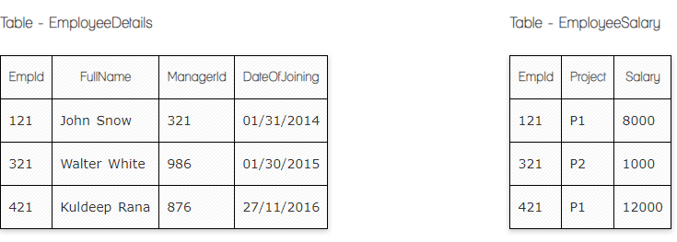

**Ques.1. Write a SQL query to fetch the count of employees working in project 'P1'.**

**Your Answer:**

**Select *, COUNT (EmpID), Project**

**From EmployeeSalary**

**GROUP BY Project**

**HAVING Project=P1**

**Ques.2. Write a SQL query to fetch employee names having salary greater than or equal to 5000 and less than or equal 10000.**

**Your Answer:**

**Select FullName, Salary**

**From EmployeeDetails**

**Inner Join EmployeeSalary**

**ON EmployeeSalary.EmpID=EmployeeDetails.EmpID**

**Where Salary Between 5000 AND 10000**

**Ques.3. Write a SQL query to fetch count of employees sorted by project's count in descending order.**

**Your Answer:**

**Select *, COUNT (EmpId), (Project)**

**FROM EmployeeSalary**

**Group By Project**

**Order By ProjectCount DESC**

**Ques.4. Write a query to fetch employee names and salary records. Return employee details even if the salary record is not present for the employee.**

**Your Answer:**

**Select EmployeeDetails. FullName, EmployeeSalary.Salary**

**From Employeesalary as ES**

**Left Join EmployeeDetails as ED**

**ON ES.EmpID=ED.EmpID**

**Ques.5. Write a SQL query to create an empty table with ‘Test’ name.**

**Your Answer:**

**Create Table Test(**

**ID int NOT NULL UNIQUE**

**Student Name varchar (100), NOT Null**

**)**

**Ques.6. Write a SQL query to delete an empty table with ‘Test’ name.**

**Your Answer:**

**DROP TABLE Test**

**Ques.7. Write a SQL query to fetch all the Employees details from EmployeeDetails table who joined in Year 2016.**

**Your Answer:**

**Select \***

**From EmployeeDetails**

**Where DateofJoining like ‘%2016%’**

**Ques.8. Write a SQL query to insert new record to the EmployeeDetails table with any data.**

**Your Answer:**

**INSERT INTO EmployeeDetails (FullName, DateofJoining)**

**VALUES (‘Jemma Mkrtchyan’, ‘28/08/2016’)**

**Ques.9. Write a SQL query to update EmployeeSalery table with setting Salary to 2000 for Project P2.**

**Your Answer:**

**UPDATE EmployeeSalary**

**SET Salary=2000**

**Where Project=’P2’**

**Now take these two tables:**

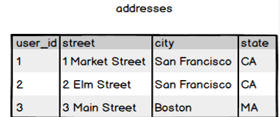

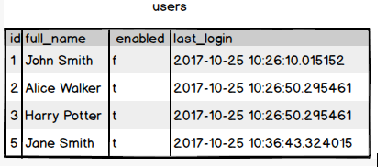

**Ques.11. Write a SQL query to fetch all users full_name from San Francisco.**

**Your Answer:**

**Select Addresses.city, Users.FullName**

**From Users**

**Inner Join Users**

**ON Addresses.user_id=Users.Id**

**Where Addresses.city=’San Francisco’**

**Ques.12. Write a SQL query to fetch all users full_name, last_login who are enabled**

**Your Answer:**

**Select Full_name, last_login, enabled**

**From Users**

**Where Enabled=’t’**

**Ques.13. Write a SQL query to fetch all users full_name who are not from Main street**

**Your Answer:**

**Select Addresses.street, Users.full_name**

**From Users**

**Inner Join Addresses**

**ON Addresses.user_id=Users.Id**

**Where street != 'Main Street'**

**Ques.14. Write a SQL query to fetch all users full_name who are from Main street or San Francisco**

**Your Answer:**

**Select Addresses.street, city, Users.full_name**

**From Users**

**Inner Join Addresses**

**ON Addresses.user_id=Users.Id**

**Where Addresses.street=’Main street’ OR City=’San Francisco’**

**Ques.15. Write a SQL queryto fetch user full_name who is equal to user_id from Boston (find user_id value in sub_query)**

**Your Answer:**

**Select Users.Full_name**

**From Users**

**Where User_id IN**

**(Select User_id**

**From Adresses**

**Where city=’Boston’)**