CSCI 5408

DATA MANAGEMENT AND WAREHOUSING

LAB - 1

Banner ID: B00984406

Table of Contents

1. Check how many unique actors are present in IMDB dataset….......................................3
2. Check how many movies are released between the year 1990s till 2000.........................4
3. Find the list of genres of movies directed by Christopher Nola.........................................5
4. Find the list of all directors, and the movie name which are ranked between 8 to 9 and have a genre of Sci-Fi and Action......................................................................................6
5. Find the name of the movie in which the actor’s role is any doctor, and the movie has the highest number of roles of doctor......................................................................................7
6. Find the list of the movies that start with the letter ‘f’……..................................................8
7. Reference……...................................................................................................................9

Query 1

**Problem Statement**

Check how many unique actors are present in the IMDB dataset.

**SQL Syntax**

SELECT COUNT(DISTINCT CONCAT(first_name, ' ', last_name)) AS UniqueActors FROM actors;

**Explanation**

* Firstly, we get the first name and last name of the actors from the IMDB.
* After that, I combined 2 fields by using CONCAT function.
* At last, use the DISTINCT to return unique actors.

**Output Screenshot**

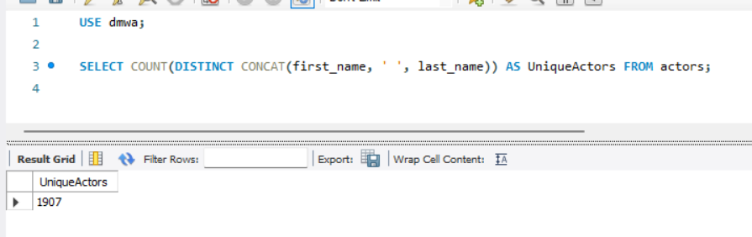

Query 2

**Problem Statement**

Check how many movies are released between the year 1990s till 2000.

**SQL Syntax**

SELECT COUNT(*) as movies_released_between_1990_to_2000

FROM movies

WHERE year >= 1990 AND year <= 2000;

**Explanation**

* First, use the BETWEEN operator to get the record from the 1990 to 2000.
* Next, use the COUNT to get released movies.

**Output Screenshot**

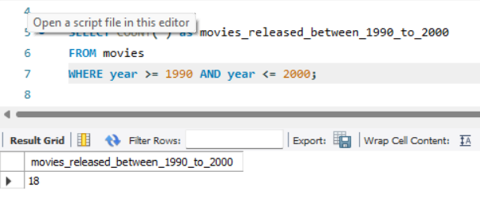

Query 3

**Problem Statement**

Find the list of genres of movies directed by Christopher Nola.

**SQL Syntax**

SELECT movies_genres.genre FROM movies_directors

JOIN directors ON directors.id = movies_directors.director_id

JOIN movies_genres ON movies_genres.movie_id = movies_directors.movie_id

WHERE directors.first_name = 'Christopher' AND directors.last_name = 'Nolan';

**Explanation**

* First, specify the genre column from the genres of the movies table to return.
* Next, do the JOIN on the directors table based on the common field director_id to join the two tables.
* Finally, join the same result with the movies_genres table based on the movie-id and use the condition on the first name and last name field of the directors table to return output.

**Output Screenshot**

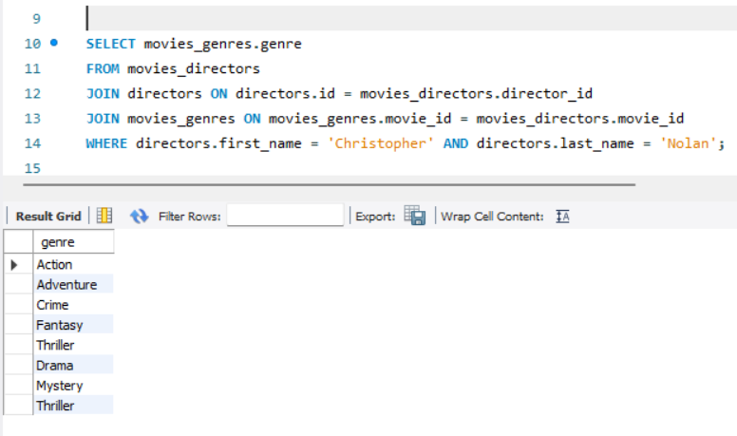

Query 4

**Problem Statement**

Find the list of all directors, and the movie name which are ranked between 8 to 9 and have a genre of Sci-Fi and Action

**SQL Syntax**

SELECT CONCAT(d.first_name, ' ', d.last_name) AS director_name, m.name AS moviesname

FROM directors d

JOIN movies_directors md ON d.id = md.director_id

JOIN movies m ON md.movie_id = m.id WHERE m.rank BETWEEN 8 AND 9

AND m.id IN (

SELECT movie_id

FROM movies_genres

WHERE genre IN ('Sci-Fi', 'Action')

GROUP BY movie_id

HAVING COUNT(DISTINCT genre) = 2

);

**Explanation**

* First, I concatenate the first and last names of the directors and labeling it as a “moviesname”
* After, we join the table to get the movies names, directors and genres.
* After that, do filter by the given rank and the genres ‘Sci-Fi’ and ‘Action’ and connect movies along with the directors.
* Finally, we ensure the unique combination of the director name and movies name.

**Output Screenshot**

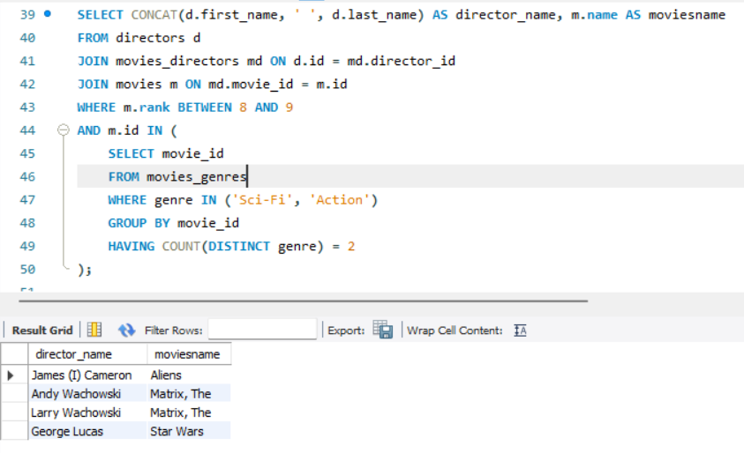

Query 5

**Problem Statement**

Find the name of the movie in which the actor’s role is any doctor, and the movie has the highest number of roles of doctor.

**SQL Syntax**

SELECT name FROM ( SELECT MAX(movie_id) AS max_movie_id FROM roles WHERE role LIKE '%doctor%') AS roles

LEFT JOIN movies

ON movies.id = roles.max_movie_id;

**Explanation**

* First, the highest movie_id is determined from the “roles” table where the role containes the doctor and give alias “roles” to that.
* Then we left join the result with the movies table using movie_id.
* Finally, we retrieve the names of the movies from the movies table that have a matching movie_id.

**Output Screenshot**

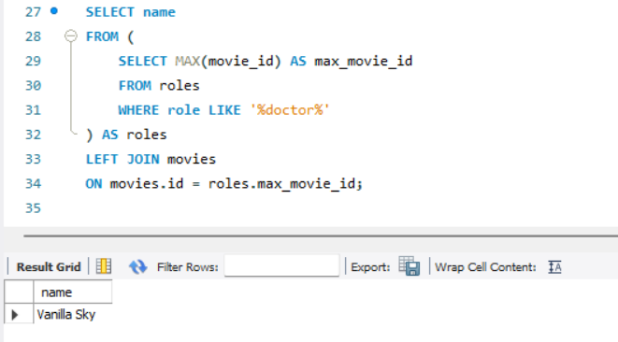

Query 6

**Problem Statement**

Find the list of the movies that start with the letter ‘f’.

**SQL Syntax**

SELECT * FROM movies WHERE name LIKE 'f%';

**Explanation**

* Here, we get the all columns from movies table and filter rows where the name starts with the letter “f” using LIKE operator.

**Output Screenshot**

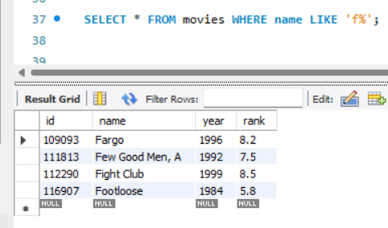

Reference:  
  
[1] "MySQL DISTINCT Operator," JavaTPoint, [Online]. Available:

<https://www.javatpoint.com/mysql-distinct>.[Accessed 9 May 2024]

[2] "SQL JOIN Clause," W3Schools, [Online]. Available:

<https://www.w3schools.com/sql/sql_join.asp>.[Accessed 9 May 2024]

[3] "SQL CONCAT() Function," W3Schools, [Online]. Available:

<https://www.w3schools.com/sql/func_sqlserver_concat.asp>.[Accessed 9 May

2024]