The Boy Who Followed the Fireflies / Ang Bata nga Misunod sa mga Alitaptap
Target Grade Level: Grade 6
Location / Setting: Barangay Quezon, Tagbina, Surigao del Sur
Subject Integration: English, Science, Values Education
Theme: Curiosity, safety, and responsible decision-making
Learning Competency: Identify important details, explain a character’s actions, and infer the lesson of a story using evidence.

The Story / Ang Istorya
Page 1
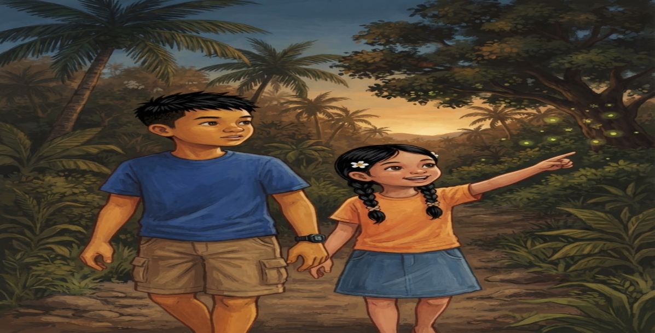

English:
One evening, twelve-year-old Nico was walking home with his younger sister, Lila. As they passed a grassy area near their house, they saw several fireflies glowing among the trees. Lila stopped to watch them, but Nico noticed that the fireflies were moving farther into the dark field.
Bisaya:
Usa ka gabii, naglakaw pauli si Nico, dose anyos, uban sa iyang manghod nga si Lila. Samtang miagi sila sa sagboton nga lugar duol sa ilang balay, nakakita sila og mga alitaptap nga nagsiga taliwala sa mga kahoy. Mihunong si Lila sa pagtan-aw, apan namatikdan ni Nico nga ang mga alitaptap nagpadulong sa ngitngit nga uma.

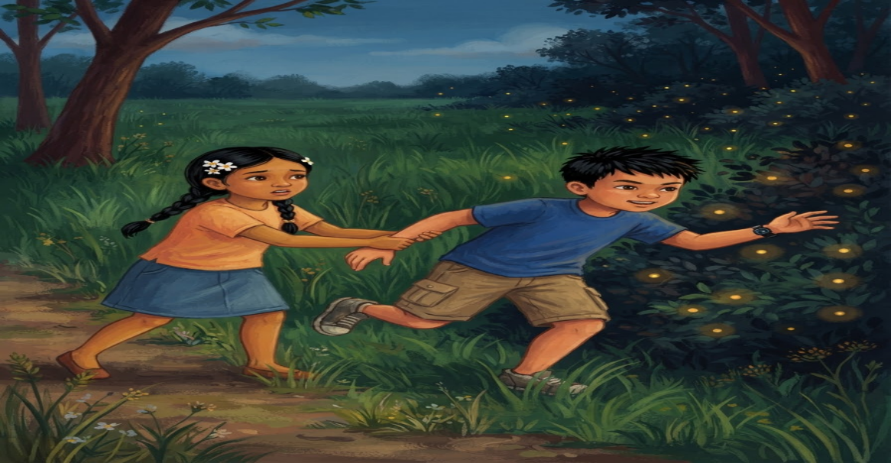
Page 2

English:
Nico became curious and wanted to follow them. He took a few steps forward, but Lila held his arm. She reminded him that their mother had told them not to go far from home at night.
Bisaya:
Nakuryoso si Nico ug gusto niyang sundon ang mga alitaptap. Milakaw siya og pipila ka lakang paingon didto, apan gigunitan siya ni Lila sa bukton. Gipahinumdoman siya niini nga giingnan sila sa ilang inahan nga dili molayo sa balay panahon sa gabii.

Page 3
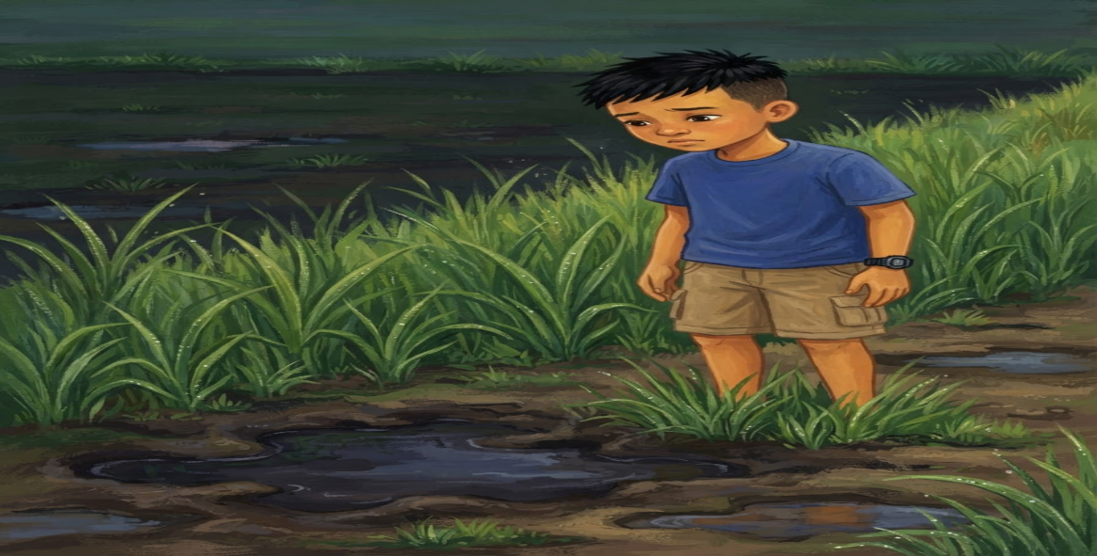
English:
Nico looked at the dark field. He could see a narrow path, but he could not tell what was beyond it. He also noticed that the ground was wet after the rain. Nico realized that following the fireflies could be dangerous.
Bisaya:
Mitutok si Nico sa ngitngit nga uma. Nakita niya ang usa ka gamay nga agianan, apan dili niya makita kung unsay naa sa unahan. Namatikdan usab niya nga basa ang yuta tungod sa ulan. Nasabtan ni Nico nga mahimong peligroso ang pagsunod sa mga alitaptap.

Page 4

English:
Instead of going farther, Nico and Lila stayed near their house. They watched the fireflies from a safe place. Nico wondered why the fireflies were gathering near the trees.
Bisaya:
Imbis nga mopadayon pa, nagpabilin sila ni Lila duol sa ilang balay. Gitan-aw nila ang mga alitaptap gikan sa luwas nga lugar. Natingala si Nico kung nganong nagtapok ang mga alitaptap duol sa mga kahoy.

Page 5


English:
The next morning, Nico told their science teacher about the fireflies. Their teacher explained that fireflies often live-in places with plants, moisture, and clean surroundings. She also reminded the class not to catch or harm them.
Bisaya:
Pagkasunod buntag, gisultihan ni Nico ang ilang Science teacher bahin sa mga alitaptap. Gipatin-aw sa ilang magtutudlo nga ang mga alitaptap kasagarang nagpuyo sa mga lugar nga adunay mga tanom, kaumog, ug limpyo nga palibot. Gipahinumdoman usab niya ang klase nga dili sila dakpon o pasakitan.

Page 6

English:
The teacher asked the pupils to observe the area without disturbing the fireflies. Nico and his classmates noticed that the trees and grass around the area were still healthy. They also saw that the place had no piles of trash.
Bisaya:
Gipangutana sa magtutudlo ang mga estudyante nga obserbahan ang lugar nga dili samokon ang mga alitaptap. Namatikdan ni Nico ug iyang mga kauban nga himsog pa ang mga kahoy ug sagbot sa maong lugar. Nakita usab nila nga walay tapok sa basura didto.

Page 7


English:
Nico remembered how close he had been to walking into the dark field. He was thankful that Lila had stopped him. He learned that being curious was good, but safety should always come first.
Bisaya:
Nahinumdom si Nico kung unsa siya kasuod sa pagsulod sa ngitngit nga uma. Mapasalamaton siya nga gipahunong siya ni Lila. Nakakat-on siya nga maayo ang pagkamausisaon, apan ang kaluwasan kinahanglan kanunay nga unahon.

Page 8

English:
That evening, Nico and Lila watched the fireflies again from their yard. They smiled as the tiny lights moved between the trees. Nico no longer felt the need to follow them. He was happy simply to observe them from a safe place.
Bisaya:
Niadtong gabhiona, gitan-aw na usab nila ni Lila ang mga alitaptap gikan sa ilang nataran. Mipahiyom sila samtang ang gagmay nga kahayag naglihok taliwala sa mga kahoy. Wala na mobati si Nico og panginahanglan nga sundon sila. Nalipay na siya nga magtan-aw niini gikan sa luwas nga lugar.

Comprehension Check-Up
Directions: Read each question carefully. Choose the letter of the correct answer.
1. Who was Nico with when he first saw the fireflies?
A. His older brother
B. His younger sister, Lila
C. His mother
D. His Science teacher
2. Why did Nico want to follow the fireflies?
A. He wanted to catch all the fireflies.
B. He wanted to bring them to school.
C. He was curious about where the fireflies were going.
D. He wanted to sell them.

3. Why did Lila stop Nico from entering the field?
A. She reminded him that their mother told them not to go far from home at night.
B. She wanted to go home alone.
C. She was afraid of the fireflies.
D. She wanted to play inside the house.

4. What made Nico realize that following the fireflies could be dangerous?
A. The fireflies suddenly disappeared.
B. His sister started running away.
C. Their mother called them for dinner.
D. The field was dark, the path was unclear, and the ground was wet after the rain.

5. What lesson did Nico learn from the experience?
A. It is always safe to explore dark places.
B. Children should ignore their parents' warnings.
C. Curiosity is good, but safety should always come first.
D. Fireflies should be caught and kept in jars.
Answer Key:
- B
- C
- A
- D
- C

