The Missing Footbridge of Quezon
Ang Nawala nga Footbridge sa Quezon
Target Grade Level: Grade 6
Setting: Barangay Quezon, Tagbina, Surigao del Sur
Subject Integration: English & Science
Themes: Cooperation, Safety, Problem-Solving, and Community
Learning Competencies: Main Idea, Cause and Effect, Making Inferences, and Character Analysis

Page 1 – The Shortcut Home
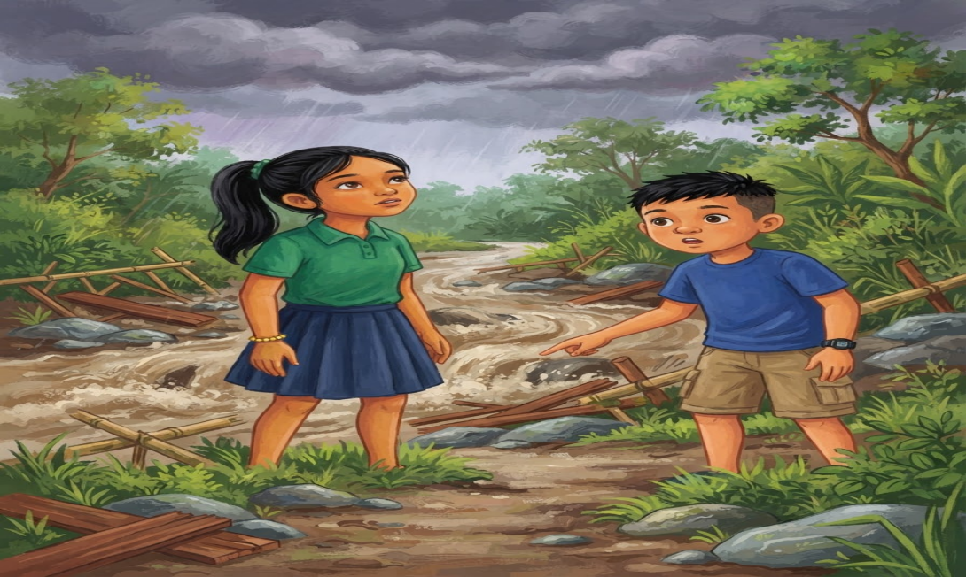
English
It was Friday afternoon in Barangay Quezon, Tagbina. Dark clouds were gathering above the coconut trees as Lia and her classmates walked home from school.
They usually crossed a small wooden footbridge over a narrow creek. The bridge was their quickest way home.
“Let’s hurry,” Lia said. “It looks like it’s going to rain.”
Her friend Nico pointed at the creek.
“Wait. The water looks higher than usual.”
Lia stopped.
The water was already flowing faster, carrying small leaves and twigs downstream.

Bisaya
Biyernes sa hapon sa Barangay Quezon, Tagbina. Nagtapok ang mga itom nga panganod ibabaw sa mga punoan sa niyog samtang naglakaw pauli gikan sa eskwelahan si Lia ug iyang mga classmates.
Kasagaran, motabok sila sa gamay nga kahoy nga footbridge ibabaw sa usa ka gamay nga sapa. Kini ang pinakapaspas nilang agianan pauli.
“Dali ta,” miingon si Lia. “Murag moulan na gyud.”
Gitudlo ni Nico ang sapa.
“Kadali. Murag mas taas ang tubig kaysa naandan.”
Mihunong si Lia.
Mas kusog na ang agos sa tubig ug nagdala kini og gagmay nga dahon ug mga sanga.

Page 2 – The Bridge Is Gone
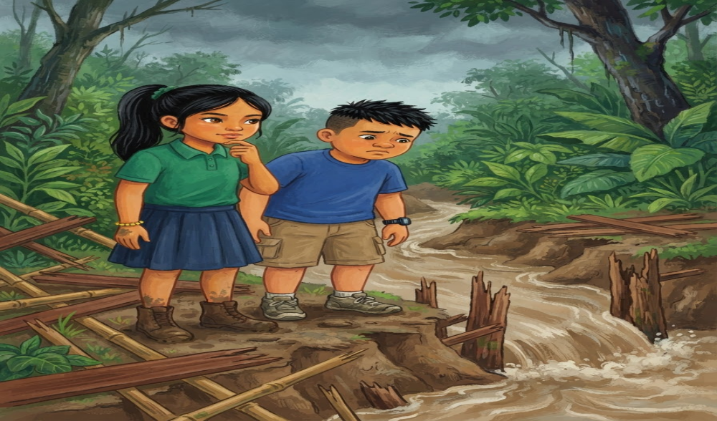

English
When they reached the creek, everyone suddenly stopped.
The wooden footbridge was gone.
“Where is the bridge?” Nico asked.
Lia looked downstream.
Heavy rain from the previous night had caused the creek to rise. The strong current had damaged the bridge and carried several wooden boards away.
“We can't cross here,” Lia said.
“But this is the only way!” one of their classmates complained.
Lia shook her head.
“We need to find another safe route.”
Instead of taking a dangerous shortcut, the group decided to return to the barangay hall and ask for help.

Bisaya
Pag-abot nila sa sapa, kalit nga mihunong ang tanan.
Nawala ang kahoy nga footbridge.
“Asa na ang bridge?” pangutana ni Nico.
Gitan-aw ni Lia ang ubos nga bahin sa sapa.
Tungod sa kusog nga ulan sa miaging gabii, misaka ang tubig sa sapa. Nadaot ang footbridge ug gidala sa kusog nga agos ang pipila ka tabla.
“Dili ta mahimong motabok diri,” miingon si Lia.
“Pero mao ra man ni ang atong agianan!” reklamo sa usa nilang classmates.
Milingo si Lia.
“Kinahanglan mangita ta og laing luwas nga agianan.”
Imbis nga mosulay og delikadong shortcut, mibalik ang grupo sa barangay hall aron mangayo og tabang.

Page 3 – A Community Problem
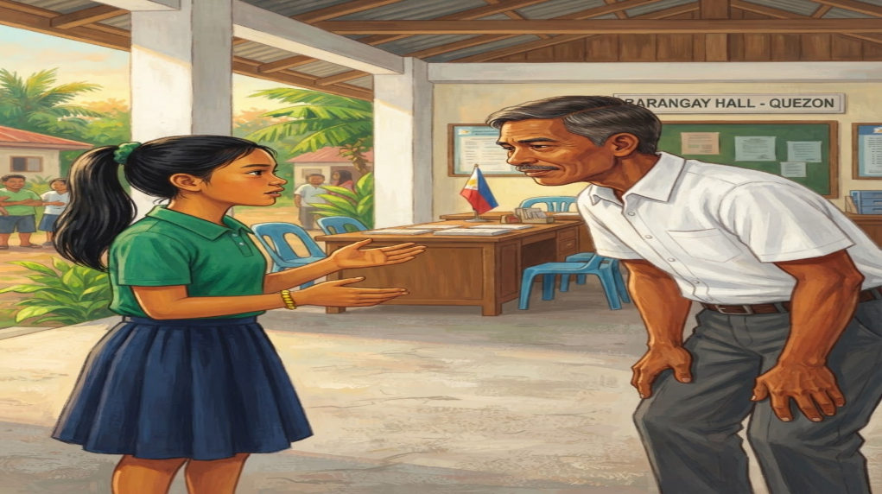
English
At the barangay hall, they told Kapitan Ramon what had happened.
Kapitan Ramon thanked them for reporting the problem.
“Good decision,” he said. “Never cross a flooded creek when the current is strong.”
The next morning, several parents and community members inspected the area.
They found broken boards, fallen branches, and mud along the creek.
The children wanted to help.
“We may be young, but we can still do something,” Lia said.
The adults agreed to let them help in safe ways.
The children collected small pieces of trash and cleared the pathway away from the creek.

Bisaya
Sa barangay hall, gisultihan nila si Kapitan Ramon bahin sa nahitabo.
Gipasalamatan sila ni Kapitan Ramon sa pag-report sa problema.
“Maayo ang inyong desisyon,” miingon siya. “Ayaw gyud motabok sa baha nga sapa kung kusog ang agos.”
Pagkasunod buntag, gisusi sa pipila ka ginikanan ug mga miyembro sa komunidad ang lugar.
Nakita nila ang mga nabali nga tabla, nangahulog nga mga sanga, ug lapok daplin sa sapa.
Gusto motabang ang mga bata.
“Bata pa mi, pero aduna gihapon mi’y mahimo,” miingon si Lia.
Miuyon ang mga hamtong nga motabang sila sa luwas nga paagi.
Gipanghipos sa mga bata ang gagmay nga basura ug gilimpyohan ang agianan palayo sa sapa.

Page 4 – Finding a Safer Way
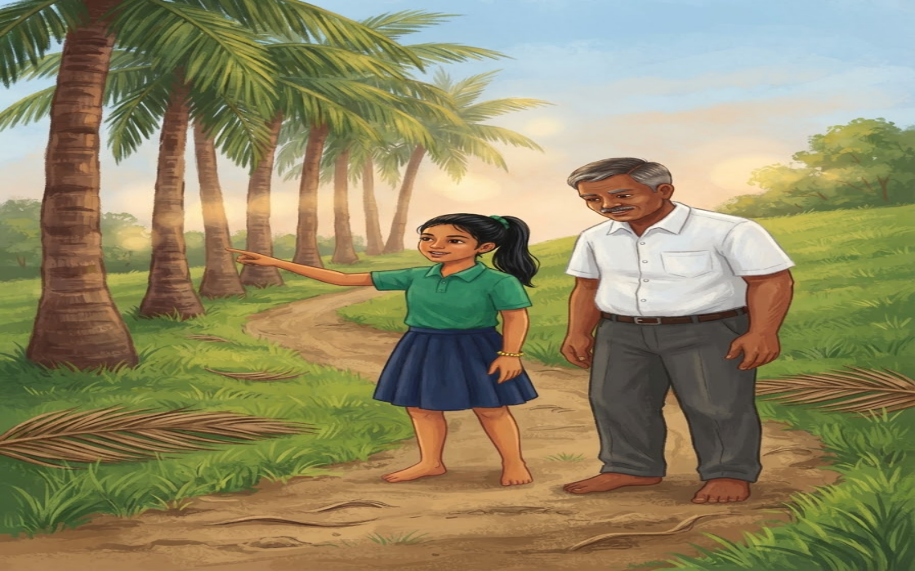
English
While the adults planned how to repair the footbridge, Lia noticed something.
“There is another pathway near the old coconut trees,” she said.
The adults checked the path.
It was longer, but it was dry and safe.
Kapitan Ramon smiled.
“This can be our temporary route while the footbridge is being repaired.”
Lia felt proud.
Her idea had helped the community find a safer way home.
Nico smiled at her.
“Sometimes, the longer road is better if it keeps us safe.”
Lia nodded.
Bisaya
Samtang nagplano ang mga hamtong unsaon pag-ayo sa footbridge, adunay namatikdan si Lia.
“Aduna pay laing agianan duol sa mga karaang punoan sa niyog,” miingon siya.
Gisusi sa mga hamtong ang agianan.
Mas layo kini, apan uga ug luwas.
Mihiyom si Kapitan Ramon.
“Mahimo nato kining temporaryong agianan samtang giayo ang footbridge.”
Nalipay si Lia.
Ang iyang ideya nakatabang sa komunidad sa pagpangita og mas luwas nga agianan pauli.
Mihiyom si Nico kaniya.
“Usahay, mas maayo ang mas taas nga agianan kung luwas kita.”
Mitungo si Lia.
Page 5 – Working Together
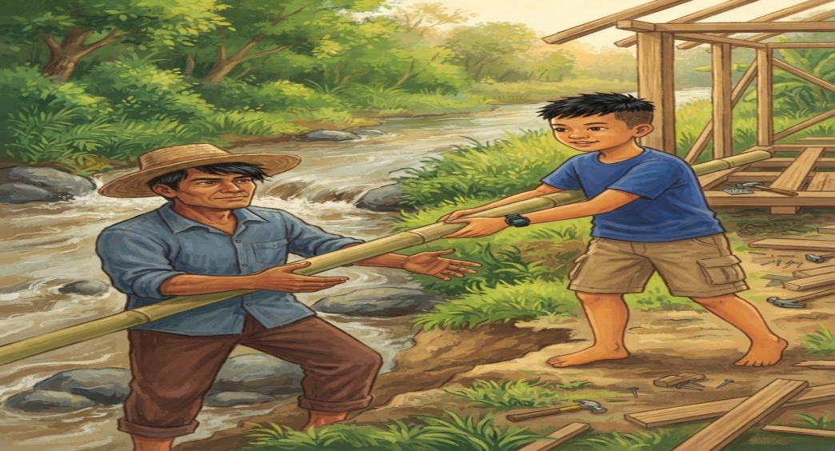
English
For several days, the community worked together.
The adults repaired the footbridge using strong wood and bamboo. The children helped by keeping the area clean and reminding younger children not to play near the creek.
After the repairs were finished, everyone gathered to inspect the new bridge.
“It looks stronger now!” Nico said.
Kapitan Ramon reminded everyone, “A bridge connects two places, but cooperation connects a community.”
Lia smiled.
She realized that solving a community problem was not the responsibility of one person alone.
Everyone had a role to play.
Bisaya
Sulod sa pipila ka adlaw, nagtinabangay ang komunidad.
Giayo sa mga hamtong ang footbridge gamit ang lig-on nga kahoy ug kawayan. Mitabang ang mga bata pinaagi sa paglimpyo sa palibot ug pagpahinumdom sa mga gagmay nga bata nga dili magdula duol sa sapa.
Human mahuman ang pag-ayo, nagtigom ang tanan aron susihon ang bag-ong footbridge.
“Mas lig-on na karon!” miingon si Nico.
Gipahinumdom ni Kapitan Ramon ang tanan, “Ang bridge nagdugtong sa duha ka lugar, apan ang panagtinabangay nagdugtong sa usa ka komunidad.”
Mihiyom si Lia.
Nakasabot siya nga ang pagsulbad sa problema sa komunidad dili responsibilidad sa usa lang ka tawo.
Ang matag usa adunay papel nga mahimo.

Page 6 – A Lesson to Remember
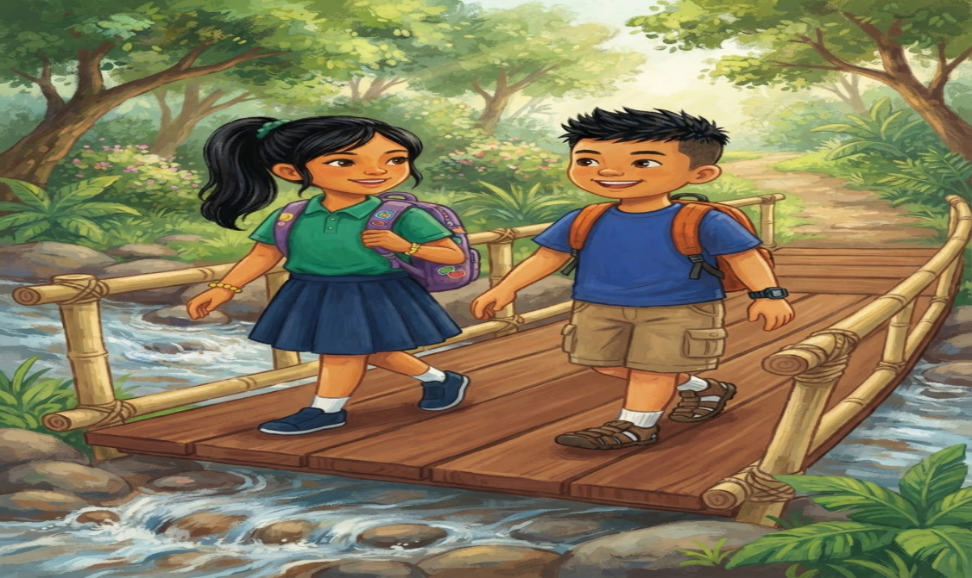

English
The following Monday, Lia and her classmates crossed the repaired footbridge on their way to school.
They stopped for a moment and looked at the flowing creek below.
“I'm glad we didn't cross when the water was strong,” Nico said.
“Me too,” Lia replied.
She learned three important lessons: stay safe, speak up when there is danger, and work together to solve problems.
As they continued walking, Lia looked back at the bridge.
It was more than just a way across the creek.
It was a reminder that a strong community is built through responsibility, cooperation, and care.

Bisaya
Pagkasunod Lunes, mitabok si Lia ug iyang mga classmates sa giayong footbridge padulong sa eskwelahan.
Mihunong sila kadiyot ug gitan-aw ang nagaagos nga tubig sa ubos.
“Maayo nga wala ta mitabok niadtong kusog pa ang agos,” miingon si Nico.
“Bitaw,” tubag ni Lia.
Nakat-on siya og tulo ka importanteng leksyon: mag-amping, mosulti kung adunay peligro, ug magtinabangay sa pagsulbad sa problema.
Samtang nagpadayon sila sa paglakaw, milingi si Lia sa footbridge.
Dili lang kini ordinaryong agianan ibabaw sa sapa.
Kini usa ka pahinumdom nga ang lig-on nga komunidad natukod pinaagi sa responsibilidad, panagtinabangay, ug pag-atiman.

Comprehension Check-Up
Directions: Read each question carefully. Choose the letter of the correct answer.
1. What is the main idea of the story?
A. Children should never cross bridges.
B. People can solve community problems through cooperation and responsible decisions.
C. Rain always destroys bridges.
D. Lia wanted to become a barangay leader.

2. What caused the footbridge to be damaged?
A. Strong wind.
B. People broke it.
C. Heavy rain caused the creek to rise, and the strong current damaged the bridge.
D. The children played on it.

3. Why did Lia refuse to cross the creek?
A. She was afraid of the dark.
B. The water was high, and the current was strong.
C. She wanted to go home.
D. She forgot her bag.

4. What did the children do to help the community?
A. They repaired the bridge themselves.
B. They crossed the dangerous creek.
C. They cleaned the area and helped keep younger children safe.
D. They went home and waited.

5. What can you infer about Lia based on her actions?
A. She is careless.
B. She is selfish.
C. She is responsible, observant, and willing to help others.
D. She does not listen to adults.

Answer Key:
- B
- C
- B
- C
- C

