The School Garden Project / Ang Proyekto sa Hardin sa Eskwelahan
Target Grade Level: Grade 6
Location / Setting: Barangay Quezon, Tagbina, Surigao del Sur
Subject Integration: English, Science, Values Education
Theme: Cooperation, responsibility, and care for the environment
Learning Competency: Identify a problem, explain the actions taken to solve it, and describe the lesson learned from the experience.

The Story / Ang Istorya

Page 1
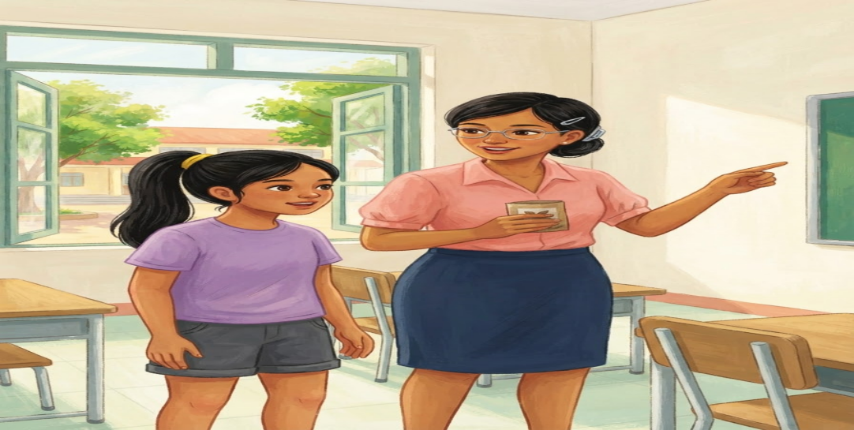
English:
One Monday morning, the Grade 6 pupils of Quezon Elementary School started their school garden project. Their teacher, Ms. Lara, divided them into small groups. Each group was given a task to prepare the soil and plant vegetables.
Bisaya:
Usa ka Lunes sa buntag, gisugdan sa mga Grade 6 nga estudyante sa Quezon Elementary School ang ilang proyekto sa hardin sa eskwelahan. Gibahin sila sa ilang magtutudlo nga si Ma’am Lara ngadto sa gagmay nga grupo. Ang matag grupo gihatagan og buluhaton sa pag-andam sa yuta ug pagtanom og mga utanon.

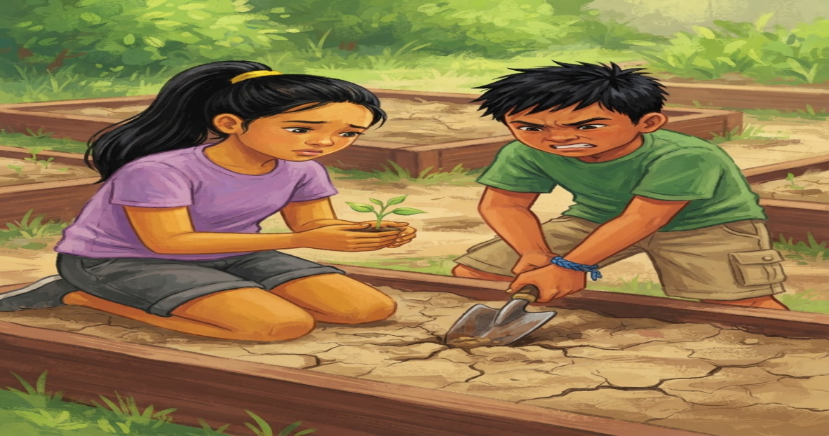
Page 2

English:
Ana and her group planted pechay, tomatoes, and eggplants. They were excited to see the plants grow. However, Ana noticed that some parts of the garden were dry and the soil was hard.
Bisaya:
Si Ana ug ang iyang grupo mitanom og pechay, kamatis, ug talong. Nalipay sila nga makita ang pagtubo sa mga tanom. Apan namatikdan ni Ana nga ang ubang bahin sa hardin uga ug gahi ang yuta.

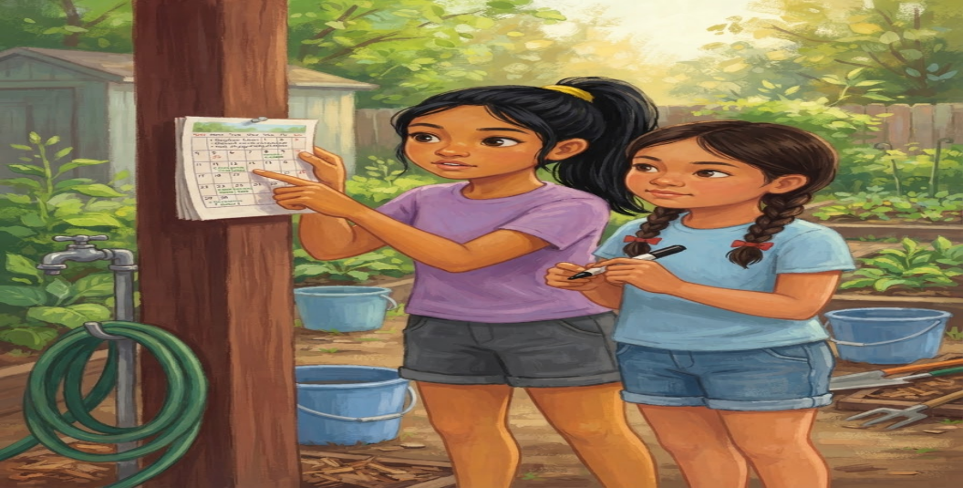
Page 3

English:
Ana suggested watering the plants every afternoon. Her group agreed, but they realized that they could not water the whole garden every day because their water supply was limited. They decided to make a schedule.
Bisaya:
Misugyot si Ana nga bisbisan ang mga tanom matag hapon. Miuyon ang iyang grupo, apan ilang nasabtan nga dili nila mabisbisan ang tibuok hardin kada adlaw tungod kay limitado ang ilang suplay sa tubig. Nakahukom sila nga maghimo og iskedyul.

Page 4
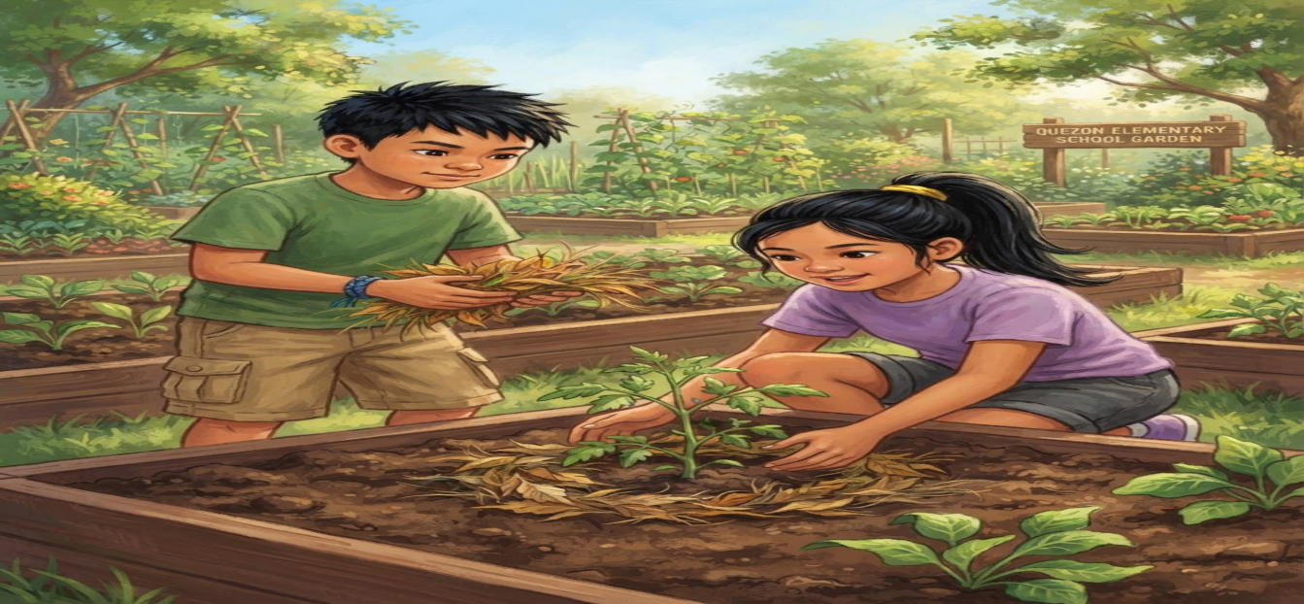
English:
The pupils also collected dry leaves and grass around the school. They placed them around the plants to help keep the soil moist. Their teacher explained that this could also help protect the soil.
Bisaya:
Ang mga estudyante nangolekta usab og mga uga nga dahon ug sagbot palibot sa eskwelahan. Gibutang nila kini palibot sa mga tanom aron makatabang sa pagpabiling basa sa yuta. Gipatin-aw sa ilang magtutudlo nga makatabang usab kini sa pagpanalipod sa yuta.

Page 5
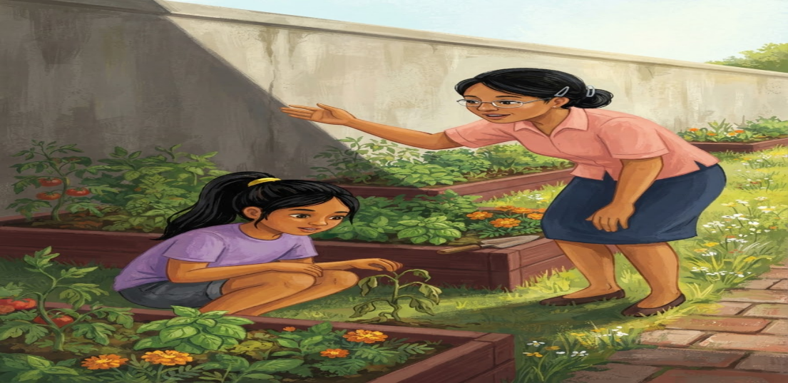

English:
After one week, the pupils noticed that some plants were growing well while others were still small. Instead of blaming one another, they checked the garden carefully. They found that some plants were not receiving enough sunlight.
Bisaya:
Human sa usa ka semana, namatikdan sa mga estudyante nga ang ubang tanom maayo ang pagtubo samtang ang uban gagmay pa. Imbis nga magbasolay, ilang gisusi pag-ayo ang hardin. Nakita nila nga ang ubang tanom wala makadawat og igo nga kahayag sa adlaw.

Page 6
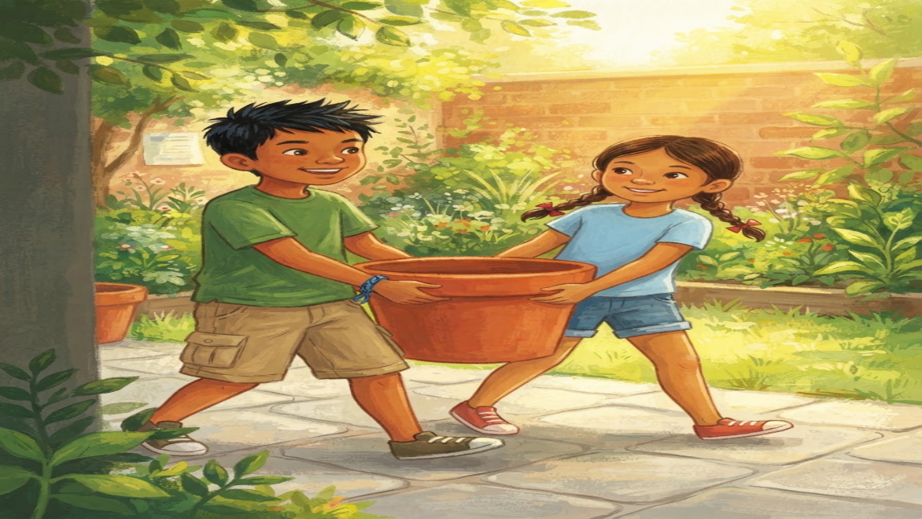
English:
With their teacher’s guidance, they moved some containers to a brighter area. They continued following their watering schedule and removed weeds from the garden. Everyone worked together.
Bisaya:
Uban sa giya sa ilang magtutudlo, ilang gibalhin ang ubang mga sudlanan ngadto sa mas hayag nga lugar. Padayon nilang gisunod ang iskedyul sa pagbisbis ug nangibot sila sa mga sagbot sa hardin. Ang tanan nagtinabangay.

Page 7
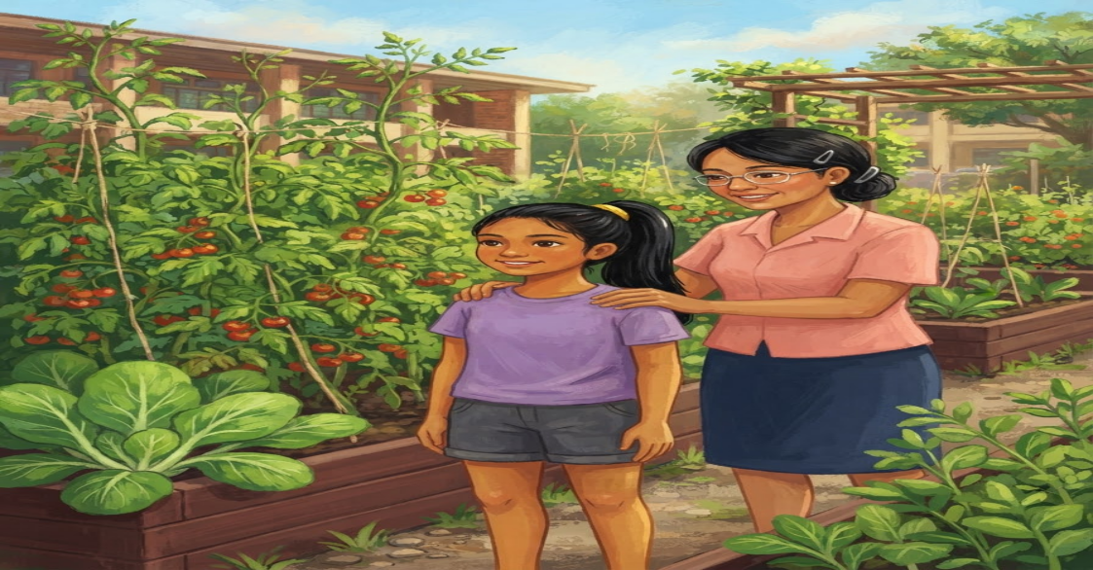
English:
After several weeks, the garden became green and healthy. The pupils were proud when they saw the vegetables growing. They learned that a garden needs regular care, not just planting.
Bisaya:
Human sa pipila ka semana, nahimong lunhaw ug himsog ang hardin. Nalipay ug nanghambog ang mga estudyante sa ilang nakita nga nagtubo na ang mga utanon. Nakakat-on sila nga ang hardin nagkinahanglan og kanunay nga pag-atiman, dili lang pagtanom.

Page 8
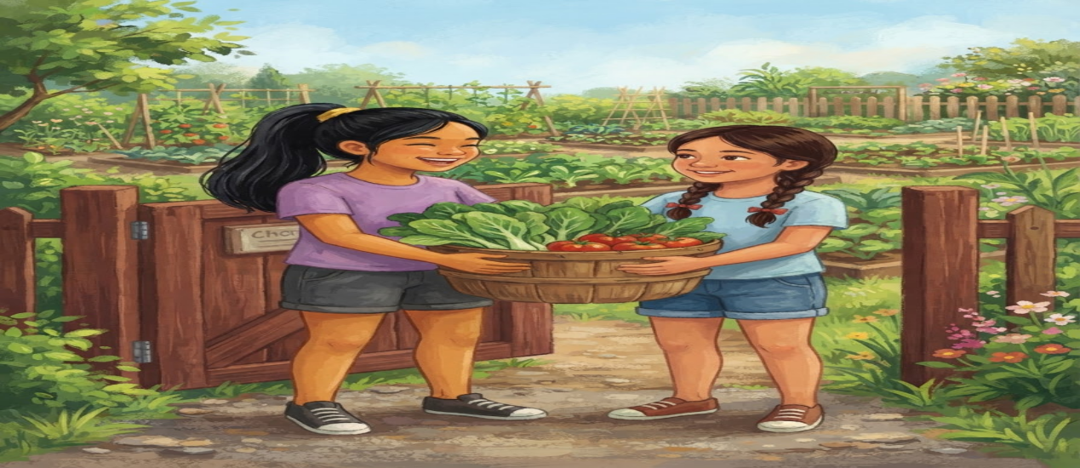

English:
Ana looked at her classmates and smiled. She realized that their garden became successful because everyone shared the work and took responsibility. The school garden taught them that small efforts can create something useful when people work together.
Bisaya:
Mitutok si Ana sa iyang mga kauban ug mipahiyom. Nasabtan niya nga nahimong malampuson ang ilang hardin tungod kay ang tanan nagtinabangay ug nagdala sa ilang responsibilidad. Gitudloan sila sa hardin sa eskwelahan nga ang gagmay nga paningkamot mahimong mapuslanon kung ang mga tawo magtinabangay.

Comprehension Check-Up
Direction: Read each question carefully. Choose the letter of the correct answer.
1. What was the main project of the Grade 6 pupils?
A. To build a new classroom.
B. To create and take care of a school garden.
C. To clean the school library.
D. To organize a sports competition.
2. Where did the story happen?
A. Tagbina National High School.
B. San Isidro Elementary School.
C. Quezon Elementary School in Barangay Quezon.
D. Surigao del Sur Provincial Park.

3. What problem did Ana notice in the garden?
A. Some parts of the garden were dry, and the soil was hard.
B. The garden had too many flowers.
C. The plants were growing too quickly.
D. The garden was full of fruits.

4. What did the pupils do because their water supply was limited?
A. They stopped watering the plants.
B. They removed all the plants from the garden.
C. They watered the plants only once a month.
D. They made a watering schedule to manage the available water.

5. Why did the pupils put dry leaves and grass around the plants?
A. To prevent the plants from receiving sunlight.
B. To help keep the soil moist and protect it.
C. To make the garden look messy.
D. To stop the plants from growing.
Answer Key:
- B
- C
- A
- D
- B

