Zero Percent Battery at the Robusta Farm
Target Grade Level: Grade 6
Location/Setting: Barangay Quezon, Tagbina, Surigao del Sur
Subject Integration: English and Science
Themes: Problem-Solving, Responsibility, Technology, and Agriculture
Learning Competencies: Identifying the Main Idea, Understanding Cause and Effect, Making Inferences, and Analyzing Character Actions

Page 1 – A Morning at the Farm
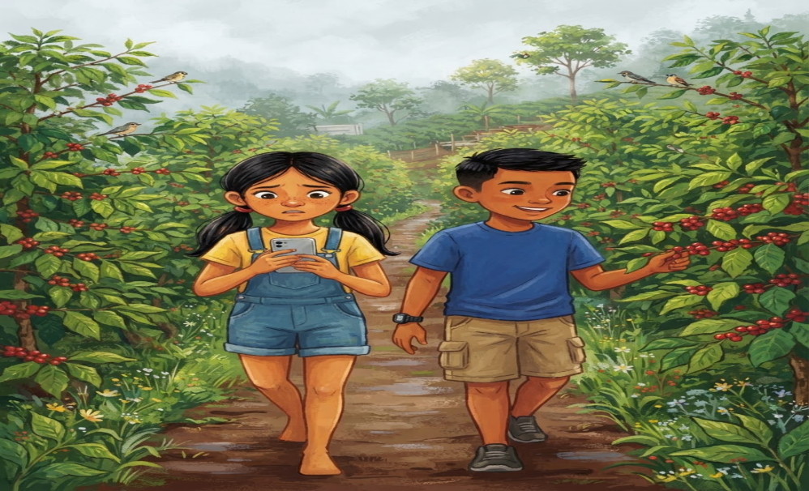
English
Early one Saturday morning, Mika and her cousin Junjun walked along the muddy path to their family’s Robusta coffee farm in Barangay Quezon, Tagbina, Surigao del Sur.
The morning air was cool, and the smell of ripe coffee cherries filled the farm. Birds chirped from the trees while farmers picked red coffee cherries and placed them in baskets.
Mika brought her cellphone because she wanted to take pictures and record a video for their school project.
“Junjun, look! The coffee cherries are so red!” Mika said excitedly.
“Take a picture of me, too!” Junjun laughed.
Mika opened her camera.
Suddenly, her phone showed:
“Battery: 5%.”
“Oh no! My battery is almost empty!” Mika said.

Bisaya
Sayo sa usa ka Sabado sa buntag, naglakaw si Mika ug iyang ig-agaw nga si Junjun sa lapok nga agianan padulong sa ilang Robusta coffee farm sa Barangay Quezon, Tagbina, Surigao del Sur.
Bugnaw pa ang hangin, ug napuno sa humot sa hinog nga bunga sa kape ang umahan. Nag-awit ang mga langgam sa mga kahoy samtang ang mga mag-uuma namupo sa pula nga mga bunga sa kape ug gibutang kini sa mga bukag.
Nagdala og cellphone si Mika kay gusto siyang mokuha og mga litrato ug mag-record og video para sa ilang school project.
“Junjun, tan-awa! Pula na kaayo ang mga bunga sa kape!” excited nga miingon si Mika.
“Litrati pud ko!” katawa ni Junjun.
Gibuksan ni Mika ang camera.
Kalit lang, mipakita sa iyang cellphone:
“Battery: 5%.”
“Sus! Hapit na mahurot akong battery!” miingon si Mika.

Page 2 – Zero Percent Battery
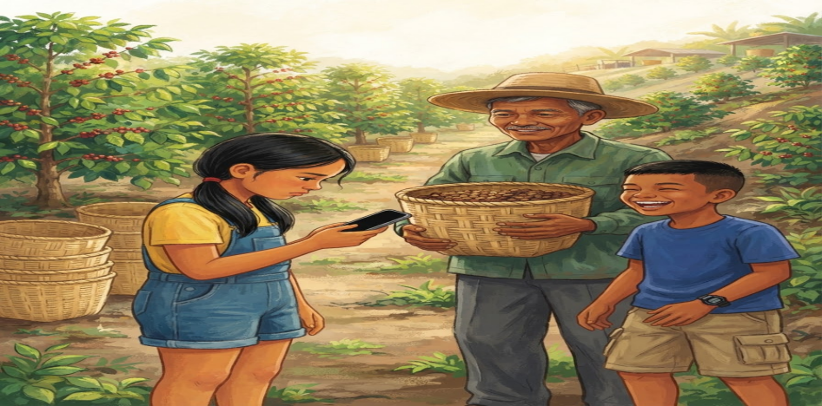
English
Mika continued taking pictures of the coffee trees, baskets, and her grandfather, Lolo Ben, while he was harvesting coffee.
“Just one more video,” Mika said.
A few minutes later, the screen suddenly went black.
0% BATTERY
Mika stared at her phone.
“Oh no! Not now!”
Junjun laughed.
“I told you not to use your phone too much!”
“But I need pictures for our project,” Mika replied.
Lolo Ben smiled and said, “Sometimes, you do not need a screen to learn. Look around you. This farm is also a classroom.”
Mika looked around.
For the first time that morning, she put her cellphone inside her bag.

Bisaya
Nagpadayon si Mika sa pagkuha og mga litrato sa mga punoan sa kape, mga bukag, ug sa iyang apohan nga si Lolo Ben samtang namupo kini og kape.
“Usa na lang ka video,” miingon si Mika.
Pipila ka minuto ang milabay, kalit nga nangitngit ang screen.
0% BATTERY
Gitutokan ni Mika ang iyang cellphone.
“Sus! Karun pa gyud!”
Nakatawa si Junjun.
“Giingnan man tika nga ayaw sige og gamit sa imong cellphone!”
“Pero kinahanglan nako og mga litrato para sa among project,” tubag ni Mika.
Mihiyom si Lolo Ben ug miingon, “Usahay, dili kinahanglan og screen aron makakat-on. Tan-awa ang inyong palibot. Ang umahan usa usab ka classroom.”
Gitan-aw ni Mika ang palibot.
Sa unang higayon nianang buntaga, gibutang niya ang cellphone sulod sa iyang bag.

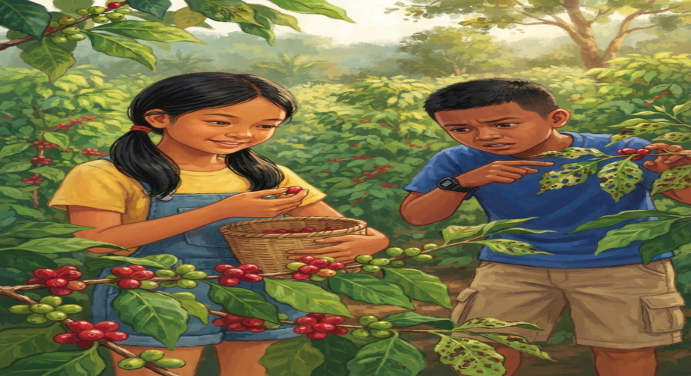
Page 3 – Learning from the Farm

English
Lolo Ben handed Mika a small basket.
“Since your phone is out of battery, why don't you help us harvest coffee?”
Mika smiled and nodded.
As they worked, she noticed that some coffee cherries were bright red while others were still green.
“Lolo, why don't we pick all of them?” Mika asked.
“The red cherries are ripe and ready to harvest,” Lolo Ben explained. “The green ones need more time to mature.”
Mika carefully picked only the ripe cherries.
She realized that farming required more knowledge and patience than she had imagined.
Suddenly, Junjun shouted, “Mika! Look at this!”
He pointed to a coffee plant with several damaged leaves.

Bisaya
Gihatagan ni Lolo Ben si Mika og gamay nga bukag.
“Kay nahurot na man ang battery sa imong cellphone, nganong motabang man ka namo sa pagpupo og kape?”
Mihiyom ug mitango si Mika.
Samtang nagtrabaho sila, namatikdan niya nga ang uban nga bunga sa kape pula na, samtang ang uban berde pa.
“Lolo, nganong dili man nato puniton tanan?” pangutana ni Mika.
“Ang pula nga mga bunga hinog na ug andam nang puniton,” gipatin-aw ni Lolo Ben. “Ang mga berde kinahanglan pa og panahon aron mahinog.”
Maampingong gipupo ni Mika ang mga hinog nga bunga.
Nakasabot siya nga ang pag-uma nagkinahanglan og mas daghang kahibalo ug pailob kaysa iyang gihunahuna.
Kalit nga misinggit si Junjun, “Mika! Tan-awa ni!”
Gitudlo niya ang usa ka punoan sa kape nga adunay pipila ka nadaot nga mga dahon.

Page 4 – Finding the Problem
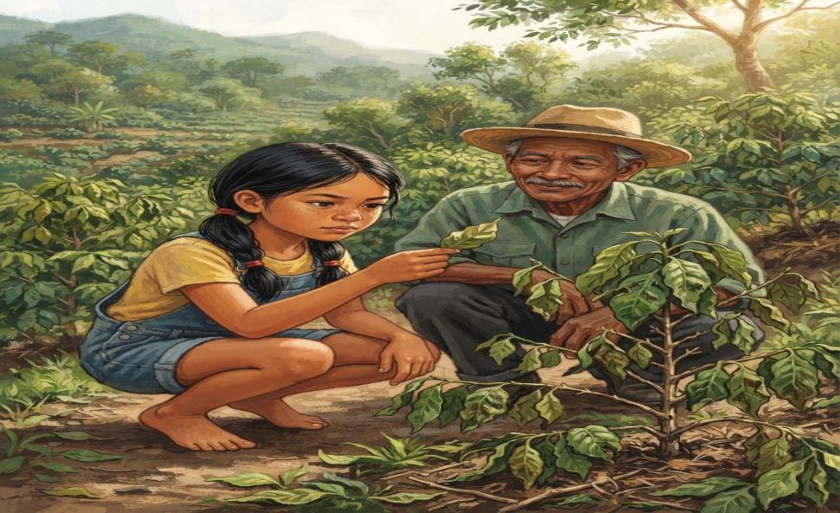
English
Mika and Junjun looked closely at the coffee plant.
“Maybe the plant needs more water,” Mika suggested.
Lolo Ben shook his head.
“Not every problem has the same cause. Look carefully.”
Mika examined the leaves.
She noticed tiny insects underneath them.
“Oh! There are tiny insects on the leaves!”
“Exactly,” Lolo Ben said. “Farmers need to observe their plants carefully. If we notice a problem early, we have a better chance of protecting the crops.”
Mika took out her notebook and wrote:
Observation: Tiny insects were found under the damaged leaves.
Possible Cause: The insects may be damaging the leaves.
Action: Tell an adult and check the other plants.

Bisaya
Gisusi pag-ayo nila ni Mika ug Junjun ang punoan sa kape.
“Siguro kinahanglan og dugang tubig ang tanom,” sugyot ni Mika.
Milingo si Lolo Ben.
“Dili tanan problema parehas og hinungdan. Tan-awa pag-ayo.”
Gisusi ni Mika ang mga dahon.
Namatikdan niya ang gagmay nga mga insekto sa ilalom niini.
“Oh! Naay gagmay nga insekto sa mga dahon!”
“Sakto,” miingon si Lolo Ben. “Kinahanglan maampingong obserbahan sa mga mag-uuma ang ilang mga tanom. Kung sayo nato mamatikdan ang problema, mas dako ang posibilidad nga mapanalipdan nato ang mga tanom.”
Gikuha ni Mika ang iyang notebook ug gisulat:
Obserbasyon: Adunay gagmay nga mga insekto sa ilalom sa nadaot nga mga dahon.
Posibleng Hinungdan: Ang mga insekto mahimong nakadaot sa mga dahon.
Buhaton: Sultihan ang usa ka hamtong ug susihon ang ubang mga tanom.

Page 5 – More Than a School Project
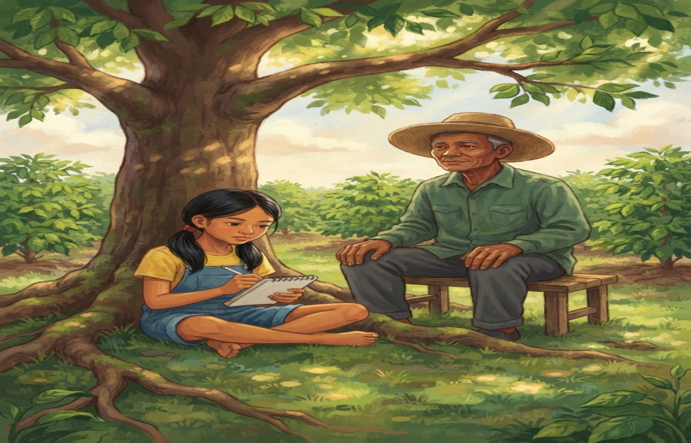
English
After helping on the farm, Mika sat under a coffee tree with Lolo Ben.
“Lolo, I thought I needed my cellphone to finish my project,” she said.
Lolo Ben smiled.
“Technology can help us learn, but it is not the only way to learn. We can also learn by observing, asking questions, helping others, and experiencing things ourselves.”
Mika looked at her basket of coffee cherries.
She had planned to make a simple photo presentation. Now, she had something more meaningful—a real experience to share.
She wrote in her notebook:
“Today, my phone reached zero percent, but my learning reached one hundred percent.”
Junjun laughed.
“That would be a great title for your project!”

Bisaya
Human sa pagtabang sa umahan, milingkod si Mika ilalom sa usa ka punoan sa kape uban ni Lolo Ben.
“Lolo, abi nako kinahanglan gyud nako ang akong cellphone aron mahuman akong project,” miingon siya.
Mihiyom si Lolo Ben.
“Ang teknolohiya makatabang nato sa pagkat-on, apan dili kini mao ra ang paagi sa pagkat-on. Makakat-on usab ta pinaagi sa pag-obserba, pagpangutana, pagtabang sa uban, ug pagsinati sa mga butang mismo.”
Gitan-aw ni Mika ang iyang bukag nga puno sa mga bunga sa kape.
Nagplano siya nga maghimo og yano nga photo presentation. Apan karon, aduna na siyay mas bililhon nga butang—usa ka tinuod nga kasinatian nga iyang ikasulti.
Gisulat niya sa iyang notebook:
“Karon, nahurot ang battery sa akong cellphone, pero napuno og kahibalo ang akong hunahuna.”
Nakatawa si Junjun.
“Maayo kaayo na nga title para sa imong project!”

Page 6 – The Lesson from the Farm
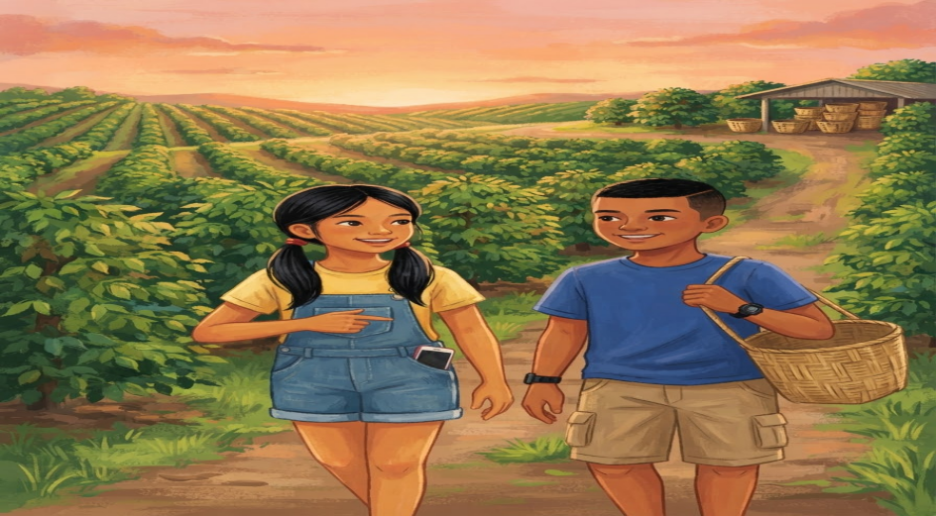
English
Before going home, Mika helped return the baskets to the farm shed.
She looked at the rows of Robusta coffee plants.
The farm was no longer just a place where coffee grew. It had become a place where she learned about plants, observation, responsibility, and problem-solving.
Mika smiled.
“Next time, I’ll bring a fully charged phone,” she joked.
Lolo Ben laughed.
“That is a good idea. But remember to charge your mind, too.”
Mika nodded.
As they walked home, her phone was still at 0% battery.
But she did not mind.
Her notebook was full of observations, questions, and new ideas.
She realized that even when technology stops working, learning can continue.

Bisaya
Sa wala pa sila mouli, mitabang si Mika sa pagbalik sa mga bukag ngadto sa bodega sa umahan.
Gitan-aw niya ang mga laray sa mga punoan sa Robusta coffee.
Ang umahan dili na lang usa ka lugar diin nagtubo ang kape. Nahimo kini nga lugar diin nakakat-on siya bahin sa mga tanom, pag-obserba, responsibilidad, ug pagpangita og solusyon sa problema.
Mihiyom si Mika.
“Sunod, magdala na gyud ko og fully charged nga cellphone,” iyang gi-joke.
Nakatawa si Lolo Ben.
“Maayo na. Apan hinumdumi nga kinahanglan usab nimong i-charge ang imong hunahuna.”
Mitungo si Mika.
Samtang naglakaw sila pauli, nagpabilin sa 0% battery ang iyang cellphone.
Apan wala na siya magproblema niini.
Napuno ang iyang notebook og mga obserbasyon, pangutana, ug bag-ong mga ideya.
Nakasabot siya nga bisan kung mohunong ang teknolohiya, makapadayon gihapon ang pagkat-on.

Comprehension Check-Up
A. Multiple Choice
Direction: Read each question carefully. Choose the letter of the correct answer.
1. What is the main lesson of the story?
A. Technology is the only way to learn new things. B. Farming is easy and requires little effort. C. Real-life experiences can teach valuable lessons, even without technology. D. Cellphones should never be used for school activities.
2. Where did Mika’s experience take place?
A. Barangay Poblacion B. Barangay Quezon, Tagbina, Surigao del Sur C. Barangay San Isidro D. Barangay Malixi
3. Why did Mika bring her cellphone to the coffee farm?
A. To play mobile games. B. To communicate with her friends. C. To take pictures and record videos for her school project. D. To listen to music while working.
4. What happened when Mika’s cellphone battery reached 0%?
A. She lost her cellphone. B. Her cellphone fell into the mud. C. Her cellphone got wet. D. She could no longer use her cellphone to take pictures and record videos.
5. What did Mika discover when she examined the coffee plant?
A. The plant had no roots. B. Some leaves were damaged, and tiny insects were found underneath them. C. The plant had too many fruits. D. The plant was completely dry.

Answer Key:

- C
- B
- C
- D
- B

