**Task 16: Building and Deploying a Custom Apache Web Server with Docker on Ubuntu 18.04**

A **Dockerfile** is a text file that contains a series of instructions on how to build a Docker image. It automates the process of setting up the environment, installing dependencies, and configuring the application inside a container. The Dockerfile defines the steps needed to create a custom image for a specific application or service.

1. **Docker file with Base Image ubuntu:18.04**

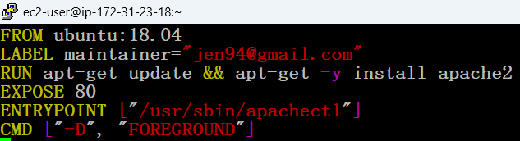

1. **The Output**

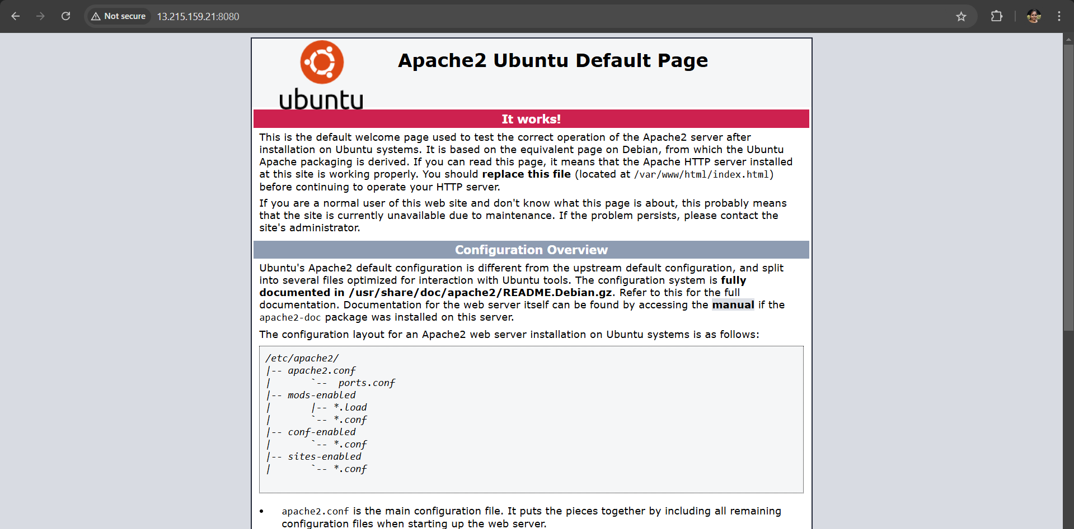

1. **Docker file with the custom index.html page**

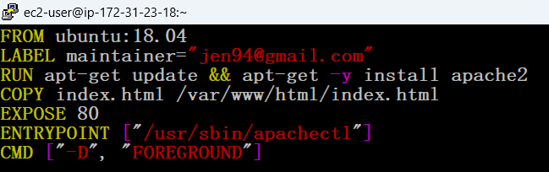

1. **The Output**

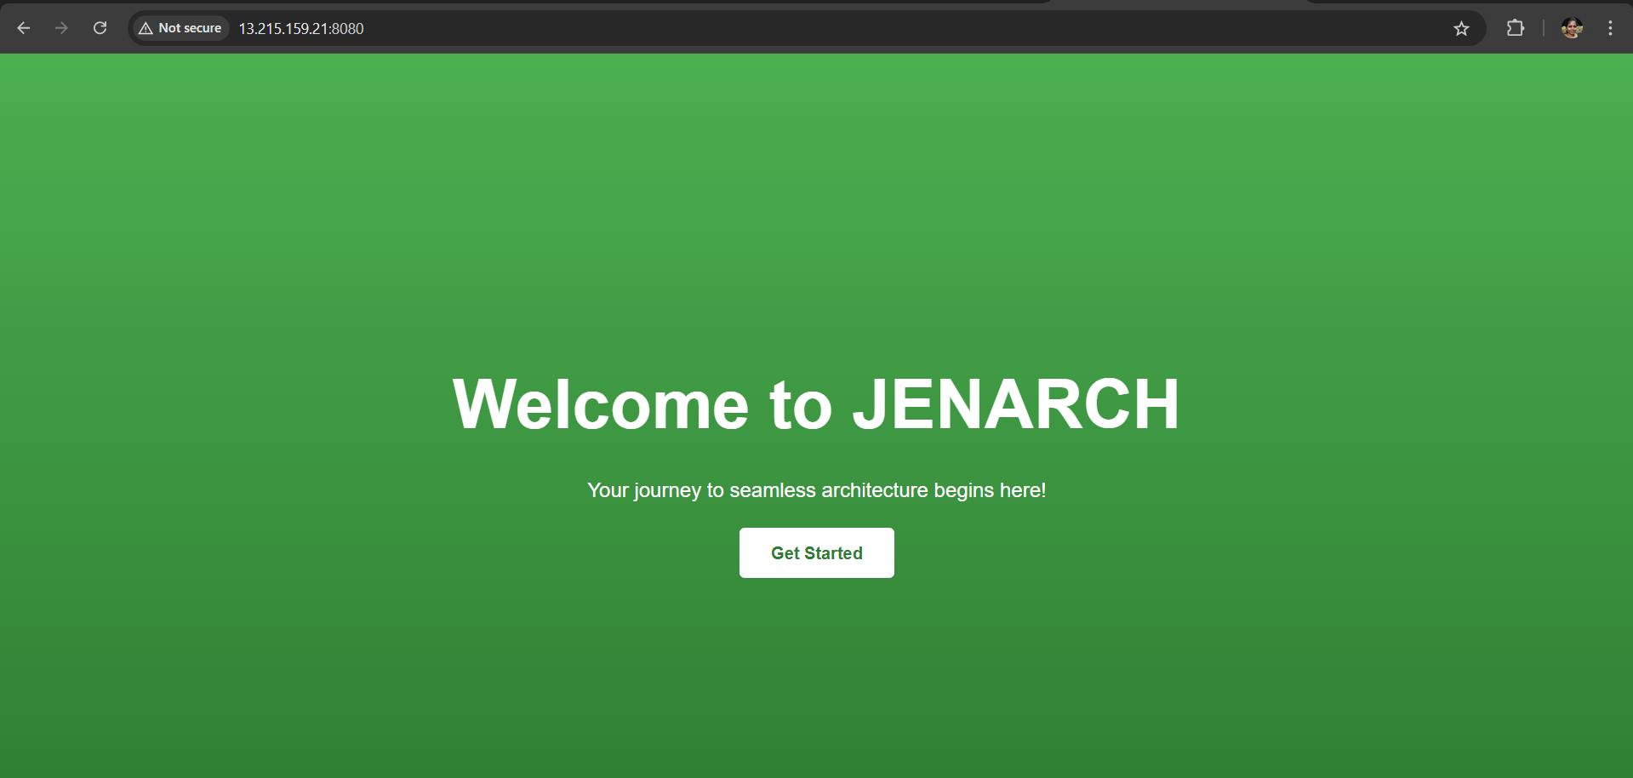

* There is no need the VOLUME instruction in our Dockerfile because your index.html file is a static asset that doesn’t require persistence or sharing between containers. The COPY command is enough to copy the file into the container's Apache server directory, and Apache will serve it.
* VOLUME is typically used when you need to persist data (e.g., databases, logs) or share data between containers, which isn’t necessary for your static content.