**Task 17: Ansible - YAML & YAML Data Types**

**YAML:**

**YAML** (short for "YAML Ain't Markup Language") is a human-readable data serialization format. It is commonly used for configuration files, data storage, and exchanging data between programming languages due to its simplicity and readability.

**Key Features of YAML:**

* **Human-Readable: Designed to be easy for humans to read and write, with a clean and intuitive syntax.**
* **Lightweight: Avoids unnecessary symbols like brackets and semicolons, using indentation to define structure.**
* **Flexible: Supports multiple data types, including scalars (strings, numbers), arrays, dictionaries, and more.**
* **Language-Agnostic: Used across a variety of programming languages for data serialization.**
* **Widely Used in DevOps: YAML is popular in tools like Kubernetes, Ansible, and CI/CD pipelines (e.g., GitHub Actions).**

**Basic Syntax Rules:**

* **Indentation: Uses spaces (not tabs) to define nesting. Each level of hierarchy is indented.**
* **Key-Value Pairs: Denoted by key: value.**
* **name: Jenifer**
* **Lists (Sequences): Represented with dashes (-).**
* **favorite_colors:**
  + **blue**
  + **green**
* **Comments: Lines starting with # are comments.**
  + **# This is a comment**
* **Multi-line Strings: Handled using | (literal block) or > (folded block).**
  + **literal_Block_scalar: |**

**Line 1**

**Line 2**

**Line 3**

**A Sample YAML Snippet:**

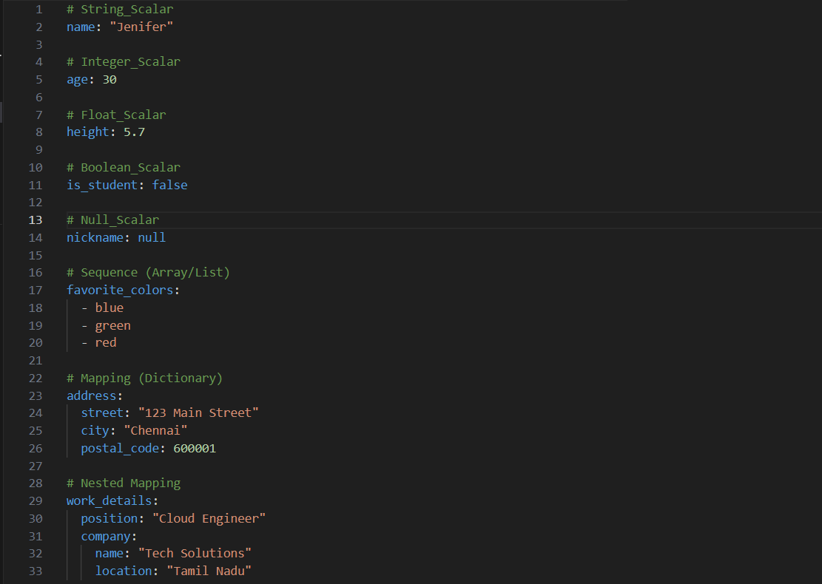

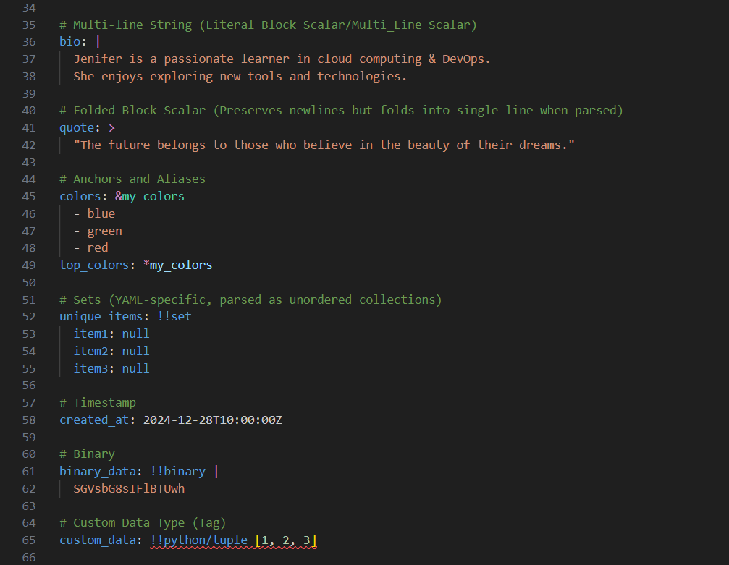

* **Scalar**

**A scalar in YAML is a single value, which could be a string, number, or Boolean. Scalars are the simplest data type in YAML and can be used for both basic and complex values.**

* **Sequence (Array)**

**A collection of ordered values (list). Denoted by a dash (-) or enclosed in square brackets [ ].**

### Mapping (Dictionary)

**A collection of key-value pairs. Keys must be unique, and values can be any data type.**

### Nested Mapping

**A mapping within another mapping, used to organize data hierarchically.**

### Multi-line String (Literal Block Scalar)

**A string spanning multiple lines. Uses | to preserve newlines exactly as written.**

### Folded Block Scalar

**Similar to multi-line strings but uses > to collapse newlines into spaces, creating a single continuous line.**

### Anchors and Aliases

**Anchors (&) define reusable content, while aliases (*) reference that content elsewhere.**

### Sets

**A YAML-specific data type representing an unordered collection of unique items.**

### Timestamp

**Represents date and time information in ISO 8601 format.**

### Binary

**Encodes binary data as Base64. Useful for storing files or large data blobs.**

### Custom Data Type (Tag)

**YAML allows the use of custom data types, often with type tags (e.g., !!python/tuple). These are interpreted by specific parsers or tools.**

**YAML Lint is a tool used to validate and analyze YAML files for syntax correctness and formatting issues. It ensures that YAML documents conform to proper syntax and structure, preventing errors during parsing or execution in applications that consume the YAML files.**

**The Output:**

