**SI 379 – Building Interactive Applications**

**Homework 3 Code – [Jennifer Jung]**

**GenAI**

**1) GenAI tools used?**

yes no



If no genAI tools were used, skip the rest of the genAI section.



**2) Tools used** ►

**3) Prompts used** ►

**4) Precision of generated code** ►

not close fairly close right on

**5) Overall completion time with genAI** ►

decreased about the same increased

**Code**

**Rides page**

*[your Rides page HTML code here]\**

**<!DOCTYPE html>**

**<html lang="en-us">**

**<!--==================================================================**

**//**

**// Web site: Iron Island Amusement Park**

**// Web page: Rides**

**// Description:**

**//   This web page contains information about rides at the Iron Island**

**// Amusement Park.**

**//**

**//=================================================================-->**

**<head>**

**<title>Iron Island Rides, v3</title>**

**<meta charset="UTF-8">**

**<meta name="author" content="Jennifer Jung">**

**<meta name="description" content="Iron Island">**

**<meta name="keywords" content="park, rides, fun">**

**<meta name="viewport" content="width=device-width, initial-scale=1">**

**<!-- Favicon link -->**

**<link rel="shortcut icon" href="Image-IronIslandLogo.jpg" type="image/x-icon">**

**<!-- External CSS link -->**

**<link rel="stylesheet" href="IronIsland-ExternalStyles.css">**

**<!-- DataTables CSS and script links -->**

**<link rel="stylesheet" href="https://cdn.datatables.net/2.0.5/css/dataTables.dataTables.min.css">**

**<script src="https://ajax.aspnetcdn.com/ajax/jQuery/jquery-3.7.1.min.js">**

**</script>**

**<script src="https://cdn.datatables.net/2.0.5/js/dataTables.min.js">**

**</script>**

**<!-- Internal script -->**

**<script>**

**"use strict";**

**// Declare rides array**

**var rides;**

**//================================================================**

**// loadRides**

**//================================================================**

**function loadRides() {**

**$.getJSON("Rides.json", function (data) {**

**console.dir(data);**

**console.log("Rides array retrieved successfully from Rides.json");**

**$('#tblRides').DataTable({**

**data: data,**

**columns: [**

**{ title: "Ride" },**

**{ title: "Intensity" },**

**{ title: "Recommended Ages" },**

**{ title: "Image" }**

**],**

**autoWidth: false**

**});**

**}).fail(function () {**

**console.error("Failed to load rides data from Rides.json");**

**});**

**}**

**</script>**

**</head>**

**<body onload="loadRides()">**

**<!-- Header section -->**

**<div class="headerPanel">**

**<h1>**

**Iron Island Rides**

**</h1>**

**</div>**

**<!-- Menu section -->**

**<div class="menuPanel">**

**<h2>**

**<a href="IronIsland-Park.html">Park Page</a>**

**<a href="IronIsland-Rides.html">Rides Page</a>**

**<a href="IronIsland-Tickets.html">Tickets Page</a>**

**</h2>**

**</div>**

**<hr>**

**<!-- Table section -->**

**<div class="tablePanel">**

**<!-- DataTables placeholder -->**

**<table id="tblRides" class="display">**

**<thead>**

**<tr>**

**<th>Ride</th>**

**<th>Intensity</th>**

**<th>Recommended Ages</th>**

**<th>Image</th>**

**</tr>**

**</thead>**

**<tbody>**

**<tr>**

**<td>Row 1 Data 1</td>**

**<td>Row 1 Data 2</td>**

**<td>Row 1 Data 3</td>**

**<td>Row 1 Data 4</td>**

**</tr>**

**</tbody>**

**</table>**

**</div>**

**<hr>**

**<!-- Footer section -->**

**<div class="footerPanel">**

**<h3>**

**Iron Island**

**&nbsp;&nbsp;7912 Coventry, Grosse Ile, MI 48138**

**&nbsp;&nbsp;734-761-3355**

**&nbsp;&nbsp;<a href="mailto:info@ironislandpark.com">**

**Email Us!</a>**

**&nbsp;&nbsp;Copyright &#169; 2024**

**</h3>**

**</div>**

**</body>**

**</html>**

*[your Rides page screenshot, including console, here]**  
  
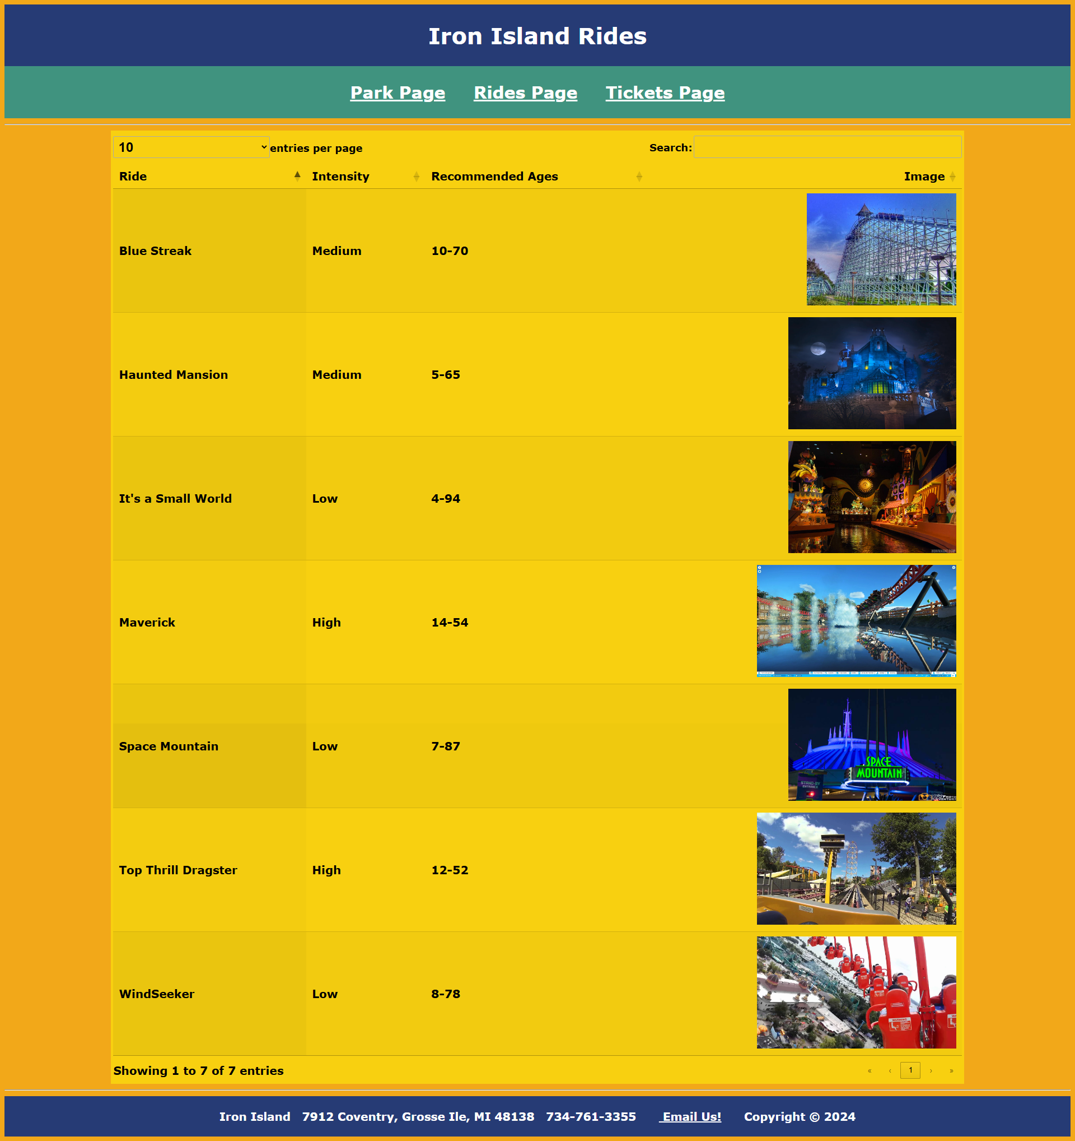*

**Tickets page**

*[your Tickets page HTML code here]\**

**<!DOCTYPE html>**

**<html lang="en-us">**

**<!--==================================================================**

**//**

**// Web site: Iron Island Amusement Park**

**// Web page: Tickets**

**// Description:**

**//   This web page enables a customer to order tickets to visit the**

**// Iron Island Amusement Park.**

**//**

**//=================================================================-->**

**<head>**

**<title>Iron Island Tickets, v3</title>**

**<meta charset="UTF-8">**

**<meta name="author" content="Jennifer Jung">**

**<meta name="description" content="Iron Island">**

**<meta name="keywords" content="park, rides, fun">**

**<meta name="viewport" content="width=device-width, initial-scale=1">**

**<!-- Favicon link -->**

**<link rel="shortcut icon" href="Image-IronIslandLogo.jpg" type="image/x-icon">**

**<!-- External CSS link -->**

**<link rel="stylesheet" href="IronIsland-ExternalStyles.css">**

**<!-- jQuery -->**

**<script src="https://ajax.googleapis.com/ajax/libs/jquery/3.5.1/jquery.min.js"></script>**

**<!-- Internal script -->**

**<script>**

**"use strict";**

**//================================================================**

**// updateTicketCost**

**//================================================================**

**let discountCodes = {};**

**function loadCodes() {**

**$.getJSON("DiscountCodes.json", function (data) {**

**if (data) {**

**console.log("Discount codes retrieved successfully from json");**

**loadCodesResponse(data);**

**} else {**

**console.error("Failed to retrieve discount codes");**

**}**

**}).fail(function (jqxhr, textStatus, error) {**

**const err = textStatus + ", " + error;**

**console.error("Failed to load json: " + err);**

**});**

**}**

**function loadCodesResponse(data) {**

**data.forEach(function (discount) {**

**discountCodes[discount[0]] = discount[1];**

**});**

**console.log("Loaded discount codes:", discountCodes);**

**updateTicketCost();**

**}**

**function updateTicketCost() {**

**var ticketsCost = (parseInt(txtTickets?.value) || 0) * 75;**

**var parkingCost = cmbParking?.value === "Regular" ? 50 :**

**cmbParking?.value === "Premium" ? 100 : 0;**

**var enteredCode = txtDiscountCode?.value.trim() || "";**

**console.log("Entered discount code:", enteredCode);**

**var discountAmount = parseInt(discountCodes[enteredCode]) || 0;**

**console.log("Discount amount applied:", discountAmount);**

**var subtotal = ticketsCost + parkingCost - discountAmount;**

**var tax = subtotal * 0.06;**

**var total = subtotal + tax;**

**txtTicketCost?.setAttribute('value', ticketsCost.toFixed(2));**

**txtParkingCost?.setAttribute('value', parkingCost.toFixed(2));**

**txtDiscountAmount?.setAttribute('value', discountAmount.toFixed(2));**

**txtSubtotal?.setAttribute('value', subtotal.toFixed(2));**

**txtTax?.setAttribute('value', tax.toFixed(2));**

**txtTotal?.setAttribute('value', total.toFixed(2));**

**}**

**</script>**

**</head>**

**<body onload="loadCodes()">**

**<!-- Header section -->**

**<div class="headerPanel">**

**<h1>**

**Iron Island Tickets**

**</h1>**

**</div>**

**<!-- Menu section -->**

**<div class="menuPanel">**

**<h2>**

**<a href="IronIsland-Park.html">Park Page</a>**

**<a href="IronIsland-Rides.html">Rides Page</a>**

**<a href="IronIsland-Tickets.html">Tickets Page</a>**

**</h2>**

**</div>**

**<hr>**

**<!-- Left panel -->**

**<div class="contentPanel4">**

**<!-- Form -->**

**<form method="get" enctype="application/x-www-form-urlencoded"**

**action="http://www.strategicsystems.biz/Scripts/ServerResponse.php">**

**<!-- Customer name and e-mail -->**

**<label for="txtCustomerName">Customer name:</label>**

**<input id="txtCustomerName" type="text" name="txtCustomerName" placeholder="your name" required>**

**<br><br>**

**<label for="txtCustomerEmail">Customer e-mail:</label>**

**<input id="txtCustomerEmail" type="email" name="txtCustomerEmail" placeholder="your e-mail" required>**

**<br><br>**

**<!-- Date and part of day -->**

**<label for="txtDate">Date:</label>**

**<input id="txtDate" type="date" name="txtDate" value="2024-09-26" min="2024-05-01" max="2024-10-31" required>**

**<br><br>**

**<fieldset>**

**<legend>Part of day</legend>**

**<input id="rbHalfDay" type="radio" name="rbPartOfDay" value="HalfDay">**

**<label for="rbHalfDay"> Half day</label>**

**<br>**

**<input id="rbWholeDay" type="radio" name="rbPartOfDay" value="WholeDay" checked>**

**<label for="rbWholeDay"> Whole day</label>**

**<br>**

**</fieldset>**

**<br><br>**

**<!-- Tickets -->**

**<label for="txtTickets">Tickets (1-21):</label>**

**<input id="txtTickets" type="number" name="txtTickets" value="2" min="1" step="1" max="21" required**

**onchange="updateTicketCost()">**

**<br><br>**

**<!-- Parking option -->**

**<label for="cmbParking">Parking:</label>**

**<select id="cmbParking" name="cmbParking" onchange="updateTicketCost()">**

**<option value="Regular" selected>Regular</option>**

**<option value="Premium">Premium</option>**

**<option value="NotNeeded">Not Needed</option>**

**</select>**

**<br><br>**

**<!-- Discount code -->**

**<label for="txtDiscountCode">Discount code:</label>**

**<input id="txtDiscountCode" name="txtDiscountCode" placeholder="Enter discount code" oninput="updateTicketCost()">**

**<br><br>**

**<!-- Payment type fieldset -->**

**<fieldset>**

**<legend>Payment type</legend>**

**<input id="rbCredit" type="radio" name="rbPaymentType" value="Credit" checked>**

**<label for="rbCredit"> Credit</label>**

**<br>**

**<input id="rbPayPal" type="radio" name="rbPaymentType" value="PayPal">**

**<label for="rbPayPal"> PayPal</label>**

**<br>**

**<input id="rbVenmo" type="radio" name="rbPaymentType" value="Venmo">**

**<label for="rbVenmo"> Venmo</label>**

**<br>**

**</fieldset>**

**<br>**

**<!-- Cost Summary -->**

**<label>Ticket Cost ($):</label>**

**<input type="text" name="txtTicketCost" id="txtTicketCost" readonly>**

**<br><br>**

**<label>Parking Cost ($):</label>**

**<input type="text" name="txtParkingCost" id="txtParkingCost" readonly>**

**<br><br>**

**<label>Discount Amount ($):</label>**

**<input type="text" name="txtDiscountAmount" id="txtDiscountAmount" readonly>**

**<br><br>**

**<!-- Ticket costs -->**

**<label>Subtotal ($):</label>**

**<input type="text" name="txtSubtotal" id="txtSubtotal" readonly>**

**<br><br>**

**<label>Tax ($):</label>**

**<input type="text" name="txtTax" id="txtTax" readonly>**

**<br><br>**

**<label>Total ($):</label>**

**<input type="text" name="txtTotal" id="txtTotal" readonly>**

**<br><br>**

**<!-- Form buttons -->**

**<input type="submit" value="Submit" class="formButton">**

**<input type="reset" value="Reset" class="formButton">**

**</form>**

**</div>**

**<!-- Right panel -->**

**<div class="contentPanel4">**

**<!-- Park seating chart -->**

**<img src="Image-IronIsland.jfif" alt="Iron Island Park Map" width="70%" height="auto">**

**</div>**

**<!-- Footer section -->**

**<div class="footerPanel">**

**<h3>**

**Iron Island**

**&nbsp;&nbsp;7912 Coventry, Grosse Ile, MI 48138**

**&nbsp;&nbsp;734-761-3355**

**&nbsp;&nbsp;<a href="mailto:info@ironislandpark.com">**

**Email Us!</a>**

**&nbsp;&nbsp;Copyright &#169; 2024**

**</h3>**

**</div>**

**</body>**

**</html>**

*[your Ticket page screenshot 1, including data and console, here]\*\**

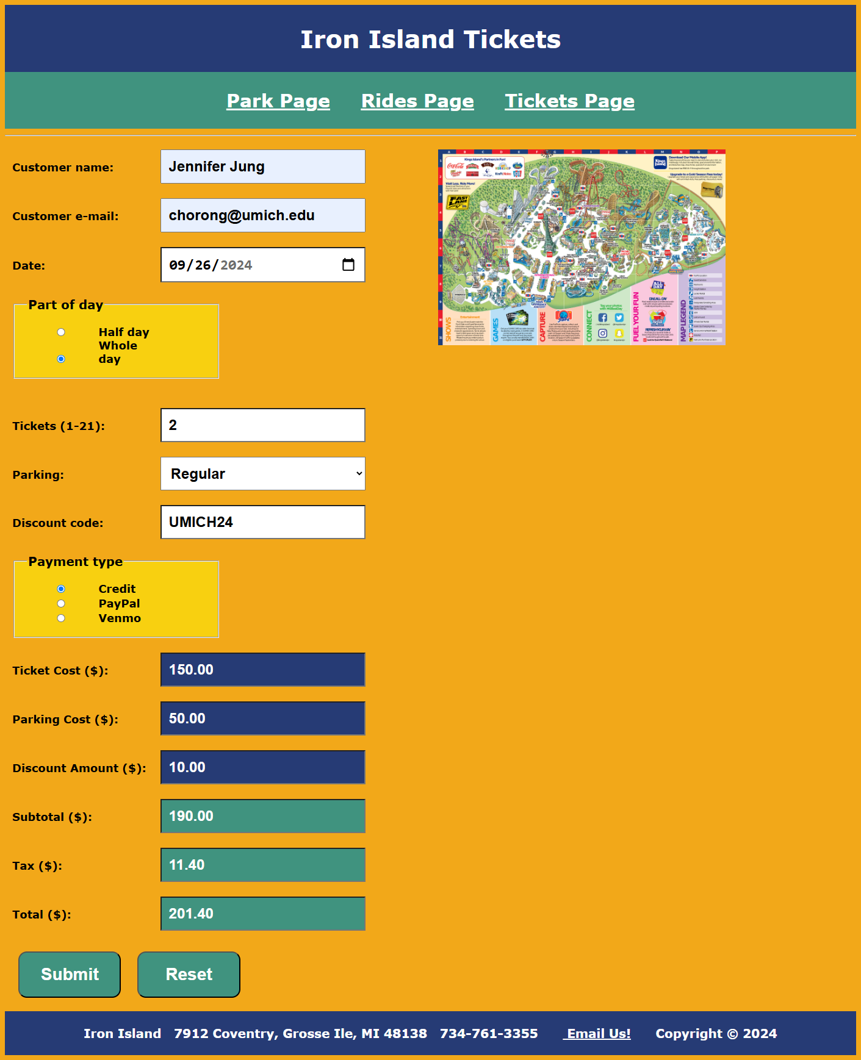

*[your www.strategicsystems.biz/Scripts/ServerResponse.php screenshot 1 here]**.*

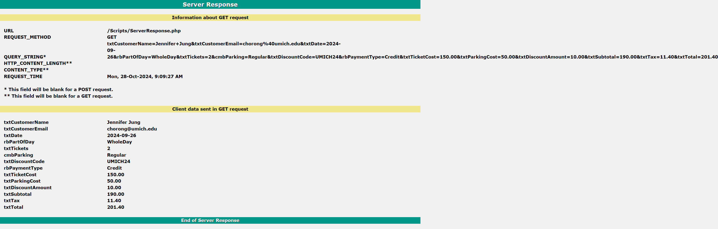

*[your Ticket page screenshot 2, including data and console, here]\*\**

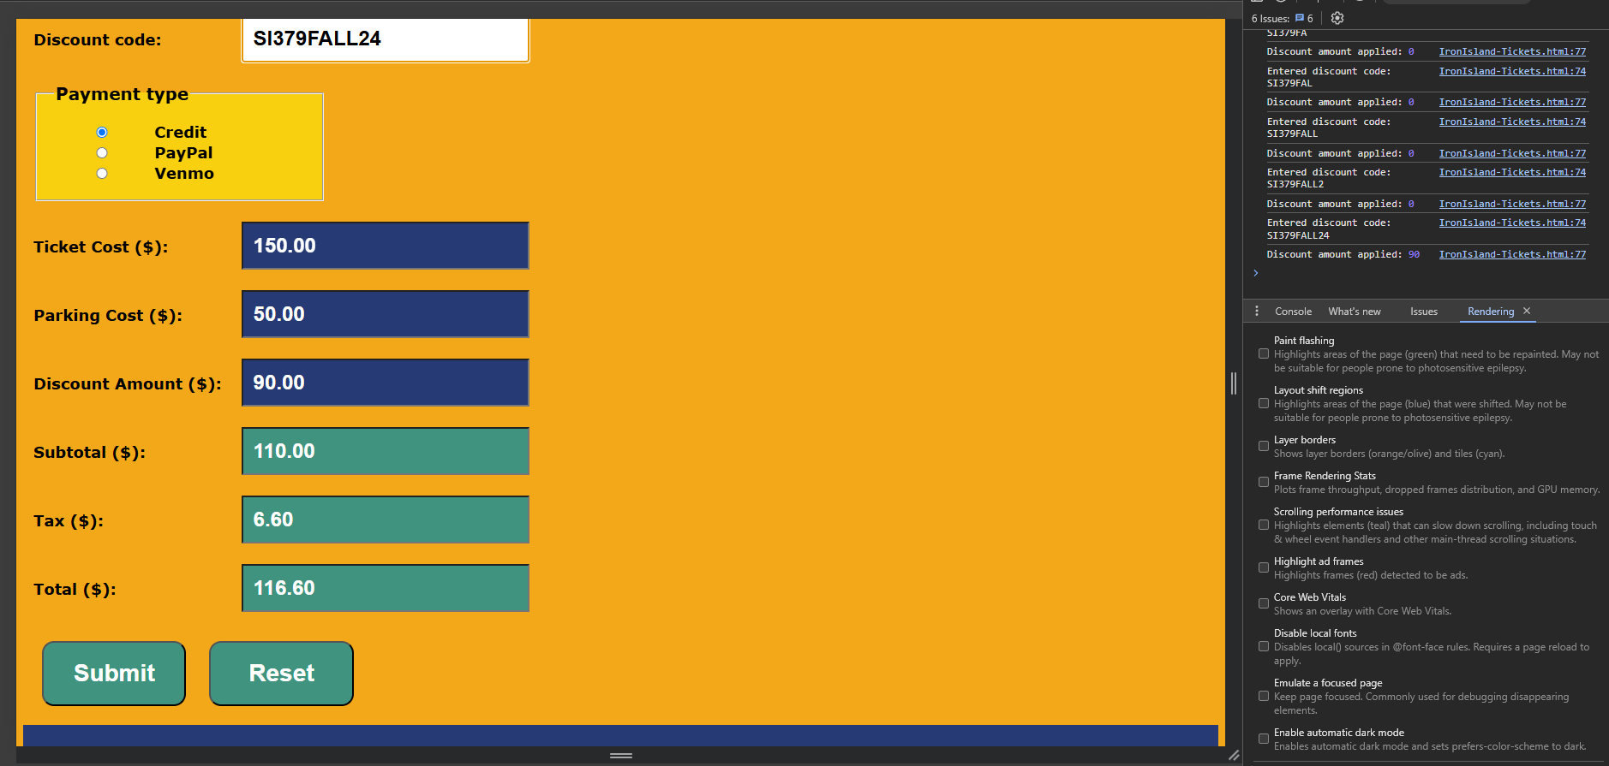

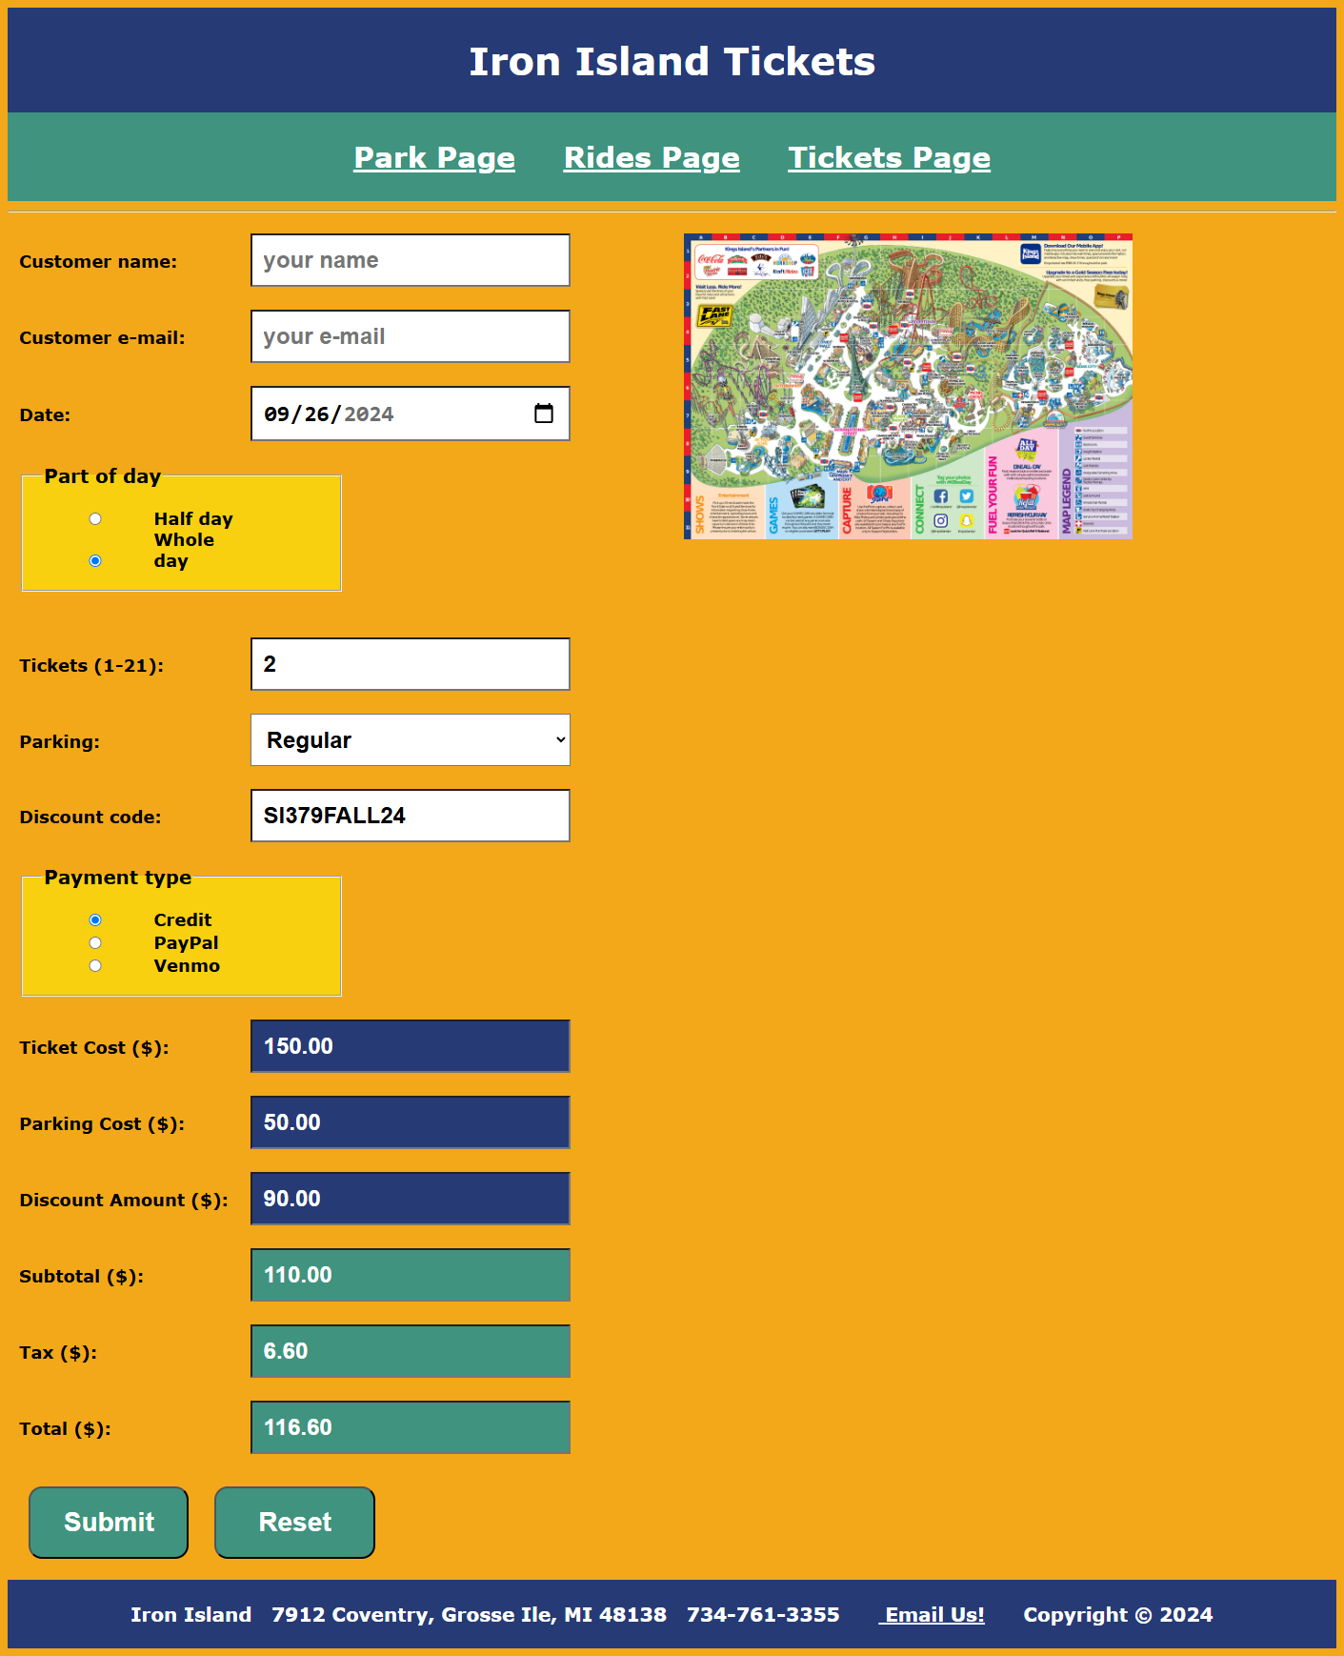

*[your www.strategicsystems.biz/Scripts/ServerResponse.php screenshot 2 here]**.  
  
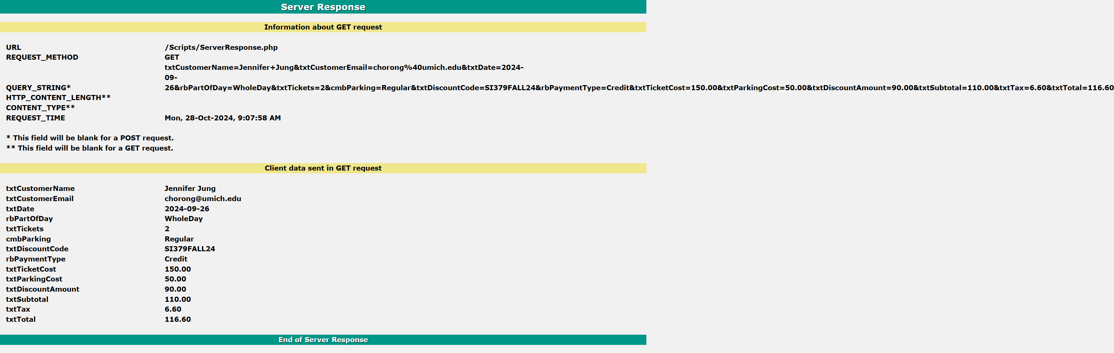*

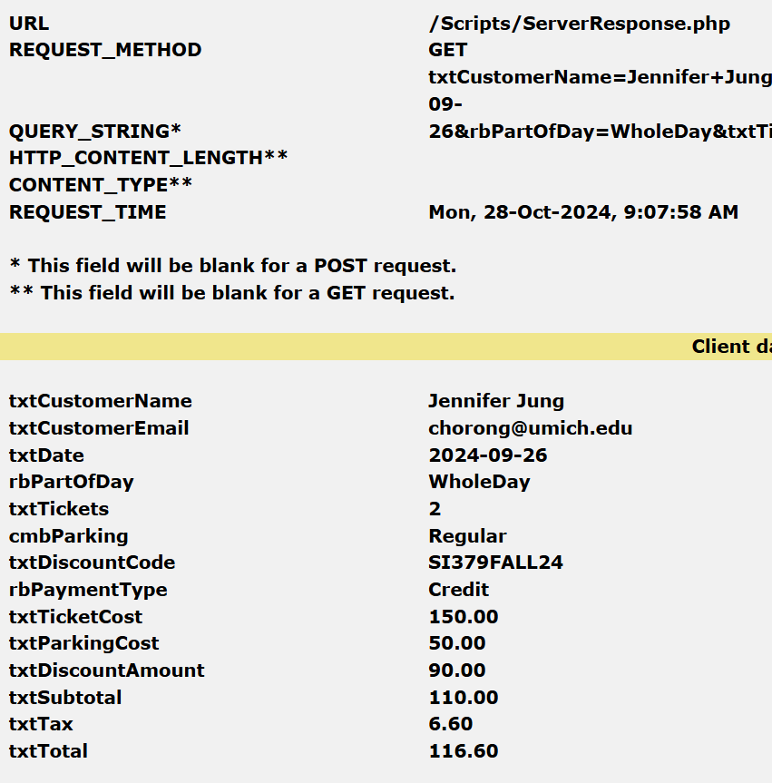

**CSS file**

*[your CSS code here]\**

**/*====================================================================**

**Web site: Iron Island Amusement Park**

**Title: External Styles**

**Description:**

**This CSS page contains external styles for the web site.  The**

**color scheme used is composed of the five colors shown in the color**

**scheme section.**

**====================================================================*/**

**/*====================================================================**

**Color scheme**

**====================================================================*/**

**:root**

**{**

**--color-darkgold: #F2A819FF;**

**--color-lightgold: #F8D010FF;**

**--color-blue: #263B75FF;**

**--color-teal: #40937FFF;**

**--color-orange: #E85134FF;**

**}**

**/*====================================================================**

**General style**

**====================================================================*/**

**\***

**{**

**box-sizing: border-box;**

**}**

**/*====================================================================**

**Body style**

**====================================================================*/**

**body**

**{**

**background-color:var(--color-darkgold);**

**font-family:verdana, georgia, san-serif;**

**font-size:20px;**

**font-weight:bold;**

**}**

**/*====================================================================**

**Anchor style**

**====================================================================*/**

**a**

**{**

**color:white;**

**padding:20px;**

**}**

**/*====================================================================**

**Fieldset styles**

**====================================================================*/**

**fieldset**

**{**

**background-color:var(--color-lightgold);**

**color:black;**

**padding:20px;**

**width:50%;**

**}**

**fieldset input**

**{**

**width:35%;**

**}**

**/*====================================================================**

**Heading styles**

**====================================================================*/**

**h1**

**{**

**font-size:40px;**

**text-align:center;**

**}**

**h2**

**{**

**font-size:30px;**

**text-align:center;**

**}**

**h3**

**{**

**font-size:20px;**

**text-align:center;**

**}**

**/*====================================================================**

**iFrame style**

**====================================================================*/**

**iframe**

**{**

**display: block;**

**margin-left:auto;**

**margin-right:auto;**

**}**

**/*====================================================================**

**Input and select styles**

**====================================================================*/**

**input, select**

**{**

**background-color:white;**

**font-size:24px;**

**font-weight:bold;**

**padding:12px;**

**width:50%;**

**}**

**input:read-only**

**{**

**background-color:var(--color-teal);**

**color:white;**

**}**

**#txtTicketCost,**

**#txtParkingCost,**

**#txtDiscountAmount {**

**background-color: var(--color-blue);**

**}**

**/*====================================================================**

**Label style**

**====================================================================*/**

**label**

**{**

**display:inline-block;**

**font-size:18px;**

**width:35%;**

**}**

**label.statusLabel**

**{**

**display:inline-block;**

**background-color:var(--color-darkgold);**

**color:black;**

**font-size:32px;**

**font-weight:bold;**

**margin:20px;**

**padding:20px;**

**width:25%;**

**}**

**/*====================================================================**

**Class styles**

**====================================================================*/**

**.headerPanel**

**{**

**background-color:var(--color-blue);**

**clear:both;**

**color:white;**

**padding:4px;**

**width:100%;**

**}**

**.menuPanel**

**{**

**background-color:var(--color-teal);**

**clear:both;**

**padding:4px;**

**width:100%;**

**}**

**.contentPanel1**

**{**

**background-image:**

**linear-gradient(var(--color-darkgold), var(--color-lightgold));**

**color:black;**

**float:left;**

**height:300px;**

**overflow:auto;**

**padding:12px;**

**width:35%;**

**}**

**.contentPanel2**

**{**

**background-image:**

**linear-gradient(var(--color-darkgold), var(--color-lightgold));**

**color:black;**

**float:left;**

**height:300px;**

**overflow:auto;**

**padding:12px;**

**width:30%;**

**}**

**.contentPanel3**

**{**

**float:left;**

**height:auto;**

**margin-left:auto;**

**margin-right:auto;**

**padding:12px;**

**width:50%;**

**}**

**.contentPanel4**

**{**

**float:left;**

**height:auto;**

**margin-left:auto;**

**margin-right:auto;**

**padding:12px;**

**width:50%;**

**}**

**.tablePanel**

**{**

**background-color:var(--color-lightgold);**

**clear:both;**

**margin-left:auto;**

**margin-right:auto;**

**padding:4px;**

**width:80%;**

**}**

**.footerPanel**

**{**

**background-color:var(--color-blue);**

**clear:both;**

**color:white;**

**padding:4px;**

**width:100%;**

**}**

**.formButton**

**{**

**background-color:var(--color-orange);**

**border-radius: 1vw;**

**color:white;**

**font-size:28px;**

**margin:10px;**

**padding:20px;**

**width:25%;**

**}**

**/*====================================================================**

**Pseudo classes**

**====================================================================*/**

**a:hover, .formButton:hover**

**{**

**background-color:var(--color-blue);**

**}**

**\* Copying-and-pasting web page code to a Word document**

**macOS**

1) From within the HTML editor window, press **command-A** and press **command-C**.

2) From within the Word document, press **command-V**.

**Windows**

1) From within the HTML editor window, press **CTRL-A** and press **CTRL-C**.

2) From within the Word document, press **CTRL-V**.

**\*\* Copying-and-pasting a web page to a Word document**

**macOS**

1) From the browser window, press **shift-command-4-space**.

2) From within the Word document, **command-V**.

**Windows**

1) From the browser window, press **ALT-PrintScreen**.

2) From within the Word document, press **CTRL-V**.