AML 3104 Assignment 2

Campus Recruitment Prediction Report
Student: Jennylynne Dominguez
Course: AML 3104 – Assignment 2

1. Dataset Description & Preprocessing

The dataset contains historical records of students' academic performance, specializations, and whether they were successfully placed in campus recruitment.
It includes both numerical and categorical features, with 'status' as the target (1 = Placed, 0 = Not Placed).
Preprocessing Steps:
- Imputed missing salary values with the median.
- Encoded categorical variables using Label Encoding.
- Feature engineering included: avg_score, mba_to_degree_ratio, mba_minus_degree.
- Applied Standard Scaling.

2. Models Trained and Rationale

- Logistic Regression: Baseline linear classifier, interpretable.
- SVM: Effective in high-dimensional space.
- Decision Tree: Handles non-linearity, interpretable.
- Random Forest: Reduces overfitting, ensemble strength.
- Voting Classifier (Soft & Hard): Combines all models to improve generalization.

3. Evaluation Metrics Summary
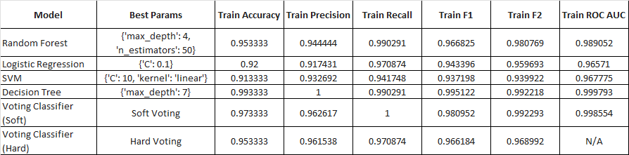
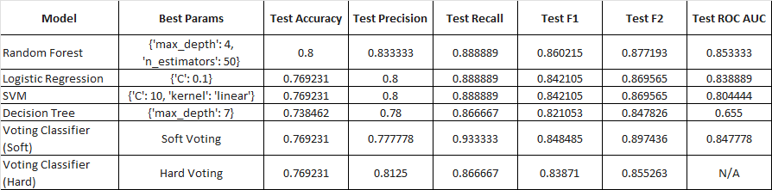

4. Confusion Matrix Insights
Each model was evaluated on both training and test sets using confusion matrices.

Key observations:
- Random Forest had the best balance between precision and recall, with fewer false positives and false negatives.
- Soft Voting Classifier gave the best recall and F2 score, making it ideal if minimizing false negatives is more important.

5. Conclusion
Best Model Overall: Random Forest
Why: It offered the best precision and F1-score, making it ideal when you want to reduce false positives — i.e., avoid wrongly predicting that a student will be placed.
Alternative: Soft Voting Classifier – Best when your goal is to maximize recall or catch all potentially placed candidates, even if a few are wrongly predicted.

