**Baldwin Symbiosis Smooths the Fitness Landscape of Species**

Jennifer Hallinan1*, Anil Wipat2, 3

1BioThink, Brisbane, QLD

2School of Computing, Newcastle University, Newcastle upon Tyne, UK

3Do you want add industry links here?

*Corresponding author: [j.hallinan@biothink.net](mailto:j.hallinan@biothink.net)

# Abstract

# Introduction

The complexity of the mammalian gut microbiome, and its links to host health, wellbeing, and even behaviour, has been a topic of considerable interest over the past decade. The human microbiome comprises at least XX bacterial species, and has been shown to affect organism characteristics as diverse as obesity, insulin resistance, and diabetes.

One aspect of the microbiome which has only recently become a serious topic of investigation is its effects on the evolution of the organism.

The microbiome can have more subtle effects upon the evolution of a species. The genes carried in the somatic cells of the host are complemented by those carried by the myriad microbial species in the gut. The expression of these genes is affected by the number and species of commensals and the environment, both external to the host and within the gut, forming a complex network of interactions. One of the ways in which these interactions could affect evolution is when genes carried in the microbiome complement those of the host, thus smoothing the fitness landscape of the host, and facilitating the evolutionary process. It has been demonstrated that mutation-based evolution occurs most rapidly on a smooth fitness landscape (Fragata et al. 2019; Ueda, Takeuchi, and Kaneko 2017) and hence smoothing the fitness landscape would be advantageous to organisms living in a rapidly changing environment.

## The Baldwin effect

In 1896, the American psychologist James Mark Baldwin suggested that learning on the part of an individual can facilitate the evolution of the population to which that individual belongs (Baldwin 1896). The basic concept is that if an individual carries genes predisposing it to be able to rapidly learn a behaviour, or develop a phenotype, which is evolutionarily advantageous, that individual will have a fitness advantage, and the predisposing genes will spread throughout the population. These genes can then evolve into versions which do not require the learning phase, and the trait becomes genetically determined. Although the advent of Darwin’s theories meant that the Baldwin Effect was subsequently neglected, and often regarded as an aspect of Lamarckism, the concept was revisited in the twentieth century by Hinton and Nowlan (Hinton and Nowlan 1987), who developed a computational model which demonstrated that the mechanism is plausible. We revisited this model in 2001, and used it to demonstrate that practical aspects of the evolutionary process—in this case, the strength of the selection pressure—can affect the results obtained (Wiles et al. 2001).

Recent findings about the role of the microbiome in the evolution of domestic dogs (Rampelli et al. 2021) have indicated that amylase genes carried by microbes in the gut of canids may have helped wild dogs to adapt to the dietary supplementation available from early humans, in the form of carbohydrates, which were not previously a major part of the dogs’ diet. This adaptation smoothed the way for dogs to co-exist with humans, contributing to the domestication of the dogs, and quite possibly to modifications of human behaviour, which have not fully been explored.

The gut microbiome is less stable than the host genome, since it can be altered by environmental changes such as dietary modifications, and even eliminated almost completely by gastrointestinal diseases. Although there is no current evidence for transfer of amylase genes from the gut microbiome to mammalian cells, such transfers have been observed in

And there is currently considerable interest in the use of microbial cells as

We therefore included an option to transfer genes from the microbiome to the host genome, and investigated the conditions under which such transfer would be beneficial.

In this study we investigated the relationship between the genetic composition of the gut microbiome, that of the host, and the effects of these interactions upon the evolution of the host population.

## Amylase

AMY2B is one of three genes known to code for starch breakdown in the saliva and pancrease. It catalyzes the first step in the digestion of starch to glucose in the small intestine, the breakdown of starch to the oligosaccharides maltose and maltriose (Mocharla, Mocharla, and Hodes 1990). There is considerable variation in the numbers of copies of the AMY2B gene, with an individual human genome carrying two to six copies of the gene (Elder et al. 2018). It has been demonstrated that increased copy numbers of the amylase genes correspond to increased ability to metabolize starch (ref). Considerable research has indicated that as dogs became domesticated they acquired increased numbers of amylase genes (Axelsson et al. 2013), allowing them to supplement the energy available from hunting and scavenging with the more easily acquired leavings of humans. Like humans, modern dog (*Canis lupus familiaris*) populations exhibit considerable variation in AMY2B copy number, with diploid copy numbers ranging from 4 to 30 (n = 136) (Axelsson et al. 2013), whereas species which have been less exposed to humans, such as dingos (*Canis lupis dingo*) and wolves (*Canis lupus*) carry, on average, two copies of the gene (Ollivier et al. 2016).

# Materials and Methods

The population in this study consisted of two types of individuals: hosts and microbes. There is one type of host, the dog, and multiple types of microbes. We focused upon a single gene, in keeping with the findings of Rampelli et al., the amylase gene, AMY2B. Each host starts with two copies of AMY2B in the host genome, and two in the microbial genome. The number of microbes in the microbiome are set randomly at the beginning of each run, and remained unchanged throughout the run. For each run of the algorithm, a population of hosts is established, each of which contained a subset of the available microbes. Both host and microbiome are modelled as strings of genes, on the assumption that while the host genome is rarely shared with the gut microbes, the microbiome exchanges genes more-or-less freely (de Sousa, Lourenço, and Gordo 2023), so microbes do not need to be modelled individually.

In the absence of carbohydrate as an energy source, wild canids obtain energy primarily from fat, carbohydrates, and protein from hunted or scavenged prey animals. However, there is an energy penalty involved in such scavenging and, in particular, hunting.

## Evolutionary algorithm

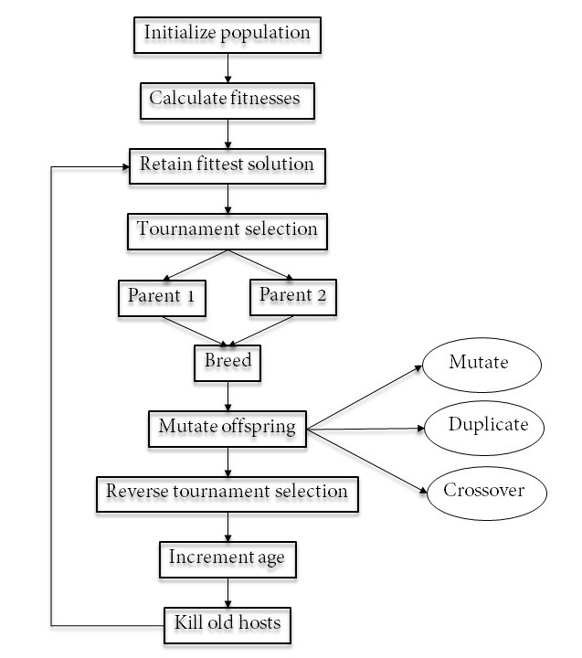

Figure 1. The evolutionary algorithm. Tournament selection is used to select parents from the next generation; following the generation of offspring a proportion of less fit individuals are deleted at random.

### Fitness function

The fitness function used was based on the proportions of energy sources used by wolves, which have little exposure to humans. Wolves have a small number of AMY2B genes, because they encounter vegetable matter in the gut of prey, and there is some evidence that individuals, particularly pups may deliberately eat vegetation to treat gastrointestinal problems. The protein–fat–carbohydrate profile of wolves in a study by (Hewson-Hughes et al. 2012) was 54:45:1%, different from that in domestic dogs, which was measured at 30:63:7% by energy. For all nutrients a maximum amount which can be utilized is set.

Under the assumption that carbohydrate is the preferred source of energy, this nutrient is considered first when calculating the fitness. Protein and fat are then assessed in turn. Protein and fat incur an energy penalty to reflect the effort required to hunt, whereas carbohydrate does not. The total fitness is thus

$$fit=c+\left(p-pen\right)+\left(f-pen\right)$$

Where *c* is carbohydrate, *p* is the amount of protein available, *f* is the amount of fat available, and *pen* is the penalty term.

### Parameters

As many as possible of the parameters for the algorithm were taken from the literature.

|  |  |  |  |  |
| --- | --- | --- | --- | --- |
| Parameter | Meaning | Value | Mutable? | Reference |
| hAmy | Number of host amylase genes | 2 |  |  |
| mAmy | Proportion of microbial genes which are amylases |  |  |  |
| Fat | Amount of fat available | 10 | Y |  |
| Carb | Amount of carbohydrate available | 2 | Y |  |
| Protein | Amount of protein available | 10 | Y |  |
| Penalty | Penalty to obtain protein or fat | 1 | Y |  |
| cMax | Maximum carbohydrate that can be used | 7 | Y |  |
| pMax | Maximum protein that can be used | 30 | Y |  |
| fMax | Maximum fat that can be used | 63 | Y |  |
| numGenes | Maximum number of genes available in the system | 10 | Y |  |
| maxHostGenes | Maximum number of genes in the host | 100 | Y |  |
| maxMicGenes | Maximum number of genes in a microbial genome | 20 | Y |  |

# Results

What are we trying to show? Baldwin. OK, but that’s too obvious. Some subtleties about how the Baldwin effect works. Effect of diarrhoea/antibiotics?

# Discussion

Make the point that this is not just about amylase genes; we are using them as a stand-in for the basic idea that the gut microbiome is a Baldwin mechanism. The same mechanism is almost certainly true of many other traits.

Throughout this paper, we have referred to the largest organism as the host. However, the results of this study, and those of many others, make it clear that the host does not exist alone, and that the microbiome is an integral, albeit dynamic, component of the host. Mice have been raised under laboratory conditions to be microbiome-free, but although they survive and are relatively healthy in a lab environment, at least until used for further experiments, there has been little research into their phenotypic differences from wild mice. they are unlikely to survive in the wild. Acquire new microbiome. Unlikely to be competitive in an evolutionary context.

# Conclusions

AMY2B is one of three genes known to code for starch breakdown in the saliva and pancreas. Omitting the other genes from this model reduces its complexity, making it more comprehensible, with the tradeoff of loss of accuracy.

# References

Axelsson, Erik, Abhirami Ratnakumar, Maja-Louise Arendt, Khurram Maqbool, Matthew T Webster, Michele Perloski, Olof Liberg, Jon M Arnemo, Åke Hedhammar, and Kerstin Lindblad-Toh. 2013. 'The genomic signature of dog domestication reveals adaptation to a starch-rich diet', *Nature*, 495: 360-64.

Baldwin, J. M. 1896. 'A new factor in evolution', *The American Naturalist*, 30: 441 - 51.

de Sousa, Jorge Moura, Marta Lourenço, and Isabel Gordo. 2023. 'Horizontal gene transfer among host-associated microbes', *Cell Host & Microbe*, 31: 513-27.

Elder, Patrick JD, David B Ramsden, David Burnett, Martin O Weickert, and Thomas M Barber. 2018. 'Human amylase gene copy number variation as a determinant of metabolic state', *Expert Review of Endocrinology & Metabolism*, 13: 193-205.

Fragata, Inês, Alexandre Blanckaert, Marco António Dias Louro, David A Liberles, and Claudia Bank. 2019. 'Evolution in the light of fitness landscape theory', *Trends in Ecology & Evolution*, 34: 69-82.

Hewson-Hughes, Adrian K., Victoria L. Hewson-Hughes, Alison Colyer, Andrew T. Miller, Scott J. McGrane, Simon R. Hall, Richard F. Butterwick, Stephen J. Simpson, and David Raubenheimer. 2012. 'Geometric analysis of macronutrient selection in breeds of the domestic dog, Canis lupus familiaris', *Behavioral Ecology*, 24: 293-304.

Hinton, Geoff, and Steven J. Nowlan. 1987. 'How learning can guide evolution', *Complex Systems*, 1: 495 - 502.

Mocharla, Hanna, Raman Mocharla, and ME Hodes. 1990. 'α-Amylase gene transcription in tissues of normal dog', *Nucleic Acids Research*, 18: 1031-36.

Ollivier, Morgane, Anne Tresset, Fabiola Bastian, Laetitia Lagoutte, Erik Axelsson, Maja-Louise Arendt, Adrian Bălăşescu, Marjan Marshour, Mikhail V Sablin, and Laure Salanova. 2016. 'Amy2B copy number variation reveals starch diet adaptations in ancient European dogs', *Royal Society Open Science*, 3: 160449.

Rampelli, Simone, Silvia Turroni, Florencia Debandi, Antton Alberdi, Stephanie L. Schnorr, Courtney A. Hofman, Alberto Taddia, Riccardo Helg, Elena Biagi, Patrizia Brigidi, Federica D'Amico, Maurizio Cattani, and Marco Candela. 2021. 'The gut microbiome buffers dietary adaptation in Bronze Age domesticated dogs', *iScience*, 24: 102816.

Ueda, Masahiko, Nobuto Takeuchi, and Kunihiko Kaneko. 2017. 'Stronger selection can slow down evolution driven by recombination on a smooth fitness landscape', *PLoS ONE*, 12: e0183120.

Wiles, Janet, Ruth Schulz, Jennifer Hallinan, Scott Bolland, and Bradley Tonkes. 2001. "Probing the persistent question marks." In *Proceedings of the 3rd Annual Conference on Genetic and Evolutionary Computation*, 710-17. Citeseer.