**Jen-Kai-Wang 1/5 homework01**

**1.**

**(a) :**

**Comment based on the histograms**

**Ans :**

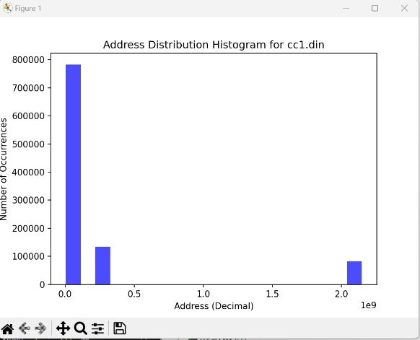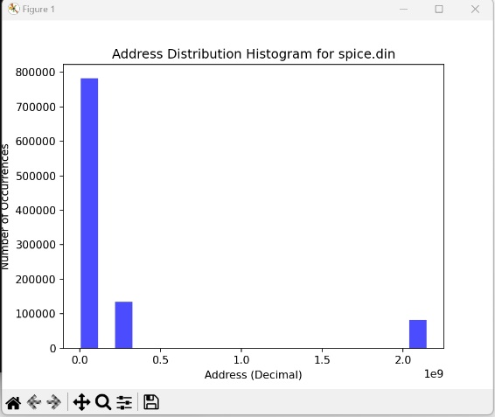

For cc1.din and spice.din :

The histogram for cc1.din and spice.din are both reveals a concentrated distribution of addresses within a specific range(0.000-0.1195, 0.1785-0.2985, 2.0875-2.147),

with a peak occurring around decimal address range (0.000-0.1195).

**(b) :**

**(b-1) : What is the frequency of writes**

**Ans :**

The frequency of writes in cc1.din is 235196

The frequency of writes in spice.din is 373203

**(b-2) : What is the frequency of reads**

**Ans :**

The frequency of reads in cc1.din is 638435

The frequency of reads in spice.din is 700336

**(b-3) : Please comment on these results**

**Ans :**

Comparing the read and write frequencies between cc1.din and spice.din, can observe that spice.din tends to have higher frequencies for both reads and writes.

**Jen-Kai-Wang 2/5 homework01**

**2.**

**(a)**

**(a-1) Write a program, using C, C++, or Java, that multiplies two rectangular matrices -- please no square matrices -- whose elements are randomly generated. You may not use a matrix multiplication library in your code. You will have two versions of the program, one in which matrix elements are integers and another one where they are real numbers (double) (2x15 points).**

**Ans :**

Integer.java、Double.java

**(a-2)**

**Measure the time it takes each program to complete (2x5) and then compare the performance of the two systems (5).**

**Ans :**

|  |  |  |
| --- | --- | --- |
| **Manufacturer** | **AMD** | **AMD** |
| **Operating System** | **Xubuntu(64-bit)** | **Windows 11(64-bit)** |
| **Base Memory** | **4GB** | **16GB** |
| **Compiler** | **VScode** | **VScode** |
| **Integer Program Execution Time** | | |
| **First time** | 10sec | 9sec |
| **Second time** | 13sec | 12sec |
| **Third time** | 15sec | 10sec |
| **Integer Program execution average time** | 13sec | 10sec |
| **Double Program Execution Time** | | |
| **First time** | 25 | 15 |
| **Second time** | 18 | 15 |
| **Third time** | 19 | 17 |
| **Double Program execution average time** | 21sec | 16sec |

**Jen-Kai-Wang 3/5 homework01**

**(a-3)**

**Is the performance ratio the same as the clock rate ratio of the two systems (5)?**

**Ans :**

In my opinion, I use Xubuntu and Windows, but I use a virtual machine, so I cannot compare clock rate ratio of two systems because they are same. However, when comparing the performance ratio of the two systems Windows is faster than Xubuntu.

Performance ration with integer program = 13/10 = 1.3

Performance ration with double program = 21/16 = 1.3125

**Explain. Based on the retail price of the two systems, which one is more cost effective (5)?**

**Ans :**

In my opinion, I use Xubuntu and Windows, but I use a virtual machine, so I cannot compare the price of the two systems. However, when comparing the performance of the two programs, I think Windows is a better choice.

**Jen-Kai-Wang 4/5 homework01**

**(b)**

**(b-1)**

**Change your multiplication algorithm and repeat the steps above; for instance, if you used the the naive multiplication algorith with the column in the inner loop, then just use the same algorithm with the row in the inner loop**

**Ans :**

IntegerSecond.java、DoubleSecond.java

**(b-2)**

**Measure the time it takes each program to complete (2x5) and then compare the performance of the two systems (5).**

**Ans :**

|  |  |  |
| --- | --- | --- |
| **Manufacturer** | **AMD** | **AMD** |
| **Operating System** | **Xubuntu(64-bit)** | **Windows 11(64-bit)** |
| **Base Memory** | **4GB** | **16GB** |
| **Compiler** | **VScode** | **VScode** |
| **IntegerSecond Program Execution Time** | | |
| **First time** | 12 | 10 |
| **Second time** | 13 | 13 |
| **Third time** | 11 | 13 |
| **IntegerSecond Program execution average time** | 12 | 12 |
| **DoubleSecond Program Execution Time** | | |
| **First time** | 27 | 28 |
| **Second time** | 25 | 22 |
| **Third time** | 30 | 31 |
| **DoubleSecond Program execution average time** | 27 | 27 |

**Jen-Kai-Wang 5/5 homework01**

**(b-3)**

**Is the performance ratio the same as the clock rate ratio of the two systems (5)?**

**Ans :**

In my opinion, I use Xubuntu and Windows, but I use a virtual machine, so I cannot compare clock rate ratio of two systems because they are same. When comparing the performance ratio of the two systems they are also same.

Performance ration with integer program = 12/12 = 1

Performance ration with double program = 27/27 = 1

**Explain. Based on the retail price of the two systems, which one is more cost effective (5)?**

**Ans :**

In my opinion, I use Xubuntu and Windows, but I use a virtual machine, so I cannot compare the price of the two systems. However, when comparing the performance of the two programs, even though in part B the answers are the same, I still think Windows is a better choice because of the part A answer.

Github link : <https://github.com/JenKaiWang/CS402.git>