Few Shot Forgery Detection

余振揚 NM6121030機器人 徐仁瓏 RE6121011數據所
梁菁芸 Q36134182 電通所 鄭翊宏 P76121657 資工所

https://github.com/LittleFish-Coder/few-shot-forgery-detection

- Introduction
Our goal is to identify whether a video is real or fake. We use three models for transfer learning and observe the effects of finetuning in a few-shot setting. We use two datasets: FaceForensics++ and Celeb-DF (Figure 1). The latter contains 59 different faces and has more realistic Deepfake effects, while the former includes more fake videos that can be identified. All three models have been pretrained on FaceForensics++, and we will use Celeb-DF for finetuning.

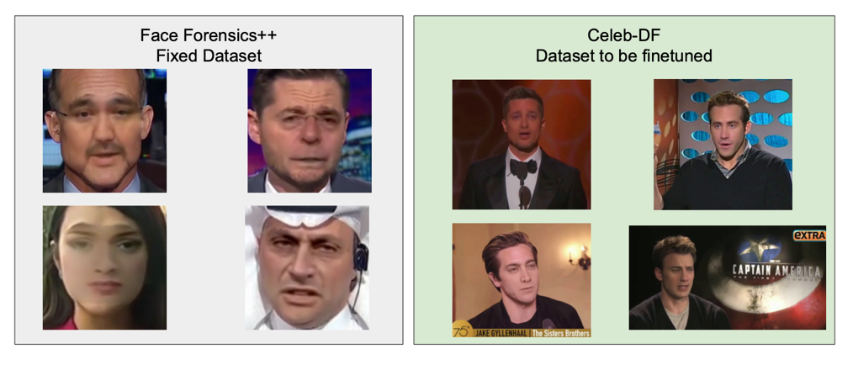
Figure1: Dataset (FaceForensics++&Celeb-DF)

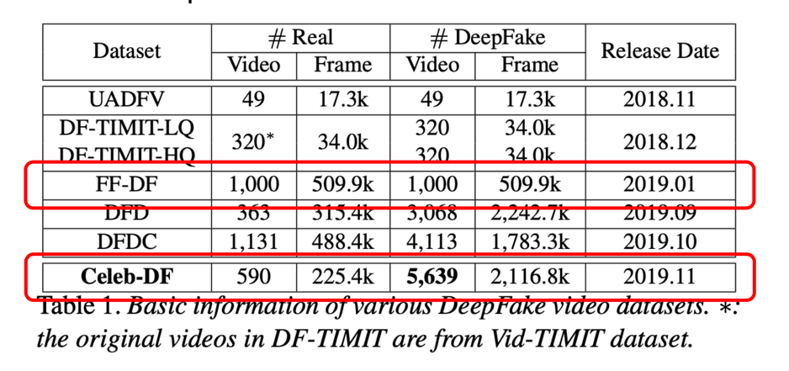
Table1: Dataset Comparison

- Methodology
- Detection Pipeline
First, we perform face detection on the input image to extract the facial region. Next, we crop the image to different sizes based on the requirements of different models. Finally, we classify the cropped images using the classification model to determine whether the video is real or fake.

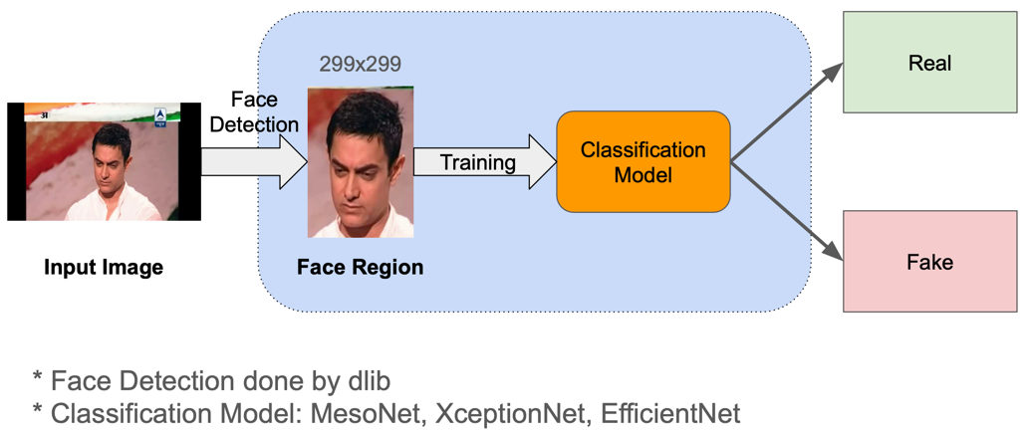
Figure2: Detection Pipeline

- Proposed Pipeline
For the three models pretrained on FaceForensics++, we will finetune them using the new dataset.

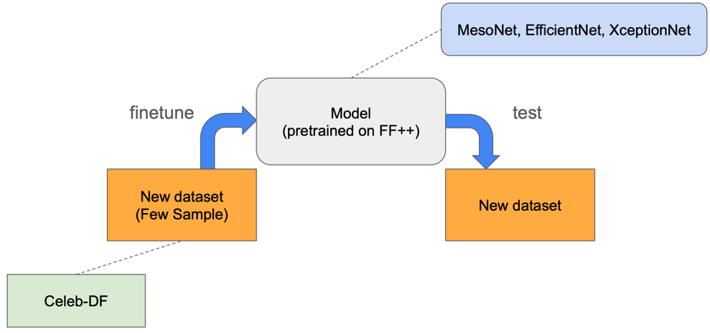
Figure3: Proposed Pipeline

- Experiment
- Training Phase
We first split the video into frames of images array, and then label the images with the same label as the video.
We then randomize the order of the images and split the images into training set and validation set.

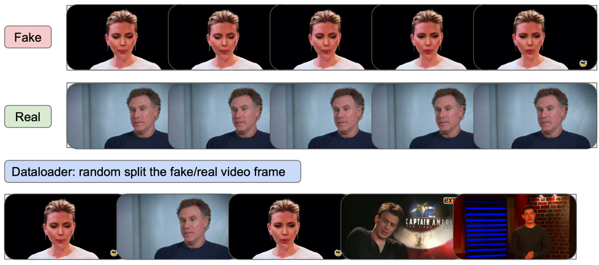
Figure4: Dataloader Design

- Testing Phase
In the testing phase, we feed the testing video into the model and get the prediction of each frame. We then calculate the average prediction of all frames in the video and use it as the final prediction of the video.

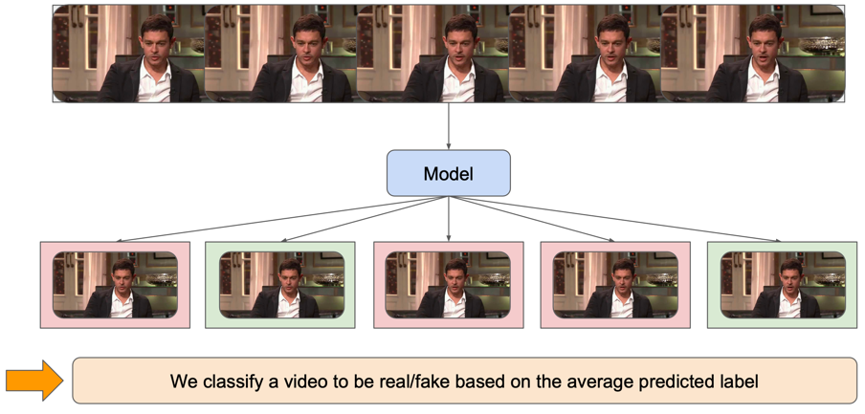
Figure5: Testing phase
*The model will assign a real or fake label to each frame. The label that appears more will be used to determine whether the video is classified as real or fake.

- Implementation Detail
Model pretrained on FaceForensics++ c23
- models: MesoNet(2018), XceptionNet(2016), EfficientNet(2019)
Finetune 1%, 5%, 10%, 50%, 100% Celeb-DF
- Training set: 1%, 5%, 10%, 50%, 100%
- Validation set: 1%
- Testing set: all Celeb-DF official testing set

Hyperparameter
- Loss: Cross Entropy
- Optimizer: Adam
- Learning rate: 0.001
- Scheduler: StepLR, step size=5
- Epoch
Shot | 1% | 5% | 10% | 50% | 100%
Epoch | 100 | 100 | 100 | 50 | 30
Table 2: Epochs for different training dataset

- Results
- Model Generalization on Pretrained-Model (zero-shot)
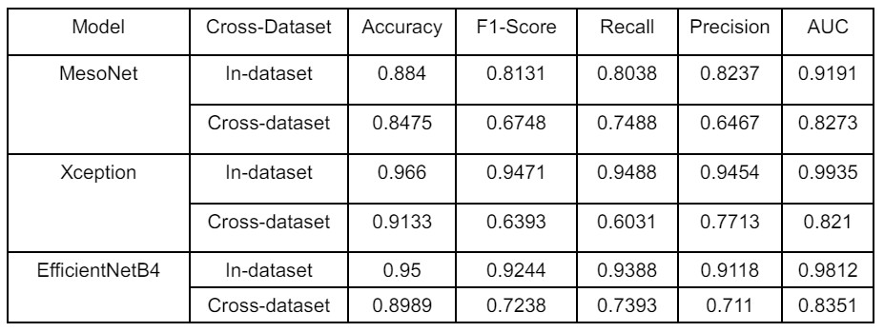

- MesoNet
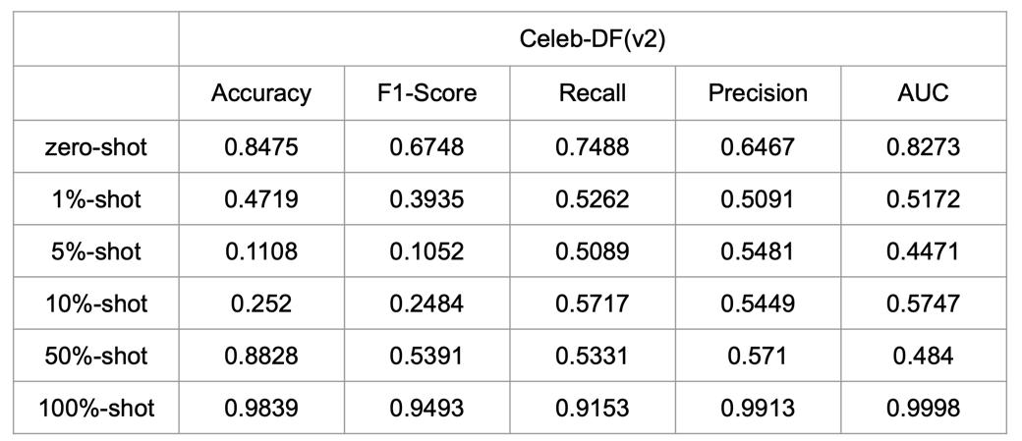

- Xception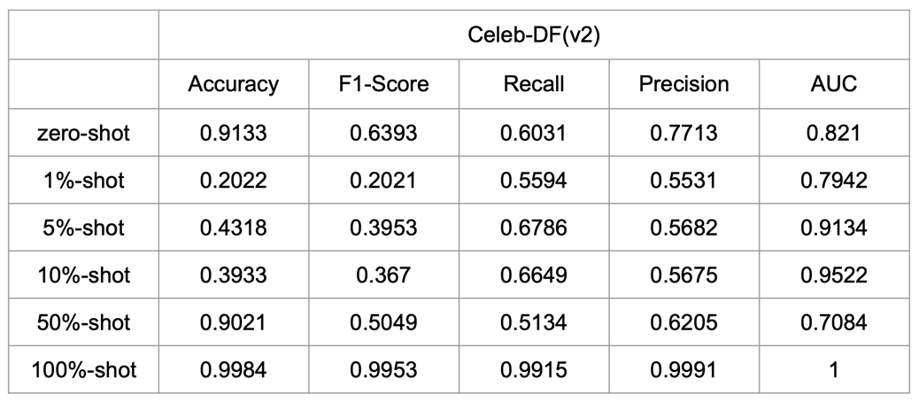

- EfficientNetB4
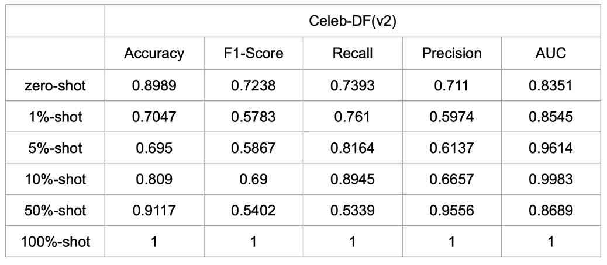

- Model Comparison on Different Metrics
F1-Score
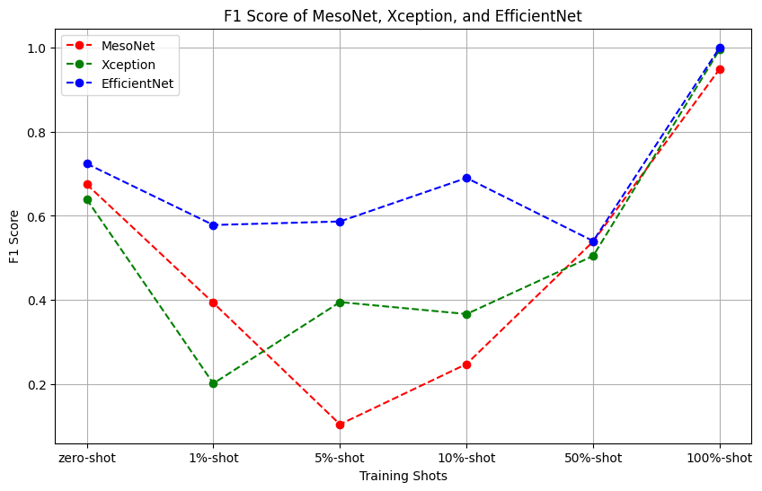

Accuracy
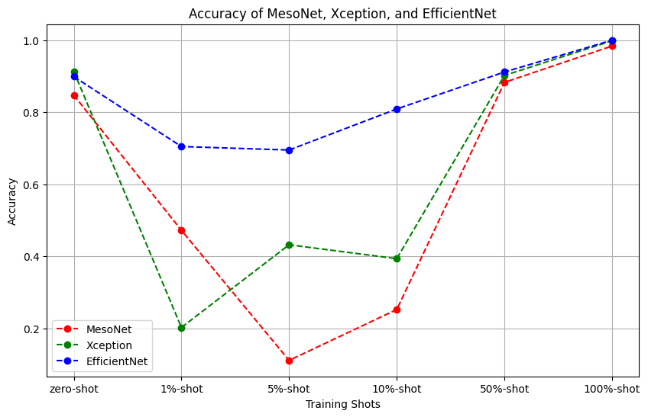

AUC
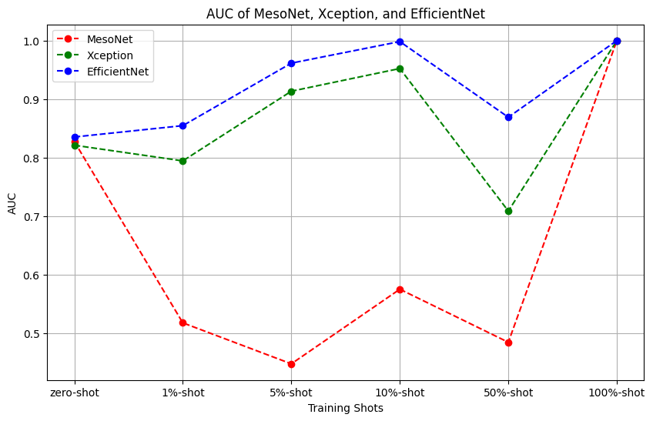

- Conclusion
EfficientNet outperforms the other two models when testing few-shot samples.

Our assumption is that since the difference between real and fake images is small, it’s very hard to distinguish them by using simple convolutional feature extraction method.

Also, we think Residual component plays an important role in this task.

- Reference
[1] dlib: https://github.com/davisking/dlib
[2] MesoNet: https://github.com/DariusAf/MesoNet
[3] XceptionNet: https://medium.com/ching-i/inception-系列-xception-fd2a4a4e7e82
[4] EfficientNet: https://medium.com/ching-i/efficientnet-論文閱讀-e828ac005ce8

Fail to apply on this project
[5] MTCNN: https://github.com/ipazc/mtcnn
[6] ViT (MARLIN): https://github.com/ControlNet/MARLIN
[7] DFDC Dataset: https://ai.meta.com/datasets/dfdc/

- GitHub
https://github.com/LittleFish-Coder/few-shot-forgery-detection

