INFO 6053 Automated Test Tools

Project 1

Selenium Installation and Assessment

Prepared By:

Jenab Vohra – 0904905

Jay Mangnani – 0904910

Jay Patel –

Harpreet Kaur-

Introduction

The Selenium is free open source software which helps the users in testing the scripts automatically by running the selenium test cases. This environment of selenium works well with the Firefox and Chrome and to the ground it is most efficient to develop test cases. As, it runs the scripts automatically it works as the time – saver and saves tomes by not running the scripts manually. It has many Selenium commands, that records the user’s actions and play back the script in the manner one had record it, using existing Selenium commands, with parameters defined by the context of that element. This is not only the tool to run the java script automatically but good approach of Selenium script syntax. Selenium focuses on automating web-based applications.It has four components.

* Selenium Integrated Development Environment (IDE)
* Selenium Remote Control (RC)
* WebDriver
* Selenium Grid

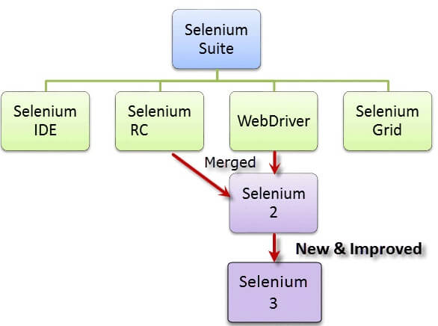

Advantages of Selenium:

* Easy to install
* No programming concepts needed just the HTML and DOM is needed.
* Can export the test to the format usable Selenium Web Driver.
* Provides support for extensions.

Disadvantages of Selenium:

* Available on Chrome & Firefox.
* Designed to create the prototype of tests.
* No support of iterational and conditional operations.
* Test execution is slow compared to the Web Driver.

2. Screenshot of the Selenium IDE installed in the laptop.

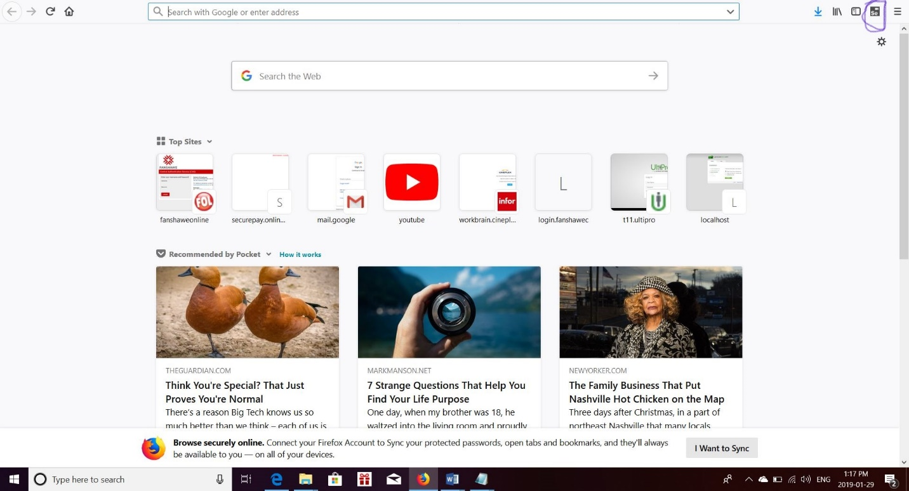

**Selenium IDE plugin features**