**BOOKSTORE**

Database class project 2020/2021

|  |  |  |  |  |
| --- | --- | --- | --- | --- |
| Student Name in English | Student Name in Arabic | Student ID | Section | Work percentage |
| Alaa Yamak | آلاء يمك | 11923556 | 8-9:30 | 50% |
| Jenan Abualrub | جنان أبو الرب | 11924400 | 8-9:30 | 50% |
|  |  |  |  |  |

Date/time

---------------------------------------------This section is intended for the Instructor---------------------------------------

|  |  |
| --- | --- |
| **Topic** | **Mark** |
| Project Requirements and Modeling |  |
| Correctness of Database mapping |  |
| Functional Dependency and Normalization |  |
| Project Tools |  |
| Project Discussion |  |
| Project Completeness |  |
| Project Output Results or reporting (JasperReport, charts, graphs, etc.) |  |
| Project Administration and Management |  |
| Project Report |  |
| Project Idea |  |
| Project Complexity |  |
| Team work |  |
|  |  |
|  |  |
|  |  |

**Abstract:**

**This project represents an application designed to be used at a bookstore. The application is provided with features that enable users of 4 different roles to use it. Besides the main goal of the application which is to allow customers to buy books without the need to show at the bookstore; there are also some actions which tend to give customers a chance to communicate with employees by making suggestions. It also gives a chance for people to apply for a job at the bookstore by filling up an application form, which is reviewed later by the manager ONLY. To keep the bookstore up to date; the staff is responsible of adding new books to system and managing the stock.**

**Table of content:**

**\*Manager**

**\*Employee**

**\*Customer**

**\*Applicant**

**\*Carts and its items**

**Introduction:**

Our project is a bookstore application, that consists mainly of the manager, employees, customers and a job application box.

To regulate access to the system, a role-id has been adopted for each of these four types (manager, employee, customer, applicant).

The manager is primarily responsible for the entire system. He has the authority to access and modify employee information, such as changing the salary, and viewing the carts and what has been purchased.

As for the employees, their responsibility is to organize the store, add new books and follow up on customer suggestions for what they want.

The customer enters the store mainly for the sake of purchasing, he can control his cart by adding and removing books before confirming his order.

**Requirements:**

* The bookstore database keeps track of all accounts created by users of different roles. There are four types of persons who could create an account in this system. As the bookstore has lots of books; each book’s details will be recorded and kept track of by the database.
* For each person, the database stores the person’s: **Name**, **SSN**, **Birthdate**, **Gender**, **Email** **Address** and **Phone number**.
* There are four subclasses of the person entity: Manager, Employee, Customer and Applicant.
* Manager: can access employees’ profiles and edit their salaries. Also capable of hiring new employees by reading application forms filled by the applicants. The manager has access to all books in the system. Thus, she can add or edit any book. She also has the right to view all shopping carts bought by the customers.
* Employees: each employee has their own **salary**. Employees are responsible of adding and editing books. They also receive suggestions from customers about adding new books. The suggestion will be available to all employees, the first employee to view it can mark it as seen so no conflict occurs.
* Customers: whenever a customer accesses the system, a cart will be reserved to carry all books chosen by this customer. The customer has the right to check the cart at the end of the shopping process. Customers can suggest new books by sending the suggestions to the employees.
* Applicants: when a person applies for a job in the bookstore, they will be asked to fill an application form, which will be checked later by the manager. If the applicant was hired, their username/password will remain the same as their role will change from applicants to employees.
* Accounts: each account has a unique **username** and a **password**. As there are different types of users in the system, the role to be played by each account will be specified in the database.
* Roles: there are only four roles. To make sure there are no mistakes made by the user the database offers certain roles, each specified by its **ID** and **type**.
* Cart: each cart has its **ID**, **Date** and **Total price**. It also contains books, where the quantity selected for each book differs according to the customer’s choice. All carts are stored in the database.
* Items: each **cart** contains items which will be stored in the items table to show the chosen books specified by their isbn and the quantity bought
* Books: for each book the database stores the following information: **ID**, **Title**, **Author**, **Book-image**, **Description**, **language**, **Price** and **Quantity**. The quantity and price can be changed by both the employees and the manager. Books can be added to the database by the employees and the manager as well.

**The Functional Dependency:**

**MANGER**

SSN -> F_NAME, M_NAME, L_NAME, BIRTH_DATE, PHONE, CITY, EMAIL, GENDER, E_IMAGE

**ACCOUNTS**

USERNAME-> PASSWORD, R_ID, SSN

**APPLICANTS**

SSN -> F_NAME, M_NAME, L_NAME, BIRTH_DATE, PHONE, CITY, EMAIL, GENDER, ACADEMIC_LEVEL, WORKING_HOURS, SEEN

**BOOKS**

ISBN -> TITLE, BOOK_IMAGE, AUTHOR, B_DESCRIPTION, PRICE, QUANTITY, B_LANGUAGE

**CARTS**

C_ID -> SSN, C_DATE, T_PRICE

**CUSTOMERS**

SSN -> F_NAME, M_NAME, L_NAME, BIRTH_DATE, PHONE, CITY, EMAIL, GENDER

**EMPLOYEES**

SSN -> F_NAME, M_NAME, L_NAME, BIRTH_DATE, PHONE, CITY, EMAIL, GENDER, SALARY, E_IMAGE

**ITEMS**

C_ID, ISBN -> QUANTITY

**LANGUAGES**

SSN, LANGUAGES

**Working_days**

SSN, wday

**The EER diagram has a DROW.IO file included in the project files.**

The normalization process:

**Applicants**:



The languages attribute is a multivalued attribute, thus we converted it to 1NF.

The same goes for the working_days attribute.

Result:



 

SSN, languages (composite primary keys) SSN, WDAY (composite primary keys)

**Accounts**:

|  |  |  |  |  |
| --- | --- | --- | --- | --- |
| USERNAME | PASSWORD | SSN | R_ID | R_TYPE |

Due to the functional dependency as R_ID specifies the value or R_TYPE, a new table called roles was built applying 3NF.

Result:

Accounts: Roles:

|  |  |  |  |
| --- | --- | --- | --- |
| USERNAME | PASSWORD | SSN | R_ID |

|  |  |
| --- | --- |
| R_ID | R_TYPE |

R_ID (Foreign key) R_ID (primary key)

**Carts:**

|  |  |  |  |  |
| --- | --- | --- | --- | --- |
| C_ID | SSN | C_DATE | ITEMS | TOTAL_PRICE |

Items is a multivalued attribute, to overcome that; a new table was created as follows:

|  |  |  |  |
| --- | --- | --- | --- |
| C_ID | SSN | C_DATE | TOTAL_PRICE |

|  |  |  |
| --- | --- | --- |
| C_ID | ISBN | QUANTITY |

**Tools:**

* **NetBeans**
* **Sql developer**
* **TICO jaspersoft**
* **Drow.io**
* **Word**

**Discussing the GUI :**

This view is responsible of logging into the application. It asks the user to enter the username and password, then the screen is displayed based on the role-id of each type we have.

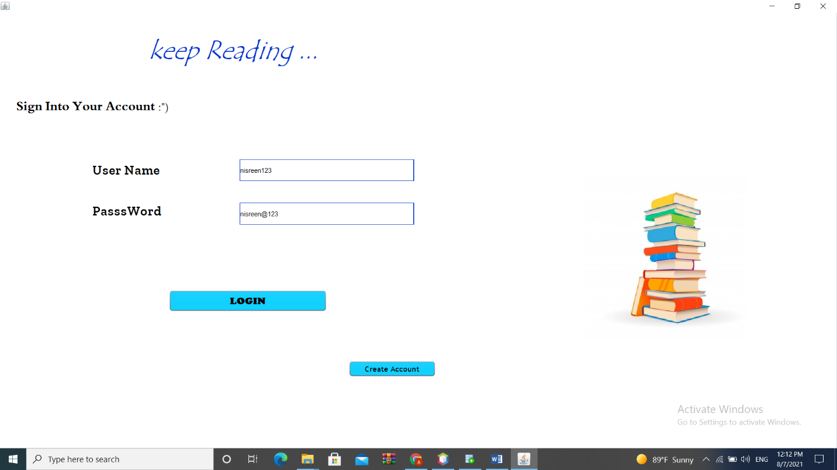

**If you want to create a customer account or an account to submit an employment application, you can fill in this GUI.**

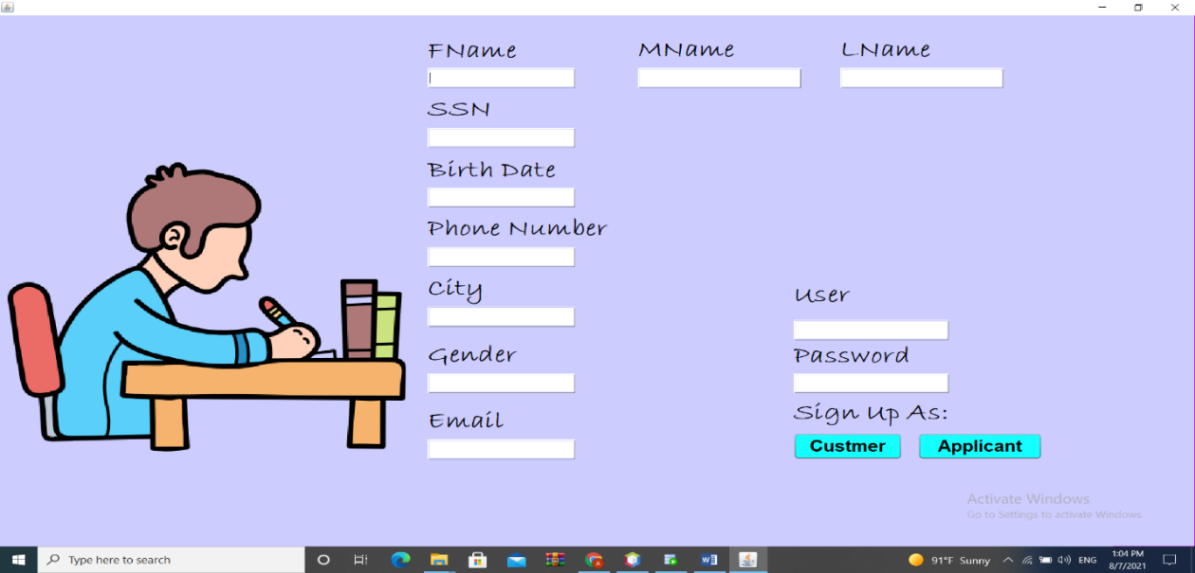

**\*\* The following GUI is for the manager**

**The home view:**

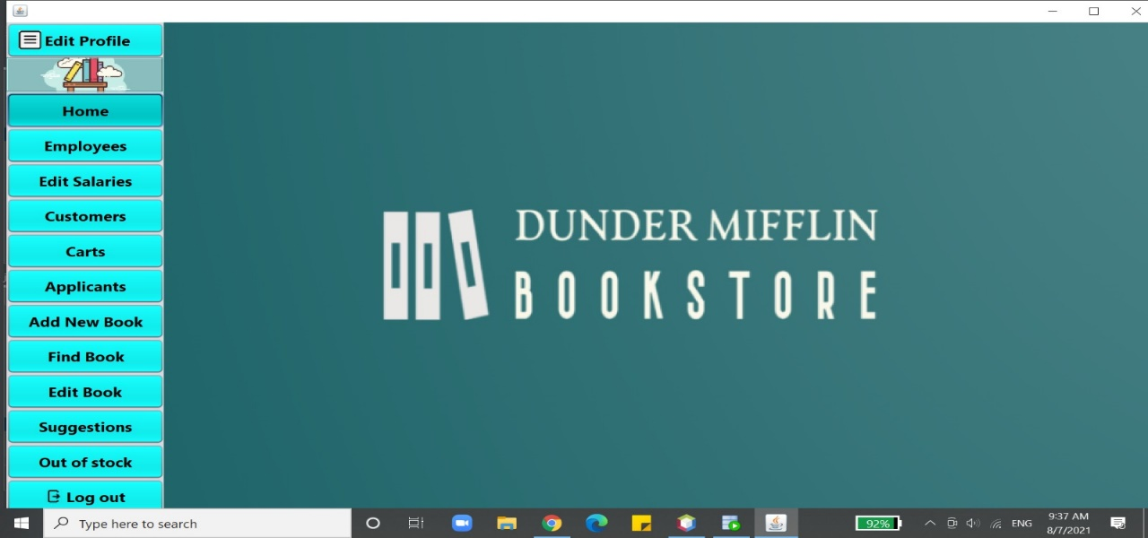

**Edit profile view in order to edit personal data.**

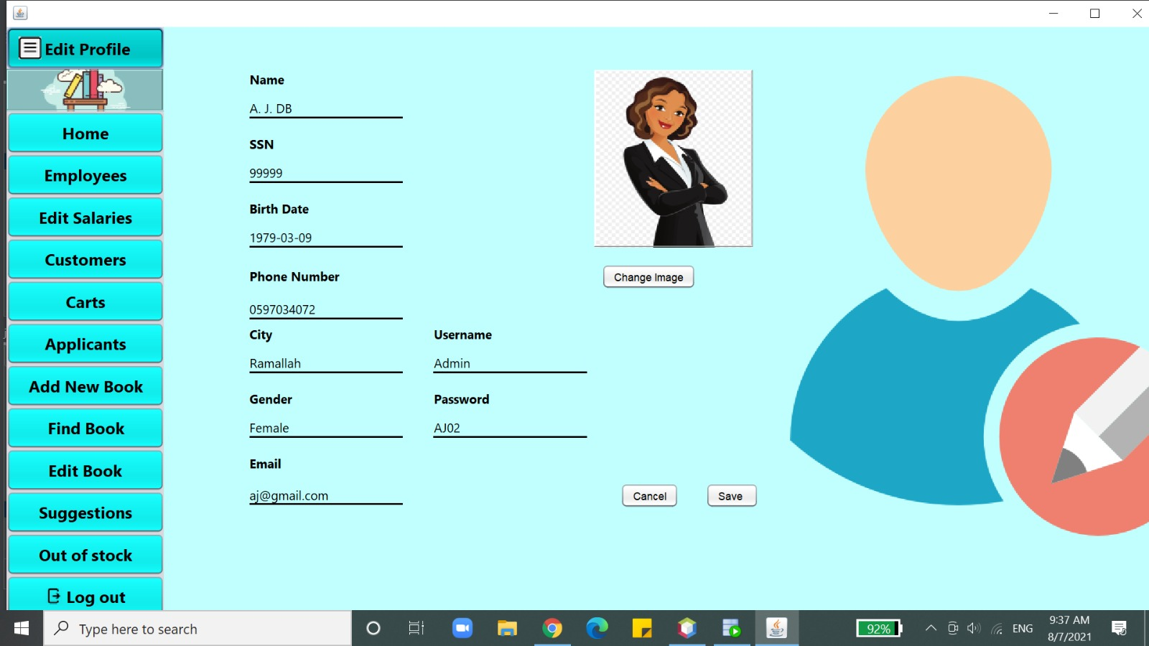

**Employees view which displays all employees’ information.**

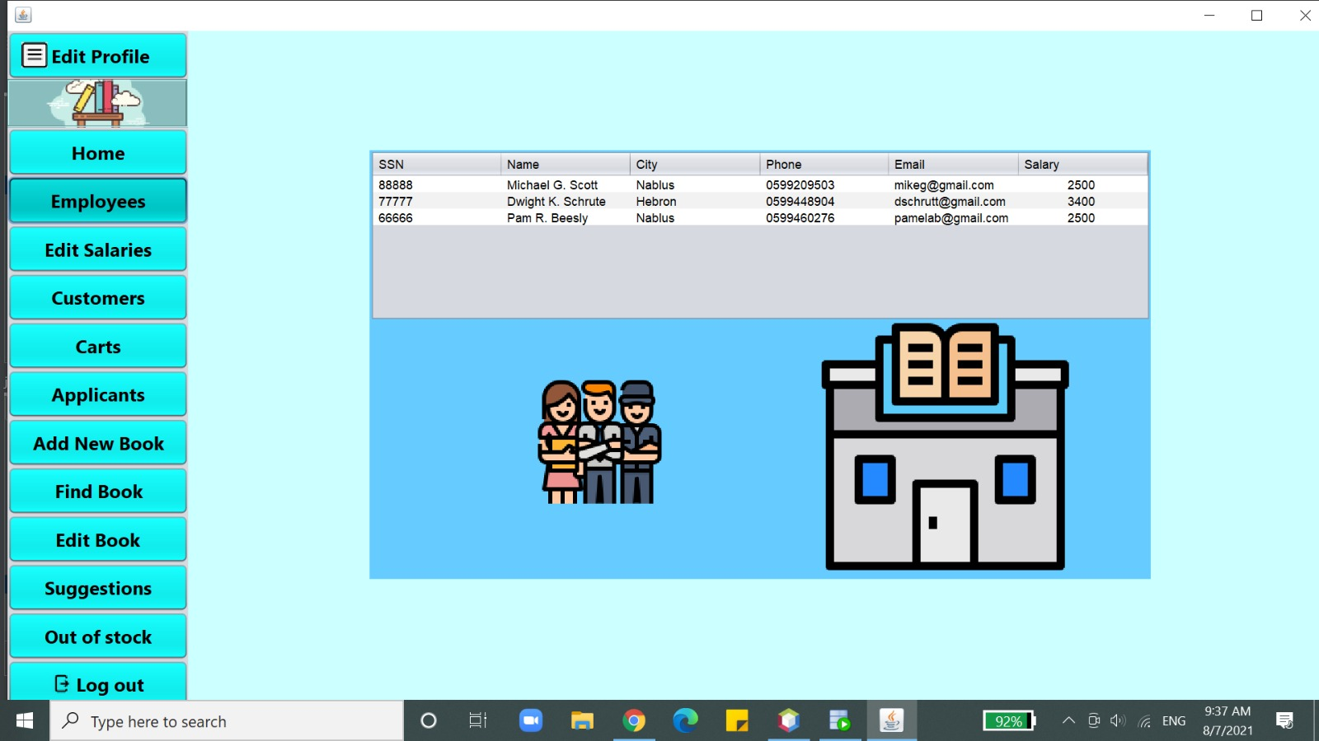

**Edit salary view which enables the manager to modify the salaries of her employees by searching them using the SSN.**

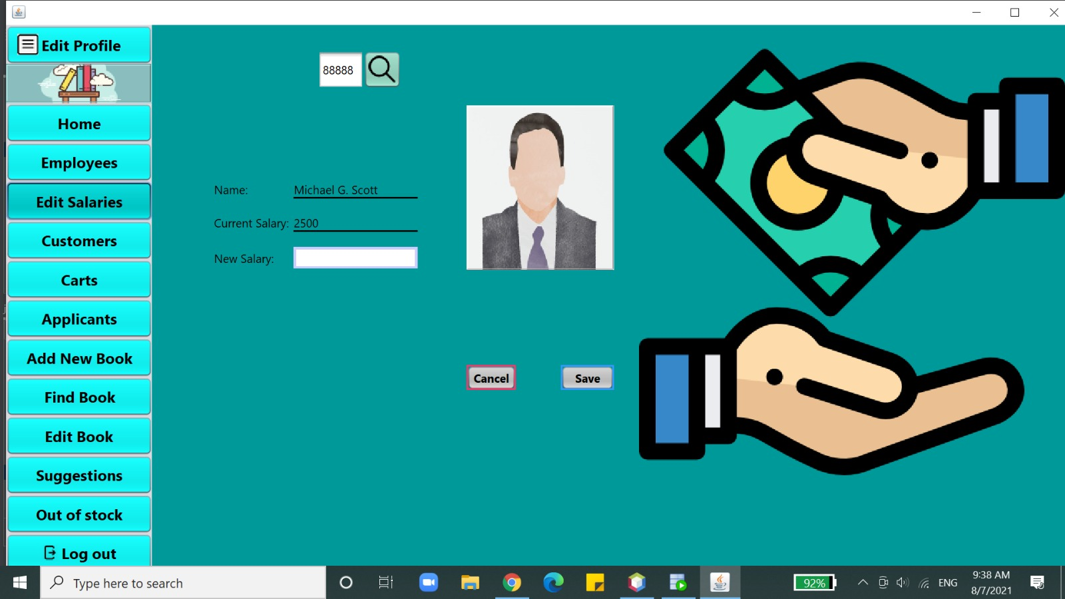

**Customers view which displays customers’ main personal data, it also shows the number of carts bought by them.**

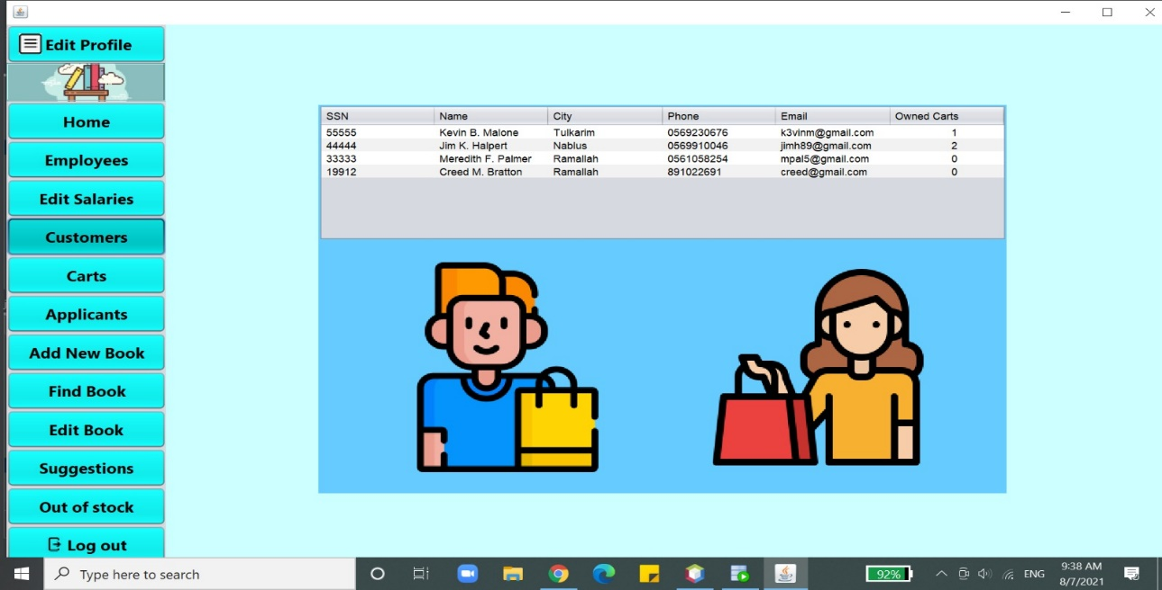

**Cart view, which displays the data of each cart in terms of the customer who purchased it with the total price.**

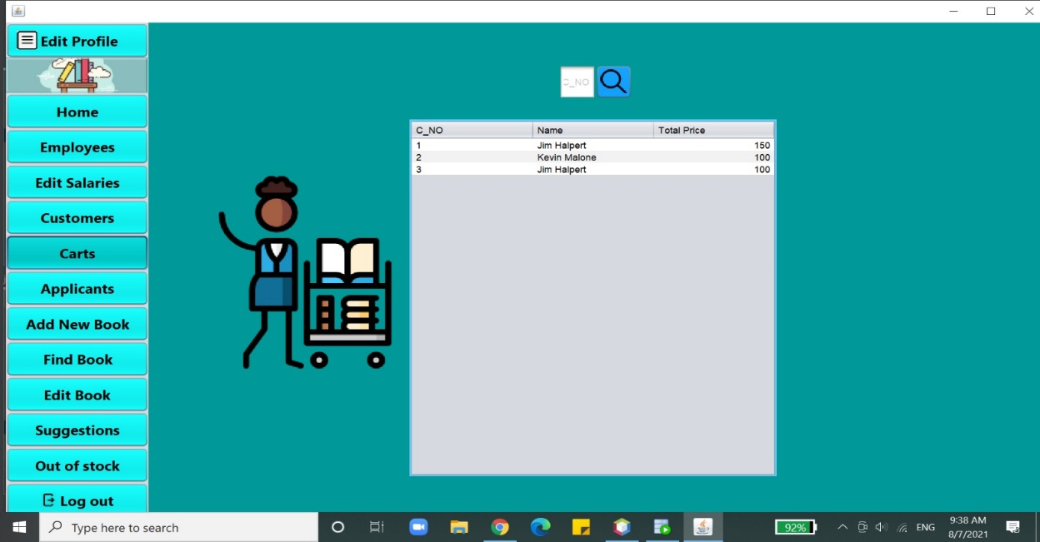

**Carts view also enables the employee to view the contents of each cart by searching its number.**

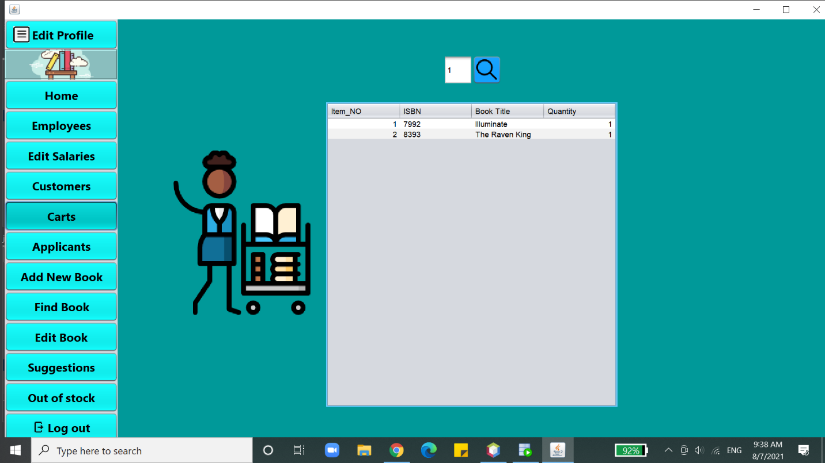

**Applicant view which displays all applicants information. To move between the application forms, the arrow at the right bottom is used.**

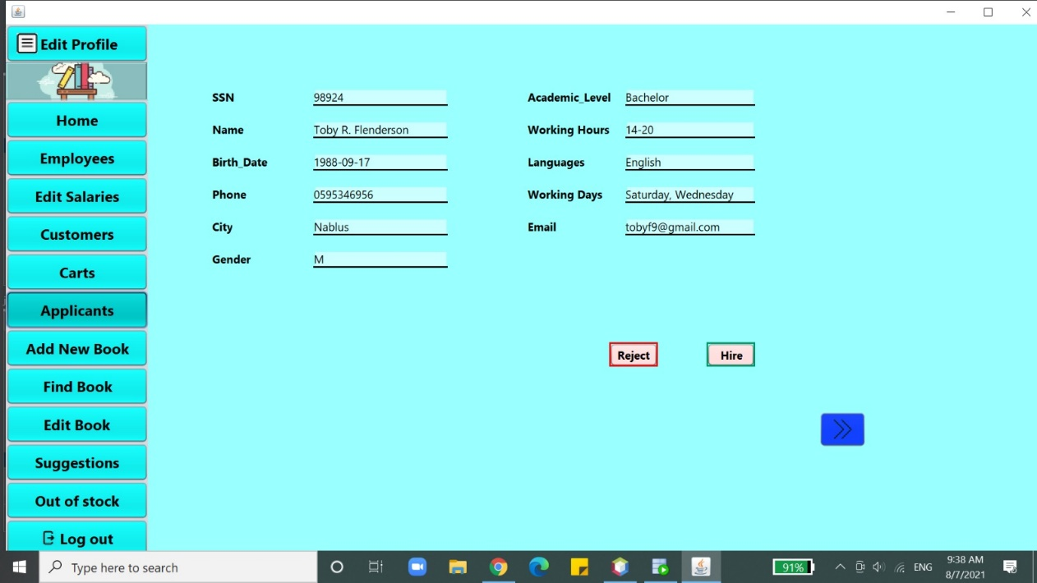

**\*\* Now these GUI are for both manager and employee.**

**This is the GUI for adding new books to the store by the manager or employees.**

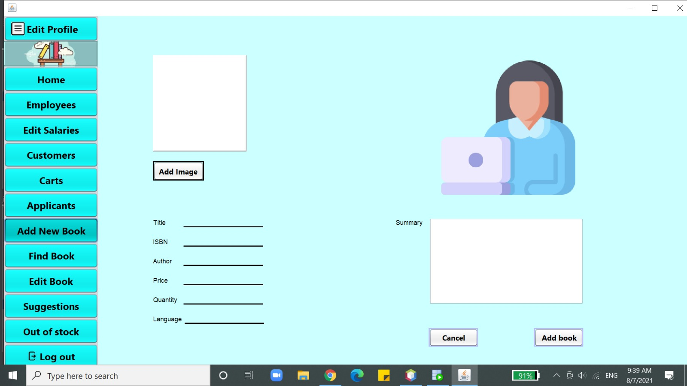

**To search for a specific book by its name or its ISBN.**

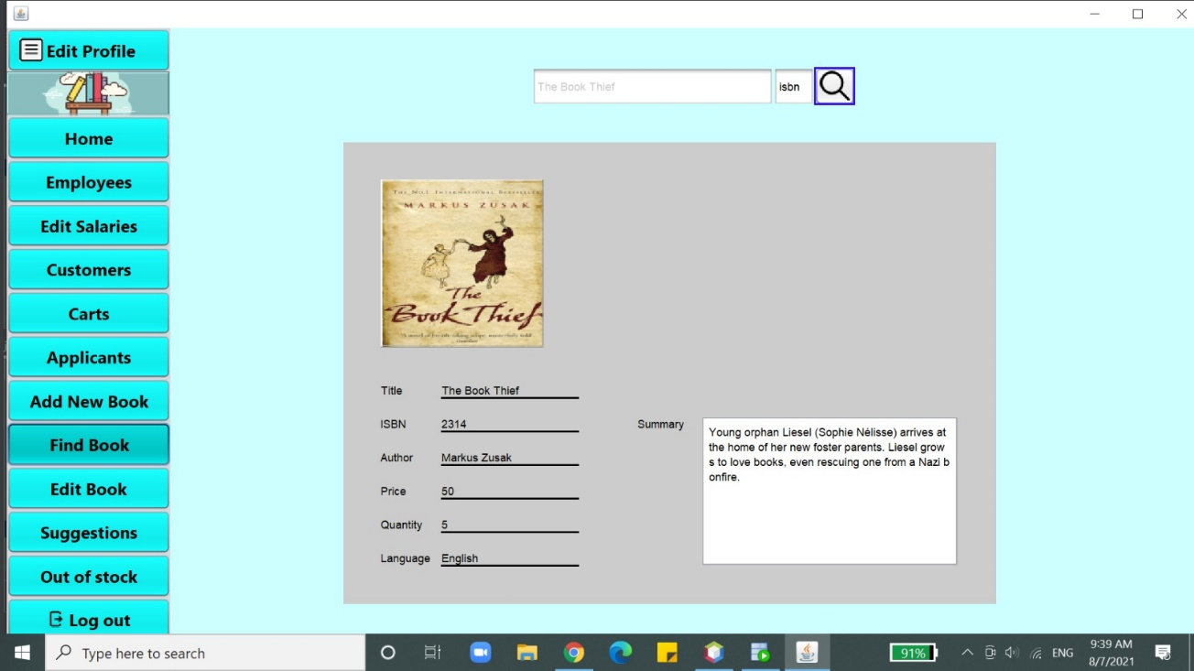

**In order to modify the information of a particular book.**

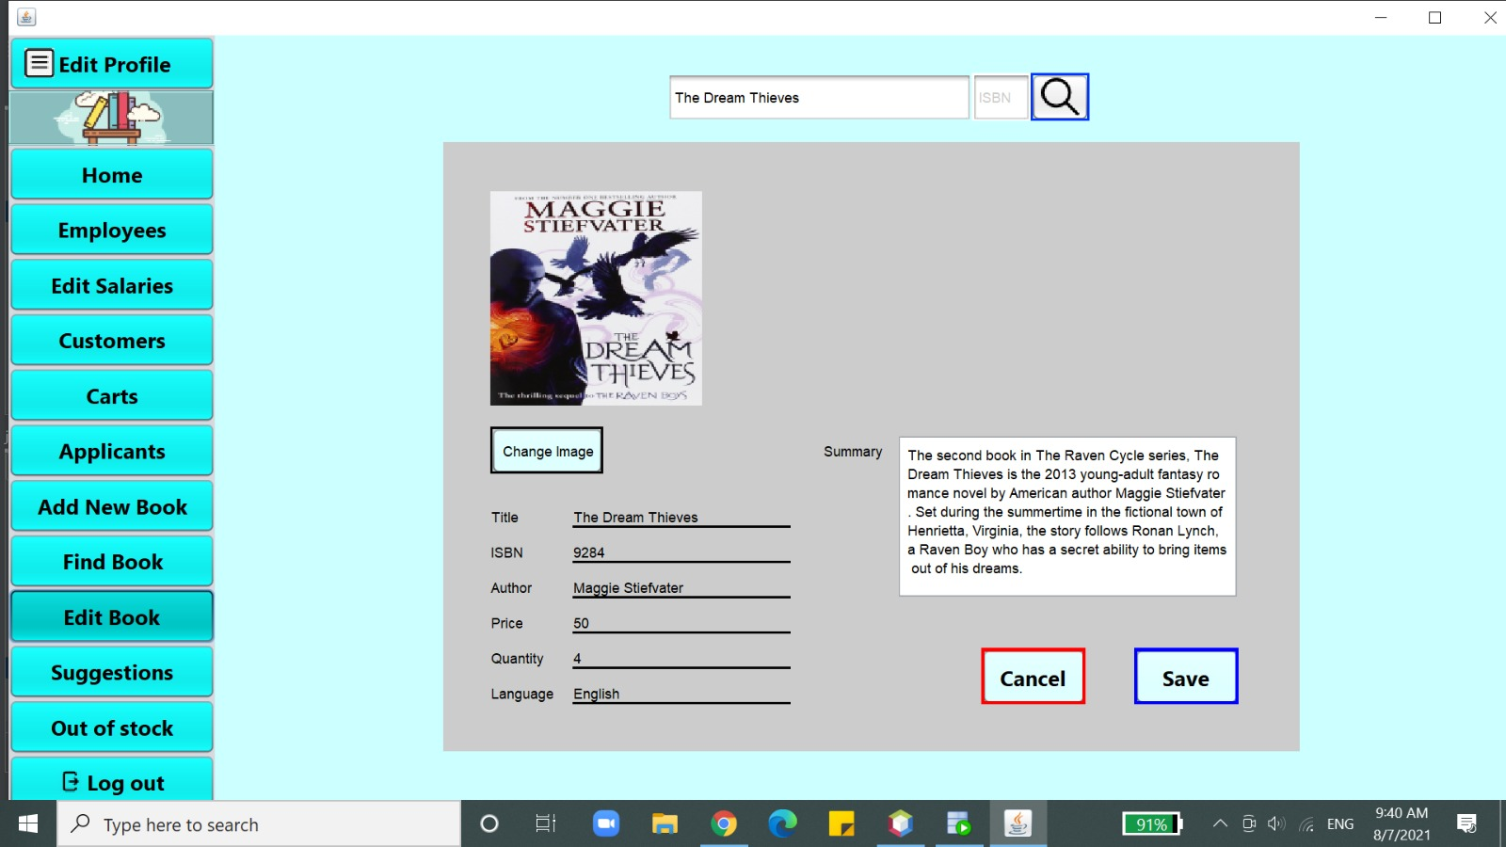

**This GUI is in order to see all the suggestions made by customers.**

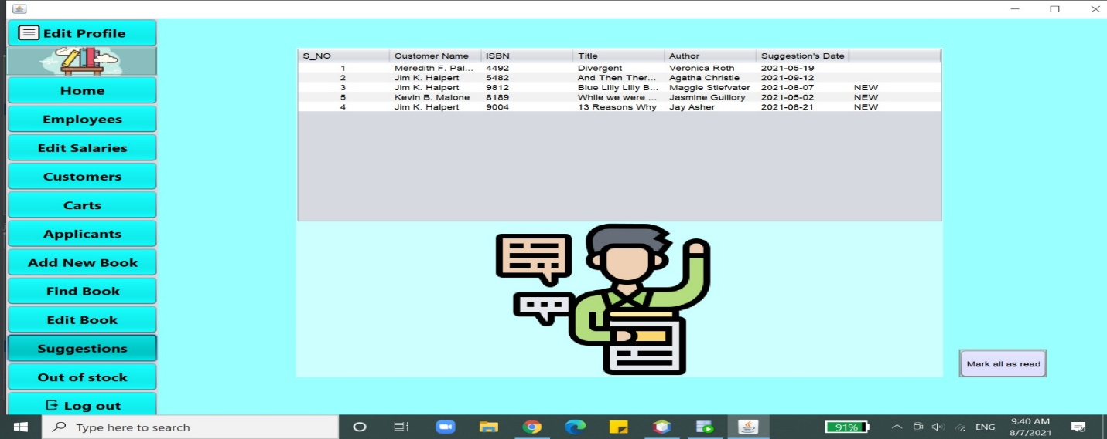

**When the quantity of this book becomes zero, that is, when all the books have been purchased, then “out of stock” appears next to the name of the book in order to alert that and add a new quantity.**

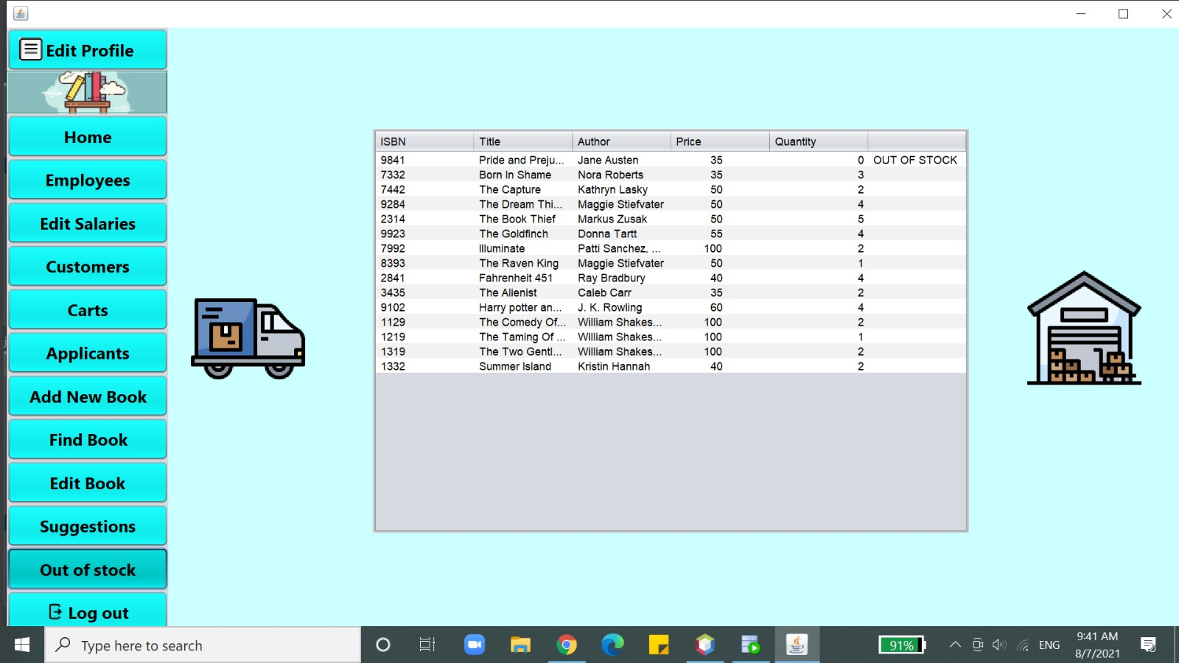

**\*\* These GUI are for customers**

**Edit profile view in order to edit personal data.**

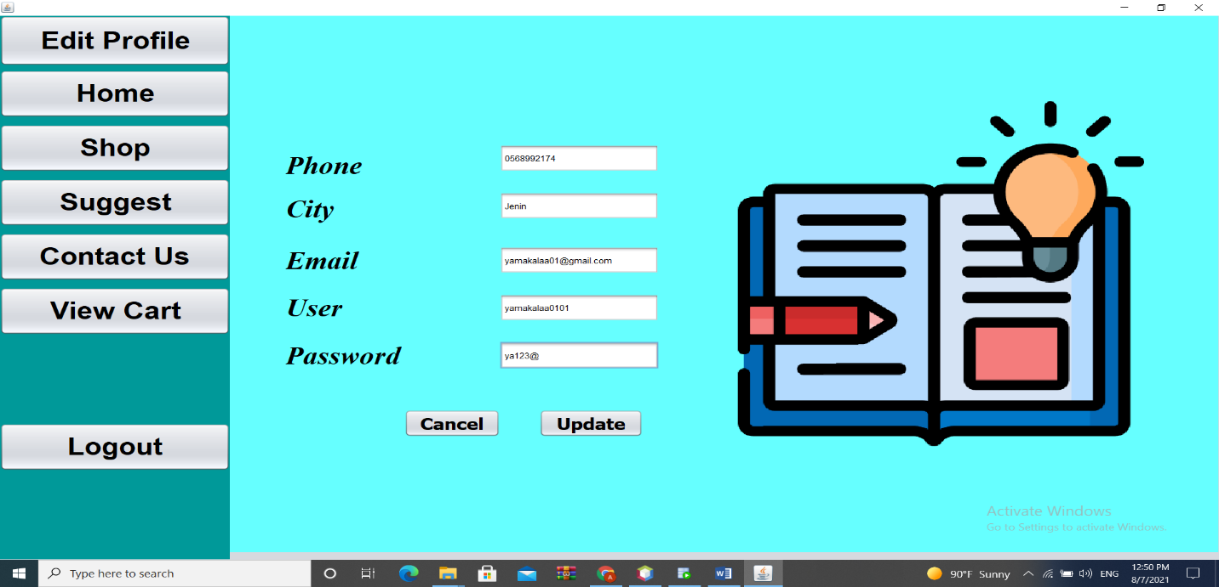

**GUI of the process of displaying books to the customer in order to choose what they want to buy..**

**The purchase process is done by double clicking on it and adding it to the cart.**

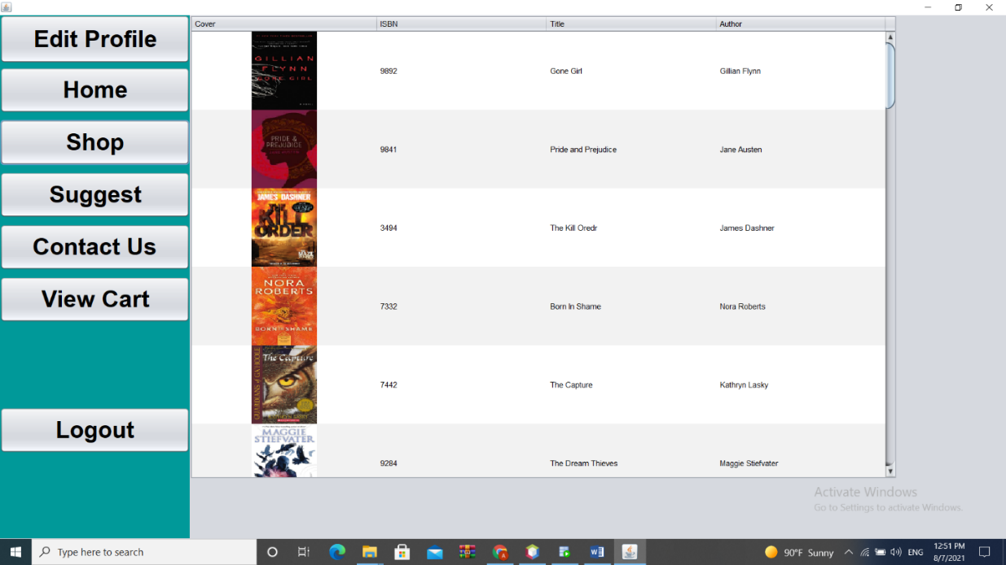

**This is in order to display the contents of the cart and change it before confirming the order.**

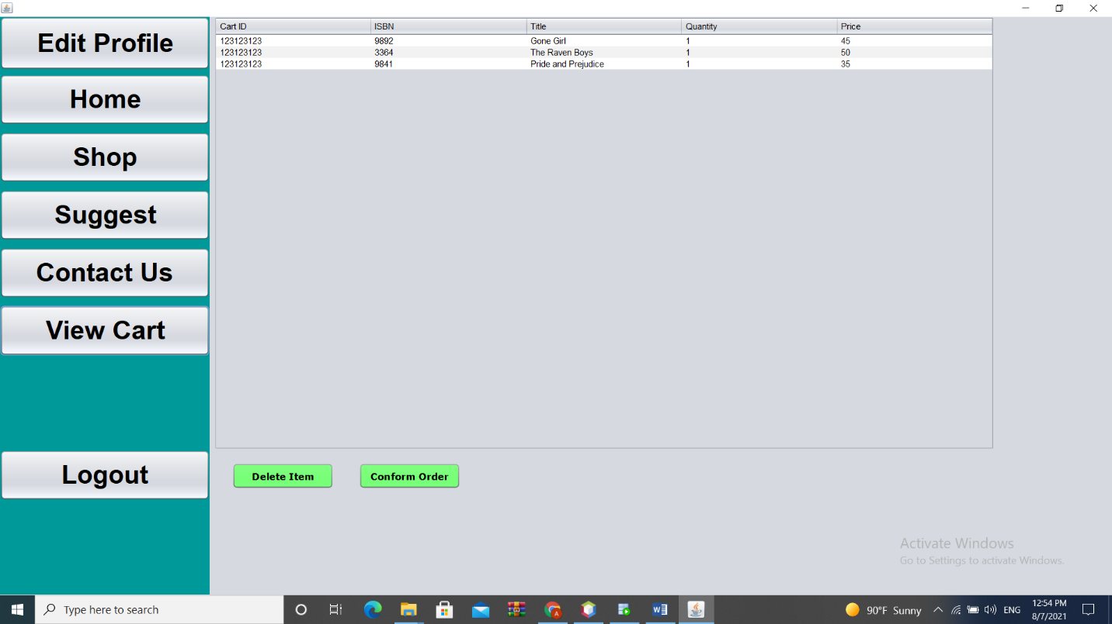

**This is in order to suggest a book that is not in the store, where the order is sent to the employees.**

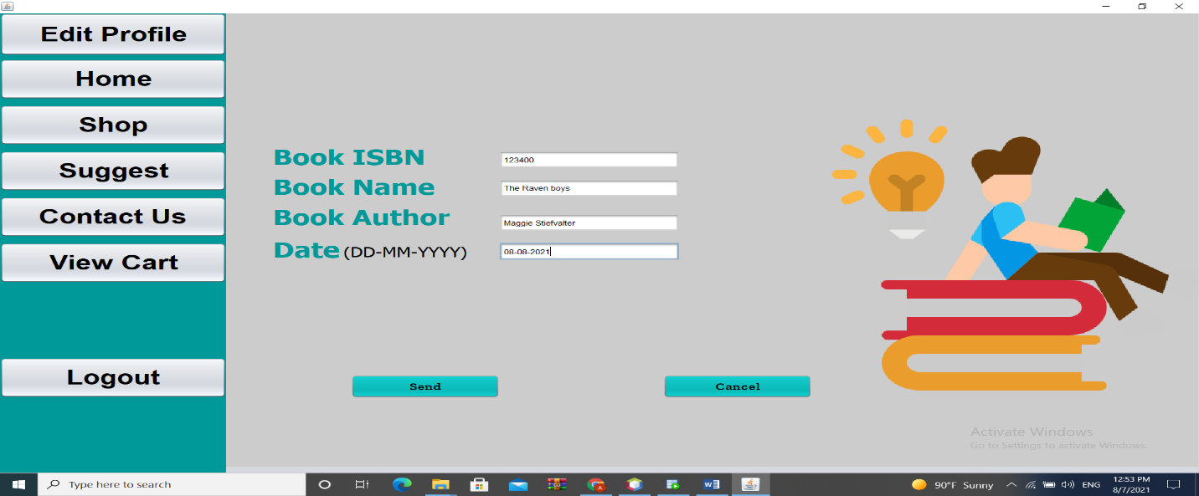

**TO contact us ☺*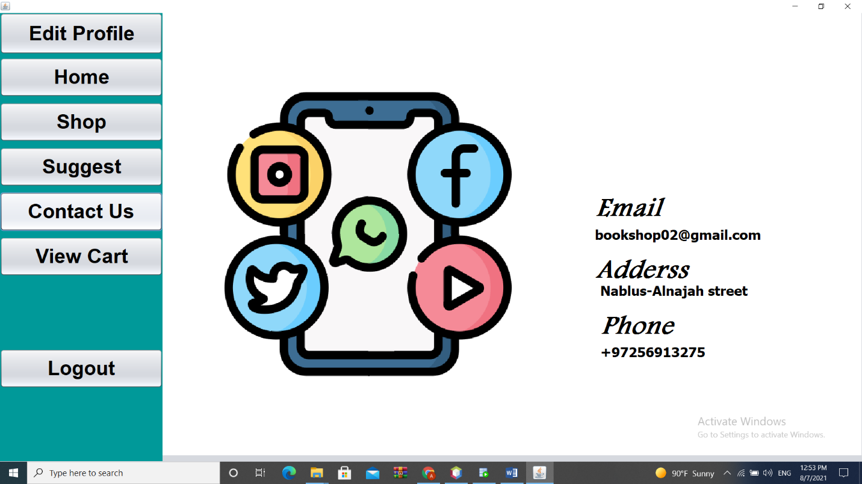***

**This is for the applicants through which the employment application is filled out.**

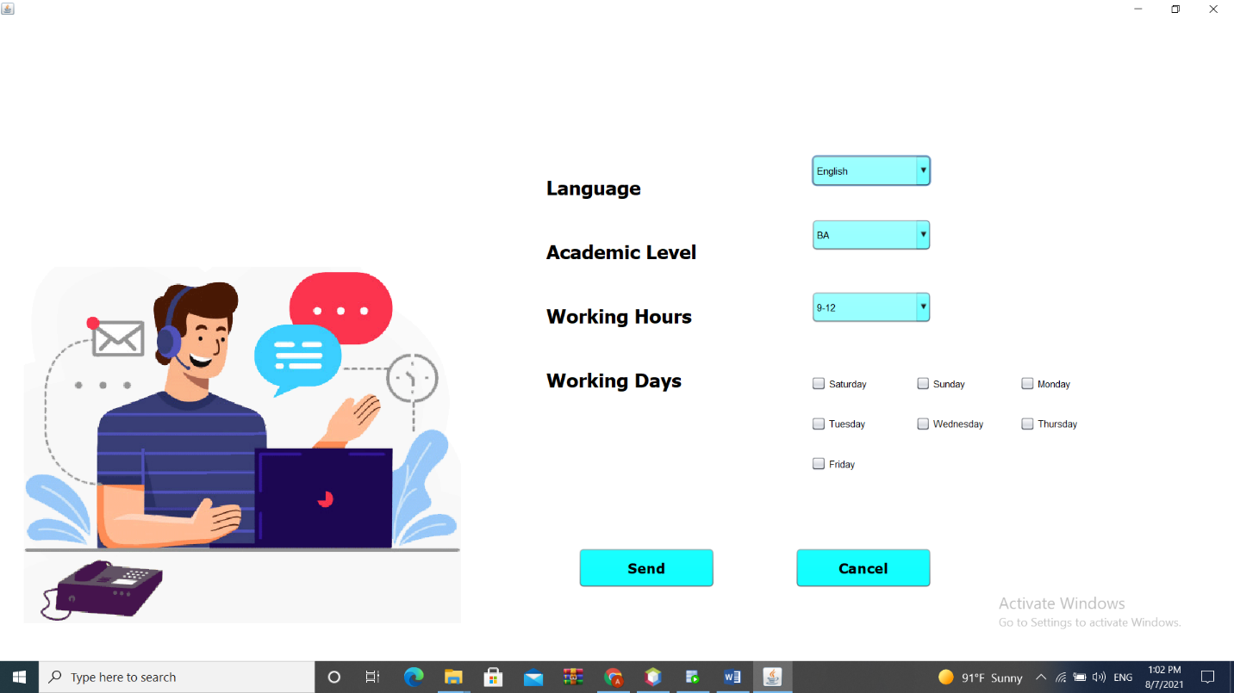

**Conclusion:**

**Our intention was to create an application that does all the main functionalities required by any bookstore app. Thankfully, we fulfilled everything as we were planning to and we were able to overcome all the technical issues. Most importantly, the project gave us a good opportunity to practice the new concepts presented by this course.**

**References:**

1. **Lectures and slides.**

[**https://moodle.najah.edu/pluginfile.php/380041/mod_resource/content/2/DatabaseSEversion2021.pdf**](https://moodle.najah.edu/pluginfile.php/380041/mod_resource/content/2/DatabaseSEversion2021.pdf)

1. **Stackoverflow.**

[**https://stackoverflow.com/**](https://stackoverflow.com/)

1. **Book stores.**

[**https://famtime.com/shop/?gclid=CjwKCAjw3riIBhAwEiwAzD3TieiQhw8KHvEiwk-GGarW5VgXn5KJopm0GgIdwtAOwu1uSZP6g_z9bhoCAgIQAvD_BwE**](https://famtime.com/shop/?gclid=CjwKCAjw3riIBhAwEiwAzD3TieiQhw8KHvEiwk-GGarW5VgXn5KJopm0GgIdwtAOwu1uSZP6g_z9bhoCAgIQAvD_BwE)